1. Set up your subversion account.

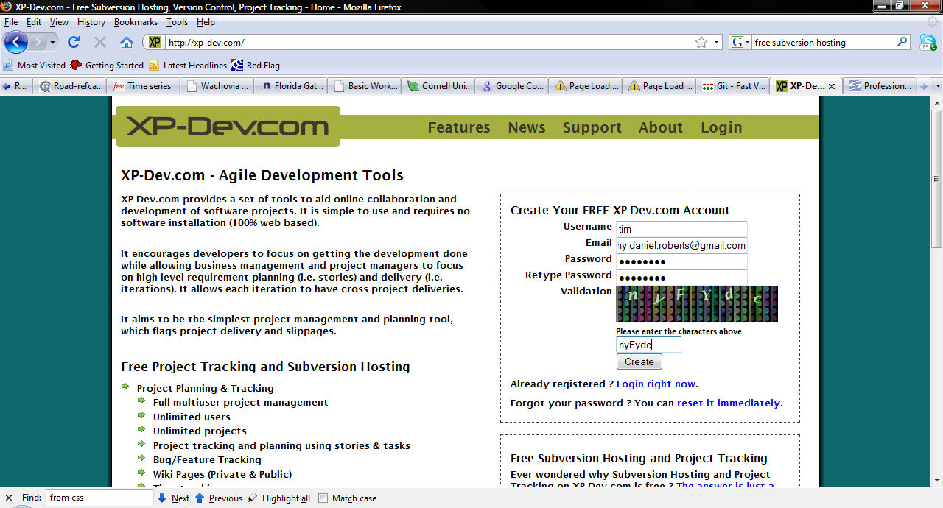

r

1. Download and install Tortoise SVN.

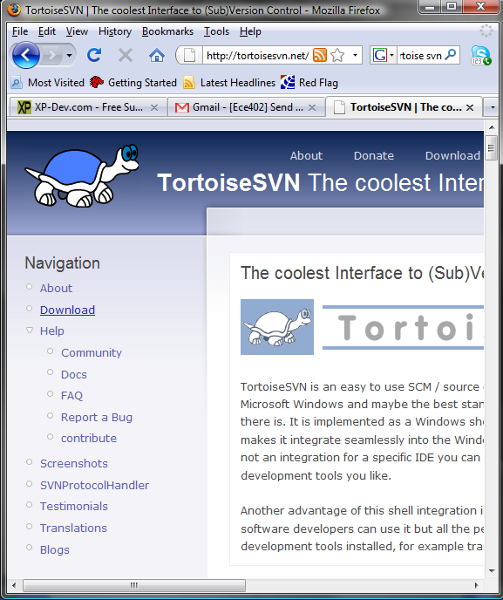

1. Start a new folder in your project directory called SVNRepository

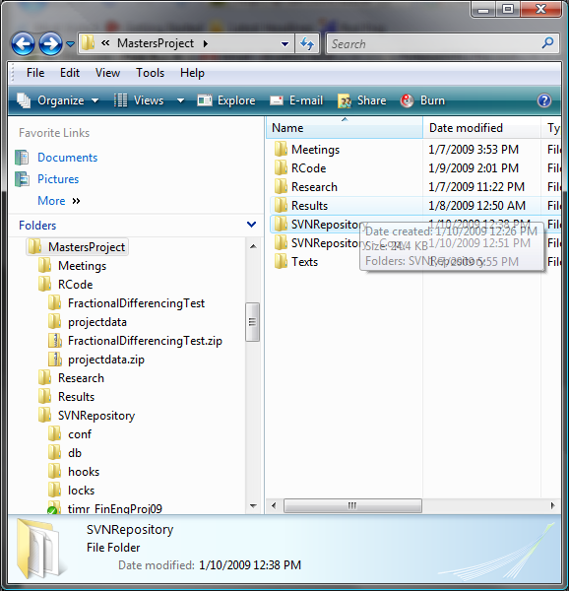

1. Perform an SVN checkout (downloads the subversion server folders to your PC) By right clicking on SVNRepository and Right Click -> SVN Checkout

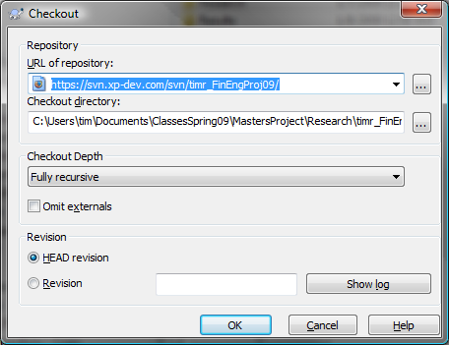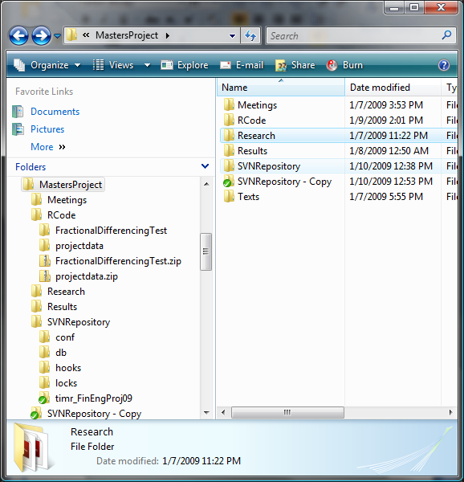

1. Make some changes, add files, whatever. 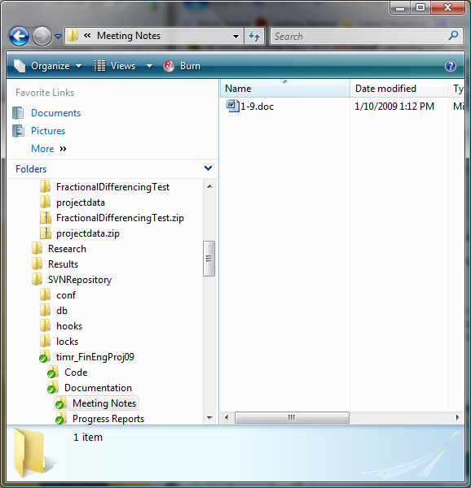
2. Do an SVN commit (right click on head folder and click SVN Commit)

