MULTILAYER NEURAL NETWORKS and
COMPETITIVE LEARNING

MULTILAYER NEURAL NETWORKS

Introduction

Feedforward Operation and Classification

Backpropagation Algorithm

Error Surface

Backpropagation as Feature Mapping

Backpropagation, Bayes Theory and Probability

Practical Techniques for Improving Backpropagation

COMPETITIVE LEARNING

The competitive learning algorithm is related to the k-means algorithm and is based on neural networks learning rules.
Each d-dimensional vector is augmented (with x₀=1) and normalized to have length ||x||=1.
The desired number of clusters c is fixed

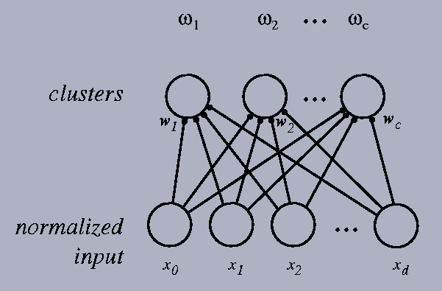

Each cluster center is initialized with a randomly chosen weight vector , also normalized ||w_{j}||=1, j=1, .., c.
When a new pattern is presented, each of the output units computes its net activation, w^{t}x.
Only the most active neuron (i.e., the closest to the new pattern) is permitted to update its weights using
followed by an overall weight normalization 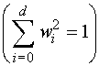

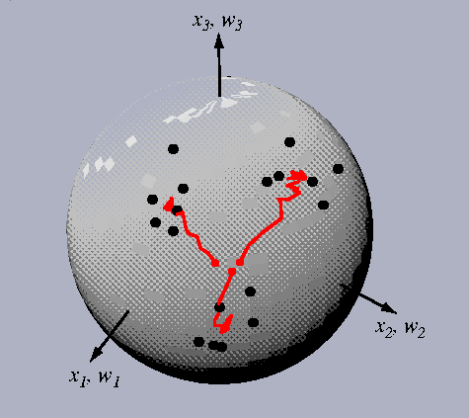
Trajectories of 3 cluster centers in response to a sequence of patterns chosen randomly from the set.
All 3-D patterns have been normalized 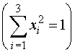, and hence lie on a sphere.
AT the end of learning, each weight vector lies in the center of a cluster.

Algorithm
Begin
Initialize
Normalize all patterns: 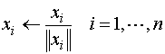
Repeat
Select a random pattern x
Compute net activations: 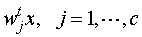
Find the winning node 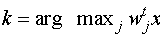
Update weight of winning node
Normalize weight: 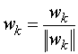
Until no significant change in w in n attempts
End
Unknown Number of clusters
An on-line clustering algorithm
Begin
Initilize
Repeat
Accept a new pattern x
Find nearest cluster: 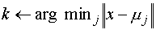
If 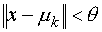
Then
Else add new cluster with mean
Normalize weight 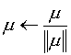
Until no more patterns
End

LEARNING VECTOR QUANTIZATION

A supervised learning algorithm.
Begin
Initialize
Repeat
Accept a new pattern x
Find nearest cluster:
If k is the correct label
Else
Until no significant change in in n attempts
End

Interpretation
Correct classification lead to a refinement of in a direction toward x.
Incorrect classification moves in the opposite direction.
Other (not close to x) are not changed.

