# 美国能源信息署数据采集需求

###### 概述

采集目标是美国能源信息署（EIA）网站上相关数据。

数据采集入口：<https://www.eia.gov/dnav/pet/PET_SUM_SNDW_A_EPC0_FPF_MBBLPD_W.htm>

###### 采集步骤

1. 美国原油产量历史数据采集：点击左侧【Download Series History】，下载历史数据。

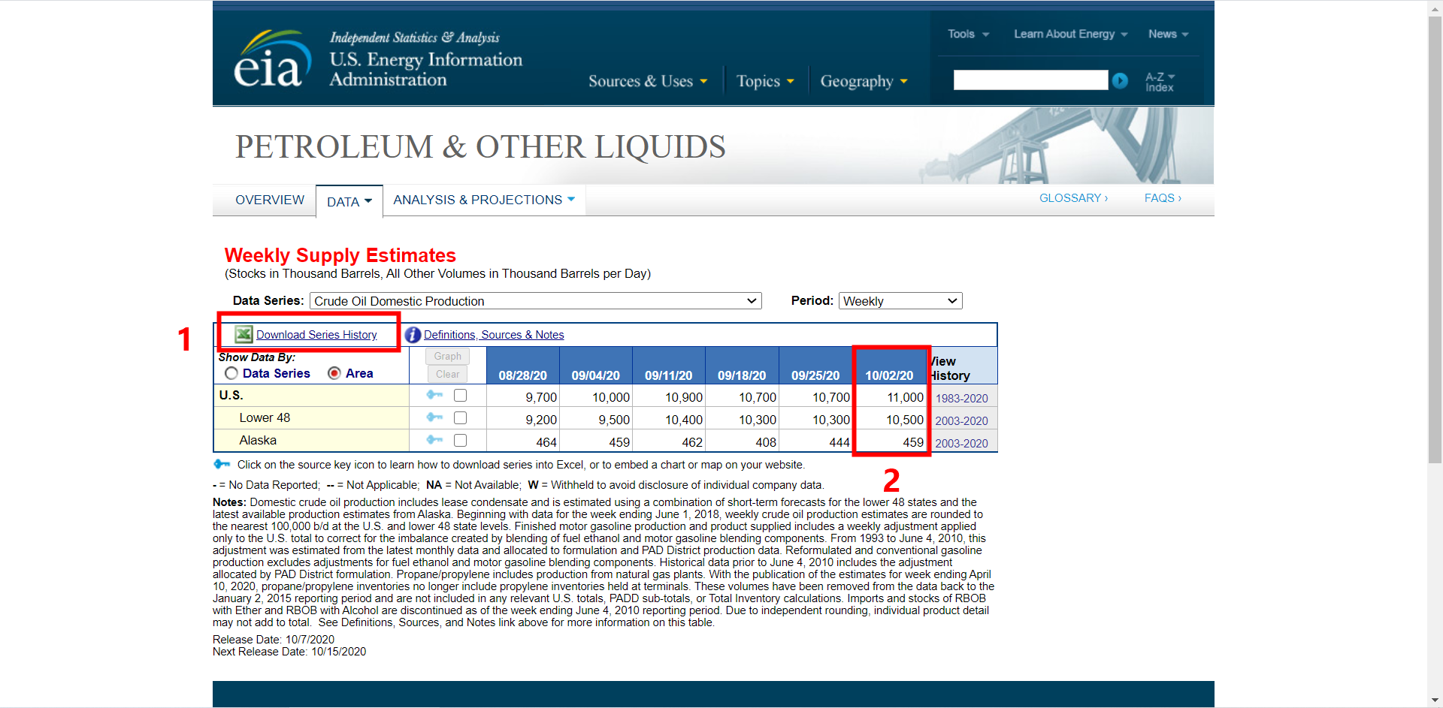

1. 日常更新数据采集（每周一次）：采集上图表格右侧第二列数据，包括首行【日期】，第二行【U.S.】数据，第三行【Lower 48】数据，第三行【Alaska】数据，分别添加至上述历史数据表格文档【Data 1】页面最末行中。

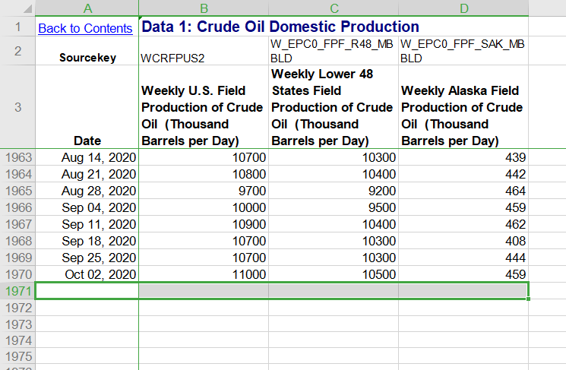

1. 点击【Data Series】右侧选项栏，点击进入下述栏目，重复步骤1-2，完成相关历史数据下载及日常更新。
2. Crude Oil Domestic Production,
3. Refinery Crude Oil Inputs,
4. Refinery Gross Inputs,
5. Refinery Operable Capacity (Calendar Day),
6. Refinery Percent Operable Ultilization,
7. Net Production - Propane/Propylene,
8. Stocks - Total Crude and Products (Including SPR),
9. Stocks - Total Crude and Products (Excl. SPR),
10. Stocks - Crude Oil (Including SPR),
11. Stocks - Propane/Propylene (Excl. Propylene at Terminal),
12. Stocks - Propylene (Nonfuel Use),
13. Stocks - Propane/Propylene (Incl. Propylene at Terminal),
14. Days of Supply - Crude Oil,
15. Imports - Crude oil,
16. Imports - Crude oil, Commercial,
17. Imports - by SPR,
18. Imports - into SPR by Others,
19. Imports - Propane/Propylene,
20. Exports - Total Crude Oil and Products,
21. Exports - Crude Oil,
22. Exports - Products,
23. Exports - Propane/Propylene,
24. Net Imports - Total Crude Oil and Products,
25. Net Imports - Crude oil,
26. Net Imports - Petroleum Products,
27. Product Supplied - Propane/Propylene

