**Homework Web Application**

Introduction

This document will present the architecture and technology of Homework web application. We developed the application in Microsoft Visual Studio using .Net Framework, MVC, Web API, C#, JavaScript, HTML, CSS, SQL Server database and Entity Framework etc.

Architecture

Here is the architecture of the application

Business Layer

View

Model

Database

WEB API

(Data Access Layer)

Controller

MVC (Model–view–controller) is a web software design pattern with many advantages. This pattern was used in Homework application.

ASP.NET Web API is a framework that makes it easy to build HTTP services that reach a broad range of clients including browsers and mobile devices etc. It was also used in this application.

A typical request from view gets response from server by following steps:

1. The request will pass validations in business layer
2. It gets controller
3. The controller will call Web API in data layer to access database
4. Web API will return results back to the controller
5. The controller will read and parse results and send them to the view

Usage of the Application

By the application you may take a look at all users, sort or search them. You may create new users for now. The functionalities to edit and delete users will come soon.

The first page will show all users, the screenshot is as follows.

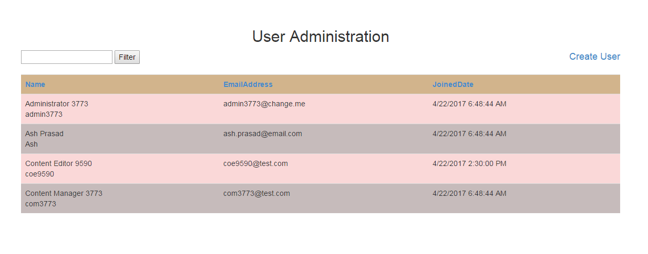

On this page you may

1. Click column names to sort the list.
2. Type in text box at left corner and click button filter to search users
3. Click link Create User at left corner to add new users

Here is the screen shot of the dialog for creating new user:

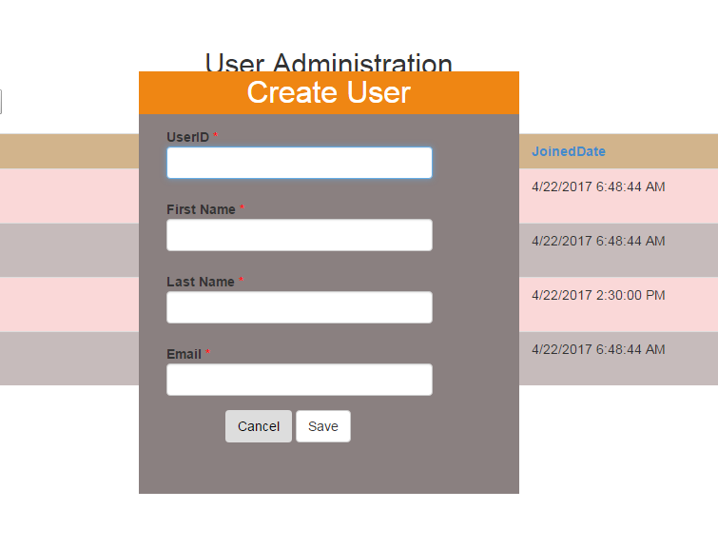

On this page you may

1. Type in all fields
2. Click button Save to save the new user and close the dialog.
3. Or click button Cancel to close the dialog

When you click button Save the application will check all fields to make sure they are not empty, the userID is unique and email address is valid. Otherwise you will see some warnings on the screen.

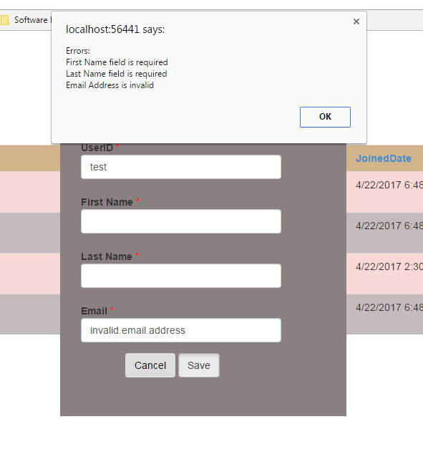

Notes

1. IDE is Microsoft Visual Studio 2015 for Web
2. SQL Server is Microsoft SQL Server Express (64-bit), version 12.0.2269.0
3. ~\Controllers\Api\UserController.cs has XML comments