**AHSANULLAH UNIVERSITY OF SCIENCE AND TECHNOLOGY**

**Department of Computer Science and Engineering**

Fall 2023

CSE 3104 Database Lab (Group – A204)

Project Proposal Report

Topic: **E-Commerce Platform with Integrated Auction Functionality - Database Management System**

Submitted to

Nawshin Tabassum Tanny

Lecturer (Grade I), Department of CSE, AUST

Mr. Tanveer Ahmed Belal

Assistant Proffesor, Department of CSE, AUST

Submitted by

Name: Zayeed Hasan, Student ID: 20210204032

Name: Mirza Naeem Beg, Student ID: 20210204033

Name: Salim Ullah Sadiq, Student ID: 20200204085

Submitted on: 06/06/2024



**Introduction**

The rapid expansion of e-commerce has necessitated the development of robust database management systems to support complex functionalities such as user management, product listings, order processing, and auctions. This project proposal outlines the creation of a comprehensive database management system (DBMS) for an e-commerce platform with an integrated auction feature, developed using Microsoft SQL Server. The system will be designed to handle both standard e-commerce operations and dynamic auction activities, ensuring efficient data management and transaction processing.

**Motivation**

The motivation for this project arises from the need for a scalable and secure DBMS capable of supporting an advanced e-commerce platform with auction capabilities. Existing e-commerce platforms often lack integrated auction systems or rely on separate, less efficient solutions. By developing a unified database for both e-commerce and auction functionalities, this project aims to enhance user engagement, streamline data processing, and improve overall platform performance.

**Requirements**

**Goals**

* Develop a robust and scalable DBMS to support e-commerce and auction functionalities.
* Ensure data integrity, security, and efficient transaction processing.
* Utilize Microsoft SQL Server to leverage its powerful database management capabilities.

**Objectives**

* Design a normalized database schema to support user management, product listings, orders, cart, reviews, auctions, and bids.
* Implement stored procedures, triggers, and indexes to optimize database performance and ensure data integrity.
* Develop a comprehensive set of tables and relationships to accurately model the platform's data requirements.

**Functionalities**

* **User Management:** Store and manage user information securely.
* **Product Management:** Maintain detailed records of product listings and categories.
* **Order Processing:** Track and manage customer orders and order items.
* **Cart Management:** Handle user cart items and quantities.
* **Review System:** Store and retrieve user reviews and ratings for products.
* **Auction Management:** Manage auction creation, bidding, and auction status.
* **Bid Tracking:** Record and process user bids on auction items.

**Features**

* **User Authentication Data:** Securely store user credentials and profile information.
* **Product Catalog:** Maintain comprehensive product details, including pricing and categorization.
* **Order and Payment Data:** Track order statuses, payment details, and shipment tracking.
* **Auction Data:** Manage auction details, including starting bids, current bids, reserve prices, and auction timings.
* **Bid Data:** Record bid amounts, timestamps, and user information for each bid.

**Entity Relation Diagram**

**Entities and Attributes**

Users (id: Primary key, name, email, password, address, created_at, updated_at)

**Products** (id: Primary key, name, description, price, category_id: Foreign key referencing Categories(id), image, created_at, updated_at)

**Categories** (id: Primary key, name)

**Orders** (id: Primary key, user_id: Foreign key referencing Users(id), total_amount, status, created_at, updated_at)

**Order_Items** (id: Primary key, order_id: Foreign key referencing Orders(id), product_id: Foreign key referencing Products(id), quantity, price)

**Cart** (id: Primary key, user_id: Foreign key referencing Users(id), product_id: Foreign key, referencing Products(id), quantity, created_at, updated_at)

**Reviews** (id: Primary key, user_id: Foreign key referencing Users(id), product_id: Foreign key referencing Products(id), rating, comment, created_at, updated_at)

**Auctions** (id: Primary key, product_id: Foreign key referencing Products(id), seller_id: Foreign key referencing Users(id), starting_bid, current_bid, reserve_price, start_time, end_time, status, created_at, updated_at)

**Bids** (id: Primary key, auction_id: Foreign key referencing Auctions(id), user_id: Foreign key referencing Users(id), bid_amount, bid_time)

**ERD Visual Representation**

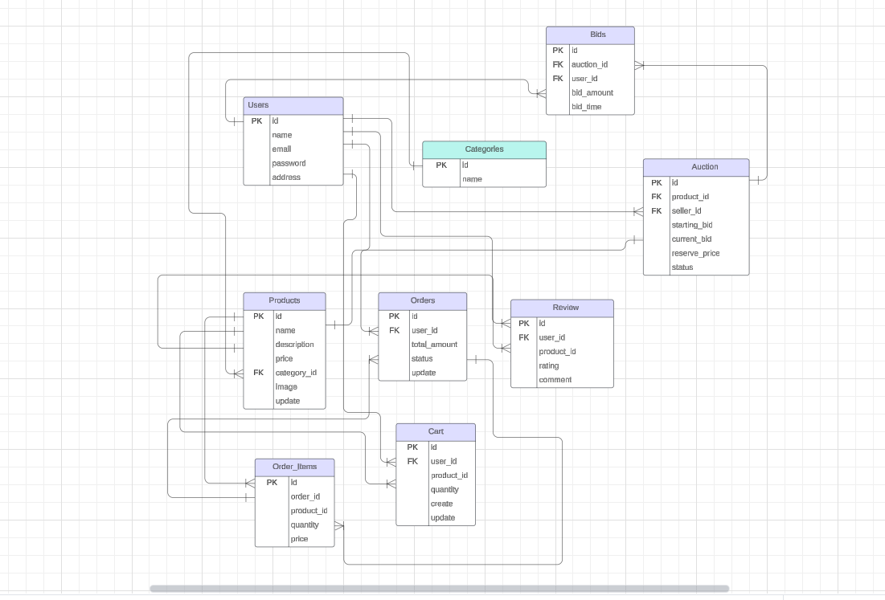

**Development Tools and Platforms**

**Database Management System**

* **Microsoft SQL Server:** The primary DBMS used for creating, managing, and querying the database. It provides robust performance, security, and scalability features essential for handling complex e-commerce and auction functionalities.

**Development Environment**

* **SQL Server Management Studio (SSMS):** A comprehensive tool for managing the SQL Server database, creating and modifying database structures, and writing and executing SQL queries.

**Conclusion**

This project aims to develop a comprehensive and efficient DBMS for an e-commerce platform with integrated auction functionalities using Microsoft SQL Server. The detailed entity-relationship design and the use of powerful development tools will ensure the creation of a scalable, secure, and high-performance database system. This project will address the need for a unified e-commerce and auction platform, providing enhanced user engagement and streamlined data manage.