Moutai, Dove team up to offer liquor-filled chocolate

By WANG ZHUOQIONG | CHINA DAILY | Updated: 2023-09-15 07:02

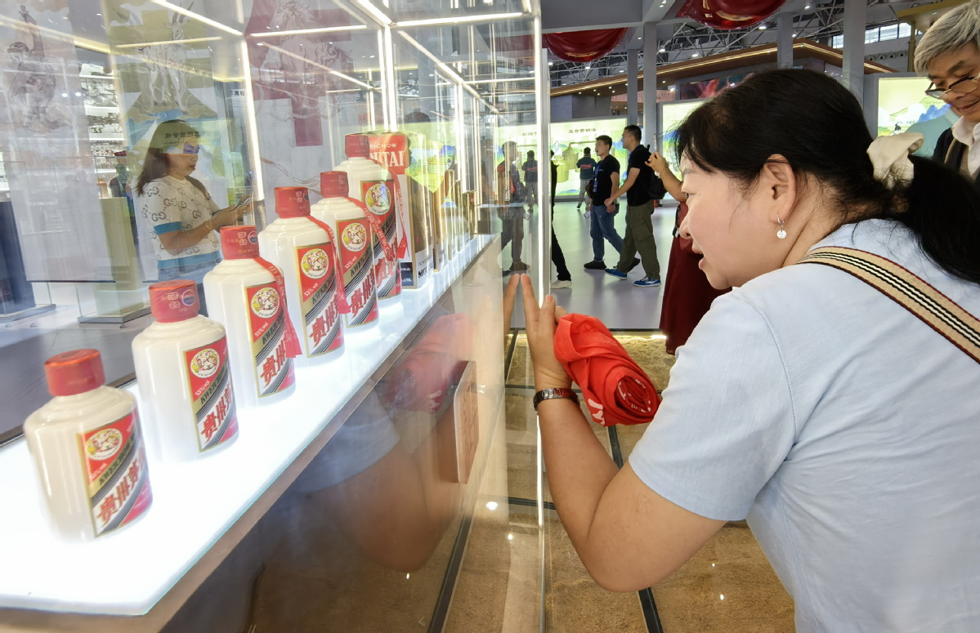

A view of the booth of Kweichow Moutai during an expo in Guiyang, Guizhou province. WU DONGJUN/FOR CHINA DAILY

Kweichow Moutai, a homegrown luxury liquor brand, has partnered with Mars Inc-owned Dove to make liquor-filled chocolate, in a bid to make its products more appealing to the country's younger generation.

The product, which is expected to retail from Saturday, is priced at 35 yuan ($4.81) for a gift box of two pieces and 99 yuan for a box of six, according to Moutai's WeChat mini program. Products with less sugar are priced at 39 yuan for a box of two, 109 yuan for a box of six and 179 yuan for a box with a dozen pieces.

贵州茅台，一家本土的奢侈白酒品牌，与马氏公司旗下的德芙合作推出了酒心巧克力，旨在使其产品对中国年轻一代更具吸引力。

据茅台的微信小程序显示，该产品预计从周六开始销售，售价为35元（4.81美元）一盒两颗装，99元一盒六颗装。低糖产品的售价为39元两颗装，109元六颗装，179元一打装。

Moutai announced the partnership with Dove on Thursday, just 12 days after it teamed up with China's largest coffee chain Luckin Coffee on a liquor-coffee drink which sold 5.42 million cups and reached sales of 100 million yuan on launch day.

Mid-Autumn Festival that falls on Sept 29 is the primary gifting season for chocolate and alcoholic products in China.

The Moutai-Dove tie-up has buoyed the chocolate market mood — which experienced growth challenges during the past three years — and is set to make the Moutai brand more accessible to young consumers in the country, said Jason Yu, general manager of Kantar Worldpanel China.

Since young consumers often pursue healthy lifestyles, the consumption of chocolate has grown slowly in China, thereby entailing greater innovation in taste and packaging.

茅台在周四宣布与德芙合作，仅在12天前，茅台还与中国最大的咖啡连锁店瑞幸咖啡合作推出了一款酒咖饮品，上市首日销售了542万杯，并达到1亿元的销售额。

中国的中秋节定于9月29日，是巧克力和酒类产品的主要赠礼季节。

茅台与德芙的合作提振了巧克力市场情绪，这个市场在过去三年中面临增长挑战，同时也使茅台品牌更容易接触到中国年轻消费者。康泰纳仕世界面板中国区总经理Jason Yu表示，年轻消费者通常追求健康的生活方式，因此中国巧克力的消费增长缓慢，需要在口味和包装方面进行更大的创新。

According to market research firm Euromonitor International, the retail value of the chocolate confectionery sector in China has grown marginally in recent years, from 21.5 billion yuan in 2018 to 22.3 billion yuan in 2023. The sector is forecast to reach 25.6 billion yuan in 2028.

The partnership means more in terms of branding than sales volume, said Zhu Danpeng, an independent food and beverages analyst.

"Behind every collaboration, the corporate value and persistence in long-term development make the longevity of a brand, not a one-time deal," he said. In recent years, "liquor plus" has become a driving force for Moutai to grow revenue and to get closer to consumers, he added.

根据市场研究公司欧睿国际（Euromonitor International）的数据，中国巧克力糖果行业的零售价值近年来略有增长，从2018年的215亿元增加到2023年的223亿元。预计该行业在2028年将达到256亿元的规模。

独立食品和饮料分析师朱丹鹏表示，这种合作对品牌推广的意义大于销售量。他指出：“每一次合作背后，企业的价值观和对长期发展的坚持，才是一个品牌长盛不衰的关键，不是一次性的交易。”他补充说，在近年来，“酒加”已成为茅台增加收入和更亲近消费者的推动力。

The domestic chocolate market is dominated by international confectionery brands. According to a 2021 report by iiMedia that ranked chocolate brands in China, Dove, Ferrero Rocher and Snickers were in the first tier, with sales higher than all other brands combined.

Moutai has of late paid more attention to diversification and internationalization.

In May, the nation's most renowned liquor brand said it had rolled out six types of ice cream products and begun to develop liquor-filled chocolate.

The company said it now has 11 types of ice cream with the Moutai flavor, selling nearly 10 million cups this year. In 2022, sales of Moutai-flavored ice cream hit 262 million yuan, according to the company.

Moreover, culturally innovative products, such as Moutai-themed blind-box gift sets, have been developed since 2022, contributing to nearly 600 million yuan in revenue last year.

"Dove's global branding and reputation offer Moutai a pivot to double down on its expansion in the home and overseas markets," said Zhu.

国内巧克力市场主要由国际糖果品牌主导。根据2021年iiMedia的一份中国巧克力品牌排名报告，德芙、费列罗和士力架位居第一梯队，销售额超过其他品牌总和。

近年来，茅台越来越注重多元化和国际化发展。今年5月，这个国内最知名的白酒品牌宣布推出了六种类型的冰淇淋产品，并开始研发酒心巧克力。目前，他们推出了11种茅台口味的冰淇淋，今年的销售量接近1000万杯。根据公司数据，2022年茅台口味冰淇淋的销售额达到了2.62亿元。

此外，茅台还开发了一些具有文化创新的产品，例如茅台主题盲盒礼品套装。去年，这些产品贡献了近6亿元的收入。

朱丹鹏表示：“德芙作为全球知名品牌，为茅台在国内外市场的扩张提供了重要支持。”