[Leaders](https://www.economist.com/leaders/) | OpenChaos

The fallout from the weirdness at OpenAI

## Sam Altman is set to return, but the episode holds deeper lessons

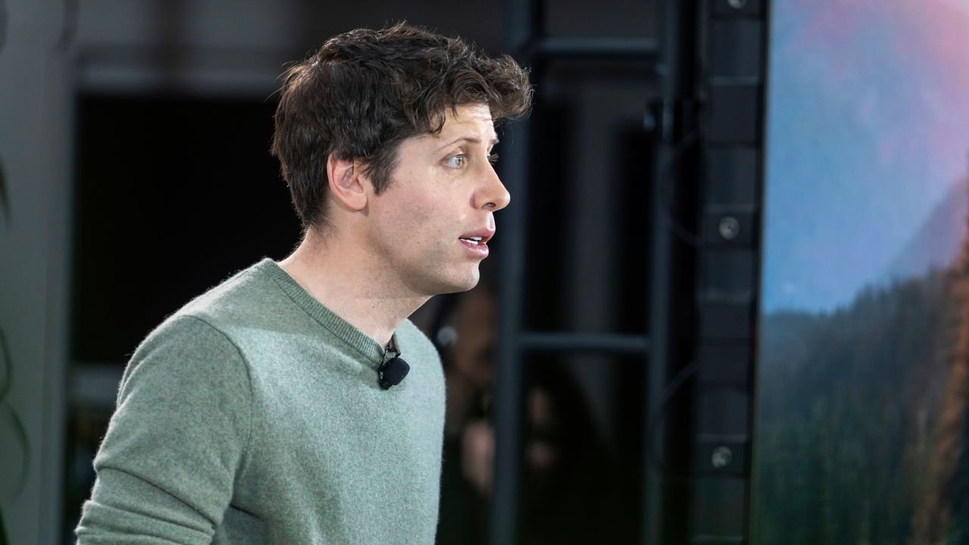

Five very weird days passed before it seemed that Sam Altman would stay at Openai after all. On November 17th the board of the maker of Chatgpt suddenly booted out its chief executive. On the 19th it looked as if Mr Altman would move to Microsoft, Openai’s largest investor. But employees at the startup rose up in revolt, with almost all of them, including one of the board’s original conspirators, threatening to leave were Mr Altman not reinstated. Between frantic meetings, the top brass tweeted heart emojis and fond messages to each other. By the 21st, things had come full circle.

在过去5天中，发生了一系列非常奇怪的事件，最终似乎看起来山姆·阿特曼会留在OpenAI。

11月17日，Chatgpt的董事会突然罢免了首席执行官。19日，阿特曼似乎会加入了OpenAI。

最大的投资者微软。然而，原OpenAI创业公司的员工们发起了反抗，几乎所有人，包括董事会的最初参与者，威胁说如果阿特曼不被恢复职位，他们就会离开。在忙碌的会议中，高层们在推特上互相发爱心表情和亲切的信息。到了21日，一切又回到了原点。

All this seems stranger still considering that these shenanigans were taking place at the world’s hottest startup, which had been expected to reach a valuation of $90bn. In part, the weirdness is a sign of just how quickly the relatively young technology of generative artificial intelligence has been catapulted to fame. But it also holds deeper and more disturbing lessons.

当考虑到这发生在估计将达到900亿美元的全球最热门初创公司，这一切似乎更加奇怪。在某种程度上，这种怪异现象表明了，生成式人工智能这种相对新颖的技术，是多么迅速地获得了知名度。但它也蕴含着更深层次且更令人不安的教训。

One is the sheer power of ai talent. As the employees threatened to quit, the message “Openai is nothing without its people” rang out on social media. Ever since Chatgpt’s launch a year ago, demand for ai boffins has been white-hot. As chaos reigned, both Microsoft and other tech firms stood ready to welcome disgruntled staff with open arms. That gave both Mr Altman and Openai’s programmers huge bargaining power and fatally undermined the board’s attempts to exert control.

其一是人工智能人才的强大实力。当OpenAI员工们威胁要离职时，社交媒体上响起了“没有这些员工，OpenAI就一无是处”的声音。自从一年前推出ChatgGPT以来，在人工智能人才的需求上一直很旺盛。在混乱的局面下，微软和其他科技公司纷纷准备迎接这些OpenAI公司里对其不满的员工加入。这给了阿特曼和OpenAI的程序员们巨大的议价能力，同时也机器大地削弱了董事会对公司的控制力。

The episode also shines a light on the unusual structure of Openai. It was founded in 2015 as a non-profit research lab aimed at safely developing artificial general intelligence (agi), which can equal or surpass humans in all types of thinking. But it soon became clear that this would require vast amounts of expensive processing power, if it were possible at all. To pay for it, a profit-making subsidiary was set up to sell ai tools, such as Chatgpt. And Microsoft invested $13bn in return for a 49% stake.

这一集还凸显了OpenAI的独特组织架构。该公司于2015年成立，最初是一个非营利研究实验室，旨在安全地发展人工通用智能（AGI），即在所有思考方面能与人类相等甚至超越人类。然而他们很快发现，要实现这一目标，如果可能的话，这将需要大量昂贵的处理能力。因此，为了筹措资金，他们成立了一个盈利子公司，销售AI工具，如ChatGPT。此外，微软还以130亿美元投资了OpenAI，并获得了其49%的股权。

On paper, the power remained with the non-profit’s board, whose aim is to ensure that agi benefits everyone, and whose responsibility is accordingly not to shareholders but to “humanity”. That illusion was shattered as the employees demanded Mr Altman’s return, and as the prospect loomed of a rival firm housed within profit-maximising Microsoft.

在纸面上，权力仍然掌握在非营利机构的董事会手中，他们的目标是确保通用人工智能（AGI）造福于所有人，因此他们的责任不是面向股东，而是面向“人类”。然而，随着员工们要求阿特曼先生回归，并且有可能在以追求利润为目标的微软中设立一个竞争公司，这种幻想被打破了。

The chief lesson is the folly of policing technologies using corporate structures. As the potential of generative ai became clear, the contradictions in Openai’s structure were exposed. A single outfit cannot strike the best balance between advancing ai, attracting talent and investment, assessing ai’s threats and keeping humanity safe. Conflicts of interest in Silicon Valley are hardly rare. Even if the people at Openai were as brilliant as they think they are, the task would be beyond them.

主要的教训是利用企业结构来监管技术是愚蠢的。随着生成式人工智能的潜力变得清晰，OpenAI内部结构上的矛盾被揭露了出来。一个单一机构无法在推进人工智能、吸引人才和投资、评估人工智能存在的潜在危险以及保护人类安全之间达到最佳平衡。硅谷的利益冲突并不罕见。即使OpenAI的成员如他们自认的那样聪明，这个任务也超出了他们的能力。

Much about the board’s motives in sacking Mr Altman remains unknown. Even if the directors did genuinely have humanity’s interest at heart, they risked seeing investors and employees flock to another firm that would charge ahead with the technology regardless. Nor is it entirely clear what qualifies a handful of private citizens to represent the interests of Earth’s remaining 7.9bn inhabitants. As we published this article, new reports suggested that a replacement board would in time be appointed that included Mr Altman and a representative from Microsoft. However, personnel changes are not enough: the firm’s structure should also be overhauled.

许多关于董事会解雇阿特曼先生的动机仍然不为人所知。即使董事们真心为人类利益着想，他们也冒着投资者和员工纷纷涌向另一家不顾一切推进该技术的公司的风险。同样不清楚的是，几个私人公民有什么资格代表地球上剩下的79亿居民的利益。据我们发布本文时的最新报道，一个新的董事会将会被任命，其中包括阿特曼先生和来自微软的代表。然而，仅仅进行人事变动是不够的：公司的结构也需要进行彻底的改革。

## Board senseless

Fortunately for humanity, there are bodies that have a much more convincing claim to represent its interests: elected governments. By drafting regulation, they can set the boundaries within which companies like Openai must operate. And, as a flurry of activity in the past month shows, they are paying attention to ai. That is just as well. ai technology is too important to be left to the latest corporate intrigue.

幸运的是，人类有一些更具有说服力的机构来代表其利益：选举产生的政府。通过制定法规，它们可以为像OpenAI这样的公司设定经营的边界。正如过去一个月的活动所显示的那样，它们对人工智能非常关注。这是非常必要的。人工智能技术的重要性使其不能被最新的商业阴谋所左右。