Moutai-flavored latte gets coffee lovers all abuzz

茅台味拿铁让咖啡爱好者们兴奋不已

By CUI JIA | China Daily | Updated: 2023-09-05 07:43

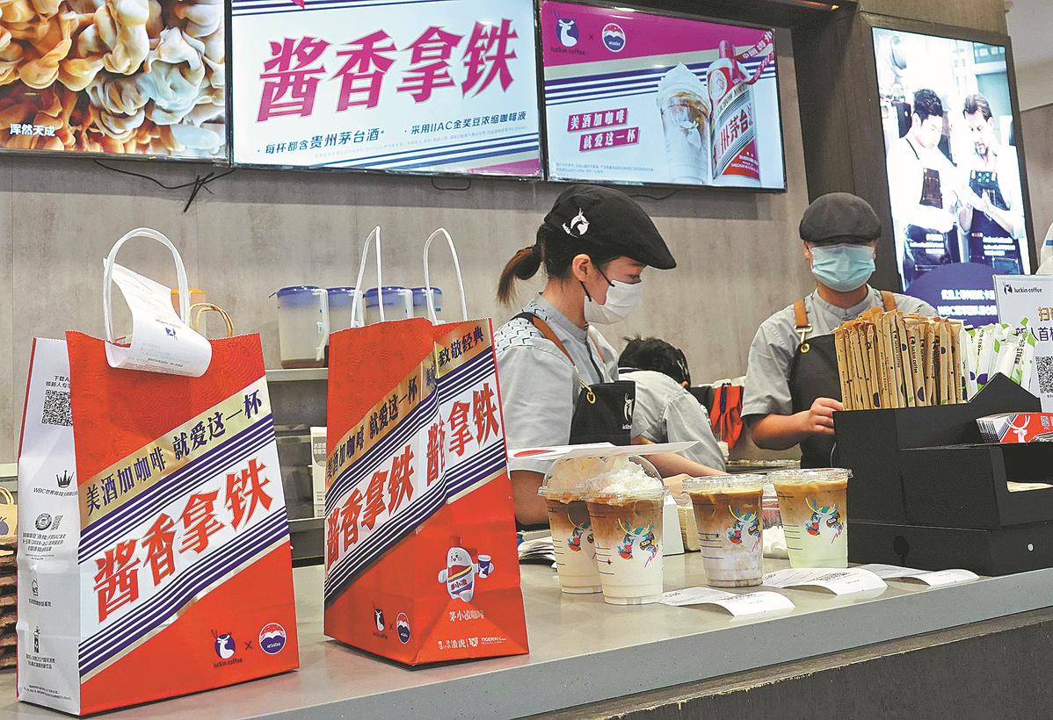

Moutai-flavored lattes are prepared for takeaway orders at a Luckin Coffee outlet in Yichang, Hubei province, on Monday. LIU JUNFENG/FOR CHINA DAILY

China's top liquor maker Kweichow Moutai and domestic coffee chain Luckin Coffee have got a hit on their hands with a new baijiu-flavored latte released Monday that quickly sold out in Beijing.

The latte, emblazoned with the iconic Moutai logo, contains less than 0.5 percent (alcohol by volume) of 53 degree Moutai, and soon became one of the most discussed topics on Chinese social media with people curious about how traditional Chinese liquor would taste with coffee.

中国顶级白酒生产商贵州茅台和国内咖啡连锁店瑞幸咖啡推出了一款以白酒为风味的拿铁，周一在北京迅速售罄，备受热捧。

这款拿铁以茅台标志性的标识为特点，其中含有不到0.5%的53度茅台酒精（体积含量），很快成为中国社交媒体上最受讨论的话题之一，人们对传统中国白酒与咖啡的味道感到好奇。

In Beijing, the Moutai-flavored latte sold out in some Luckin Coffee locations before midday. And many had to shut down their online ordering system as orders surged.

Staff members at the Luckin Coffee branch near Huixindong Bridge in Chaoyang district said that the majority of orders they had received on Monday morning were for the Moutai-flavored latte.

"It seems that people prefer iced latte, so we quickly used up the ice in the branch. The number of orders is scary," said a barista surnamed Zhang.

She said she had no choice but to temporarily stop the online ordering system at around 1:30 pm because there

were more than 200 orders still to be completed and almost all of them were for the Moutai-flavored latte.

在北京，茅台味拿铁在一些瑞幸咖啡门店中午前就售罄了。由于订单激增，许多门店不得不关闭在线订购系统。

北京朝阳区惠新东桥附近的瑞幸咖啡分店的员工表示，他们周一上午收到的大部分订单都是茅台味拿铁。

一位姓张的咖啡师说：“看起来人们更喜欢冰拿铁，所以我们分店的冰很快就用完了。订单数量真的很吓人。”

她表示，由于还有超过200个订单待完成，几乎全部都是茅台味拿铁，她别无选择，只能在下午1点30分左右暂时停止在线订购系统。

People have been sharing their reactions after trying the latte on social media, with most agreeing that the aroma of the baijiu is very strong. Some people said they even felt dizzy after drinking the coffee because of its alcohol content.

Some also wondered whether they would be allowed to drive after drinking the latte. In response, Luckin Coffee stated that underage people, pregnant women, drivers and those who are allergic to alcohol are advised not to order the drink.

On Monday, an officer from the Beijing Traffic Administration Bureau also asked people not to drive, no matter how much alcohol is actually in the latte.

In recent years, Moutai has been looking for ways to be more accessible and pull in a new generation of customers, said Zhu Danpeng, a food and drink analyst.

"By working with Luckin Coffee, which surpasses Starbucks as the largest coffee house operator in China, Moutai has made its brand younger and has generated more opportunities to develop its extended product portfolio for younger consumers in the future," Zhu said.

Moutai has run snazzy marketing campaigns in recent years in its bid for younger customers, such as by rolling out Moutai ice cream, figurines, scented sachets, canvas bags and other cultural creative products.

社交媒体上人们纷纷分享了品尝这款拿铁后的反应，大多数人一致认为白酒的香气非常浓郁。一些人甚至因为咖啡中含有酒精而感到头晕。 有人质疑喝过这款拿铁后是否还能开车。对此，瑞幸咖啡表示未成年人、孕妇、司机以及对酒精过敏的人都不推荐点这款饮品。 周一，北京交管局的一名官员也呼吁无论这款拿铁实际含有多少酒精，人们都应禁止开车。 食品和饮料分析师朱丹鹏表示，茅台近年来一直在寻求更多与年轻消费者接触的方式，并吸引新一代的顾客。 朱丹鹏说：“通过与瑞幸咖啡的合作，茅台使其品牌更年轻化，并为未来年轻消费者开发更多产品提供了机会。” 茅台近年来推出了一系列时尚的营销活动，以吸引年轻客户，例如推出茅台冰淇淋、人物模型、香囊、帆布袋和其他文创产品。