dnsWebHook 安装说明
默认目录：/usr/src/cert-manager-antsdns-webhook-release
默认系统：centos 7
1 安装DOCKER 20.10.14
curl -fsSL https://get.docker.com/ | sh
sudo systemctl start docker
sudo systemctl start docker.service
systemctl enable docker
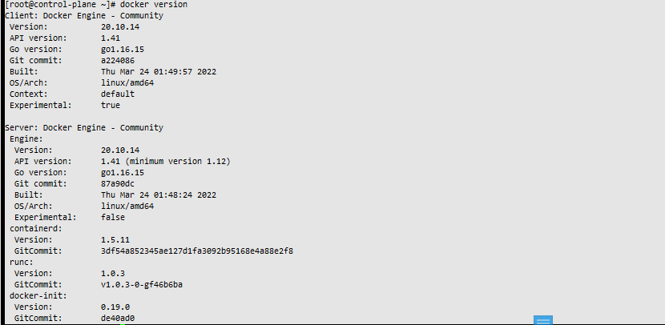
2 安装 kubectl 1.23.8
cat <<EOF > /etc/yum.repos.d/kubernetes.repo
[kubernetes]
name=Kubernetes
baseurl=http://mirrors.aliyun.com/kubernetes/yum/repos/kubernetes-el7-x86_64
enabled=1
gpgcheck=0
repo_gpgcheck=0
gpgkey=http://mirrors.aliyun.com/kubernetes/yum/doc/yum-key.gpg http://mirrors.aliyun.com/kubernetes/yum/doc/rpm-package-key.gpg
EOF
yum remove kubeadm kubectl kubelet kubernetes-cni cri-tools socat
yum --showduplicates list kubeadm
yum -y install kubeadm-1.23.8 kubectl-1.23.8 kubelet-1.23.8
systemctl enable kubelet

3 安装minikube
cd /usr/src/cert-manager-antsdns-webhook-release
sudo install minikube-linux-amd64 /usr/local/bin/minikube

4 安装crictl 及初始化minikube
cd /usr/src/cert-manager-antsdns-webhook-release
wget https://github.com/kubernetes-sigs/cri-tools/releases/download/$VERSION/crictl-$VERSION-linux-amd64.tar.gz
sudo tar zxvf crictl-$VERSION-linux-amd64.tar.gz -C /usr/local/bin
minikube start --vm-driver=none --kubernetes-version=v1.23.8 --image-mirror-country=cn --extra-config=kubelet.cgroup-driver=cgroupfs --extra-config=kubeadm.ignore-preflight-errors=SystemVerification --extra-config=apiserver.enable-admission-plugins="NamespaceLifecycle,LimitRanger,ServiceAccount,DefaultStorageClass,DefaultTolerationSeconds,MutatingAdmissionWebhook,ValidatingAdmissionWebhook,Priority,ResourceQuota" --force

5 安装cert-manager
cd /usr/src/cert-manager-antsdns-webhook-release
docker load -i quay.io_jetstack_cert-manager-cainjector_1.7.2.tar
docker load -i quay.io_jetstack_cert-manager-controller_1.7.2.tar
docker load -i quay.io_jetstack_cert-manager-webhook_1.7.2.tar
kubectl apply -f cert-manager-antsdns-webhook-v1/1.7.2cert-manager.yaml

6 安装helm(kubernetes命令行管理工具)
cd /usr/src/cert-manager-antsdns-webhook-release
tar zxf helm-v2.17.0-linux-amd64.tar.gz
cd linux-amd64/
mv helm /usr/local/bin/
chmod +x /usr/local/bin/helm

7 安装helm tiller 2.17.0
cd /usr/src/cert-manager-antsdns-webhook-release
docker load -i docker_ghcr.io.helm.tiller.2_17_0.tar
#docker pull ghcr.io/helm/tiller:v2.17.0
kubectl create serviceaccount --namespace kube-system tiller
kubectl create clusterrolebinding tiller-cluster-rule --clusterrole=cluster-admin --serviceaccount=kube-system:tiller
kubectl patch deploy --namespace kube-system tiller-deploy -p '{"spec":{"template":{"spec":{"serviceAccount":"tiller"}}}}'
helm init --service-account tiller --upgrade
helm init --service-account tiller --override spec.selector.matchLabels.'name'='tiller',spec.selector.matchLabels.'app'='helm' --output yaml | sed 's@apiVersion: extensions/v1beta1@apiVersion: apps/v1@' | kubectl apply -f -

8 安装cmctl(cert-manager配置管理命令行工具)
cd /usr/src/cert-manager-antsdns-webhook-release
tar xzf cmctl-linux-amd64.tar.gz
sudo mv cmctl /usr/local/bin

9 安装cert-manager dns webhook 模块
cd /usr/src/cert-manager-antsdns-webhook-release
docker load -i /usr/src/cert-manager-antsdns-webhook-release/docker_image_antsdns-webhook_0.1.1.tar
kubectl apply -f ./pod/00bundle.yaml

10 查看环境
docker version
helm version
minikube version
kubectl version
cmctl version
minikube kubectl -- get pods -A
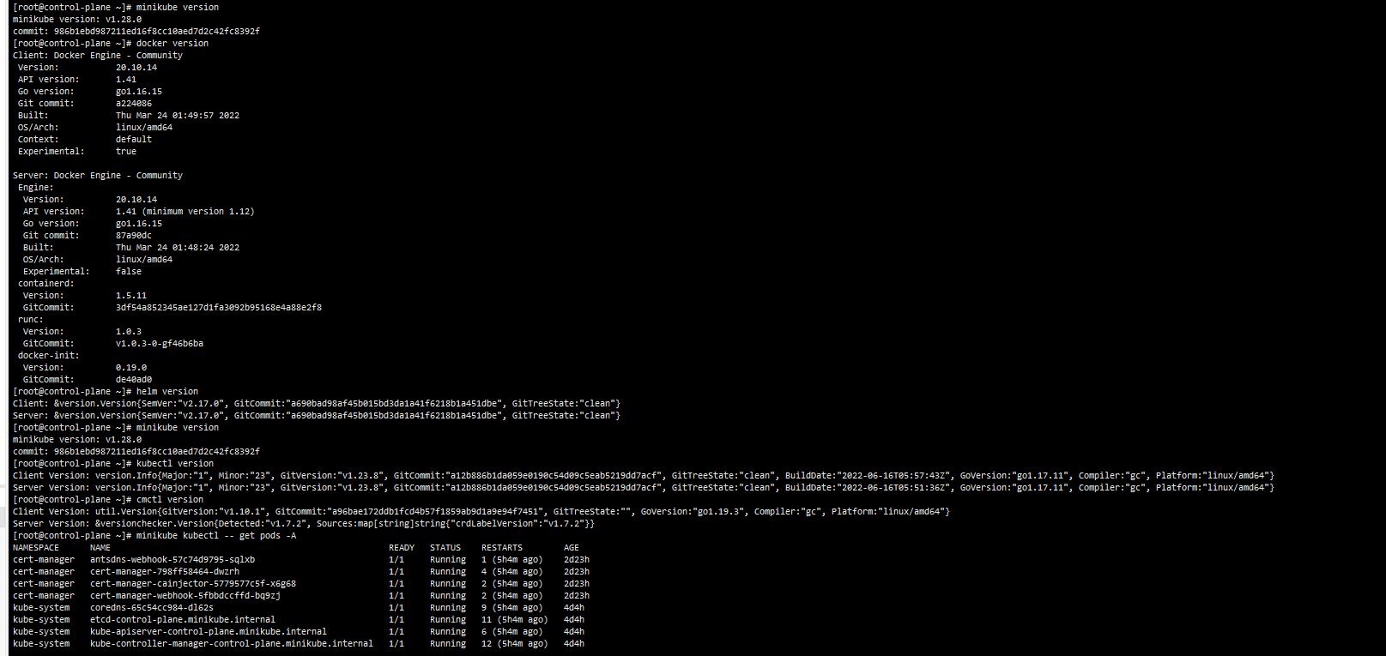

11 配置生成证书的clusterissuer
修改./prod/01cecret.yaml 中的appid,appkey为用户DNS-api密钥 SecretId,SecretKey
修改./prod/02letsencrypt-clusterissuer.yaml 的ispAddress 为https://user.dns666.com

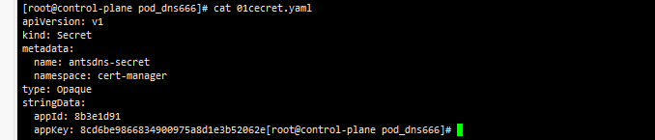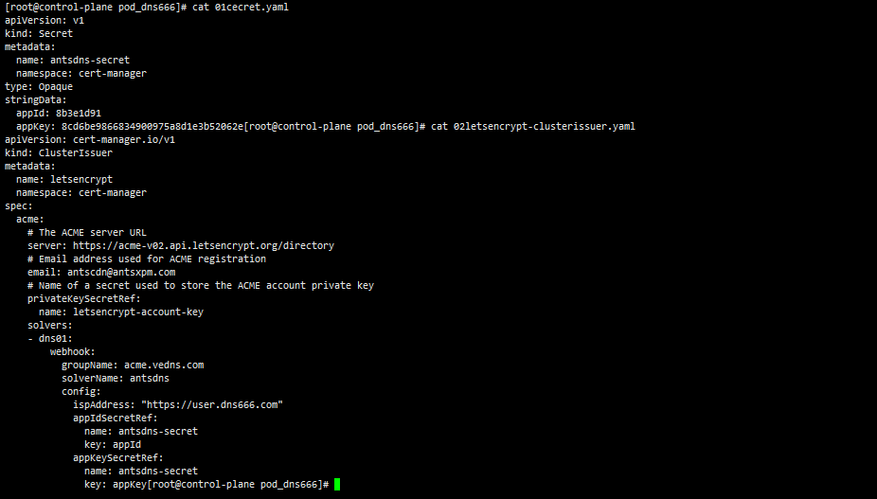

12 创建申请证书yaml文件及申请
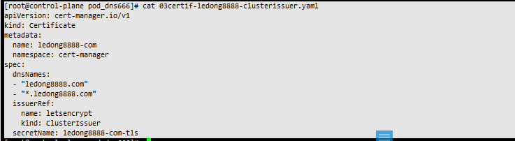
将实例中的域名换为需要申请 的后执行
kubectl apply -f xxx.yaml
将xxx.yaml换成创建的yaml文件

13 查看申请状态及查看成功的ssl证书
查看所有证书状态 kubectl get Certificate -A
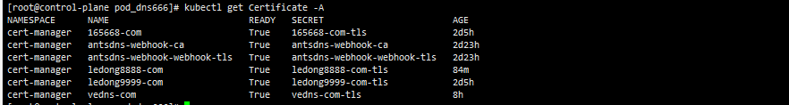
查看指定证书申请状态cmctl status certificate xxx-com -n cert-manager
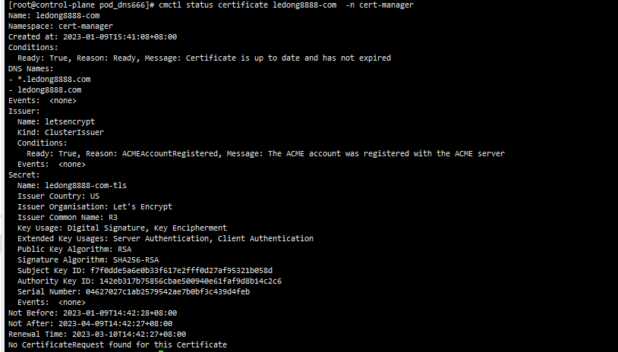
当返回如图上成功后可查看证书
kubectl get secret xxx-com-tls -n cert-manager -o yaml
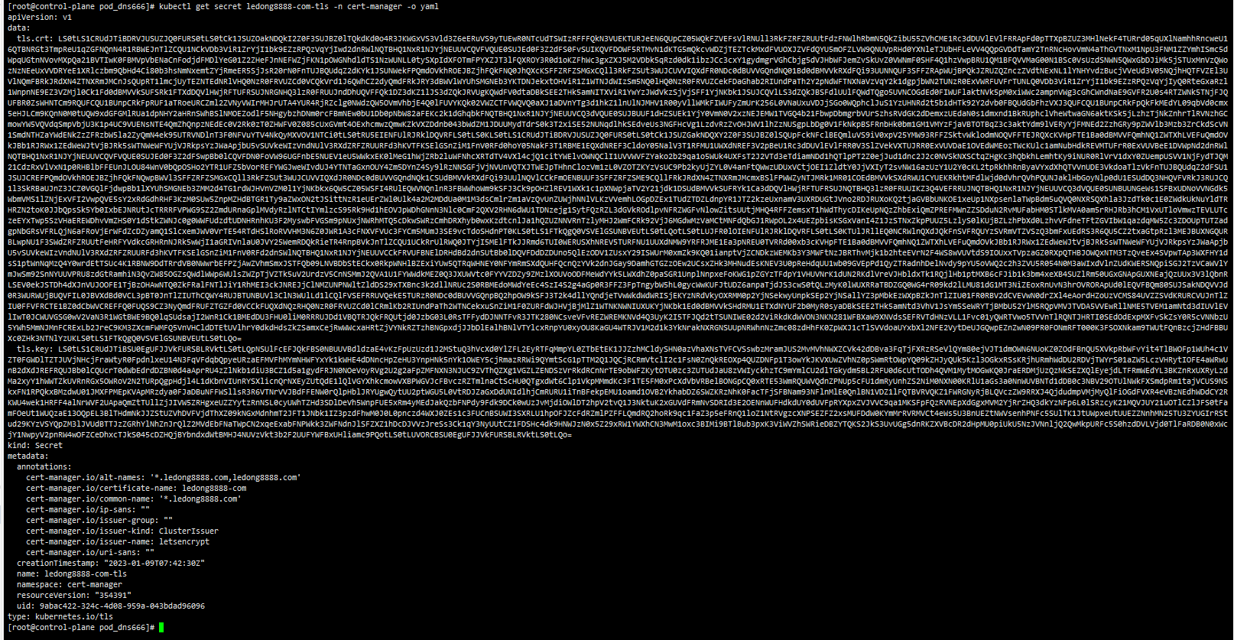
tls.crt ,tls.key即为证书内容

