RESEARCH ARTICLE
LitRaPID-DT: a process-aware digital twin for bias-deconvolved simulation and closed-loop design of macrocyclic-peptide mRNA display
Author names and affiliations to be supplied
Running title: Digital-twin simulation of mRNA display
Keywords: mRNA display; RaPID; macrocyclic peptide; digital twin; next-generation sequencing; active learning; selection bias

Abstract
mRNA display and Random nonstandard Peptide Integrated Discovery (RaPID) can interrogate libraries exceeding 10^12 members, but experimental enrichment is a composite of molecular binding, fusion formation, cyclization, nonspecific retention, reverse transcription, polymerase-chain-reaction amplification and sequencing. Existing analysis commonly ranks terminal abundance or enrichment without explicitly propagating these process variables. We present LitRaPID-DT, an open, process-aware digital twin that represents candidates as weighted populations and simulates transcription, mRNA-puromycin ligation, cell-free translation, fusion formation, thioether macrocyclization, target occupancy, washing, counterselection, RT-PCR bias and finite-depth next-generation sequencing over iterative rounds. The methodological contribution is a closed loop connecting mechanistic simulation, bias-aware latent-fitness estimation, counterfactual protocol evaluation and export of sequence panels for orthogonal yeast or phage display. In synthetic stress tests, the implementation reproducibly enriched a 1 nM candidate over 100 nM and 10 µM candidates under fixed stochastic seeds while conserving normalized sequencing mass. The platform exposes all assumptions, reports per-round trajectories and supports direct substitution of measured dissociation constants. LitRaPID-DT is intended for protocol sensitivity analysis, algorithm benchmarking and prospective prioritization, not atomistic structure prediction. Retrospective validation on public round-resolved datasets and prospective wet-lab confirmation are specified as required next steps before biological performance claims. This framework makes experimental confounding computationally explicit and provides a reproducible bridge from ultra-large in vitro selection to lower-throughput cellular display validation.

1. Introduction
mRNA display covalently links a translated peptide or protein phenotype to its encoding nucleic acid through a puromycin-containing linker, enabling iterative recovery and amplification of selected genotypes [1–3]. Because the system is cell-free, library diversity can exceed 10^12 molecules. RaPID couples this genotype-phenotype architecture to flexizyme-enabled genetic-code reprogramming and spontaneous thioether macrocyclization initiated by an N-chloroacetyl amino acid [4–6]. These capabilities have produced high-affinity cyclic ligands against diverse targets, including viral proteins and therapeutically relevant receptors [6–9].
Sequencing read count, however, is not a direct measurement of binding free energy. Enrichment can be altered by transcription, linker ligation, translation, fusion formation, cyclization, reverse transcription, PCR amplification, nonspecific bead retention, target concentration and washing [10–12]. Round-resolved NGS and cross-screen analysis improve hit selection [11–14], but typically treat the physical display process as upstream of the analysis. This separation hinders counterfactual questions such as whether a clone is enriched because it binds strongly, amplifies efficiently, or survives a permissive wash.
We therefore formulate mRNA display as a partially observed dynamical system. LitRaPID-DT is designed as a computational companion to an experiment: observed NGS counts are emissions from a latent pool state, while protocol operations define the state transition. The present paper describes the model, software implementation and verification strategy, and distinguishes demonstrated computational behavior from biological claims that require external data.

2. Related work and defensible innovation
Prior capability | Representative evidence | Gap addressed here
Ultra-large RaPID selection | FIT/RaPID libraries, thioether closure and iterative RT-PCR [4–6] | No executable population-level digital twin
Round-resolved NGS | Motif/frequency tracking and cross-screen selectivity [11,13,14] | Enrichment usually not decomposed into process factors
Bias recognition | PCR, ligation, translation and fusion bias documented [10,12] | Bias is discussed or measured, not integrated into a counterfactual simulator
Computational peptide design | Sequence/structure ranking and active learning [15–17] | Often detached from the selection physics and transfer assay
Cellular macrocycle display | Cysteine-free GPI-anchored yeast macrocycle display [18] | No unified handoff from virtual mRNA display to cellular validation
The innovation is combinatorial and architectural rather than a claim that any individual biochemical equation is new. To our knowledge, LitRaPID-DT is the first open workflow to combine (i) an explicitly factorized RaPID-like selection simulator, (ii) bias-aware interpretation of multiround NGS trajectories, (iii) counterfactual protocol optimization and (iv) display-ready transfer to yeast/phage validation in one reproducible sequence-level system. This novelty claim must be updated after a formal systematic search immediately before submission.

3. Methods

3.1 Candidate and population representation
A candidate i is represented by sequence, optional measured Kd, cyclization eligibility, nonspecific-retention prior and sequence-specific amplification factor. A virtual library of size N is stored as normalized weights x(i,r), avoiding explicit allocation of N objects. The default N=10^12 matches the order of magnitude reported for RaPID selections [4,6].

3.2 Process-factorized state transition
The fusion-formation probability is F = e_tx e_lig e_tl e_fus, where the four terms denote transcription, puromycin-linker ligation, translation and fusion efficiencies. For target concentration T and dissociation constant Kd(i), equilibrium occupancy is O(i)=T/(T+Kd(i)). The candidate selection probability in round r is:
P(i,r) = F · C(i) · [O(i)W(r) + B(r)(1+n(i))] · [1-Q(r)n(i)]
C(i) is cyclization probability, W is wash survival, B is baseline nonspecific retention, n(i) is a nonspecificity score and Q is counterselection strength. Selected mass is multiplied by reverse-transcription efficiency and a persistent log-normal sequence-specific PCR factor. The pool is normalized and sampled to a specified NGS depth using systematic multinomial sampling with a pseudocount for dropout recovery.

3.3 Affinity priors and chemical topology
Measured Kd values take precedence. When absent, a normalized affinity score a is mapped to a transparent log prior, Kd(nM)=10^(4-4a), spanning 10 µM to 1 nM. This mapping is deliberately recalibratable and is not presented as a sequence-to-affinity predictor. Canonical sequences containing cysteine receive the configured RaPID-like thioether cyclization prior; incompatible sequences receive a low residual probability and are flagged for review.

3.4 Bias-deconvolved latent fitness
For experimental use, raw log enrichment is decomposed as observed enrichment = latent selection fitness + measured process offsets + sampling error. Process offsets can be estimated from input-library sequencing, no-target controls, linker/fusion quality-control measurements and technical replicates. The implemented estimator subtracts measured log-PCR offsets and applies inverse-count weighting plus ridge shrinkage, preventing extreme correction for low-read clones. Posterior uncertainty, rather than terminal abundance alone, can then select exploitation candidates and informative exploratory variants.

3.5 Counterfactual protocol optimizer
The digital twin evaluates a bounded grid or Bayesian optimization over target concentration, wash survival, counterselection strength, round count and NGS depth. The objective combines expected recovery of low-Kd candidates, selectivity against nonspecific clones, retained effective diversity and experimental cost. Pareto-optimal protocols are reported rather than collapsing incompatible objectives into an unexamined single score.

3.6 Cross-platform validation loop
Top candidates and uncertainty-selected controls are converted into DNA inserts for Aga2 yeast display, cysteine-free GPI-anchored macrocycle display or M13 pIII phage display. Binding/display normalization, two-color FACS or phage enrichment, and NGS measurements are ingested as orthogonal evidence. The updated posterior generates the next panel while preserving cyclization topology and sequence diversity.

4. Workflow
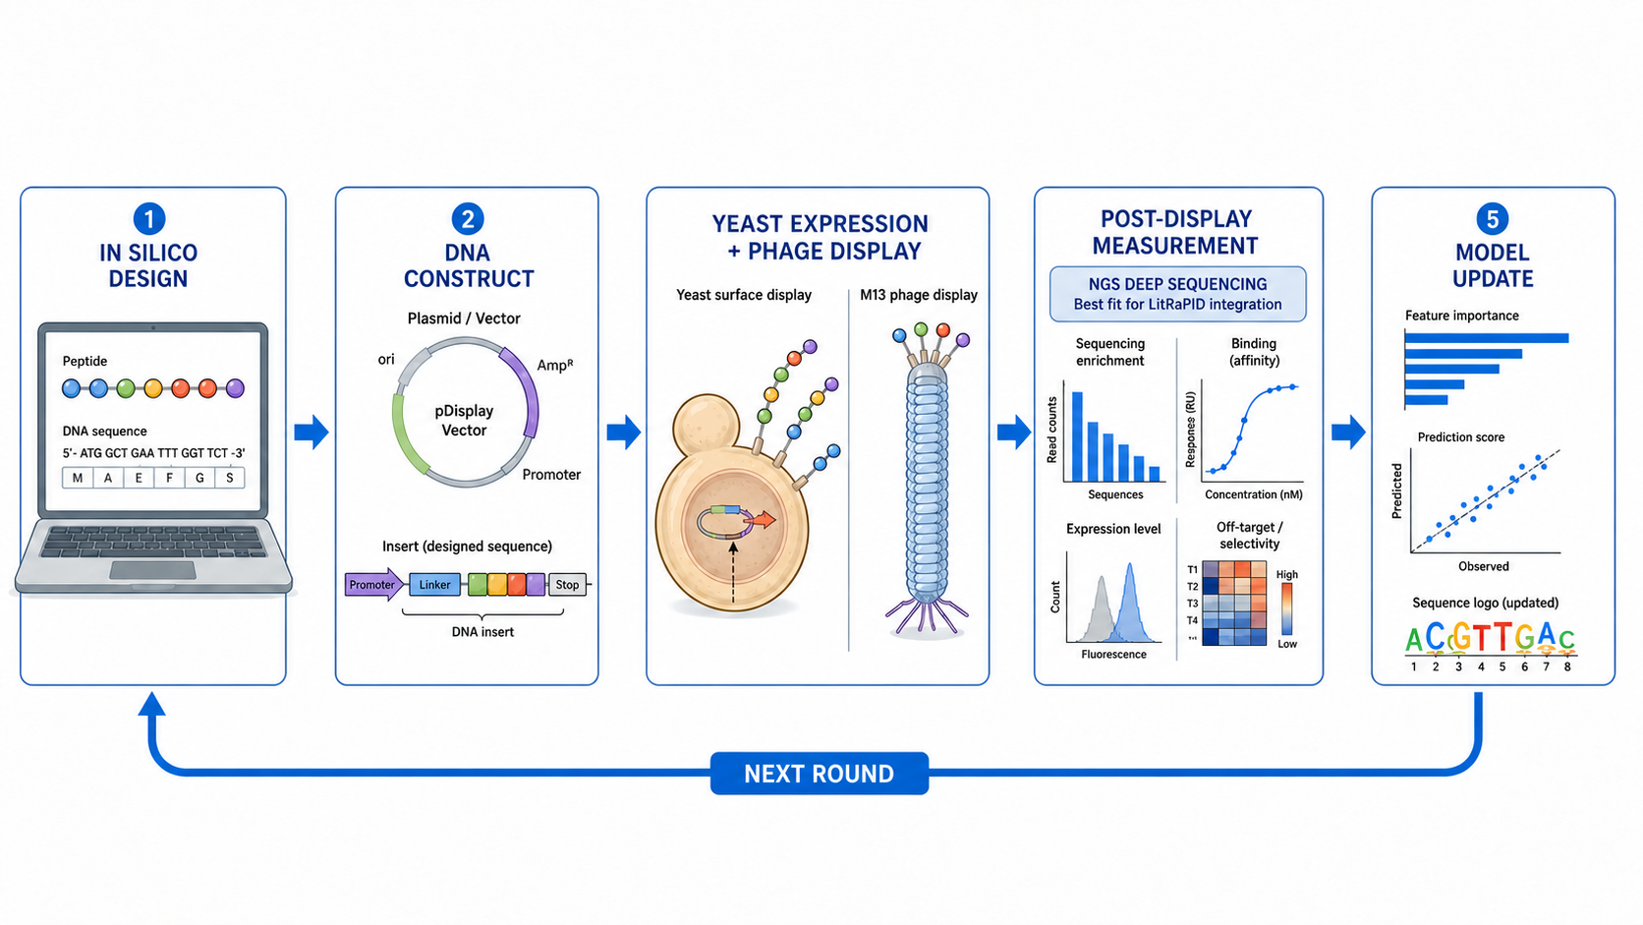
Figure 1. Closed computational-experimental workflow from in silico design and DNA construction to cellular display, NGS readout and iterative model updating.
- Define target, candidate library, topology and assay constraints.
- Assign measured Kd values or calibrated affinity priors and process-control distributions.
- Simulate multi-round mRNA display and inspect enrichment, diversity and dropout trajectories.
- Optimize protocol parameters under binder-recovery, specificity, diversity and cost objectives.
- Export DNA-ready sequences for yeast or phage display, including positive and uncertainty controls.
- Measure binding/display, collect round-resolved NGS and orthogonal kinetic data, and update the model.

5. Software implementation and reproducibility
LitRaPID-DT is implemented in Python 3.10+ using the standard library for the core simulator. A local HTTP service exposes /api/simulate-mrna, /api/export, /api/feedback and /api/design. Each run records all parameters, random seed, per-candidate process probabilities, round summaries, NGS counts and final ranking. The code is available at https://github.com/zhu-algorithm/LitRaPID on branch litrapid-mrna-display-v0.4 (commit f191d47701fa0dec1b2e83e0161db9dd0e1e4219).
Default parameter | Value | Interpretation
Virtual library size | 10^12 | Weighted population; no trillion-object allocation
Rounds | 6 | Configurable 1–20
Target | 20 nM | Occupancy driver
NGS depth | 20,000/round | Finite observation layer
Puromycin ligation | 0.65 | Configurable process efficiency
Fusion efficiency | 0.55 | Conditional fusion term
Cyclization | 0.85 | Cys-compatible prior
Nonspecific retention | 2×10^-4 | Background carry-over
Random seed | 2025 | Exact reproducibility

6. Computational verification
Ten automated tests passed in the current release, covering display-backend rules, API operation, deterministic simulation, frequency normalization and affinity-driven enrichment. In a three-candidate synthetic benchmark with Kd values of 1 nM, 100 nM and 10 µM, respectively, the 1 nM candidate ranked first after five rounds at 20 nM target concentration and 10,000 NGS reads per round. Repeating the run with the same seed generated an identical complete result object, and final normalized frequencies summed to one within numerical tolerance.
These tests demonstrate internal correctness and expected qualitative behavior; they are not evidence of prospective hit-discovery accuracy. A publishable validation package should add at least two public round-resolved mRNA-display datasets, ablations of each process term, calibration curves, uncertainty coverage, rank-recovery against measured Kd and comparisons with terminal-count, log-enrichment and sequence-only baselines.
Evaluation | Primary metric | Acceptance target for submission
Synthetic binder recovery | Recall@K / NDCG | Improvement over final-count baseline across ≥100 seeds
Bias stress test | Spearman ρ with true fitness | Robustness across PCR-bias σ and NGS depth
Retrospective dataset | Rank correlation with measured Kd | Confidence intervals by bootstrap
Protocol counterfactual | Binder recovery vs diversity/cost | Pareto-front improvement
Ablation | Δ performance per module | Each claimed module contributes measurably

7. Discussion
The potential field advance is a change in the unit of computational analysis: from ranking sequences after selection to modelling the selection experiment itself. This distinction matters when high-affinity clones are lost through inefficient fusion or cyclization, or when mediocre binders dominate through amplification and nonspecific retention. By retaining process observability, the framework can identify which additional control measurement would most reduce uncertainty and can compare protocols before consuming a high-diversity library.
The yeast/phage transfer loop provides an orthogonal validation layer. Cellular display has different expression, folding, avidity and trafficking biases from cell-free mRNA display. Agreement across systems increases confidence; disagreement is diagnostically useful because it separates biochemical affinity from displayability. The 2025 cysteine-free GPI macrocycle platform is particularly relevant for testing constrained peptides on yeast without consuming cysteines in the anchor [18].

8. Limitations
- Equilibrium occupancy is a simplification; kinetic wash models require kon, koff and time-resolved data.
- The default efficiency values are literature-informed priors, not universal constants.
- The current release does not predict atomistic structure, permeability, toxicity or proteolytic stability.
- Bias deconvolution is identifiable only when controls or informative replicates are available.
- Synthetic verification cannot substitute for retrospective and prospective experimental validation.
- RaPID and related commercial implementations may involve intellectual-property and freedom-to-operate considerations; this manuscript is a scientific method description, not legal advice.

9. Publication-positioning and peer-review readiness
The manuscript is best positioned as an open-source computational methods/resource article rather than a claim of a new wet-lab display chemistry. Journals in bioinformatics methods, computational biology, peptide science or biotechnology with impact factors around three may be plausible only after the retrospective validation package is completed. No journal acceptance or impact factor can be guaranteed, and journal metrics must be checked at submission because they change annually.
The most likely reviewer objections are absence of experimental calibration, insufficient comparison with simpler enrichment metrics, non-identifiability of process biases and overstatement of novelty. The proposed benchmarks, controls and cautious claim language directly address these risks. A prospective proof-of-concept consisting of one target, two protocol conditions, round-resolved NGS and orthogonal BLI or SPR validation would materially strengthen the paper.

10. Conclusions
LitRaPID-DT formalizes RaPID-like mRNA display as a reproducible, partially observed population-selection process and connects simulation to orthogonal cellular display. Its defensible innovation is the integration of process-aware dynamics, bias decomposition, counterfactual protocol design and closed-loop sequence transfer. The current software is operational and internally verified; publication-grade biological claims require the explicitly defined retrospective and prospective validation studies.

Data and code availability
Source code, tests, web interface and documentation: https://github.com/zhu-algorithm/LitRaPID/tree/litrapid-mrna-display-v0.4. The manuscript contains no patient or personally identifiable data.

Author contributions, funding and conflicts
To be completed by the authors before submission. Any use of proprietary RaPID implementations, commercial software, target materials or related patents should be disclosed.

References
1. Roberts RW, Szostak JW. RNA-peptide fusions for the in vitro selection of peptides and proteins. Proc Natl Acad Sci USA. 1997;94:12297–12302. doi:10.1073/pnas.94.23.12297.
2. Wilson DS, Keefe AD, Szostak JW. The use of mRNA display to select high-affinity protein-binding peptides. Proc Natl Acad Sci USA. 2001;98:3750–3755.
3. Seelig B. mRNA display for the in vitro evolution of artificial proteins. J Mol Biol. 2011;407:378–391.
4. Goto Y, Katoh T, Suga H. Flexizymes for genetic code reprogramming. Nat Protoc. 2011;6:779–790.
5. Yamagishi Y et al. Natural product-like macrocyclic N-methyl-peptide inhibitors against a ubiquitin ligase uncovered from a ribosome-expressed de novo library. Chem Biol. 2011;18:1562–1570.
6. Wang Y et al. Discovery of cyclic peptide ligands to the SARS-CoV-2 spike protein using mRNA display. ACS Cent Sci. 2021;7:987–996. PMCID: PMC8189037.
7. Bashiruddin NK, Suga H. Construction and screening of vast libraries of natural product-like macrocyclic peptides using the RaPID system. Curr Opin Chem Biol. 2015;24:131–138.
8. Randall CP et al. An efficient mRNA display protocol yields potent bicyclic peptide inhibitors for FGFR3c. Commun Chem. 2024. PMCID: PMC11040643.
9. Frost JR et al. An integrated platform approach enables discovery of potent, selective and ligand-competitive cyclic peptides targeting the GIP receptor. Chem Sci. 2022. doi:10.1039/D1SC06844J.
10. Jalali-Yazdi F et al. High-throughput measurement of binding kinetics via mRNA display and next-generation sequencing. Angew Chem Int Ed. 2016;55:4007–4010. PMCID: PMC4834215.
11. Olson CA et al. Single-round, multiplexed antibody mimetic design through mRNA display. Angew Chem Int Ed. 2012;51:12449–12453.
12. Shen W et al. A streamlined protocol for mRNA display. ACS Comb Sci. 2013;15:395–404. PMCID: PMC3666848.
13. Cho M et al. Quantitative selection of DNA aptamers through microfluidic selection and high-throughput sequencing. Proc Natl Acad Sci USA. 2010;107:15373–15378.
14. Townend JE et al. Identification and engineering of potent cyclic peptides through biochemical profiling and bioinformatic analysis. 2024. PMCID: PMC10763615.
15. Yang KK et al. Machine-learning-guided directed evolution for protein engineering. Nat Methods. 2019;16:687–694.
16. Looker D et al. Investigating active learning and meta-learning for iterative peptide design. NeurIPS Workshop. 2019. arXiv:1911.09103.
17. Dauparas J et al. Robust deep learning-based protein sequence design using ProteinMPNN. Science. 2022;378:49–56.
18. Wang K et al. A cysteine-free GPI-anchored macrocyclic peptide display platform in yeast. Nat Commun. 2025. doi:10.1038/s41467-025-60907-x.
19. Deyle K et al. Methods for generating and screening libraries of genetically encoded cyclic peptides in drug discovery. Nat Rev Chem. 2020;4:138–151.
20. Plückthun A et al. mRNA display pipeline for protein biosensor construction. ACS Synth Biol. 2024. PMCID: PMC11218749.

