各个doc中没出现的词语：
- D1: and, the, thing, ink, pink, links 5个
- D2: this, one, I, think, called a, yink, wink, pink, links, 10个
- D3: this, one, I, think, called, a, yink, thing, 8个

所有的词：this, one, I, think, is, called a, yink, he, likes, to, wink, drink, and, the, thing, ink, pink, links 共19个
He, likes, to, drink, and, the, thing is ink

- Laplace
D1：
“drink”: 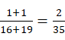,
“wink drink”: 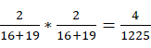,
“pink ink”: 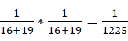
D2:
“drink”: 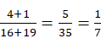,
“wink drink”: 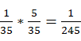
“pink ink”: 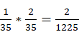
D3：
“drink”: 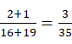,
“wink drink”: 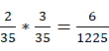,
“pink ink”:
- Lindstone:
D1：
“drink”: 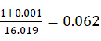,
“wink drink”: 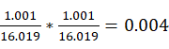,
“pink ink”: 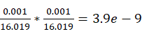
D2:
“drink”: 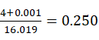,
“wink drink”: 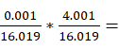0.016,
“pink ink”: 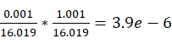
D3：
“drink”: 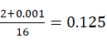,
“wink drink”: 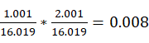
“pink ink”: 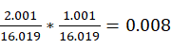
- Lindstone:
D1：
“drink”: 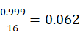,
“wink drink”: 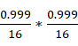,
“pink ink”: 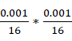
D2:
“drink”: 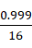,
“wink drink”: 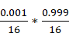,
“pink ink”:
D3：
“drink”: 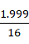,
“wink drink”: 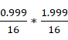
“pink ink”: 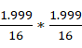

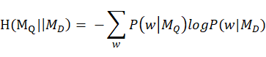
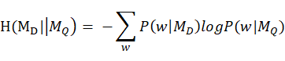
两公式显然是不对称的，不同的形式计算结果不同。
从交叉熵的意义来看，交叉熵刻画的是一个查询被文档的编码所需的长度，即通过来表达的困难程度，代表正确答案，而代表的预测值。在检索的时候，给定具体的query，要找到更合适document，显然应该选择更小的对应的document，而不是去考察

