##### Simple performance evaluation of Baidu, sogou, Bing

with three Chinese queries

IR-HW05-朱海峰-190110716

#### methods

Queries used in this evaluation:

1. 哈工大、韩杰才、校长
2. 哈尔滨、地铺、热
3. 出省、核酸、深圳

For each query, the user need:

1. Any infomation that 韩杰才 becomes new 校长 of 哈工大.
2. The news that students of some colleges in 哈尔滨make 地铺 because of the weather which is too 热.
3. The latest official policy whether 核酸 test is needed when 出省 from 深圳.

#### Procedure

###### The first query

For the first query, 哈工大、韩杰才、校长, on each search engine with top 20 documents returned, I manually judge the relevance.

Documents are just too many to list, so I just take a screenshot as an example, shown as figure 1.

Relevant documents are marked with “1” while the others I leave blank or mark with “0”, just as in figure 2.

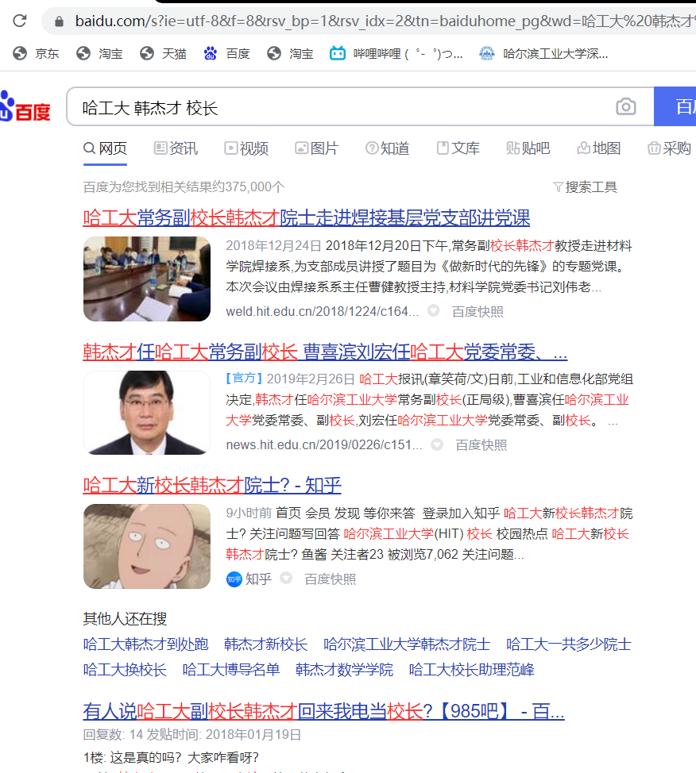

figure 1 documents returned

|  |  |  |  |  |  |  |  |  |  |  |  |  |  |  |  |  |  |  |  |  |
| --- | --- | --- | --- | --- | --- | --- | --- | --- | --- | --- | --- | --- | --- | --- | --- | --- | --- | --- | --- | --- |
|  | 1 | 2 | 3 | 4 | 5 | 6 | 7 | 8 | 9 | 10 | 11 | 12 | 13 | 14 | 15 | 16 | 17 | 18 | 19 | 20 |
| Baidu |  |  | 1 |  |  |  |  |  |  |  |  |  |  |  |  |  |  |  |  |  |
| sogou |  |  |  | 1 |  |  |  |  |  |  |  |  |  |  |  |  |  |  |  |  |
| bing |  |  |  |  |  |  |  |  |  |  |  |  |  |  |  |  |  |  |  |  |

Total documents relevant:1.



figure 2 P/R graph for the first query

baidu: $MAP=\frac{1}{1}\sum_{1}^{1}{1}=1$

sogou: $MAP=\frac{1}{1}\sum_{1}^{1}{1}=1$

bing: $MAP=0$

###### The second query

For the second query, 哈尔滨、地铺、热, methods remains the same:

|  |  |  |  |  |  |  |  |  |  |  |  |  |  |  |  |  |  |  |  |  |
| --- | --- | --- | --- | --- | --- | --- | --- | --- | --- | --- | --- | --- | --- | --- | --- | --- | --- | --- | --- | --- |
|  | 1 | 2 | 3 | 4 | 5 | 6 | 7 | 8 | 9 | 10 | 11 | 12 | 13 | 14 | 15 | 16 | 17 | 18 | 19 | 20 |
| Baidu | 0 | 1 | 1 | 1 | 0 | 1 | 1 | 1 | 1 | 0 | 1 | 0 | 0 | 1 | 1 | 1 | 0 | 0 | 0 | 0 |
| sogou | 1 | 0 | 0 | 0 | 1 | 1 | 0 | 1 | 0 | 1 | 1 | 1 | 1 | 0 | 0 | 0 | 1 | 1 | 1 | 0 |
| bing | 1 | 1 | 1 | 1 | 1 | 1 | 1 | 1 | 1 | 1 | 1 | 1 | 1 | 1 | 1 | 1 | 1 | 1 | 0 | 0 |

Total documents relevant:22.



figure 3 P/R graph for the second query

baidu: $MAP=\frac{1}{11}\sum_{1}^{11}{(\frac{1}{2}+\frac{2}{3}+\frac{3}{4}+\frac{4}{6}+\frac{5}{7}+\frac{6}{8}+\frac{7}{9}+\frac{8}{11}+\frac{9}{14}+\frac{10}{15}+\frac{11}{16})}=0.68633576$

sogou: $MAP=0.573462471$

bing: $MAP=1$

###### The third query

For the third query, 出省、核酸、深圳, methods remains the same:

|  |  |  |  |  |  |  |  |  |  |  |  |  |  |  |  |  |  |  |  |  |
| --- | --- | --- | --- | --- | --- | --- | --- | --- | --- | --- | --- | --- | --- | --- | --- | --- | --- | --- | --- | --- |
|  | 1 | 2 | 3 | 4 | 5 | 6 | 7 | 8 | 9 | 10 | 11 | 12 | 13 | 14 | 15 | 16 | 17 | 18 | 19 | 20 |
| Baidu | 1 | 1 | 1 | 0 | 1 | 1 | 1 | 0 | 1 | 1 | 1 | 0 | 1 | 0 | 1 | 0 | 0 | 0 | 0 | 0 |
| sogou | 1 | 1 | 0 | 0 | 0 | 0 | 1 | 1 | 0 | 0 | 0 | 0 | 0 | 0 | 0 | 1 | 1 | 0 | 0 | 0 |
| bing | 1 | 1 | 0 | 1 | 0 | 1 | 0 | 0 | 0 | 1 | 0 | 1 | 0 | 0 | 1 | 1 | 0 | 1 | 1 | 0 |

Total documents relevant:25.



figure 4 P/R graph for the third query

baidu: $MAP=0.853545444$

sogou: $MAP=0.599002101$

bing: $MAP=0.640964912$

#### conclusion

we can get the general MAP:

$${MAP}_{baidu}=\frac{1}{3}\sum_{1}^{3}{(1+0.6863+0.8535)}=0.8466$$

$${MAP}_{sogou}=\frac{1}{3}\sum_{1}^{3}{\left(1+0.5735+0.5995\right)}=0.7243$$

$${MAP}_{bing}=\frac{1}{3}\sum_{1}^{3}{(0+1+0.6410)}=0.547$$

With different types of need, different search engines perform differently. As I used some specific queries, the result is not as reliable as estimated.

Trying to explain for the results above, baidu, undoubtedly performs the best as well as stably, while sogou may be affected by some commercial advertisements. Bing can return many relevant documents, though, it missed information from Chinese BBS, like, zhihu, bilibili, etc.