- 配置好ESP32+VS Code 环境
  - 下载好espressif IDF，双击运行安装
  - 建好工程
  - 连接ESP32
  - 编译&烧录

ESP32教程：您对ESP32微控制器有什么了解？ - 乐鑫ESP32 - 一板网电子技术论坛 (yiboard.com)
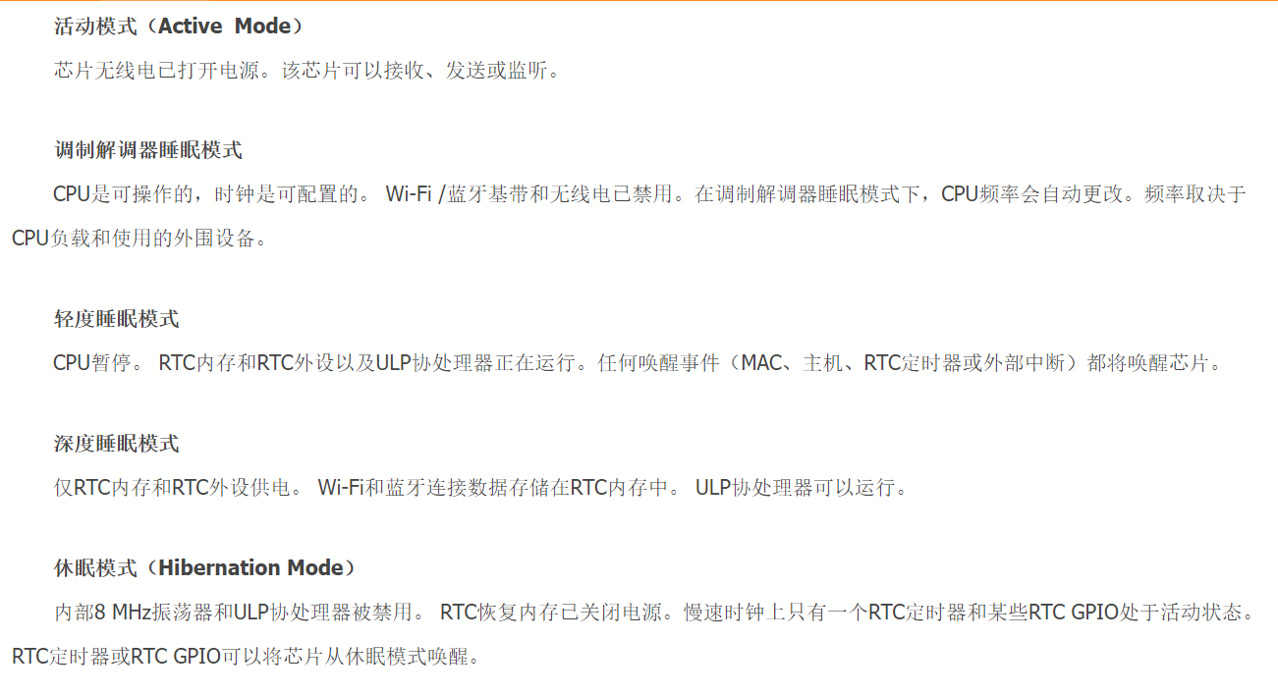

Part13--怎么区分I/O与GPIO_长路漫漫2021的博客-CSDN博客_gpio和io的区别
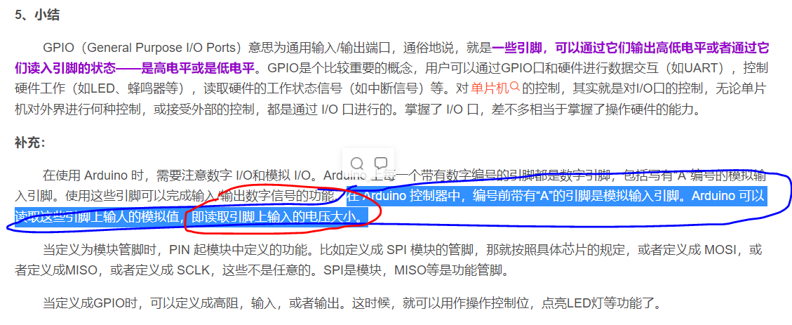
ESP32学习笔记（2）——GPIO接口使用 - 简书 (jianshu.com)
ESP32-GPIO带详细注释_曾菜鸟的博客-CSDN博客_esp32 gpio0

(ESP32学习9)PWM的输出_bird1999625的博客-CSDN博客_esp32输出pwm
PWM分辨率_gdaswater的博客-CSDN博客_pwm分辨率

int main(void){ HAL_Init(); MX_GPIO_Init(); MX_TIM4_Init(); MX_TIM3_Init(); MX_TIM12_Init();
int32_t time_stamp = 0; int32_t time_stamp_old = 0; int32_t ccr_val = 0; uint8_t add_flag = 1;
HAL_TIM_PWM_Start(&htim4, TIM_CHANNEL_2);
HAL_TIM_PWM_Start(&htim12, TIM_CHANNEL_1);
HAL_TIM_PWM_Start(&htim3, TIM_CHANNEL_3);
while (1) { time_stamp = HAL_GetTick();
if(time_stamp - time_stamp_old > 5){ time_stamp_old = time_stamp; if(add_flag){ ccr_val+=25; if(ccr_val >= 0xFFFF){ ccr_val =0xFFFF; add_flag = 0; } }
else{ ccr_val-=25; if(ccr_val <= 0){ add_flag = 1; ccr_val = 0; } }
TIM4->CCR2 = ccr_val; TIM12->CCR1 = ccr_val; TIM3->CCR3 = ccr_val; } }}

