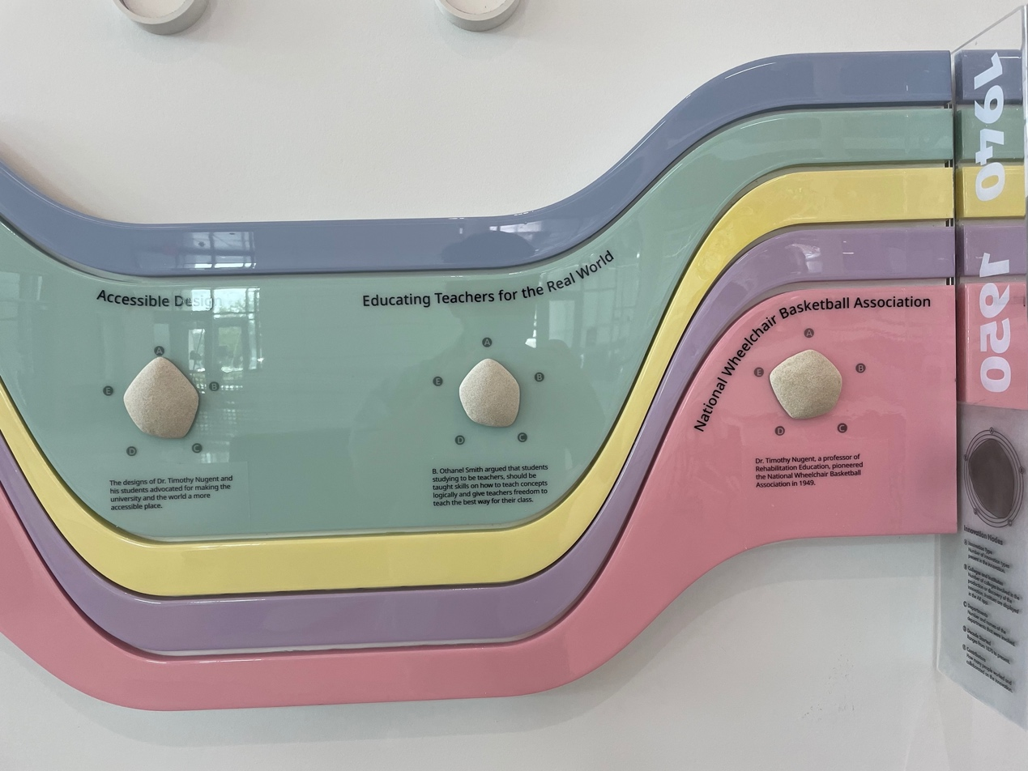

These are the visualizations I took from Seibel Center for Design. The color stripes are indicating the floating of the time and the captions of the radar gram is on a glass panel between each period. The data shown here is a history record of a collection of innovations in a certain topic

This visualization is good at measuring the historical contributions in a certain time. It is clear on the radar gram about each attributes involved. However, I still have a little idea about what are the five color stripes indicated here. There is not a clear caption of why one expands and shrinks. The captions are also a bit hard to read for this moment while the legends are separated from the gram.