Zhu_David_week_6_Viz

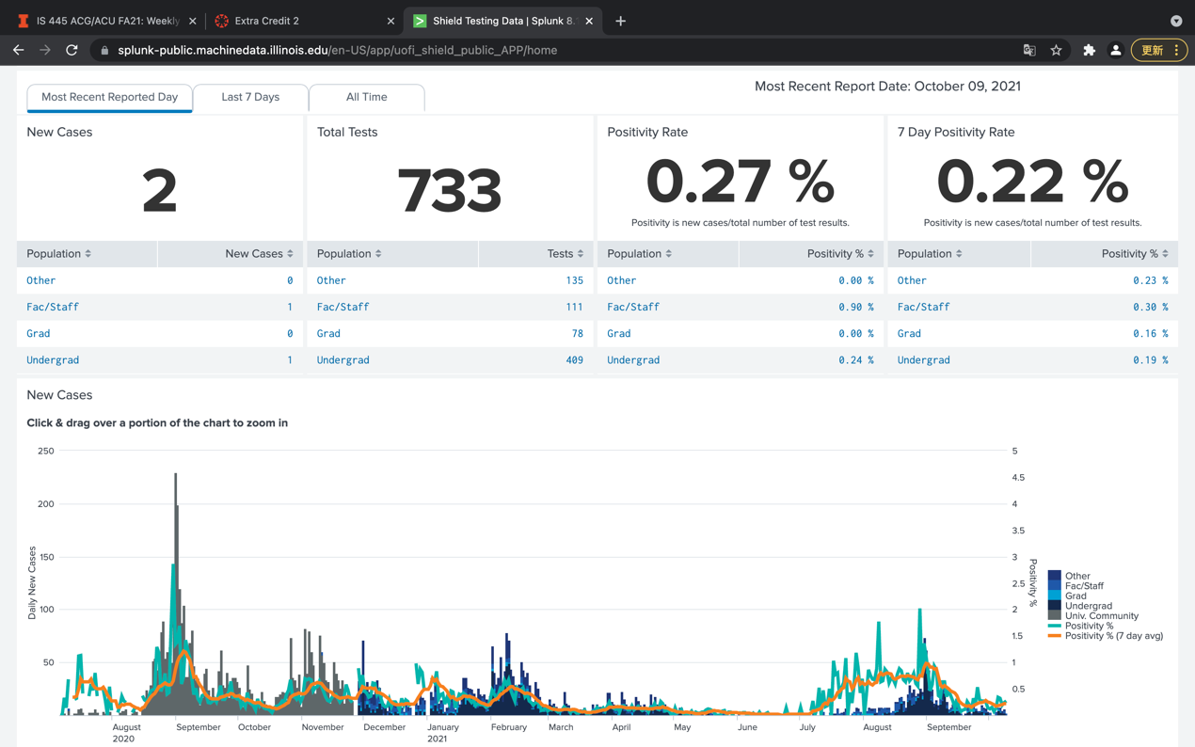

This week I look at the dashboard by UIUC about the covid positive cases. The data is from the on-campus testing center and the visualization shows how new cases are tested on each day. From the graph we can clear see the up and downs of the cases where September, 2020, and August, 2021 are the most of the new cases emerged. However, this case visualization is too compacted in the most time where positives are not so many that make the categories hard for people to read.