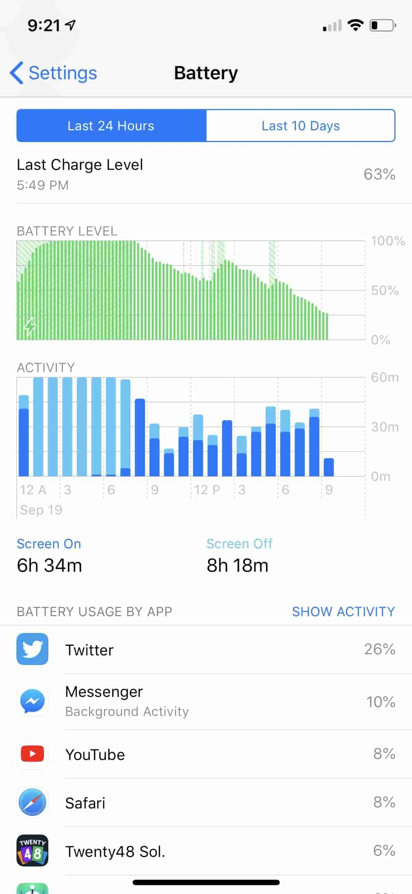

This is an excerpt from the battery usage in iPhone. The upper green graph shows the battery level as a function of time, as the lower blue one shows the screen on and screen off activity time as a function of time.

The good part of this visualization is it delivers the useful information to the user straightforward. We can easy to understand the usage of time and battery level. The green and blue are typical colors to remind users that green represents energy and blue represents consuming.

The not so good part about it is we can not know the difference in the lower blue one of what are screen on or off. Also, we can not distribute those applications to the time activities here, such as I have no idea when did I used YouTube to watch tv.