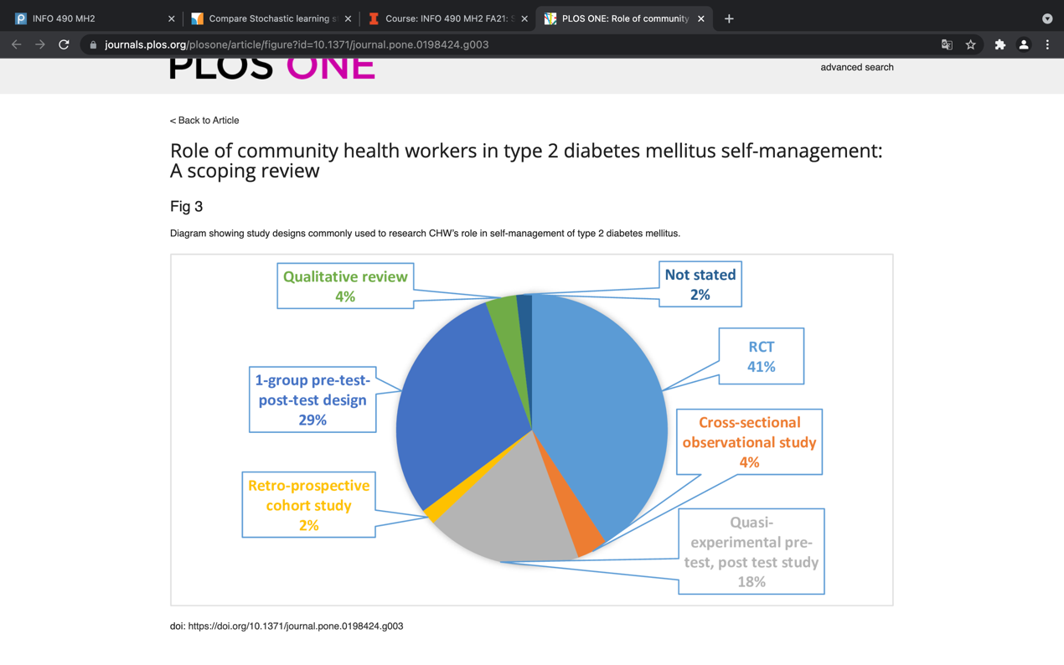

The viz is from <https://journals.plos.org/plosone/article/figure?id=10.1371/journal.pone.0198424.g003>

It is talking about study methods on diabeties groups.

It is clear at first by correct labeling and captions. But the color are overlapping a bit. There is also no explanation about what RCT means.