- 应完成工作
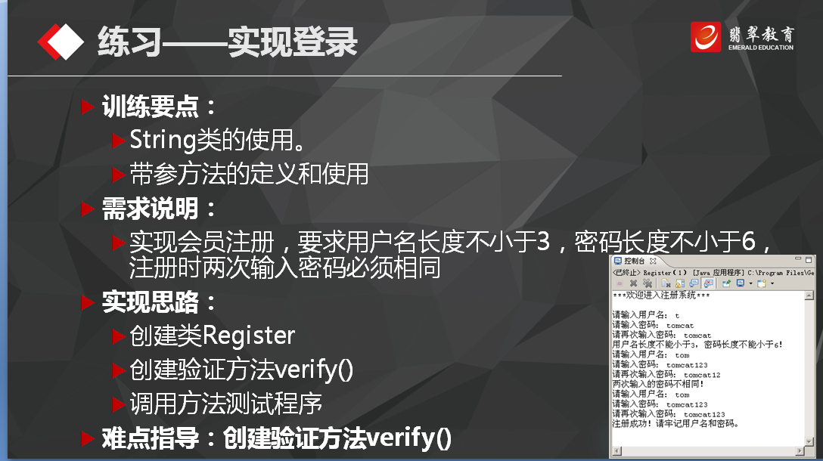public class Register {
public static void main(String[] args) {
register();

}
public static void register(){
Scanner sc = new Scanner(System.in);
System.out.println("请输入用户名和密码以及重复密码");
System.out.println("您的用户名是：");
String name = sc.next();
System.out.println("您的密码是：");
String password = sc.next();
System.out.println("请您再次输入您的密码是：");
String rePassword = sc.next();
System.out.println("请输入您的年龄");
int age = sc.nextInt();
Person per = new Person( name,age,password,rePassword);
if(per.isOk()){
System.out.println("您输入的信息符合要求，注册成功");
}else{
System.out.println("您输入的信息不对，注册失败");
//register();
}
}
} class Person{ private String name; private int age; private String password; private String rePassword;
public Person(String name,int age,String password,String rePassword){
this.name = name;
this.age = age;
this.password = password;
this.rePassword = rePassword;
}

public String getName() {
return name;
}
public void setName(String name) {
this.name = name;
}
public int getAge() {
return age;
}
public void setAge(int age) {
this.age = age;
}
public String getPassword() {
return password;
}
public void setPassword(String password) {
this.password = password;
}
public void setrePassword(String rePassword) {
this.rePassword = rePassword;
}

public boolean isOk(){
String reg1 = "[a-z]\\w*";
//String reg2 = "\\d{2}";
//String reg3 = "/^[0-9A-Za-z]{6,}$/";
String reg3 = "\\d{6}";
if(name.matches(reg1)&&password.matches(reg3)&&rePassword.matches(reg3)){
return true;
}
return false;
}
}

静态转换方法:
public static int parseInt(String s) 把字符串转换成int类型的值
public static Integer valueOf(String s) 把字符串转换成Integer对象 Integer i = Integer.valueOf(“2007”); Int value = i.intvalue(); 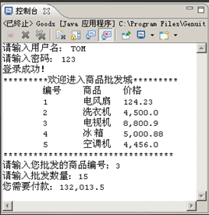
public class Zifuchuan {
public void show() {

StringBuffer sb = new StringBuffer();

sb.append("*********************").append("欢迎进入商店").append("******************\n");

sb.append(" 编号").append(" 商品").append(" 价格");

System.out.println(sb);

}
}
日期计算：
public class For {
public static void main(String[] args) {

Calendar ca = Calendar.getInstance();

ca.set(1927,7,2);

Calendar currentCa=Calendar.getInstance();

long time1 = ca.getTimeInMillis();

long time2 = currentCa.getTimeInMillis();

double dayOfTime = 24*60*60*10000;

double days = (time2 - time1) / dayOfTime;

}
}
Comparable接口： public interface Comparable{
public int compareTo(T o) ;
}
System类： int [] array1={3,1,3,6};
int [] array2=new int[7];
System.arraycopy(array1,2,array2,2,1);
Calendar类： Date类： SimpleDateFormat类：
- 未完成工作
- 未完成原因
- 工作成功
- 遇到的问题及解决方法

