2016-09-20工作日志
- 已完成工作 instanceof运算符
实现与宠物玩耍功能：
（1）Dog类
package text2;
public class Dog extends Pet{
String strain;

Dog(){

}

Dog(String name,String strain){
this.name = name;
this.health = 100;
this.intimacy = 0;
this.strain = strain;
}

public void catchingFlyDisc(){
health = health - 10;
intimacy = intimacy + 5;
}
public void print(){
System.out.print("我的名字是"+name+",我的健康值是"+health+",我与主人的亲密度是 "+intimacy);
}
}
（2）Penguin类
package text2;
public class Penguin extends Pet {
String sex;

Penguin(){

}

Penguin(String name,String sex){
this.name = name;
this.health = 100;
this.intimacy = 0;
this.sex = sex;
}

public void swimming(){
health = health - 10;
intimacy = intimacy + 5;
}
public void print(){
System.out.print("我的名字是"+name+",我的健康值是"+health+",我与主人的亲密度是 "+intimacy);
}
}
（3）Person类
package text2;
public class Person {
public void playing(Pet pet){
if(pet instanceof Dog ){
Dog dog1 = new Dog();
//dog1 = (Dog) pet;
dog1.catchingFlyDisc();
}
else{
Penguin penguin = (Penguin) pet;
penguin.swimming();
}
}
}
（4）PetMain类
package text2;
import java.util.Scanner;
public class PetMain {
public static void main(String[] args) {

Person person = new Person();

System.out.print("请输入您要玩的动物：(1)狗 (2)企鹅 ");
Scanner scanner = new Scanner(System.in);
int inputInt = scanner.nextInt();

Dog dog = new Dog("南南","雪瑞纳");
Penguin penguin = new Penguin("哈哈","Q仔");

if (inputInt == 1){
person.playing(dog);
dog.print();
}
else{
person.playing(penguin);
penguin.print();
}
}
}
- 工作成果
运行结果：
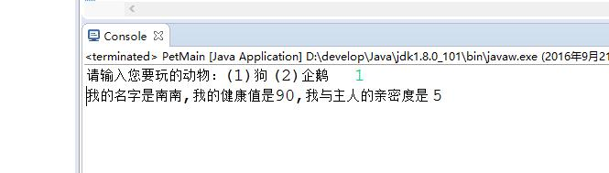
- 未完成工作
无
- 未完成原因
无

- 遇到的问题及解决方案
if(pet instanceof Dog ){
Dog dog1 = new Dog();
//dog1 = (Dog) pet;
dog1.catchingFlyDisc();
}
else{
Penguin penguin = (Penguin) pet;
penguin.swimming();
}
此时dog1类是一个新的类，与传入的dog类不同，
Dog dog1 =(Dog) pet; 即可

