- 应完成工作 sdshdkjahdsdhadshkjdhadaskjdhkjsdhkcbiadbiabfakbckjasbakbdakbd 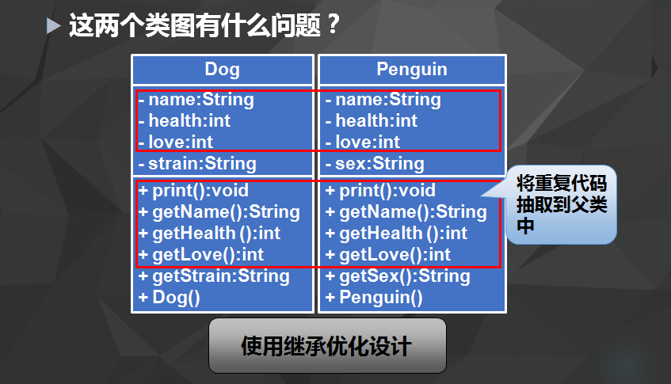
- 已完成工作
- public class Person { int age; static int power = 100; public static void main(String[] args){ Person hujintao = new Person();
hujintao.age = 73; hujintao.power = 70; Person xijinping = new Person(); xijinping.age = 74; xijinping.power = 100;
System.out.println("hujintao.age="+hujintao.age); System.out.println("hujintao.power="+hujintao.power);
System.out.println("xijinping.age="+xijinping.age); System.out.println("xijinping.power="+xijinping.power); } }
- 未完成工作
- 未完成原因
- 工作成功
- 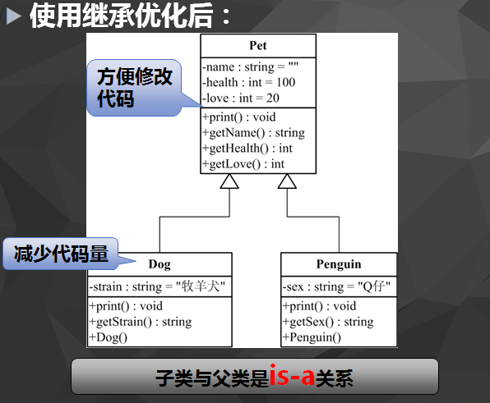
- public class Animal { public void move(){ System.out.println("动物可以移动");
}
public void bark() { // TODO Auto-generated method stub
} }
public class Dog extends Animal{ public void move(){ super.move(); System.out.println("狗可以跑和走"); }
}
public class Test { public static void main(String[] args){
Animal b = new Dog();

b.move();
b.move();
} } 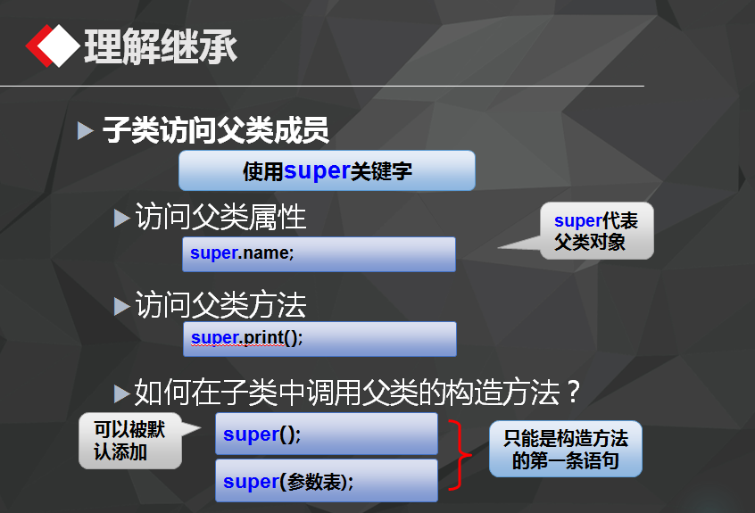 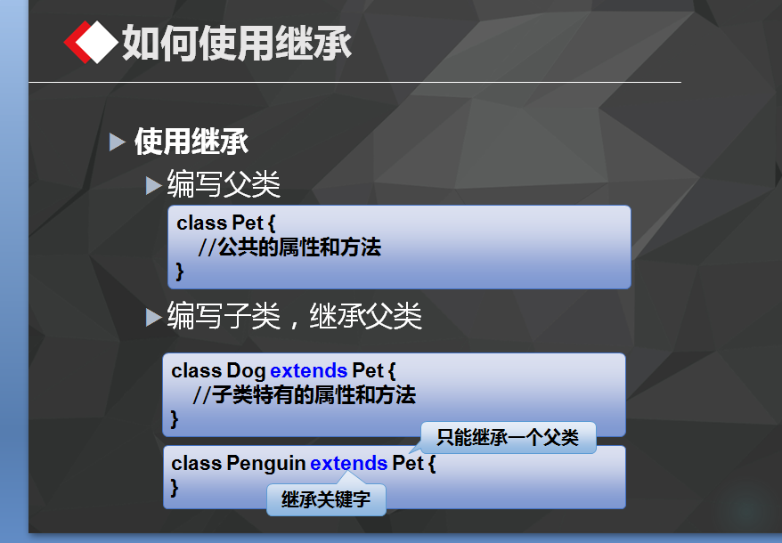 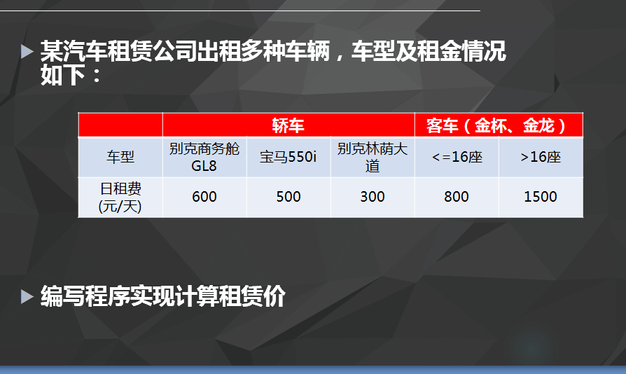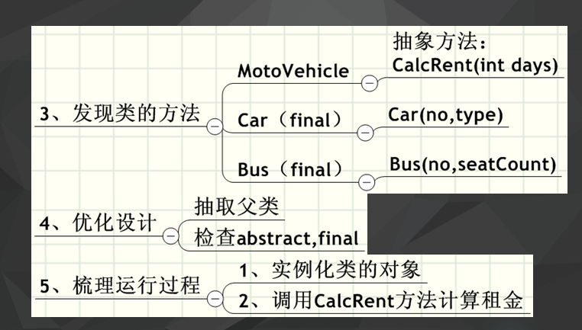 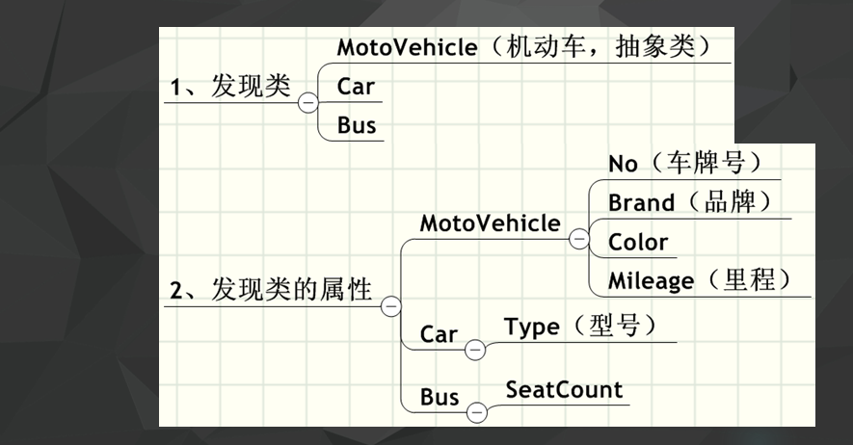public class Bus extends MotoVehic{ public int siteNum; public int site16 = 800; public int siteOther = 1000; private int days;
public Bus(String name,int siteNum,int days){
super();

this.siteNum = siteNum;
vehicName = name;

this.days = days;
}
public long CaluMoney(){
if(siteNum<=16){
return site16*days;

}
else{
return siteOther*days;
}
}
@Override
public long CalcuMoney() {
return 0;
}
}
public class Car extends MotoVehic {
public String type;
public int days; public int money;
public Car(String type,int days){
super(); this.type = type; this.days = days;
}
public long CalcuMoney(){
if("别克商务舱".equals(type)){ money = 600;
}
else if("宝马".equals(type)){ money = 500; }
else if("别克林荫大道".equals(type)){ money = 300; }
return days*money;
}
}
public abstract class MotoVehic { public String vehicName; public String vehicNo; public String color; public long mileage; public String num; public abstract long CalcuMoney(); public void print(){ long money = CalcuMoney(); System.out.println("别克商务"+vehicName+"宝马："+money); } }
- 遇到的问题及解决方法

