2016-9-21工作日志
- 1. 应完成的工作
- 学习继承 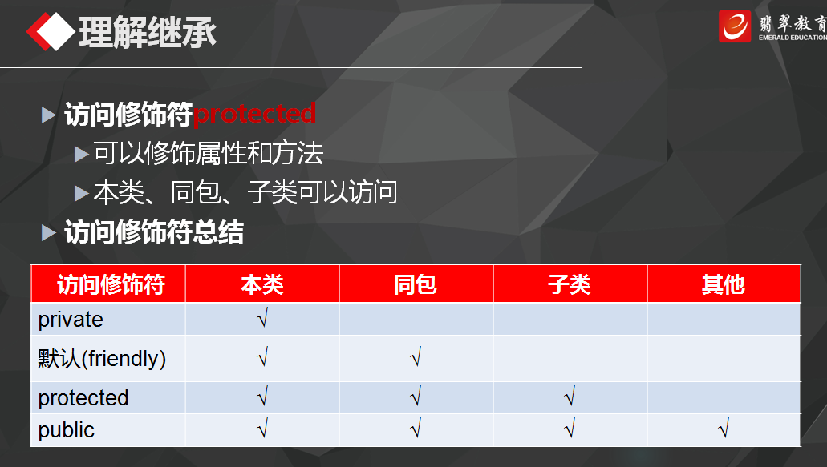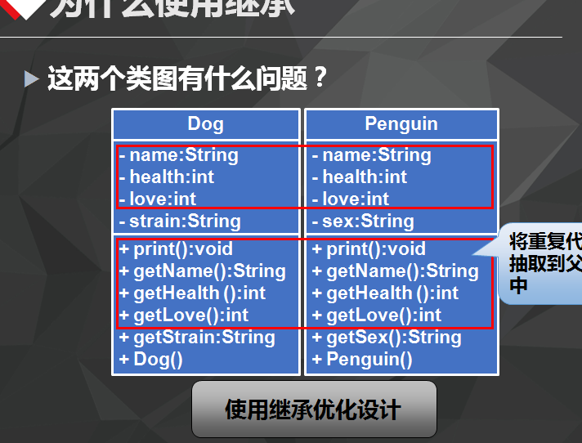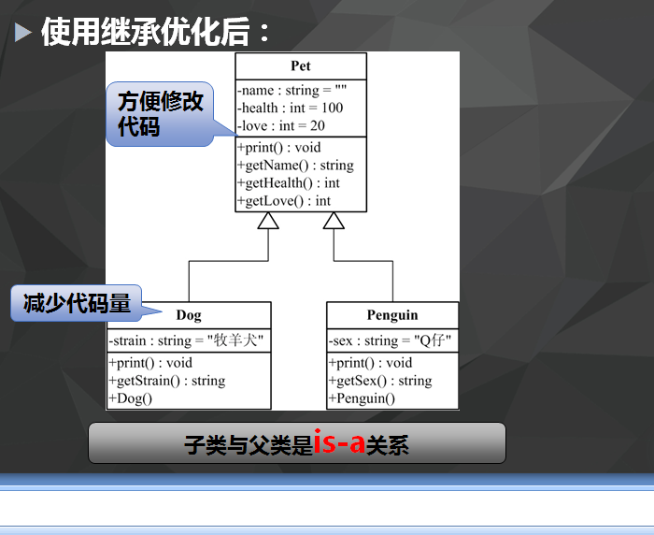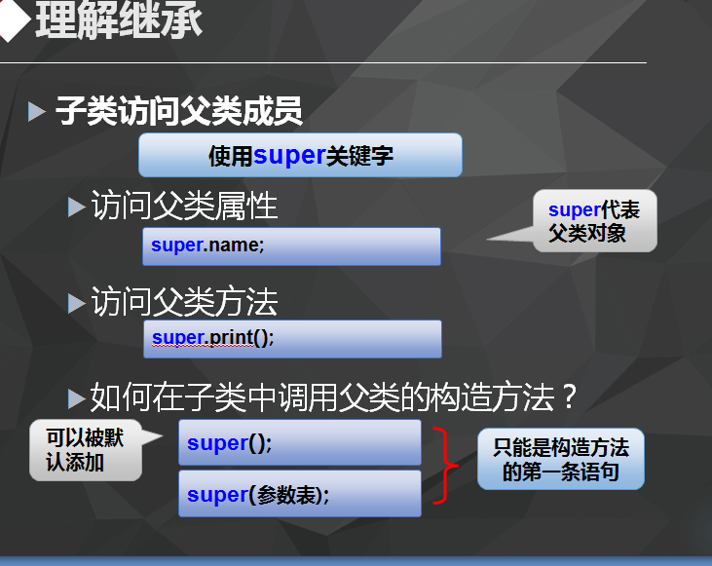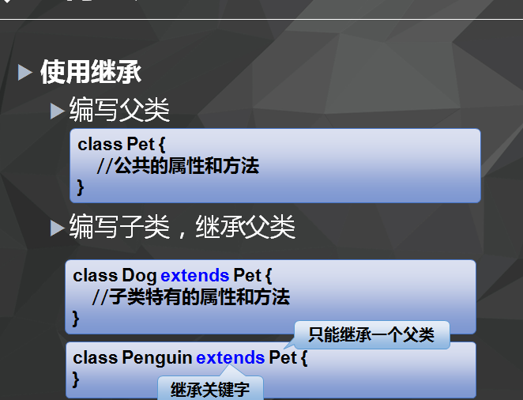
- 2. 已完成的工作
- 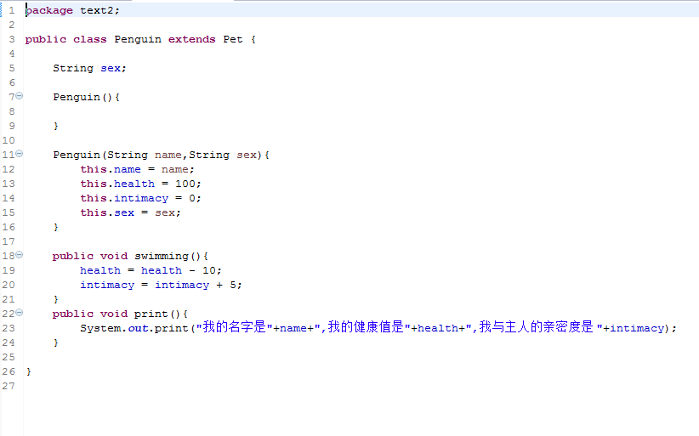package text2;
import java.util.Scanner;
public class PetMain {
public static void main(String[] args) {

Person person = new Person();

System.out.print("请输入您要玩的动物：(1)狗 (2)企鹅 ");
Scanner scanner = new Scanner(System.in);
int inputInt = scanner.nextInt();

Dog dog = new Dog("南南","雪瑞纳");
Penguin penguin = new Penguin("哈哈","Q仔");

if (inputInt == 1){
person.playing(dog);
dog.print();
}
else{
person.playing(penguin);
penguin.print();
}

}
package text2;
public class Dog extends Pet{
String strain;

Dog(){

}

Dog(String name,String strain){
this.name = name;
this.health = 100;
this.intimacy = 0;
this.strain = strain;
}

public void catchingFlyDisc(){
health = health - 10;
intimacy = intimacy + 5;
}
public void print(){
System.out.print("我的名字是"+name+",我的健康值是"+health+",我与主人的亲密度是 "+intimacy);
}
}
public class Penguin extends Pet {
String sex;

Penguin(){

}

Penguin(String name,String sex){
this.name = name;
this.health = 100;
this.intimacy = 0;
this.sex = sex;
}

public void swimming(){
health = health - 10;
intimacy = intimacy + 5;
}
public void print(){
System.out.print("我的名字是"+name+",我的健康值是"+health+",我与主人的亲密度是 "+intimacy);
}
} package text2;
public class Person {
public void playing(Pet pet){
if(pet instanceof Dog ){
Dog dog1 = new Dog();
dog1 = (Dog) pet;
dog1.catchingFlyDisc();
}
else{
Penguin penguin = (Penguin) pet;
penguin.swimming();
}

}
}
- 未完成的工作
- 未完成的原因
- 工作成功
- 遇到的问题及解决办法 感觉父类子类的代码没有理解，都是照葫芦画瓢写上去的，对于定义变量的意思感觉模糊，有时候无从下手。。。看样子只能多写孰能生巧了，，

