2016-09-28工作日志
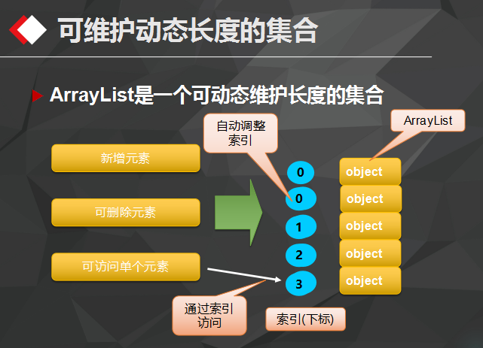
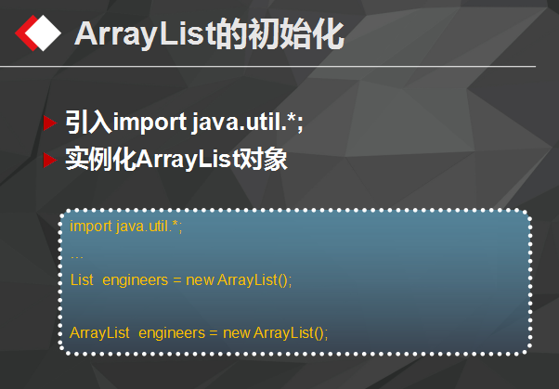
- list
  - ArrayList 可变数组
import java.util.ArrayList; import java.util.Iterator; import java.util.List;
/**
    - Created by chenyan on 2016/9/27. */ public class ListDemo {
public static void main(String[] args) {
// 创建
List<String> list = new ArrayList<String>();

// 添加
list.add("毛泽东");

list.add("周恩来");

list.add("刘少奇");

list.add(2,"朱德");

// list.add("林彪");

// 修改
// list.set(0,"林彪");

// 删除
// list.remove(0);
list.remove("毛泽东");

// 查询遍历
for(int index = 0;index< list.size();index ++) {
String name = list.get(index);
System.out.println(name);
}

System.out.println("*******************************");
for (String name : list) {
System.out.println(name);
}

System.out.println("*******************************");
Iterator<String> it = list.iterator();
while(it.hasNext()) {
String name = it.next();
System.out.println(name);
}
} }
  - LinkedList 链表
    - 在集合任何位置（头部、中间、尾部）添加、获取
    - 插入、删除操作频繁时，可使用LinkedList来提高效率
    - LinkedList还额外提供对头部和尾部元素进行添加和删除操作的方法
import java.util.ArrayList; import java.util.Iterator; import java.util.LinkedList; import java.util.List;
/**
    - Created by chenyan on 2016/9/27. */ public class LinkedListDemo {
public static void main(String[] args) {
// 创建
LinkedList<String> list = new LinkedList<>();

// 添加
list.add("毛泽东");

list.add("周恩来");

list.add("刘少奇");

list.add(2,"朱德");

// list.add("林彪");

// 修改
// list.set(0,"林彪");

// 删除
// list.remove(0);
list.remove("毛泽东");

list.addFirst("陈独秀");
list.addLast("华国锋");
// 查询遍历
for(int index = 0;index< list.size();index ++) {
String name = list.get(index);
System.out.println(name);
}

System.out.println("*******************************");
for (String name : list) {
System.out.println(name);
}

System.out.println("*******************************");
Iterator<String> it = list.iterator();
while(it.hasNext()) {
String name = it.next();
System.out.println(name);
}
} }
- set
  - Set接口也是Collection接口的子接口，但是与Collection或List接口不同的是，Set接口中不能加入重复的元素。
  - Set接口的定义： public interface Set extends Collection
  - Set接口的主要方法与Collection是一致的
  - Set接口的实例无法像List接口那样进行双向输出
  - Set接口的常用子类
    - HashSet (散列的存放) :
HashSet是Set接口的一个实现类， 主要的特点是： 里面不能存放重复元素， 采用散列的存储方式，所以是没有顺序(插入顺序)的。
  - import java.util.HashSet; import java.util.Iterator; import java.util.LinkedList;
  - /**
    - Created by chenyan on 2016/9/27. */ public class HashSetDemo {
public static void main(String[] args) {
// 创建
HashSet<String> list = new HashSet<String>();

// 添加
list.add("毛泽东");

list.add("周恩来");

list.add("刘少奇");

// list.add("林彪");

// 修改
// list.set(0,"林彪");

// 删除
// list.remove(0);
// list.remove("毛泽东");

// 查询遍历

for (String name : list) {
System.out.println(name);
}

System.out.println("*******************************");
Iterator<String> it = list.iterator();
while(it.hasNext()) {
String name = it.next();
System.out.println(name);
}
} }
    - TreeSet (有序的存放) :
      - 输入的数据进行有序排列
import java.util.Iterator; import java.util.TreeSet;
/**
        - Created by chenyan on 2016/9/27. */ public class TreeSetDemo {
public static void main(String[] args) {
// 创建
TreeSet<String> list = new TreeSet<String>();

// 添加
list.add("b毛泽东");

list.add("a周恩来");

list.add("c刘少奇");

// list.add("林彪");

// 修改
// list.set(0,"林彪");

// 删除
// list.remove(0);
// list.remove("毛泽东");

// 查询遍历

for (String name : list) {
System.out.println(name);
}

System.out.println("*******************************");
Iterator<String> it = list.iterator();
while(it.hasNext()) {
String name = it.next();
System.out.println(name);
}
} }
      - TreeSet的排序说明
        - 一个普通的类对象是不能向TreeSet集合中加入的， 如果直接加入会出现以下的异常：java.lang.ClassCastException
        - 如果要想使用TreeSet则对象所在的类必须实现Compable接口
package com.feicuiedu.demo3;
import java.util.Iterator; import java.util.TreeSet;
/**
          - Created by chenyan on 2016/9/28. */ public class TreeSetDemo {
public static void main(String[] args) {
User liubei = new User(1,"liubei", 40);
User guanyu = new User(2,"guyuan", 30);
User zhangfei = new User(3,"zhangfei", 29);
User zhugeliang = new User(4,"zhugeliang", 25);
User zhaoyun = new User(1,"zhaoyun", 16);

TreeSet<User> userSet = new TreeSet<User>();

userSet.add(zhaoyun);
userSet.add(liubei);
userSet.add(guanyu);
userSet.add(zhugeliang);
userSet.add(zhangfei);

Iterator<User> it = userSet.iterator();
while(it.hasNext()) {
User u = it.next();
System.out.println(u);
}
} } class User implements Comparable{ private int id; private String name; private int age;
public int getId() { return id; }
public String getName() { return name; }
public int getAge() { return age; }
public User(int id, String name, int age) { this.id = id; this.name = name; this.age = age; }
@Override public int compareTo(Object o) {
User u = (User)o;
int res = 0;
if (age > u.age) {
res = 2;
}
else if (age == u.age) {
res =0;
}
else {
res = -12;
}
return res;
}
@Override public String toString() { return "User{" + "id=" + id + ", name='" + name + '\'' + ", age=" + age + '}'; } }
          - 关于重复元素的说明
            - Set接口中是不允许存放重复元素的
package com.feicuiedu.demo3;
import java.util.Scanner; import java.util.Set; import java.util.HashSet; import java.util.Iterator; import java.util.Random;
/**
              - Created by chenyan on 2016/9/28. */ public class Test {
// 模拟 35 选7 public static void main(String[] args) { Scanner scanner = new Scanner(System.in); System.out.print("请输入号码的总个数:"); int totalCount = scanner.nextInt(); System.out.print("请输入号开奖号码的总个数:"); int selectCount = scanner.nextInt();
System.out.println("本期"+totalCount+"选"+selectCount+"开奖的结果是：");
Test t = new Test();
String str = t.genNumber(totalCount,selectCount);
System.out.println(str);
}
/**
                - 生成彩票号码
                - @param totalCount 号码的总个数
                - @param selectCount 开奖号码的总个数
                - @return 中奖号码的明细以","隔开 */ public String genNumber(int totalCount,int selectCount ) {
Random random = new Random();
Set set = new HashSet();
while (true) { int number = random.nextInt(totalCount);
if (number ==0) {
continue;
}
set.add(number);

if (set.size() == selectCount) {
break;
}
}
Iterator it = set.iterator();
StringBuffer sb = new StringBuffer(); while (it.hasNext()) { int index = it.next(); sb.append(index+","); } //sb.deleteCharAt(sb.length()-1); String str = sb.substring(0,sb.length()-1);
return str; } }
            - 一个类的对象是否重复需要依靠Object类中的以下方法完成：
hashCode()：指定哈希码 equals()：对象比较
          - package com.feicuiedu.demo3;
          - /**
            - Created by chenyan on 2016/9/28. */ public class User implements Comparable{ private int id; private String name; private int age;
public int getId() { return id; }
public String getName() { return name; }
public int getAge() { return age; }
public User(int id, String name, int age) { this.id = id; this.name = name; this.age = age; }
@Override public int compareTo(Object o) {
User u = (User)o;
int res = 0;
if (age > u.age) {
res = 2;
}
else if (age == u.age) {
res =0;
}
else {
res = -12;
}
return res;
}
@Override public String toString() { return "User{" + "id=" + id + ", name='" + name + '\'' + ", age=" + age + '}'; }
@Override public boolean equals(Object o) { /*if (this == o) return true; if (o == null || getClass() != o.getClass()) return false;
User user = (User) o;

if (id != user.id) return false;
if (age != user.age) return false;
return name != null ? name.equals(user.name) : user.name == null;*/

return true;
}
@Override public int hashCode() { /* int result = id; result = 31 * result + (name != null ? name.hashCode() : 0); result = 31 * result + age;*/ return 1; } }
          - package com.feicuiedu.demo3;
          - import java.util.HashSet; import java.util.Iterator;
          - /**
            - Created by chenyan on 2016/9/28. */ public class Test1 {
public static void main(String[] args) {
User liubei = new User(1,"liubei", 40);
User guanyu = new User(2,"guyuan", 30);
User zhangfei = new User(3,"zhangfei", 29);
User zhugeliang = new User(4,"zhugeliang", 25);
User zhaoyun = new User(1,"zhaoyun", 16);

HashSet<User> userSet = new HashSet<User>();

userSet.add(zhaoyun);
userSet.add(liubei);
userSet.add(guanyu);
userSet.add(zhugeliang);
userSet.add(zhangfei);

System.out.println(liubei.equals("adfasdf"));
System.out.println(liubei==guanyu);

Iterator<User> it = userSet.iterator();
while(it.hasNext()) {
User u = it.next();
System.out.println(u);
}
} }
          - 运行结果
SHAPE \* MERGEFORMAT
- map
  - HashMap
package com.feicuiedu.demo3;
import java.util.HashMap; import java.util.Iterator; import java.util.Map; import java.util.Set;
/**
  - Created by chenyan on 2016/9/28. */ public class MapDemo {
public static void main(String[] args) {
// 创建
Map<String,String> countries = new HashMap<String, String>();

// 对map添加输入
countries.put("CN", "中华人民共和国");
countries.put("RU", "俄罗斯联邦");
countries.put("FR", "法兰西共和国");
countries.put("US", "美利坚合众国");

// 查询
String country = (String) countries.get("CN");

// 遍历
// 使用Map.Entry<String, String>
Set<Map.Entry<String, String>> set = countries.entrySet();
Iterator<Map.Entry<String,String>> it = set.iterator();

while(it.hasNext()) {
Map.Entry<String,String> entry = it.next();
String key = entry.getKey();
String value = entry.getValue();
// json标准
System.out.println(key+":"+value+",");
}

System.out.println("******************************");

// 删除
//countries.remove("US");

// 使用keySet 遍历
Set<String> setKey = countries.keySet();
Iterator<String> itKey = setKey.iterator();
while(itKey.hasNext()) {
String key = itKey.next();
String value = countries.get(key);

System.out.println(key+":"+value+",");
}

boolean bln = countries.containsKey("ccc");
boolean bln1 = countries.containsValue("美利坚合众国");

System.out.println("bln="+bln+" bln1="+bln1);
/* System.out.println("CN对应的国家是：" + country); System.out.println("Map中共有" + countries.size() + "组数据");*/ } }
  - TreeMap
package com.feicuiedu.demo3;
import java.util.*;
/**
    - Created by chenyan on 2016/9/28. */ public class TreeMapDemo {
public static void main(String[] args) {
// 创建
TreeMap<String,String> countries = new TreeMap<String, String>();

// 对map添加输入
countries.put("CN", "中华人民共和国");
countries.put("RU", "俄罗斯联邦");
countries.put("FR", "法兰西共和国");
countries.put("US", "美利坚合众国");

// 查询
String country = (String) countries.get("CN");

// 遍历
// 使用Map.Entry<String, String>
Set<Map.Entry<String, String>> set = countries.entrySet();
Iterator<Map.Entry<String,String>> it = set.iterator();

while(it.hasNext()) {
Map.Entry<String,String> entry = it.next();
String key = entry.getKey();
String value = entry.getValue();
// json标准
System.out.println(key+":"+value+",");
}

System.out.println("******************************");

// 删除
//countries.remove("US");

// 使用keySet 遍历
Set<String> setKey = countries.keySet();
Iterator<String> itKey = setKey.iterator();
while(itKey.hasNext()) {
String key = itKey.next();
String value = countries.get(key);

System.out.println(key+":"+value+",");
}

boolean bln = countries.containsKey("ccc");
boolean bln1 = countries.containsValue("美利坚合众国");

System.out.println("bln="+bln+" bln1="+bln1);
System.out.println("CN对应的国家是：" + country); System.out.println("Map中共有" + countries.size() + "组数据"); } }
  - LinkedHashMap
package com.feicuiedu.demo3;
import java.util.Iterator; import java.util.LinkedHashMap; import java.util.Map; import java.util.Set;
/**
    - Created by chenyan on 2016/9/28. */ public class LinkedMapDemo {
public static void main(String[] args) {
// 创建
LinkedHashMap<String,String> countries = new LinkedHashMap<String, String>();

// 对map添加输入
countries.put("CN", "中华人民共和国");
countries.put("RU", "俄罗斯联邦");
countries.put("US", "美利坚合众国");
countries.put("FR", "法兰西共和国");

// 查询
String country = (String) countries.get("CN");

// 遍历
// 使用Map.Entry<String, String>
Set<Map.Entry<String, String>> set = countries.entrySet();
Iterator<Map.Entry<String,String>> it = set.iterator();

while(it.hasNext()) {
Map.Entry<String,String> entry = it.next();
String key = entry.getKey();
String value = entry.getValue();
// json标准
System.out.println(key+":"+value+",");
}

System.out.println("******************************222");

// 删除
//countries.remove("US");

// 使用keySet 遍历
Set<String> setKey = countries.keySet();
Iterator<String> itKey = setKey.iterator();
while(itKey.hasNext()) {
String key = itKey.next();
String value = countries.get(key);

System.out.println(key+":"+value+",");
}

System.out.println("******************************333");

for (Map.Entry<String,String> entry: countries.entrySet()) {
String key = entry.getKey();
String value = entry.getValue();
// json标准
System.out.println(key+":"+value+",");
}

boolean bln = countries.containsKey("ccc");
boolean bln1 = countries.containsValue("美利坚合众国");

System.out.println("bln="+bln+" bln1="+bln1);
/* System.out.println("CN对应的国家是：" + country); System.out.println("Map中共有" + countries.size() + "组数据");*/ } }

