**SEAGULLS! A LOT OF SEAGULLS!**

**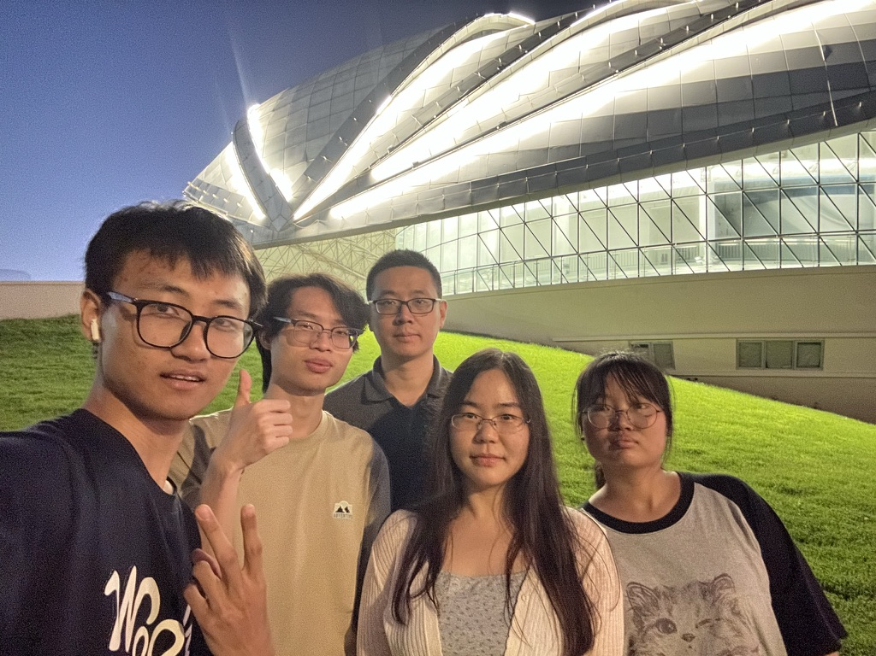*Cheers~~~***

**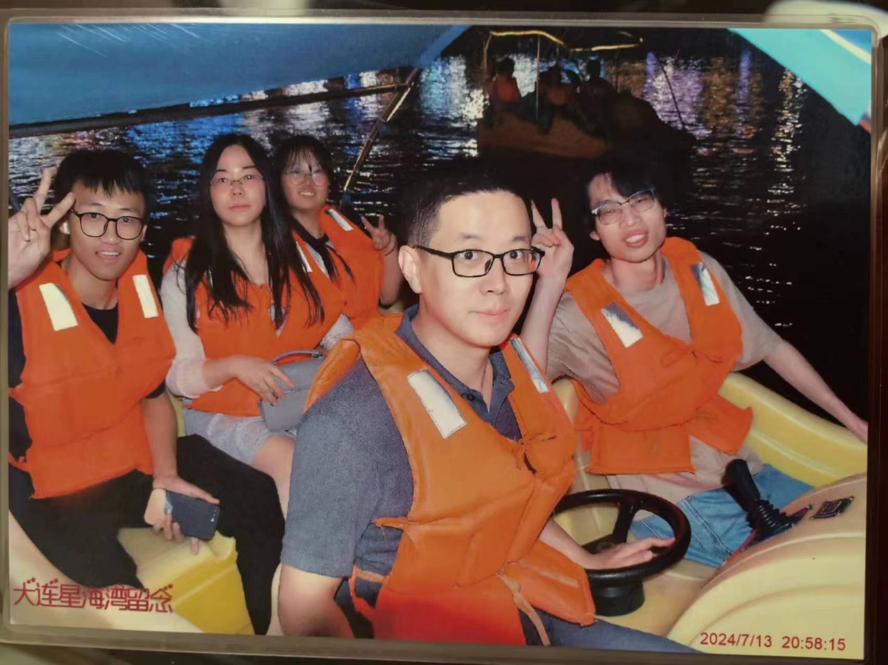*Driving a boat on the sea~~~***

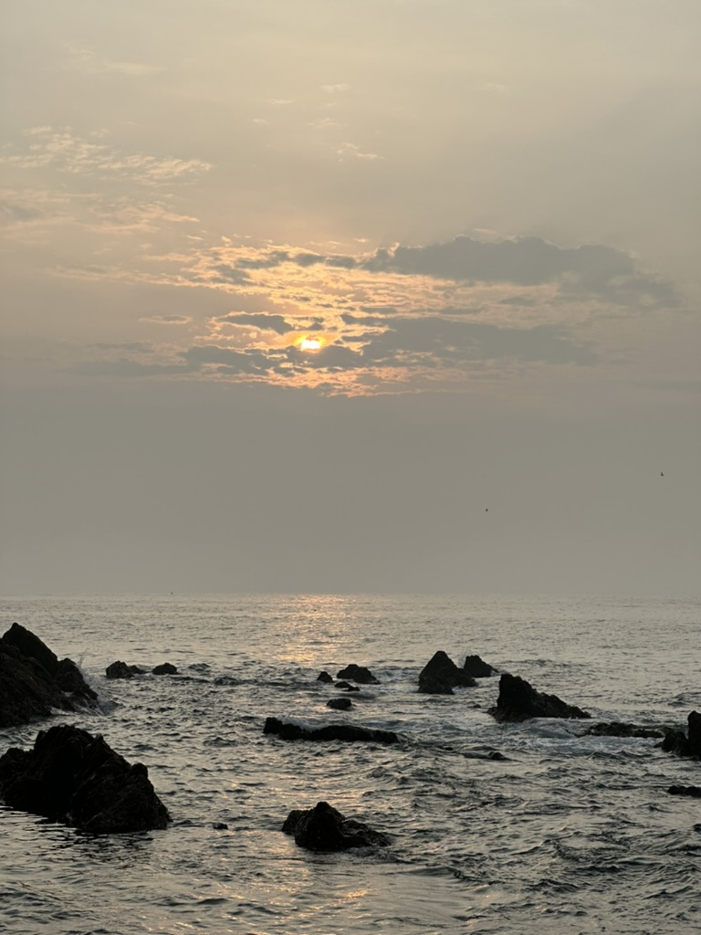

***Sunrise from the sea.***

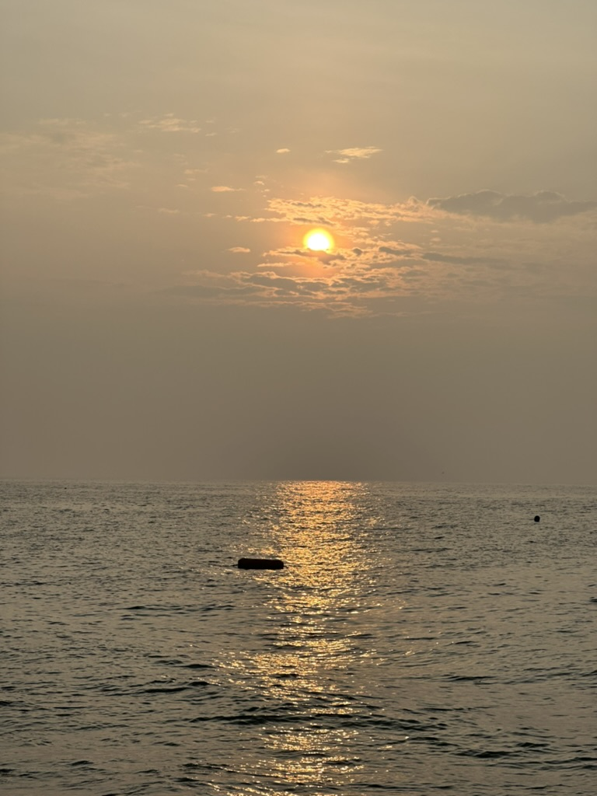

***Sunrise from the sea.***

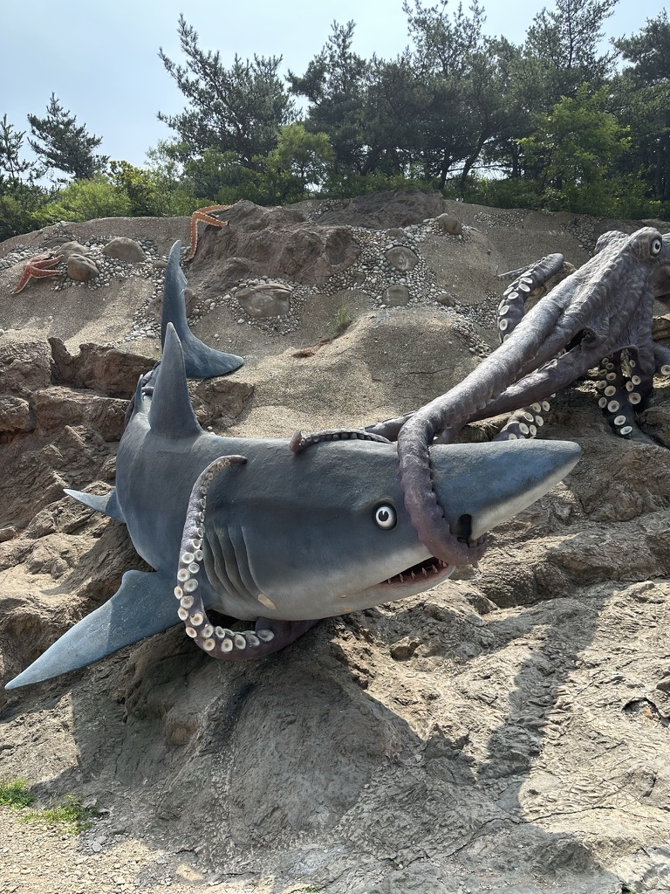

***A fight between SHARK and OCTPUS~~***