Flash Point UI Design

Group #1

The first thing that is included in our UI is the “Main Menu” which is the first menu players see when they run the game.

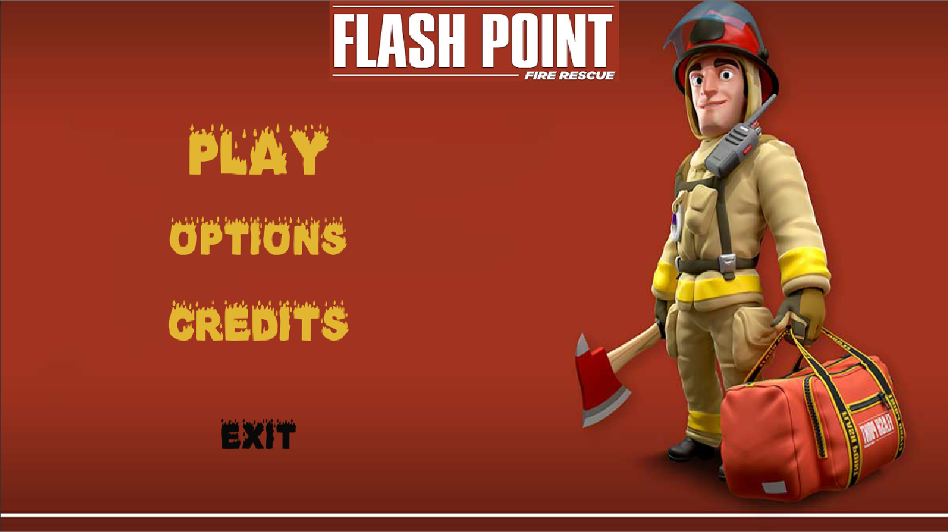

When player clicks on the button “Options” an option menu will show up for user to adjust their game settings.

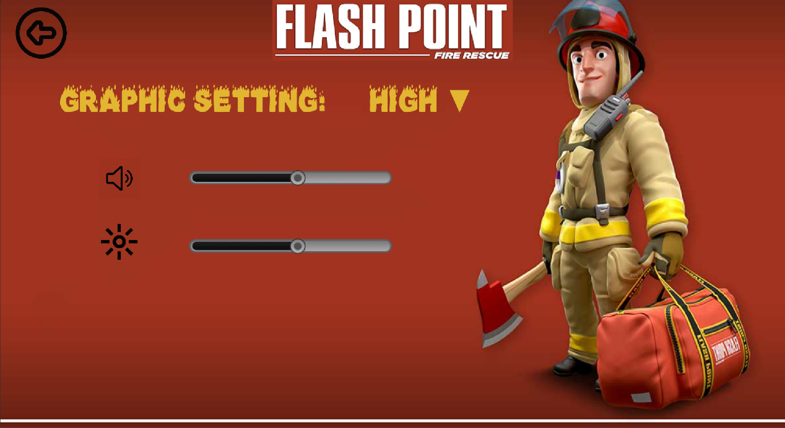

The graphic settings are in a drop-down field when the player clicks on the triangle next to current setting. The volume and brightness can be adjusted by tweaking the toggle bar. When the player clicks the back arrow on the top left corner, he/she will be take back to the “Main Menu”.

If the player clicks on the “credits” button on the main menu, a scrolling text will show up to indicate the author of this game and all helps the develops got.

When the player clicks on the “exit” button, the game exits.

When the player clicks the “play” button, a new menu will show up to help player to either create a new game or load previous game, or to join a game create by others.

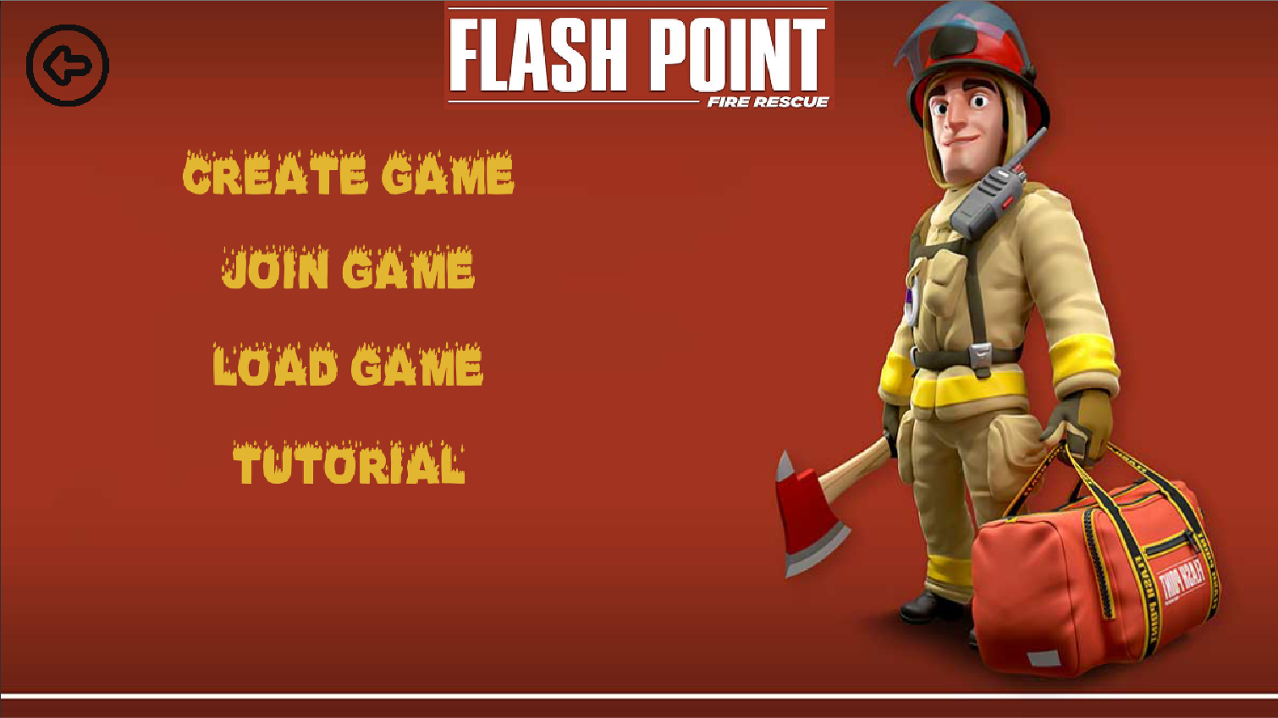

In this menu, when the player clicks on “tutorial”, a tutorial map will be automatically set up for the player to learn how to play the game. When “create game” button is clicked, the player will be taken to a game creating menu, where they can adjust all properties of their game. When the player clicks on “load game” button, the player will be directly loaded to “waiting for player to join screen” where the map and settings are of the previously saved game. When the player clicks on “join game” they will be taken to the server list where they can choose a game to join.

Here is the “create game” menu which the player gets here by clicking the “create game” button.

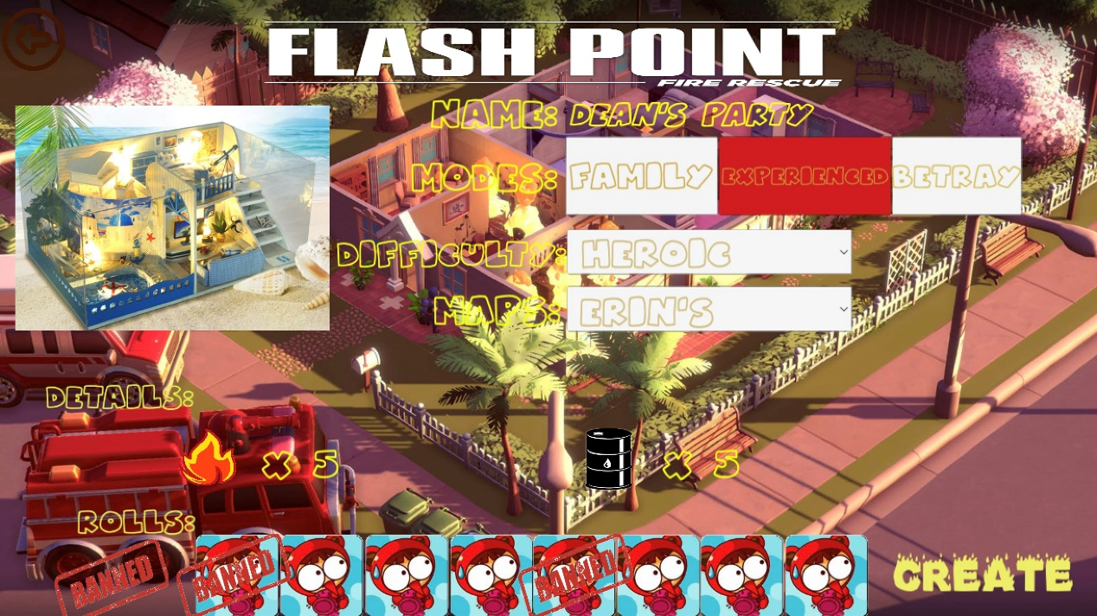

The picture to the left is showing a overview of the map the player is currently choosing, player can set all properties about the map including “game name”, “game modes” (we added a new mode where one of the players will be a criminal pretending to be a fire fighter, this is called betray mode), “difficulty”, “map (to choose a random generated map, the player can pick the random option in the drop down menu)”, “starting flames and hazmats”, and the game maker could even ban some roles that they don’t want in their game!

When player clicks “join game” button, they will be taken to below scene, where they can pick a desired game to join.

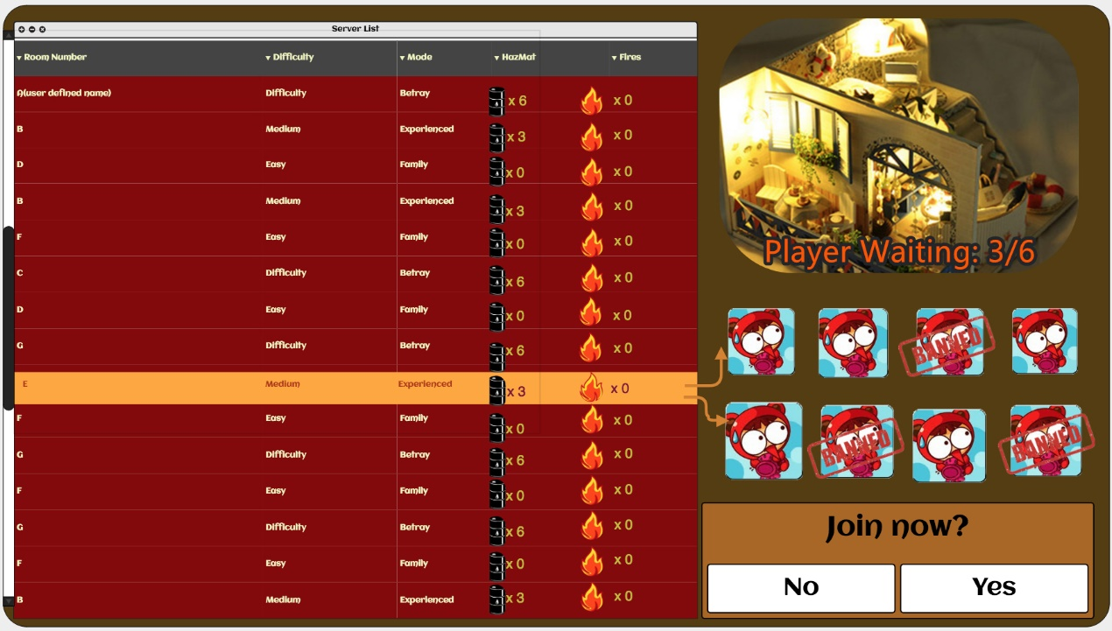

After the user press on one of the servers, they will not only see the difficulty and game settings, they will also see how many players are already in the room as well as which role is banned in this “game room”.

The below scene is when player creates a game or joins a game or load a previously saved game.

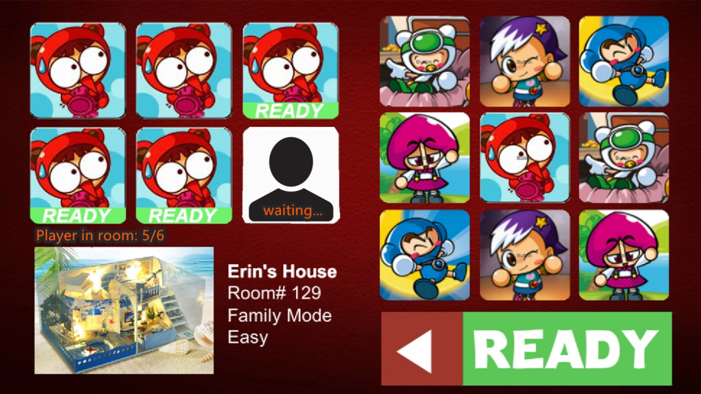

This scene is a waiting room where the player can pick their firefighter role (we will replace the role icons with more relevant art work later) and press “ready” to show that they are ready, when all players are ready, the game will start.

When the game starts, the in-game UI will be looking like this:

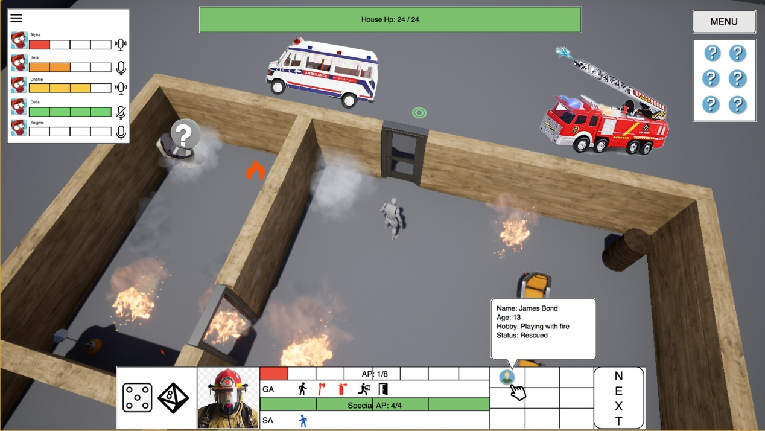

Though not showing in this picture, the floor is divided into grids that are used as coordinate of setting fire or to count down the player’s action point.

Here is the list of props and their meaning in the above picture:

* HazMat: the rusty barrel.
* Fire: the 3d flaming effect.
* Smoke: the 3d smoke effect.
* POI: the question mark on the top left corner of the house.
* Hot Spot: the 2d fire icon.
* Fire Engine and Ambulance: out side the house.

The below bar is the status bar showing the player’s status, which includes an action point bar, GA (general ability) bar that have the buttons that player can click to interact with the map, which includes walking, destroying wall, distinguish fire, carry victim, open and close door. The special AP bar only shows when the player has special AP for example “The Rescue Specialist” will have this bar to indicate his extra movement AP. The SA (special ability) bar is the bar showing the role’s special ability, if the special ability of this role is not a active ability, it will be shown as a icon but not a button (when hanging cursor over the icon descriptions of the ability will show up). The picture left to these bars are the player’s role icon. On the right, the nine grids are the player’s current inventory (which is also an extra feature we plan on adding to the game!) this inventory will show the victim the player is currently carrying or items the player currently has. When the player finishes his/her move, he/she can click on the “next” button and turn will be switched to next player. Also, at this time, the dice will roll, and a random position will be set on fire.

The top bar is showing the house’s stability, when it is empty, the house collapse.

The left box shows the status of all players (their remaining AP) and the player can also click on the “microphone” icon to mute rude players.

On the right is the POI field, whenever a player discovers a POI, one of it will be turned over.

If the player clicks the menu button, a in-game menu will show up like below image.

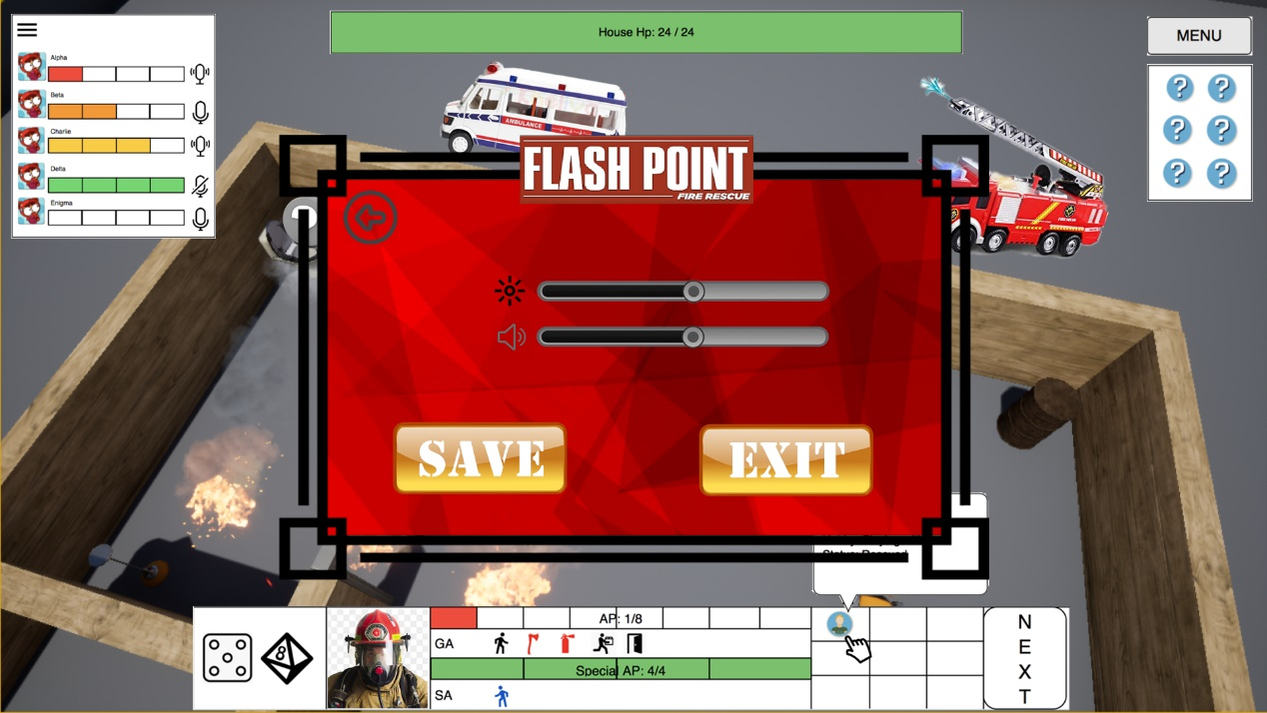

The player can adjust some of the basic settings like brightness and volume. They can also save the game and exit.