**Introduction**

This assignment makes use of data from a personal activity monitoring device. This device collects data at 5 minute intervals through out the day. The data consists of two months of data from an anonymous individual collected during the months of October and November, 2012 and include the number of steps taken in 5 minute intervals each day.

**Data**

The data for this assignment can be downloaded from the course web site: <https://d396qusza40orc.cloudfront.net/repdata%2Fdata%2Factivity.zip>

The variables included in this dataset are:

* steps: Number of steps taking in a 5-minute interval (missing values are coded as NA)
* date: The date on which the measurement was taken in YYYY-MM-DD format
* interval: Identifier for the 5-minute interval in which measurement was taken

The dataset is stored in a comma-separated-value (CSV) file and there are a total of 17,568 observations in this dataset.

**Data analysis**

**Loading and preprocessing the data**

The data loading is with: read.csv() function. Then changing to the data frame tbl form for further analysis:

**library**(dplyr)

## Attaching package: 'dplyr'

## The following objects are masked from 'package:stats':

## filter, lag

## The following objects are masked from 'package:base':

## intersect, setdiff, setequal, union

setwd("C:/my home/coursera/Data Science Specialization/Reproducible Research/assignments/assignment 1/report")

dat<-read.csv("../activity.csv")

tbl_dat<-tbl_df(dat)

rm(dat)

tbl_dat

## Source: local data frame [17,568 x 3]

## steps date interval

## 1 NA 2012-10-01 0

## 2 NA 2012-10-01 5

## 3 NA 2012-10-01 10

## 4 NA 2012-10-01 15

## 5 NA 2012-10-01 20

## 6 NA 2012-10-01 25

## 7 NA 2012-10-01 30

## 8 NA 2012-10-01 35

## 9 NA 2012-10-01 40

## 10 NA 2012-10-01 45

## .. ... ... ...

**What is mean total number of steps taken per day?**

* removing the NA steps rows from the data frame

rm_na<-filter(tbl_dat,!is.na(steps))

* Grouping the data set by date

by_date<-group_by(rm_na,date) *##%>%*

* getting and plotting the total steps taken per day

total<-summarize(by_date,total=sum(steps))

with(total,hist(total,10,col=date,

main="Frequency of the total steps in one day",

xlab="The total steps in one day"))

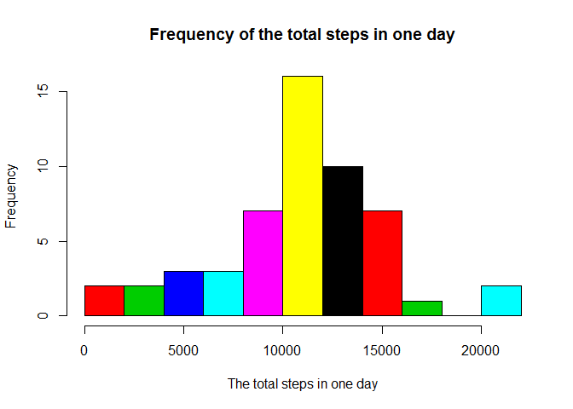

* Calculating the mean and median total number of steps taken per day

mean<-summarize(total,mean(total))

median<-summarize(total,quantile(total,probs=0.5))

So the mean total steps taken per is: 1.0766 × 104.

The median is: 1.0765 × 104.

**What is the average daily activity pattern?**

* group data by interval

by_int<-group_by(rm_na,interval)

* Average data by interval across all dates

mn_int<-summarize(by_int,steps=mean(steps))

* PLotting the time series sequence of average interval steps

**library**(ggplot2)

ggplot(data=mn_int,aes(x=interval,y=steps))+geom_line()+ xlab("Interval")+

ylab("Mean number of steps ")

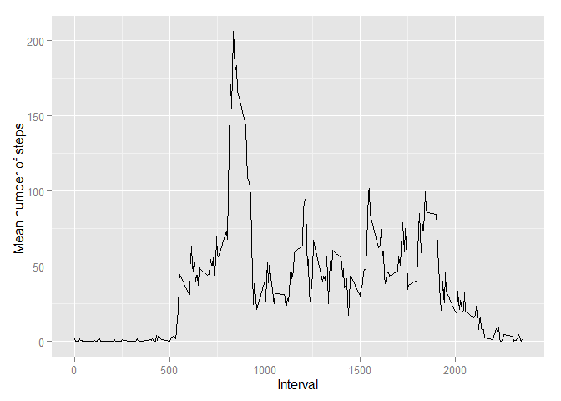

* Finding the maximum average steps interval

int_maxsteps<-mn_int[which(mn_int$steps==max(mn_int$steps)),]$interval

The maximum average steps taken interval is 835 to 840 minutes interval, which taken the 206.1698 stpes in that 5 minute interval.

**Imputing missing values**

The approach of fiiling the missing value is filling the missed steps interval as the average steps values of that interval.

The steps as:

* Finding the missing steps

na_steps<-is.na(tbl_dat$steps)

The total number of missing values in the dataset is sum(na_steps)

* Join mean interval steps across all days to the original dat set tbl_dat

join_tbl<-left_join(tbl_dat,mn_int,by="interval")

* Assigning the missing stpes field with the mean steps of that interval

join_tbl[na_steps,]$steps.x<-join_tbl[na_steps,]$steps.y

* Selecting the needed data set from the joined data set

filled_df<-select(join_tbl,steps=steps.x,date,interval)

* grouping the selected data set by date

filled_by_date<-group_by(filled_df,date)

* New total stpes taken per day

filled_total<-summarize(filled_by_date,total=sum(steps))

with(filled_total,hist(total,10,col=date,

main="Frequency of the total steps in one day",

xlab="The total steps in one day"))

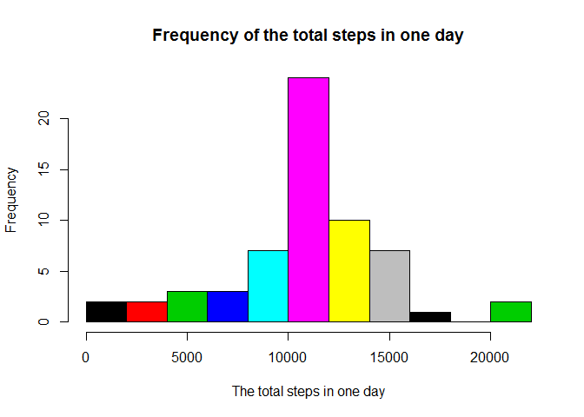

* New average and median total steps taken per day

filled_mean<-summarize(filled_total,mean(total))

filled_median<-summarize(filled_total,quantile(total,probs=0.5))

After filling the NA records, the new mean total steps taken per day become to: 1.0766 × 104.

The new median becomes to: 1.0766 × 104.

**Are there differences in activity patterns between weekdays and weekends**

* Loading the “lubridate” library

**library**(lubridate)

* Adding a new coloumn to filling data frame to indicate whether the date is the weekend

filled_df<-mutate(filled_df, weekend=factor(weekdays(ymd(date)) %in% c('Saturday','Sunday')))

* Group the new filled data frame by weekend and interval

filled_by_int_wk<-group_by(filled_df,weekend,interval)

* Calcating the average interval mean based on groups

filled_mn_int<-summarize(filled_by_int_wk,steps=mean(steps))

* Plotting the averge interval steps taken per day for the weekday and weekend individually

p_wday<-ggplot(data=subset(filled_mn_int,weekend==FALSE),aes(x=interval,y=steps))+geom_line()+

ggtitle("Weekday")+theme(axis.title = element_blank())

p_wend<-ggplot(data=subset(filled_mn_int,weekend==TRUE),aes(x=interval,y=steps))+geom_line()+

ggtitle("Weekend")+theme(axis.title = element_blank())

* Plotting two plot in one graph

**library**(gridExtra)

## Loading required package: grid

grid.arrange(p_wend,p_wday, ncol=1,sub="Interval",left="Number of steps")

