**附录一 译文**

第11届CIRP工业产品服务系统会议

基于微服务架构的中小企业制造云平台应用研究

周毅a， *，王梅林a 陈仁元b ，王阳帅b ，王娇b

a 广东工业大学信息工程学院

b 广东工业大学信息工程学院

*相应作者。 电话。 *+8618318881572；电子邮件[地址：1763562637@qq.com](mailto:1763562637@qq.com)

**摘要**

对于中小企业来说，智能制造执行是完善PSS的重要组成部分。中小企业的业务需求差异很大，系统的开发和维护面临着巨大的挑战。 然而，现有的制造执行系统无法快速响应业务重构的要求。针对当前中小企业制造执行系统的要求，随着企业在云制造中的发展，本文提出了一种基于微服务架构的中小企业制造云平台应用研究.. 在本研究中，我们介绍了平台微服务体系结构的设计和基于平台的业务系统的实现。 它可以解决传统单片架构的巨大应用造成的业务扩展和用户需求无法快速响应的问题。为业务系统的开发提供了有效的支持。

©2019年作者。 由Elsevier B.V.出版。

由第十一届工业产品服务系统CIRP会议科学委员会负责的同行评审

关键词：微服务框架；云平台；MES；中小企业；云制造

1. **导言**

智能制造是提高中小企业工业PSS的重要组成部分。 制造执行系统是智能制造生产现场管理解决方案.. 制造执行系统(MES) 是中小企业智能制造升级改造到“中国制造2025”的重要组成部分。 目前，制造执行系统技术研究需要大量的技术人员维护，同时对信息化建设成本要求高， 成本昂贵.. 因此， 它只适用于一些大型制造企业，而SMME难以实施。此外，市场上适合中小企业的MES系统平台很少。

在SSME中实施MES的主要问题概述如下：

1.不同企业之间MES业务模式存在较大差异；

2.企业内部业务流程动态配置不良；

3.企业信息技术人才的不足；

为了解决现阶段SSME信息系统建设中的上述问题，本 文采用微服务框架技术实现MES。

（1）微服务技术采用统一管理的服务注册、服务发现、消息总线、负载均衡等技术，可以快速实现MES系统业务模块的解耦和组合。 将高度耦合的集成系统应用程序划分为粒度较小的微服务业务模块.. 对于不同的企业业务系统，可以通过微服务系统组装解耦的微服务业务模块，使可以快速实现业务的实现和扩展。（2）微服务技术构建的小粒度业务模块具有特定的功能和有限的影响范围。 因此，根据SSME的业务需求，可以快速重构，大大降低 了业务重组的复杂性。 （3）微型服务业务模块可作为Docker映像部署。 快速部署Docker[9]可以实现云端的快速安装和实现，可以解决制造业技术人员短缺的问题..

**2.MES研究现状**

2.1云制造，微服务架构

中国制造信息化知名专家李伯虎提出了一种网络化服务制造新模式，将现有的网络化制造、云计算、服务型技术、高性能计算、物联网等相关技术结合起来。 他把这个模型命名为云制造。 [3]随着与2012年提出的软件隔离思想相似的微服务体系结构的概念，微服务理论不断完善，微服务开发人员的数量不断增加。 姜勇提出了基于微服务架构的基础设计[4]谭一鸣进行了基于微服务架构[5] 的高耦合平台服务框架的设计与实现.. 目前，微服务技术在各个领域的应用需求不断增加，出现了一些企业项目， 如制造业、电子商务等。[6]。

**2.2 SOA，可配置MES**

近年来，中国重庆大学刘伟宁制造实验室的研究团队 对制造业执行系统领域引入服务型技术进行了深入研究.. [1]。 西北工业大学制造技术团队张英峰通过结合新兴的物联网技术，提出了一种基于物联网技术的制造执行系 统。 [2][7]针对制造执行系统应用的多变性和复杂性，我国华中科技大学饶云清和周伟研究了装配车间可配置MES 系统，并通过工作流引擎[8]对过程模型的执行进行了指 导和控制。

**3.MES微服务框架**

3.1框架系统

本文建立了一个基于微服务框架的制造执行系统。 制造执行业务分为生产订单服务、过程管理服务、质量管理服务和生产过程服务。 利用微服务开发模型开发各种微服务模块.. 不同企业可以根据生产服务的要求，配置和部署相应的微服务模块，实现企业制造业务。 通过这种方式，企业可以实现个性化的生产要求。 系统总体架构如图所示：

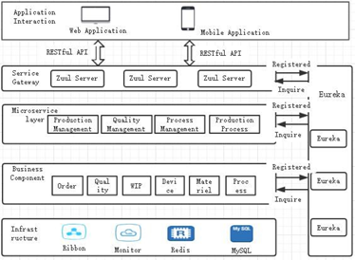

**图 1. 系统框架**

* 应用交互层

前后端分离技术用于实现制造执行系统在Web和移动 客户端上的业务操作。 通过微服务层的RESTful接口，可以相互调用服务..

* 微服务层.

微服务层由一些制造执行系统功能微服务组成，包括 生产管理微、质量管理、过程管理和生产过程微服务。 内置微服务技术，微服务层可以快速形成新型的微服务业务系统..

* 原子业务层

原子业务组件层部署MES系统的业务逻辑组件，如物 料，质量，设备，工艺管理组件中的工作等.. 微服务启动时，根据功能模式获取原子业务组件实现，通过各种原子服务完成微服务的组合..

* 基础设施层

该层主要为上层服务提供基础设施服务，包括微服务体系结构技术的一些功能组件， 以实现对微服务、Ribbon、Redis和数据库底层资源的监控。

3.2网关实现制造业务.

在微服务框架中，采用微服务网关技术实现制造执行 系统的微服务功能，微服务网关为客户端提供统一的请求入口，负责请求路由、服务组成和协议转换。 网关实现流程图如图所示 2

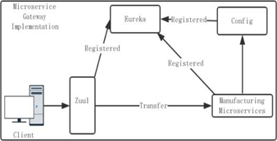

**图 2 微服务网关实现过程**

服务网关是系统的统一门户.. 注册中心提供统一的底层微服务API录入和注册管理.. 封装内部系统体系结构，并向客户端提供RESTAPI。 在启动过程中，微服务首先通过服务注册将其信息注册到服务注册中心.. 微服务客户端发送请求时，请求服务网关，然后服务网关读取请求数 据，从服务注册表中获取.. 相应的信息。 最后，服务网关调用相应的微服务。

**4.基于微服务架构的MES.**

4.1服务呼叫协议

在微服务架构下的制造执行系统中，每个微服务通过HTTP协议进行通信.. 生产订单服务，工程过程服务，订单调度服务，质量控制服务均通过请求参数实现信息传 递.. 这种消息传递方法难以保证整个制造执行系统中各微服务之间服务请求格式的一致性.. 指定基于HTTP协议的服务调用协议来封装服务请求信息，可以统一整个制造执行.. 系统中的每个微服务请求调用格式实现了服务使用者和服务发布者消息格式的统一。

当服务调用请求发生时，通过统一的协议将请求参数 承载的消息进行封装，实现服务之间请求调用的一致性， 这是保证服务调用一致性的关键.. 本节针对这个问题提出了一个服务请求协议(SRP)。 SRP描述目标服务和目标服务所需的参数信息。

通过不同的服务名称属性和参数属性，这些属性由JSON 数据表示。 使用SRP协议，可以向服务使用者提供封装目标服务和目标服务所需参数的请求实体。

该SRP协议是统一的服务请求和服务响应协议，是为实现服务请求信息和服务响应信息格式的一致性而定制的服务通信协议.. 主要由目标服务信息和目标服务所需的参数信息组成.. 这两个部分共同构成服务请求或响应的数据协议包。 为了实现与通用数据协议格式的一致性，SRP协议还包括头和主体。 该SRP协议的各种属性如下所示：.

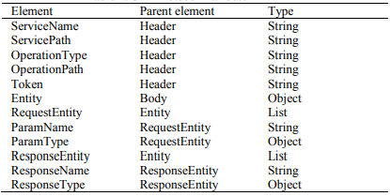

**图 3 SRP协议**

4.2生产业务流程实现.

在制造企业生产的总体过程中，主要的过程是接收采 购订单信息->订单发布->工艺路线->调度生产->生产执行->产品检验->产品报告。 在这个过程中，需要调用不同的服务模块来执行.. 基于微服务架构的MES系统是一个以服务为中心的车间制造信息管理系统，并根据MES的各个功能服务进行业务流程设计和优化。 例如，流程图金属制造执行系统的生产过程如下：

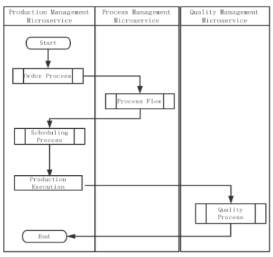

**图 4 生产工艺业务流程图**

生产管理是一种聚合服务。 它是一个暴露于客户端的边界服务。 它主要通过聚合订单服务来管理整个生产过程，流程服务、调度服务和质量检验服务。 前端订单请求到达GateAPI后，调用生产管理微服务.. 的.生产管理服务通过根据订单号调用订单服务提供的API接口生成生产订单。 生产管理服务调用流程服务，根据生产订单号和订单类型生成车间工艺.. 生成的店铺楼层流程修改确认后，可调用调度服务发布订单作业.. 车间操作员通过调度服务获得具体目标操作。 加工完成后，通过生产管理汇总上报质检信息.

⚫订购服务

订单服务主要负责生产制作订单的编辑。生产订单批次是企业订单生成后自动生成的吗从ERP系统中获得。之前的拆分操作作业在生产订单批中被释放。每一个批量生产的订单对应于一个独特的车间并对车间质量检验模板、及车间地板进行了分析车间质量检验模板对应的批次可以在生产指令作业之前编辑生产指令被释放。整个订单的接口信息服务内容如下：

表1. 订购服务

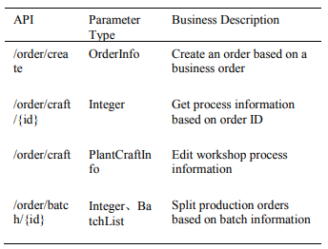

⚫ 流程服务

在流程管理业务中，首先从生产管理微应用中选择流程管理微服务和生产管理微服务来选择生产订单，通过标准流程库选择标准流程作为车间流程，在流程管理中选择每个订单批次。 制定工艺卡.. 工艺卡设置生产零件所需的一组工艺，包括所有可能的工艺。

表2 流程微服务接口业务描述

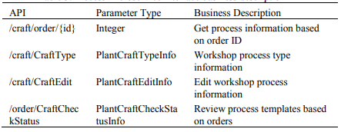

⚫ 优质服务

质量管理微服务按照标准对质量和业务流程进行控 制，为生产数据处理提供平台统计，分析和查询相关信 息，通过微服务架构API网关将质量报告信息反馈给生产 管理微服务。

表3 高质量微服务接口业务描述

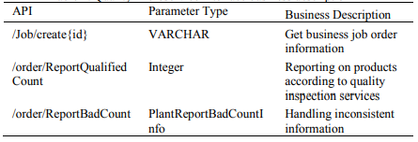

**5.结论**

本文研究并实施了应用研究基于微服务架构的SMME制造云平台，划分了SMME的业务功能将制造执行系统转化为各种微服务。建立制造执行系统业务通过微服务框架，每个业务模块都是一个可以独立部署和行的单元。和明确的模块之间的边界以消息驱动RESTAPI。为使中小企业业务多元化，微服务系统是用来装配解耦的微服务实现了服务模块的快速组装服务。对于内部业务流程的可变性，小粒度业务模块组件是由microservice技术。每个小粒度组件都有影响范围小，可实现快速内部业务流程的组合。的微观服务模块被部署为一个Docker镜像来快速实现云部署和微服务安装解决中小企业技术人才短缺。

**鸣谢**

这项工作得到了中国国家自然科学基金（编号）的支 持。 U1701266，没有。 第61372173号。 61671163)，广东省(2014B050502014，2017KCXTD011， 501130144,gdj2016004，2017b090901056，2018b030322016)，香港(编号。S/E/070/17)，广州(编号： 201802020007)

**参考文献**

[1] 大山E SA，霍斯尼T，萨利姆ABM.引用该报告.MRI脑图像分类的混合智能技术[J].[]数字信号处理，2010，20（2）：433-441.

[2] 引用该报告.洛克伍德·SA，米勒·AJ，克罗米·M.准备未来生物学系：研究生高级专业发展计划[J]，美国生物学教师，2014年.

[3] 格雷戈里·JK，LachmanN，C营地L，等.引用该报告.核心能力基础科学课程的重组：解剖学教学的一个例子[J].医学教师，2009，31（9）：855-861.

[4] 黄国，洪普，陈，等.引用该报告.Mindtool-Assisted In-Field Learning(MAIL)：台湾先进的泛素化学习项目[J].. 教育技术与社会，2014年，17（2）：4-16.

[5] 引用该报告.脚手架学生生成的问题：可定制在线学习系统的设计与开发[J.计算机在人类行为中的作用，2009，25（5）：1129-1138.

[6] 乌穆拉K，InagakiM，郑C，等.引用该报告.利用中心静脉压和组织多普勒三尖瓣/二尖瓣环速预测肺毛细血管楔压的新技术[J].心脏和血管，2014年.

**附录二 外文原文**

11th CIRP Conference on Industrial Product-Service Systems

Research on Application of SME Manufacturing Cloud Platform Based on Micro Service Architecture

Zhou Yi a,*,Wang Meilina, Chen RenYuanb,Wang YangShuaib, Wang Jiaob

aSchool of Information Engineering, Guangdong University of Technology, China

bSchool of Information Engineering, Guangdong University of Technology, China

* Corresponding author. Tel.: +8618318881572; E-mail [address:1763562637@qq.com](mailto:1763562637@qq.com)

**Abstract**

For SMEs, intelligent manufacturing execution is an important part of perfecting PSS. the business requirements of small and medium-sized manufacturing enterprises vary greatly, and system development and maintenance are facing enormous challenges. However, the existing manufacturing execution system can not quickly respond to the requirements of business reconfiguration. Aiming at the current requirements of manufacturing execution system of SME, and with the development of enterprise in cloud manufacturing, this paper proposes a manufacturing cloud platform application research for small and medium-sized manufacturing enterprises based on micro-service architecture. In this research we have introduced the design of platform's micro-service architecture and the implementation of platform-based business system. It can solve the problems of business expansion and user requirement cannot be quickly respond caused by the huge application of traditional monolithic architecture. It provides an effective support for the development of business systems.

© 2019 The Authors. Published by Elsevier B.V.

Peer-review under responsibility of the scientifi committee of the 11th CIRP Conference on Industrial Product-Service Systems

*Keywords:* Microservices Framework;Cloud Platform;MES ;SME ;Cloud Manufacturing

**1.Introduction**

Intelligent manufacturing is an important part of improving industrial PSS for SMEs. The manufacturing execution system is an intelligent manufacturing production site management solution.Manufacturing Execution System(MES) is an important part in the process of smart manufacturing upgrading and transformation of Small and Medium-sized Manufacturing Enterprises(SMME) to "made in China 2025". At present, the manufacturing execution system technology research needs a large number of technical personnel maintain, at the same time it requires high and expensive information construction costs. So it only applies to some large manufacturing enterprises, and difficult for SMME to implement. Also, there are few MES system platforms suitable for small and medium-sized enterprises in the market.

the main problems in the implementation of MES in SSME are summarized as follows:

* There is a big difference in MES business models between different enterprises.
* Poor dynamic configuration of business processes within the enterprise.
* The shortage of enterprise information technology talents.

In order to solve the above problems in the construction of information systems for SSME at this stage, this paper adopts the micro-service framework technology to implement MES.

(1) The micro-service technology adopts unified management of service registration, service discovery, message bus, load balancing and other technologies, which can realize decoupling and combination of the business modules of MES system quickly. The highly coupled integrated system applications are divided into micro-service business modules with small granularity. For different enterprise business systems, the decoupled micro-service business modules can be assembled through the micro-service system, so that the implementation and expansion of the business can be realized quickly. (2) The small-grained business module built by micro-service technology has the specific function and limited influence scope. Therefore, according to the business requirements of SSME it can be rapidly reconstructed, which greatly reducing the complexity of business restructuring. (3) The micro service business module can be deployed as a Docker image. The rapid deployment of Docker [9] can realize the rapid installation and implementation of the cloud, which can solve the problem of shortage of technical personnel in the manufacturing industry.

**2.MES research status**

* 1. **Cloud manufacturing, microservice architecture**

Li Bohu, a well-known Chinese expert on manufacturing informatization, proposes a new model of networked-oriented service manufacturing, which integrates existing networked manufacturing, cloud computing, service-oriented technology, high-performance computing, Internet of things and other related technologies. He named this model as cloud manufacturing. [3] With the concept of microservices architecture which is similar to the idea of software isolation proposed in 2012, the theory of micro services is constantly improving, and the number of developers of micro services is constantly increasing. Jiang Yong proposed the basic design based on micro-service architecture [4] Tan Yiming has carried out the design and implementation of high coupling platform service framework based on micro-service architecture [5]. At present, the application requirements of micro-service technology in various fields are increasing and some enterprise projects have emerged, such as manufacturing, e-commerce, etc. [6].

* 1. **SOA, configurable MES**

In recent years, the research team of Liu Weining's manufacturing laboratory at Chongqing University in China conducted in-depth research on the introduction of service- oriented technology in the field of manufacturing execution systems. [1]. Zhang Yingfeng, a manufacturing technology team of Northwestern Polytechnical University, proposed a manufacturing execution system based on the Internet of things technology by combining the emerging Internet of things technology. [2][7] Aiming at the variability and complexity of manufacturing execution system application, Rao Yunqing and Zhou Wei of Huazhong University of Science and Technology in China have studied the configurable MES system for assembly workshops, and guided and controlled the execution of process models through workflow engine [8].

**3.MES microservice framework**

* 1. **Framework system**

A manufacturing execution system based on microservice framework is built in this paper. Manufacturing execution

business is divided into production order service, process management service, quality management service and production process service. The micro-service development model is used to develop various micro-service modules. According to the requirements of production services, different enterprises can configure and deploy corresponding micro-service modules to implement the enterprise manufacturing business. By this way, the enterprise can achieve individualized production requirements. The overall architecture of the system is shown in the Fig.1

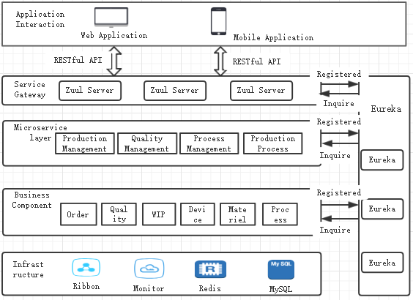

**Fig. 1. System Framework**

* Application interaction layer

The technology of separating the front and back ends is used to implement the business operations of the manufacturing execution system on the Web and mobile clients. Through the RESTful interface of the micro-service layer, the services can be called from each other.

* Microservice layer

The micro-service layer consists of some manufacturing execution system function micro-services, including production management micro, quality management, process management, and production process micro-services. Built with micro-service technology, the micro-service layer can quickly form a new micro-service business system.

* Atomic Business layer

The atomic business component layer deploys the business logic components of the MES system, such as materials, quality, equipment, work in process management components, and so on. When the microservice starts, the atomic business component implementation is obtained according to the functional mode, and the combination of the microservices is completed by various atomic services.

* Infrastructure layer

This layer mainly provides infrastructure services for upper-layer services, including some functional components of micro-service architecture technology to implement monitoring of micro-service services, Ribbon, Redis, and database underlying resources.

* 1. **Gateway implements manufacturing business**

In the micro-service framework, the micro-service function of the manufacturing execution system is implemented by adopting the micro-service gateway technology, and the micro-service gateway provides a unified request entry for the client and is responsible for request routing, service composition, and protocol conversion. The gateway implementation flow chart is shown in Fig.2

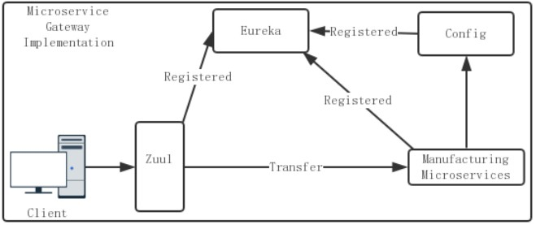

**Fig. 2. Microservice Gateway Implementation Process**

The service gateway is the unified portal of the system. The registration center provides a unified underlying microservice API entry and registration management. Encapsulates the internal system architecture and provides REST APIs to clients. During the startup process, the microservice first registers its information to the service registry through service registration. When the microservice client sends a request, it requests the service gateway, and then the service gateway reads the request data and obtains it from the service registry. Corresponding information. Finally, the service gateway calls the corresponding microservice.

**4.MES based on microservice architecture**

**4.1 Service call protocol**

In the manufacturing execution system under the micro- service architecture, each micro-service communicates through the HTTP protocol. The production order service, the engineering process service, the order scheduling service, and the quality control service all pass the request parameters to realize the information transmission. This kind of message delivery method is difficult to ensure the uniformity of the service request format between the microservices in the entire manufacturing execution system.A service call protocol based on the HTTP protocol is specified to encapsulate the service request information, which can unify the entire manufacturing execution. Each micro-service request invocation format in the system realizes the unification of the message format of the service consumer and the service publisher.

When the service invocation request occurs, the message carried by the request parameter is encapsulated by a unified protocol to achieve the consistency of the request call between the services, which is the key to ensure the consistency of the service call. This section proposes a Service Request Protocol (SRP) for this problem. The SRP describes the target service and the required parameter information of the target service through different service name attributes and parameter attributes, which are represented by JSON data. With the SRP protocol, a request entity that encapsulates the target service and the parameters required by the target service can be provided to the service consumer.

The SRP protocol is a unified service request and service response protocol, and is a service communication protocol customized to realize the consistency of service request information and service response information format. It mainly consists of the target service information and the parameter information required by the target service. These two parts together form a data protocol package for a service request or response. To achieve consistency with the common data protocol format, the SRP protocol also consists of a header and a body. The various attributes of the SRP protocol are shown in the following table:

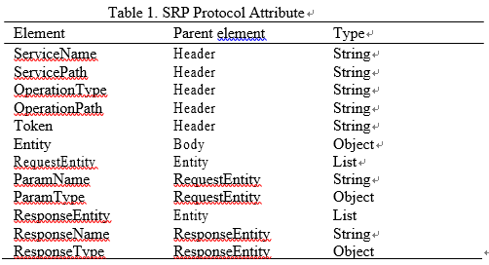

* 1. **Production business process realization**

In the overall process of production in a manufacturing enterprise, the main process is that receive the acquisition order information -> order release -> process route -> scheduling production -> production execution -> product inspection -> product report. In this process, different service modules need to be called to execute. MES system based on the micro-service architecture is a service-centered workshop manufacturing information management system, and the business process is designed and optimized according to each functional service of the MES. For example, the flow chart of the production process of metal MES is as follows:

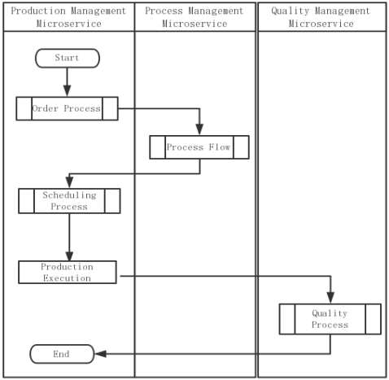

**Fig. 3. Production process business flow chart**

Production management is an aggregation service. It is a boundary service exposed to the client. It mainly manages the entire production process by aggregating order service, process service, scheduling service, and quality inspection service. After the front-end order request arrives at GateAPI, the production management micro-service is called. The production management service generates a production order by calling the API interface provided by the order service according to the order number. The production management service calls the process service to generate the shop floor process according to the production order number and the order type. After the generated shop floor process is modified and confirmed, the scheduling service can be called to release the order job. The workshop operator obtains the specific target operation through the scheduling service. After the processing is completed, the quality inspection information is reported through the production management aggregation service.

* Order Service

The order service is mainly responsible for the production and editing of the production order. A production order batch is automatically generated after the enterprise order is obtained from the ERP system. The split operation before the job is released is split in the production order batch. Each batch of production orders corresponds to a unique shop floor and shop quality inspection template, and the shop floor and shop quality inspection templates corresponding to the batch production order can be edited before the production order job is released. The interface information of the entire order service is as follows:

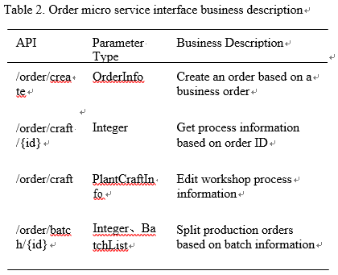

* Process Service

In the process management business, the process management micro-services and production management micro-services are first selected from the production management micro-applications to select the production orders, and the standard process is selected as the workshop process through the standard process library, and each order batch is selected in the process management. Develop a craft card. The process card sets the set of processes required to produce the part, including all possible processes.

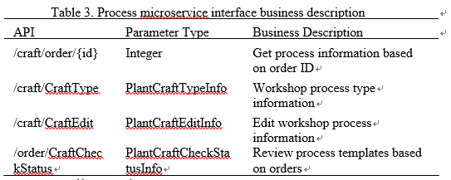

* + - Quality service

The quality management micro-service controls the quality and business process according to the criteria to provide platform statistics, analysis and query related information for production data processing, and feeds the quality report information to the production management micro-service through the micro-service architecture API Gateway.

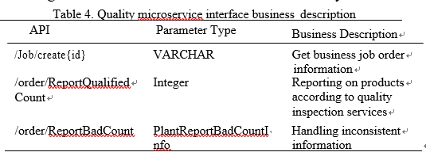

**5.Conlusion**

This paper studies and implements the application research of manufacturing cloud platform of SMME based on micro- service architecture, which divides the business functions of manufacturing execution system into various micro-services. Building the manufacturing execution system business through micro-service framework, each business module is a unit that can be deployed and run independently. And Clear boundaries are defined between modules in the form of message-driven RESTAPI . For the diversity of SME business, the microservice system is used to assemble the decoupled microservice service modules to achieve rapid assembly of services. For the variability of internal business processes, small - grained business module components are built by microservice technology. Each small - grained component has a small scope of influence and can realize the rapid combination of internal business processes. The micro-service module is deployed as a Docker image to quickly implement cloud deployment and installation of micro-services to solve the shortage of technical talents in SMEs.

**Acknowledgements**

This work is supported by the National Nature Science Foundation of China (no. U1701266, no. 61372173 and no. 61671163), the Guangdong Province (2014B050502014, 2017KCXTD011, 501130144, GDJ2016004,2017B090901056, 2018B030322016), Hong Kong (no.S/E/070/17), Guangzhou (No. 201802020007).

**References**

1. El-Dahshan E S A, Hosny T, Salem A B M. Hybrid intelligent techniques for MRI brain images classification[J]. Digital Signal Processing, 2010, 20(2): 433-441.
2. Lockwood S A, Miller A J, Cromie M M. Preparing Future Biology Faculty: An Advanced Professional Development Program for Graduate Students[J]. American Biology Teacher, 2014.
3. Gregory J K, Lachman N, Camp C L, et al. Restructuring a basic science course for core competencies: An example from anatomy teaching[J]. Medical teacher, 2009, 31(9): 855-861.
4. Hwang G, Hung P, Chen N, et al. Mindtool-Assisted In-Field Learning (MAIL): An Advanced Ubiquitous Learning Project in Taiwan[J]. Educational Technology & Society, 2014, 17(2):4-16.
5. Yu F Y. Scaffolding student-generated questions: Design and development of a customizable online learning system[J]. Computers in Human Behavior, 2009, 25(5): 1129-1138.
6. Uemura K, Inagaki M, Zheng C, et al. A novel technique to predict pulmonary capillary wedge pressure utilizing central venous pressure and tissue Doppler tricuspid/mitral annular velocities[J]. Heart & Vessels, 2014.