NYCU Pattern Recognition, Homework 2

**Deadline: April 6, 23:59**

**Part. 1, Coding (60%)**:

In this coding assignment, you are required to implement Fisher’s linear discriminant by using only [NumPy](https://numpy.org/), then train your model on the provided dataset, and evaluate the performance on testing data. Find the sample code and data on the GitHub page

<https://github.com/NCTU-VRDL/CS_AT0828/tree/main/HW2>

**Please note that only NumPy can be used to implement your model, you will get 0 point by calling sklearn.discriminant_analysis.LinearDiscriminantAnalysis.**

1. (5%) Compute the mean vectors $m_{i}$ (i=1, 2) of each 2 classes on **training data**

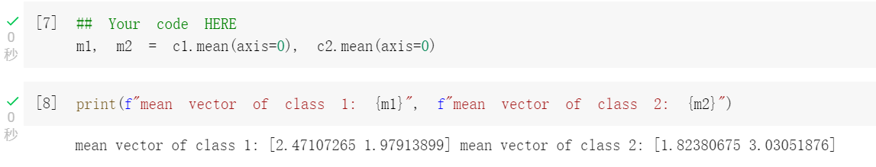

1. (5%) Compute the within-class scatter matrix $S_{W}$ on **training data**

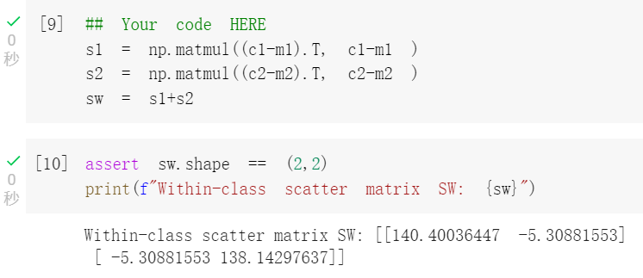

1. (5%) Compute the between-class scatter matrix $S_{B}$ on **training data**

1. (5%) Compute the Fisher’s linear discriminant $w$ on **training data**

1. (20%) Project the **testing data** by Fisher’s linear discriminant to get the class prediction by nearest-neighbor rule and calculate your accuracy score on **testing data** (you should get accuracy over 0.9)

1. (20%) Plot the **1)** **best** **projection line** on the **training data** and show the slope and intercept on the title *(you can choose any value of* ***intercept*** *for better visualization)*   
   **2)** **colorize the data** with each class **3)** project all data points on your projection line. Your result should look like the below image (This image is for reference, not the answer)



