NYCU Pattern Recognition, Homework 3

**Deadline: May 4, 23:59**

**Part. 1, Coding (80%)**:

In this coding assignment, you need to implement the Decision Tree, AdaBoost and Random Forest algorithm by using only NumPy, then train your implemented model by the provided dataset and test the performance with testing data. Find the sample code and data on the GitHub page

<https://github.com/NCTU-VRDL/CS_AT0828/tree/main/HW3>

**Please note that only NumPy can be used to implement your model, you will get no points by simply calling sklearn.tree.DecsionTreeClassifier.**

1. (5%) Gini Index or Entropy is often used for measuring the “best” splitting of the data. Please compute the Entropy and Gini Index of this array np.array([1,2,1,1,1,1,2,2,1,1,2]) by the formula below. (More details on [page 5 of the hw3 slides](https://docs.google.com/presentation/d/1kIe_-YZdemRMmr_3xDy-l0OS2EcLgDH7Uan14tlU5KE/edit#slide=id.gd542a5ff75_0_15), 1 and 2 represent class1 and class 2, respectively)

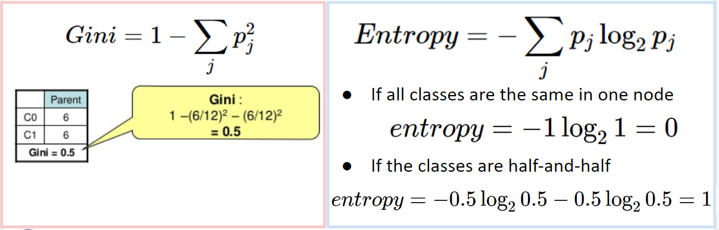

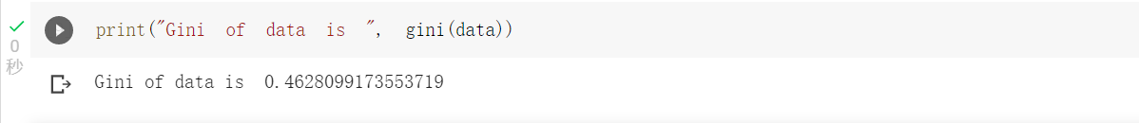

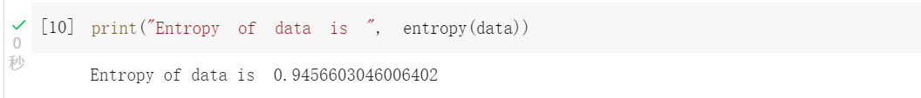

1. (10%) Implement the Decision Tree algorithm [(CART, Classification and Regression Trees)](https://scikit-learn.org/stable/modules/tree.html#tree-algorithms-id3-c4-5-c5-0-and-cart) and train the model by the given arguments, and print the accuracy score on the test data. You should implement **two arguments** for the Decision Tree algorithm, 1) **Criterion**: The function to measure the quality of a split. Your model should support “gini” for the Gini impurity and “entropy” for the information gain.   
   2) **Max_depth**: The maximum depth of the tree. If Max_depth=None, then nodes are expanded until all leaves are pure. Max_depth=1 equals split data once
   1. Using Criterion=‘gini’, showing the accuracy score of test data by Max_depth=3 and Max_depth=10, respectively.

* 1. Using Max_depth=3, showing the accuracy score of test data by Criterion=‘gini’ and Criterion=’entropy’, respectively.

*Note: Your decisition tree scores should over* ***0.7****. It may suffer from overfitting, if so,*

*you can tune the hyperparameter such as `max_depth`*

*Note: You should get the same results when re-building the model with the same  
 arguments,* ***no need to prune the trees***

*Note: You can find the best split threshold by both methods. First one: 1) Try N-1*

*threshold values, where the i-th threshold is the average of the i-th and (i+1)-th sorted*

*values. Second one: Use the unique sorted value of the feature as the threshold to split*

*Hint: You can use the recursive method to build the nodes*

1. (5%) Plot the [feature importance](https://sefiks.com/2020/04/06/feature-importance-in-decision-trees/) of your Decision Tree model. You can use the model from Question 2.1, max_depth=10. (You can use simply counting to get the feature importance instead of the formula in the reference, more details on the sample code. **Matplotlib** is allowed to be used)

Ans:

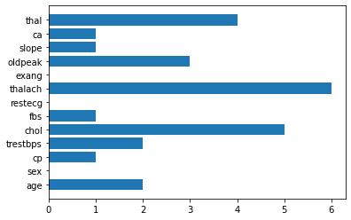

1. (15%) Implement the AdaBoost algorithm by using the CART you just implemented from question 2. You should implement **one argument** for the AdaBoost.   
   1) **N_estimators**: The number of trees in the forest.
   1. Showing the accuracy score of test data by n_estimators=10 and n_estimators=100, respectively.

1. (15%) Implement the Random Forest algorithm by using the CART you just implemented from question 2. You should implement **three arguments** for the Random Forest.  
   1) **N_estimators**: The number of trees in the forest.   
   2) **Max_features**: The number of features to consider when looking for the best split  
   3) **Bootstrap**: Whether bootstrap samples are used when building trees
   1. Using Criterion=‘gini’, Max_depth=None, Max_features=sqrt(n_features), Bootstrap=True**,** showing the accuracy score of test data by n_estimators=10 and n_estimators=100, respectively.

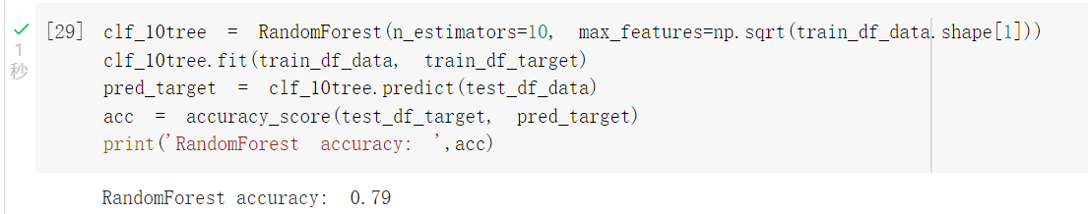

* 1. Using Criterion=‘gini’, Max_depth=None, N_estimators=10, Bootstrap=True**,** showing the accuracy score of test data by Max_features=sqrt(n_features) and Max_features=n_features, respectively.

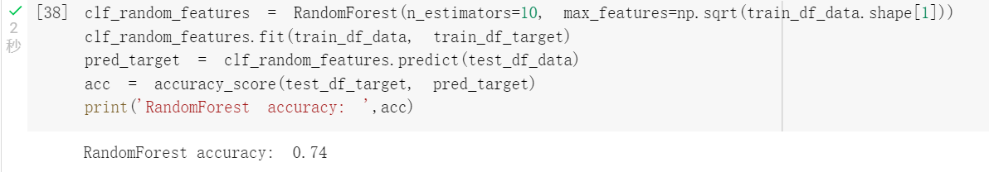

*Note: Use majority votes to get the final prediction, you may get different results when re-building the random forest model*

1. (30%) Tune the hyperparameter, perform feature engineering or implement more powerful ensemble methods to get a higher accuracy score. Screenshot your tests score on the report. Please note that only the ensemble method can be used. The neural network method is not allowed.

|  |  |
| --- | --- |
| **Accuracy** | **Your scores** |
| **acc > 0.85** | **30 points** |
| **0.8 < acc <= 0.85** | **25 points** |
| **0.7 < acc <= 0.8** | **20 points** |
| **acc < 0.7** | **0 points** |

