OS HW4 report

Name: 周孟謙

Student ID: 0816028

Q1:

Compare results between hw4_1_1 with/without synchronization.

With:

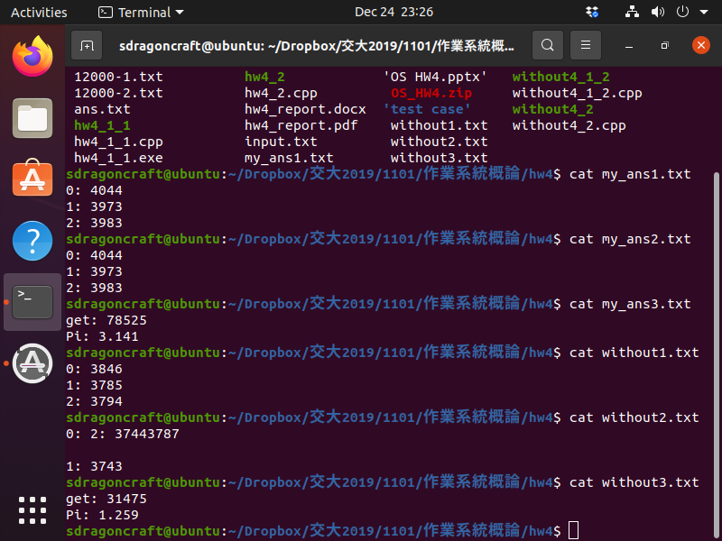

Without:



因為race condition導致counts的數量沒鎖會比有鎖還要少

Q2:

Compare results between hw4_1_2 with/without synchronization.

With:



Without:



因為race condition導致counts的數量沒鎖會比有鎖還要少，並且輸出順序不依定會依照012，甚至交錯

Q3:

Compare results between hw4_2 with/without synchronization.

With:



Without:



因為race condition導致get的數量沒鎖會比有鎖還要少，並因此算出的pi也一樣較小

Q4:

Some problems you meet and how to resolve.  
or some Reflections.

原本以為是鎖失效或沒鎖到，但其實是傳給pthread的begin和end給錯，改完後便解決了問題。