Generate observed image 1
Bilateral filtering. 1

Generate observed image
clear all;
close all;
I=double(imread('flowers.bmp'))/255;
I=mean(I,3);
sizeI=size(I);
u=I+0.1*randn(sizeI);
figure; imshow(u);title('Noisy observed image');
% Denoise
w=3;
sigma_s=1;
sigma_i=2;
size_I_noisy=size(u);
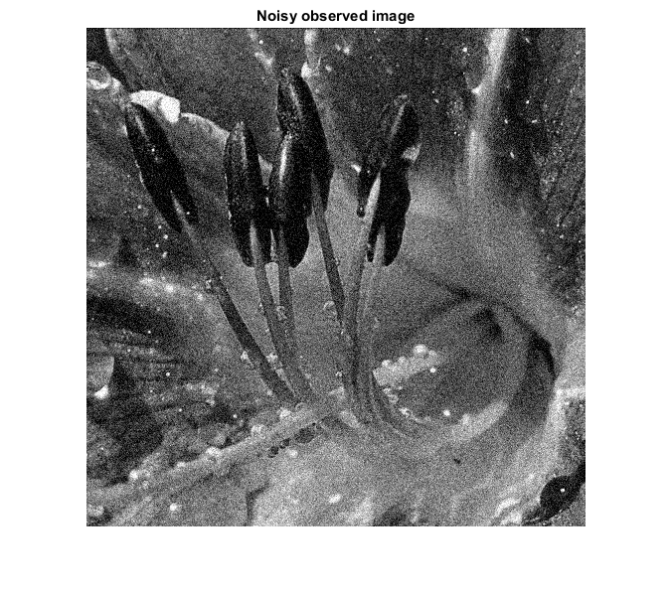

Bilateral filtering.
Pre-compute Gaussian distance weights. Step1.
spatial_weights=zeros(2*w+1,2*w+1);
for x_1=1:2*w+1
for x_2=1:2*w+1
puissance = -((x_1 - w - 1)^2 + (x_2 - w - 1)^2)/(2*sigma_s);
spatial_weights(x_1,x_2) = exp(puissance);
end;
end;
% Step2.
I_denoised = u;
for p_1 = w+1 : size_I_noisy(1)-w
for p_2 = w+1 : size_I_noisy(2)-w
square = u(p_1-w :p_1+w, p_2-w:p_2 + w);
puissance = -(square - u(p_1,p_2) * ones(2*w+1, 2*w+1)).^2/(2*sigma_i);
u_denoise = square .* spatial_weights .* exp(puissance);
C = spatial_weights .* exp(puissance);
I_denoised(p_1,p_2) = sum( u_denoise(:)) / sum(C(:));
end;
end;
figure;imshow(I_denoised);title('Denoised image');
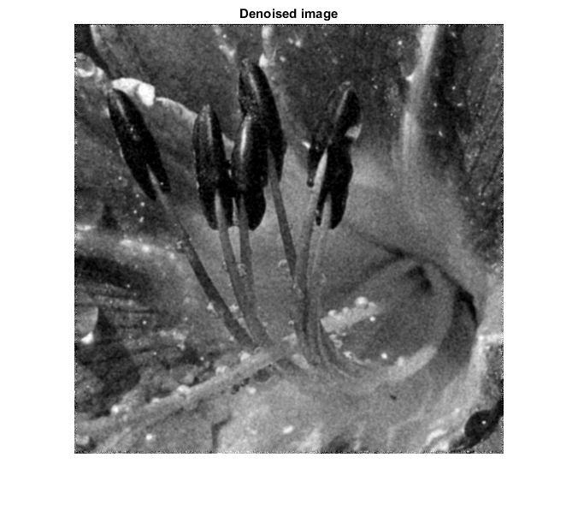
Published with MATLAB?R2015a

