1：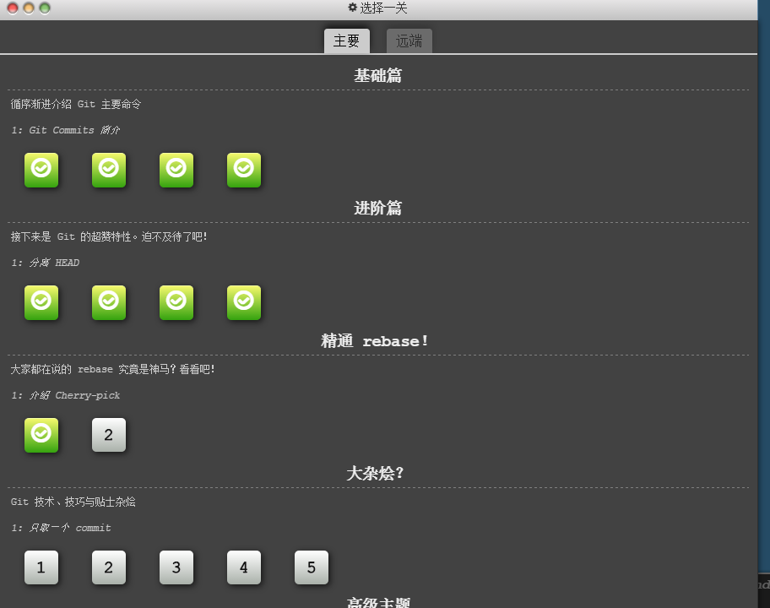

2: nmp地址

https://www.npmjs.com/package/homwork311