**Title of the final project proposal**

**Author**

*date*

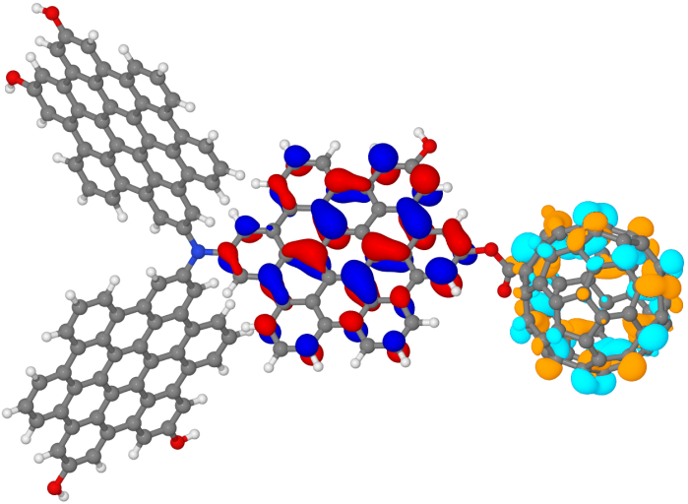 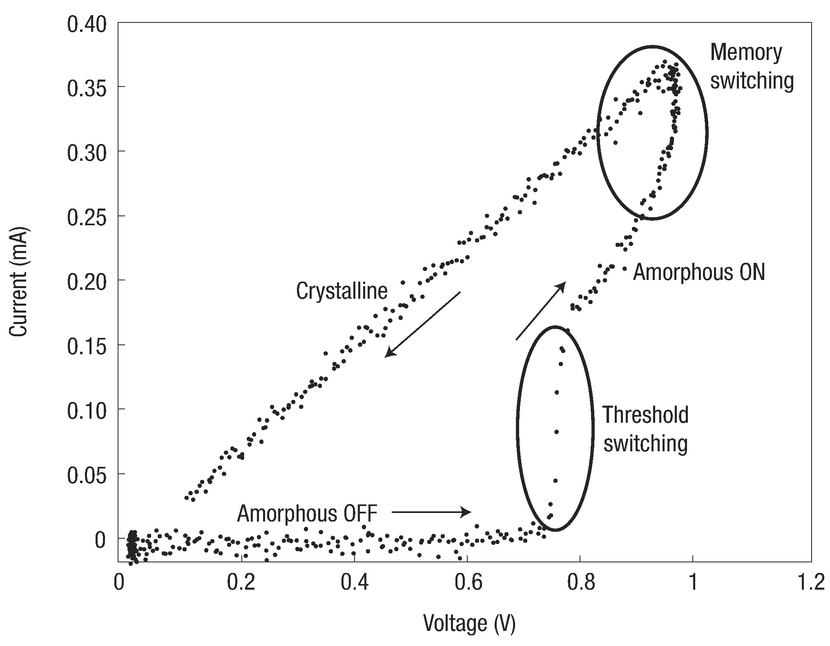

Figure. It is optional. (Left) Molecular orbitals of donor and acceptor. (Right) Phase change memory working principle.

## Goals and Objectives

Briefly describe the essence of the project. Give motivation and explain significance of the work. Describe the ultimate goal of the project and list major objectives.

## State of the art

Provide the minimum required background to understand the project. Describe state of the art in the research field you are going to innovate, including major open problems you would like to solve.

## Proposed Approach

Briefly describe the approach you will use to solve the problem. This should be a high-level description. Emphasize novelty of your approach. Prove that the stated objectives are achievable. Describe risk management.

## Work plan

Briefly describe your project plan partitioning it into milestones if needed. List the expected deliverables that you propose to achieve within the proposed time line of the project and at the end of the project.

## Resources

Prove that your research background and qualification are appropriate for the project. Describe preliminary results if any. What resources are required and available for the project.

## Expected outcome and potential impact, deliverables

Provide the most accurate estimate for the expected outcome (educational outcome is also counted). Be specific with deliverables. What is potential impact of your results.

## References

[Yan15] H Yan, C Chuang, A Zhugayevych, S Tretiak, F W Dahlquist, G C Bazan, Inter-aromatic distances in Geobacter sulfurreducens pili relevant to biofilm charge transport, Adv Mater 27, 1908 (2015)

[Nel14] T Nelson, S Fernandez-Alberti, A E Roitberg, S Tretiak, Nonadiabatic Excited-State Molecular Dynamics: Modeling Photophysics in Organic Conjugated Materials, Acc Chem Res 47, 1155 (2014)

[Zhu15] A Zhugayevych, S Tretiak, Theoretical Description of Structural and Electronic Properties of Organic Photovoltaic Materials, Annu Rev Phys Chem 66, 305 (2015)