

Report Name

Team project 2 report

John Doe, Ivan Ivanov | Survey of Materials | Date

# Introduction

In this part, as in the presentation, you need to give an overview of the problem you consider.

## State of the art

Describe current achievements and findings in the field. Again, to pretend for scientific level of your narrative, give references. For a review, you might need 5 - 10 references per page. If you want to manage your references easily, use Word’s References-> Insert citation [1]. Preferably, use IEEE or similar style. Of course, you can use external bibliography programs like Mendeley, Bibtex etc.

## Our Motivation

Tell about your goal or assignment description, why and how you are going to approach the problem or why making this review is important.

# Results and Discussion

What is needed in this section is to have a story (not just unconnected facts) which is based on your figures and tables. More on this approach is in the [Whiteside’s group paper](http://www.ee.ucr.edu/~rlake/Whitesides_writing_res_paper.pdf) [2]. In the case of a review, focus on presenting all the gathered data in the most compact and meaningful way.

Good example

If we look at the hierarchy of types of memory cells (picture below), we can see that there is a trend in building more complex structures in order to improve the quality characteristics of memory cells from “one transistor” architecture up to “one transistor NOR” and “one transistor NAND", although one of the oldest yet functional architecture of memory cells is scalable crossbar massive. Phase change materials can be implemented on many different levels starting from structural (“no-transistor PCM”) all the way to passive usage of the material for selective heating and/or cooling of memory cell parts. Other than pure PCM, crossbar cell structure can be used in combined technology, applying different principles of storing information and computing.

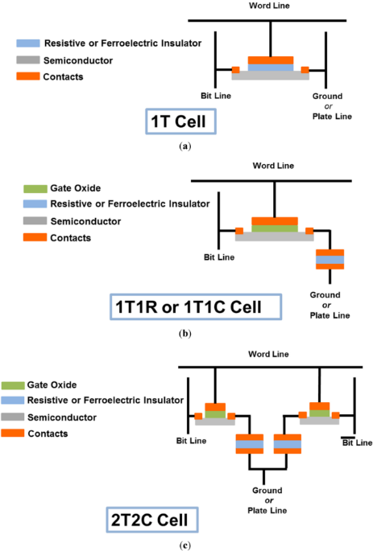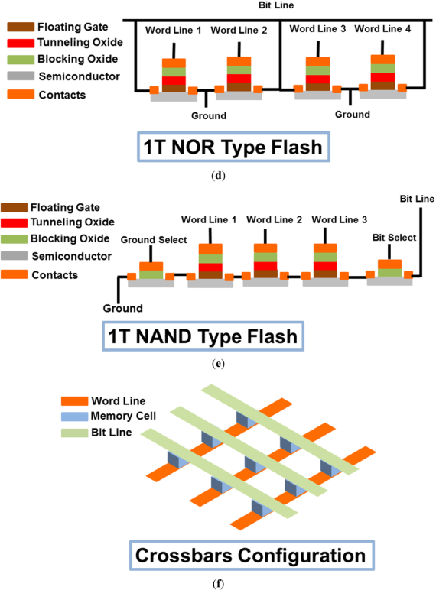

* Good illustrative picture, a story around it, and a trend catched.

# Conclusions

What we found and how we can support our thoughts from Motivation section.

Good example:  
To conclude, many possible architectures of PCM have been discovered since 1999, but yet not a single architecture has made it to the wide market (except for spread then withdrawn Micron’s 128 Mb P8P P-PCM during 2012-2014). The main expectations of a paradigm shift since 1950s Harvard architecture of computers now are Intel’s 3D XPoint PRAM and HP Memristor-based memory+logics architecture. Public announces of both technologies is scheduled on early 2016. *– what we reviewed/ discovered and what is the perspective*

Bad example:

The most important lesson from this report is probably this one: there is a universe of 2D crystals out there just awaiting to be studied. And of course each one of them has its own beauty and purpose. *– this is not meaningful, no real conclusions*

# Contributions

Ivan Ivanov – presentation, tables, figures

John Doe – report assembly, conclusions and takeaways

Bad Guy – no input

# References

|  |  |
| --- | --- |
| [1] | Microsoft, "How to make Bibliografy," 2016. [Online]. Available: https://support.office.com/en-us/article/Create-a-bibliography-3403c027-96c8-40d3-a386-bfd5c413ddbb. |
| [2] | Whiteside, "How to write a scientific paper," *Adv. Mater,* vol. 15, no. 16, 2004. |