公司名称：香港垣盛有限公司 HONG KONG WINSUN CO., LIMITED
公司地址：FLATRM 17, BLK A, 9F, ON DAK IND BUILDING, 2-6 WAHSING STREET, KWAI CHUNG
HONG KONG
邮箱:（待申请）
WhatsApp:19878866771，13926790536
公司logo：
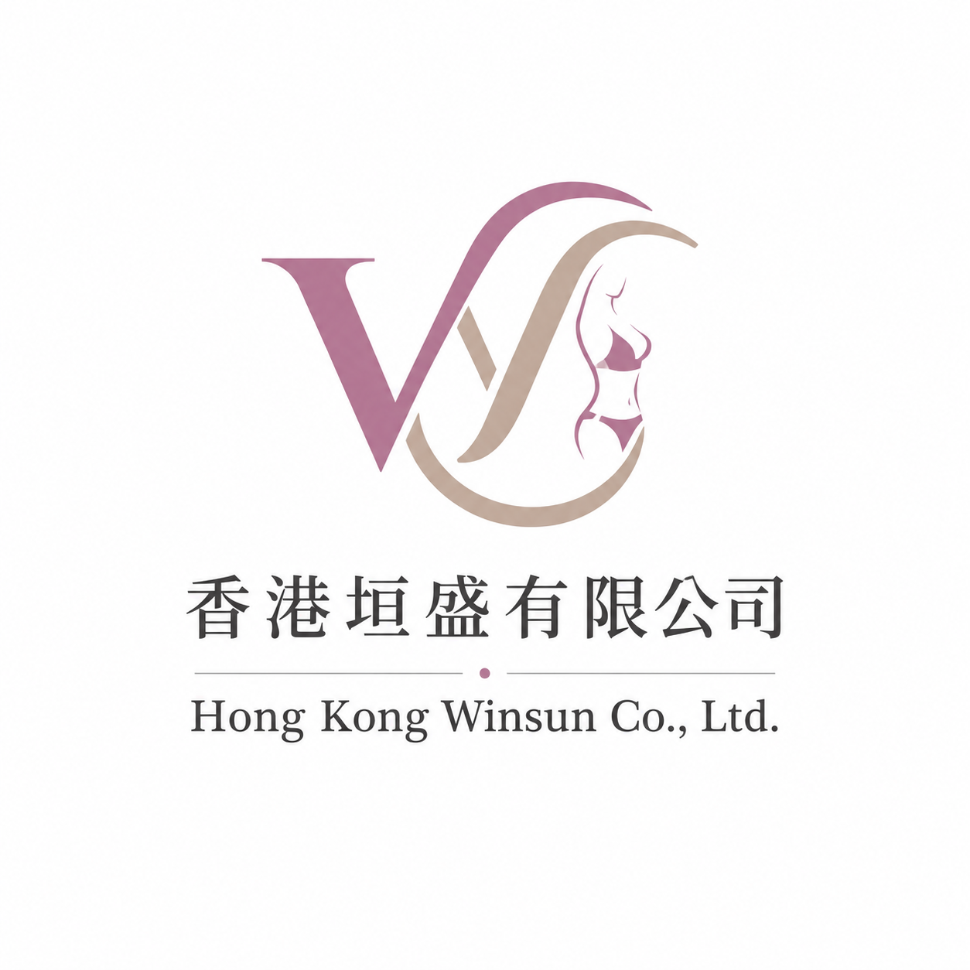

介绍
About us

Hong Kong Winsun Co., Ltd. was established in 2015 and specializes in the development, manufacturing, and export of knitted apparel and underwear products. With the continuous expansion of international business, the company has recently established its foreign trade department in Hong Kong to provide more professional and efficient one-stop sourcing services for global clients.

Our main product categories include:
• Knitted underwear
• Bras
• Panties
• Shapewear
• Thermal wear
• Loungewear and related knitted products

We focus on product quality, comfort, modern design, and market trends. Our products are exported to Russia, Europe, and many overseas markets, earning trust and long-term cooperation from customers worldwide.

With a mature production system and extensive industry experience, we provide:
• OEM manufacturing
• ODM customization
• Sample-based production
• Customized packaging
• Fast sampling and stable delivery

Supported by a professional team and reliable supply chain resources, Hong Kong Winsun Co., Ltd. is committed to offering cost-effective and competitive product solutions tailored to different market needs.

We look forward to building long-term and mutually beneficial partnerships with clients around the world.
服务器：Hostinger域名服务器
域名：winsun hk.com （namecheap注册的）

