Compilation

The procedure setting up the compile procedure has already been completed in the MESMER folder mesmer.xcodeproj under the root folder. This document is only for reference. I have to say that the procedure is not very straight forward and can spend several hours in order to figure out.

1. Create a new project and make xcode project file located in the root folder of the project. Doing this is mainly because if you place the project file in a subfolder, the SCM functionality may not take anything above one level of the folder location into account. I have no idea how XCode deal with the SCM files, so I set the project file in the root folder. To create a project, select 'File->New Project' from XCode menu bar. Create the new project using 'Standard Tool'. Create the project under where you will place your MESMER folder and name it the same as your mesmer folder. For example, if you place your mesmer folder 'mesmer' in '/code' folder, you create your project under 'code' folder and name it 'mesmer'. The project name will be 'mesmer' and be created inside '/code/mesmer' folder. After creating this project, delete two links 'main.c' and 'main.1' inside the mesmer target and also trash them. I have no idea what is the point of leaving this two files inside the target, as we have already got our own main.cpp file.
2. As we need to have qd configured before compilation, we need to create a target named 'qdconfigure'. Click 'Project->New Target' and select 'Shell Script Target'. Name the target as 'qdconfigure', and click open the triangle of the target, you will see a item called 'Run script'. Double click 'Run Script' to open it up and enter the following lines in the 'Script' box.
# shell script goes here
cd qd
chmod 755 configure
./configure
exit 0
Now you can close the 'Run Script' window and build 'qdconfigure'.
3. As both qd and tinyxml targets are linked libraries of MESMER, we need to make them either dynamic library or static libraries. Here I set them both be dynamic libraries. Click on 'Project -> New Target' and find dynamic libraries under BSD. (I am not sure whether choosing BSD is correct or not, but it works. I think this is because the platform is BSD architecture so and so.) Name the target as qd, and continue to add the target. Double click qd target to open 'Target qd info'; you will find there are four tabs. In there 'General' tab add the direct dependency of qd target to the qdconfigure target. This is because if qd is not configured platform dependently, it cannot be compiled. Once this step is performed, it will not be performed again.
4. Now close the 'qd Target Info' window, click on the qd triangle in 'Targets' to open up the triangle. You should see a dependent target called qdconfigure, and three additional items 'Copy Headers', 'Compiles Sources', 'Link Binary with Libraries' inside the qd target. Right click on qd target and click 'Add->Existing Files' to add the qd files into the qd target. In here, add the full qd folder into the qd target, XCode should understand which files to be added into which items. You should see header files are added into 'Copy Headers', and some source files are added into 'Compiles Sources'. However, not all sources are required now so we need to do some trimming; take away all Makefile's and main.c from 'Compiles Sources'. After completing this step, you should be able to build the qd target.
5. Making the tinyxml target is pretty much the same as the procedure making the qd target. Add the existing files inside tinyxml folder to target tinyxml. Be sure to remove the 'Makefile' from 'Compiles Sources' or you will see a non-fatal complaint from the compiler. The difference is, the name of tinyxml library is too long by the default setting of XCode. It tends to set the name as libtinyxml.a. We need to correct this to make MESMER recognise it. Open up the Info of target tinyxml, in 'Build' tab, find 'Executable Prefix' under 'Packaging' and remove the content 'lib'. Also, find 'Preprocessor Macros' in 'GCC 4.2 - Preprocessing' and add 'TIXML_USE_STL' to it (this step is essential for the compilation of the main target mesmer). Now you should be able to build target tinyxml.
6. For mesmer target, the procedure is the same on adding the source code to the target. Be sure to remove Makefile from the source. To complete the mesmer target after creating the qd and tinyxml target, right click on mesmer target to open up the Info. In General tab, add the dependency of mesmer target to qd and tinyxml targets. Also, add libqd.a and tinyxml.a to 'Linked Libraries'. The final step here, is to find 'Preprocessor Macros' in 'GCC 4.2 - Preprocessing' and add 'TIXML_USE_STL' to it. This sets the flag for the preprocessor. After all, you should be able to compile the whole project.
Debugging
7. To debug the code under XCode, we need to set the arguments for the executable. To do this, open up the triangle of the Executable and right click on the executable mesmer. Set the Argument to the full file path you are about the test. In addition, give 'Variables to be set in the environment' a variable 'MESMER_DIR' and give the path of the current MESMER to it. For example, one can set the argument to
-N $MESMER_DIR/MesmerQA/pentyl/pentyl_isomerization_test.xml
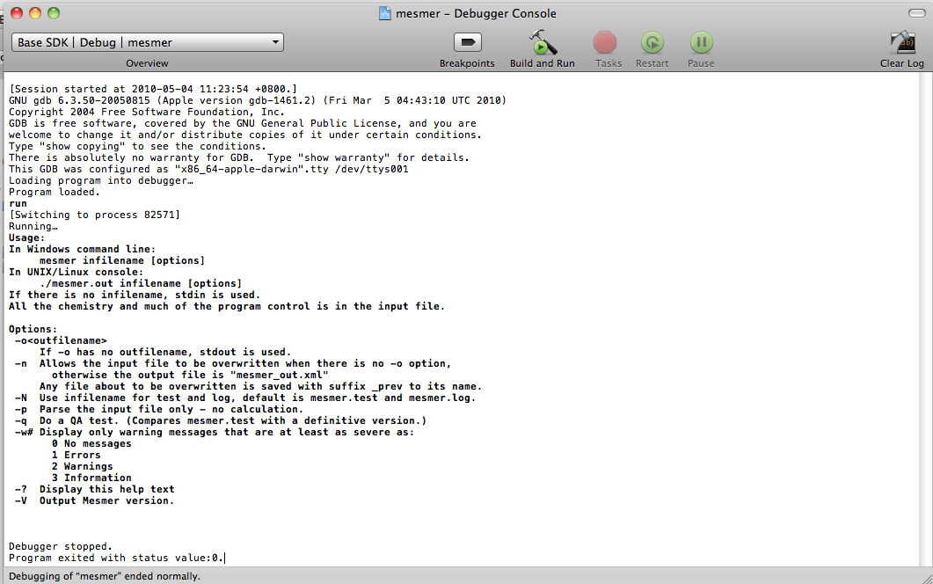
If the argument is not set, the user will see the above screen if hit 'Build and Run'.
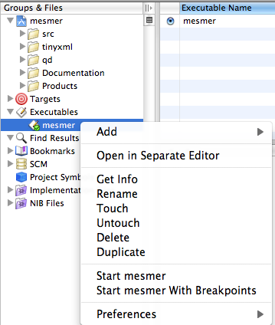
Edit the argument by selecting the 'Get Info' option while right clicking on the mesmer executable.
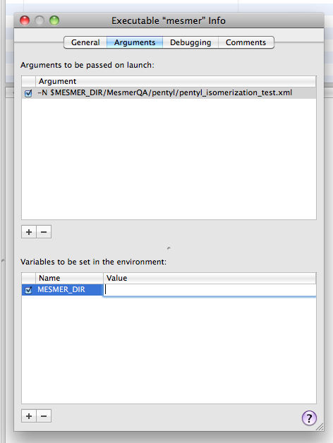
Fill in MESMER_DIR according to your mesmer folder location as above. Please note that you can enter as many arguments as possible for convenience, but only one maybe active for each instances. Here is an example:
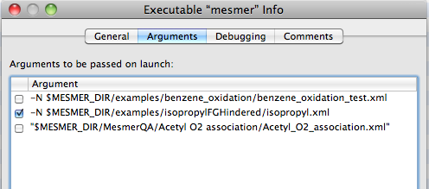
Set a breakpoint somewhere in the code and run you shall be able to see screen as below.
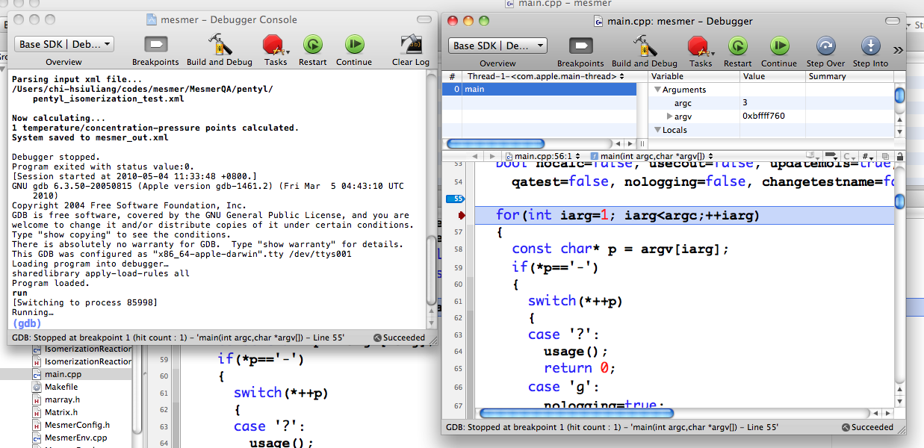
Using XCode SCM functionalities
There are many ways checking out a project in XCode. As we have already got a project file created for XCode, we do not need to create a new project, neither can we open up a existing project because we have not got a checked out version of MESMER. So, when open up XCode, it will prompt a box to ask you create a project or open an existing project, simply click cancel to close the box. Then, click on 'SCM' on the XCode menu bar as below.
Click repositories, and click 'Configure' to enter repository information like the following picture. Please note that the mosaic parts are places for your username.
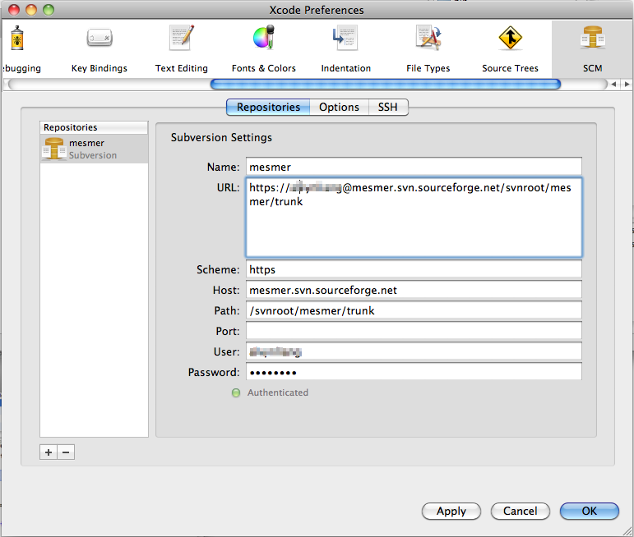
After doing so, you shall be able to check out MESMER into your computer. If you ever modify a file and wish to see a SCM response for your modification, click 'SCM->Refresh Entire Project'.
I will leave the rest for you to explore. Thanks for your attention.

