Object detection with YOLOv8
  - Milestone 2 group report using the final merged dataset
We trained YOLOv8s to identify the final Object IDs and bounding-box locations in multi-object images. The dataset contains 10,000 synthetic composites from 6,933 unique annotated source photos and covers all 73 classes. The checkpoint selected on validation is epoch 46. On 1,000 test images, mAP50 is 96.10% and mAP50–95 is 84.93%. These scores measure performance on the synthetic dataset.

Annotations and dataset generation
All 7,343 photos have annotation records. Grounding DINO processed 7,315 unique photos, followed by assistant review on 151 contact sheets. The 28 duplicates inherit canonical annotations and are excluded before splitting. The positive pool contains 6,933 unique photos and 7,080 boxes. No independent human verification was performed.
Split | Composites | Target instances | Source photos
Train | 8,000 | 47,401 | 5,549
Val | 1,000 | 5,904 | 696
Test | 1,000 | 5,881 | 688

Sources retain their exact-deduplicated Milestone 1 splits before synthesis. Composites use 80/10/10 and seed 42; every split covers 73 classes and every eligible source is used. Source paths, byte hashes and RGB-pixel hashes are disjoint between splits. Raw photos remain unchanged.
We excluded 382 unique photos marked target-absent during assistant annotation review and recorded reasons. Background names alone did not exclude photos. Valid JPEG formats and dimensions were retained. EXIF orientation and RGB conversion precede resizing. Empty labels refer only to the folder ID.
Layouts are 40% 2×2, 40% 3×3 and 20% random in every split. Grid cells contain full positive source photos, resized with aspect ratio preserved and padded; scale and position vary inside cells. Random images use 2–4 contextual crops. Repeated targets are retained. Training adds flips and mild brightness/contrast changes; transforms update boxes.
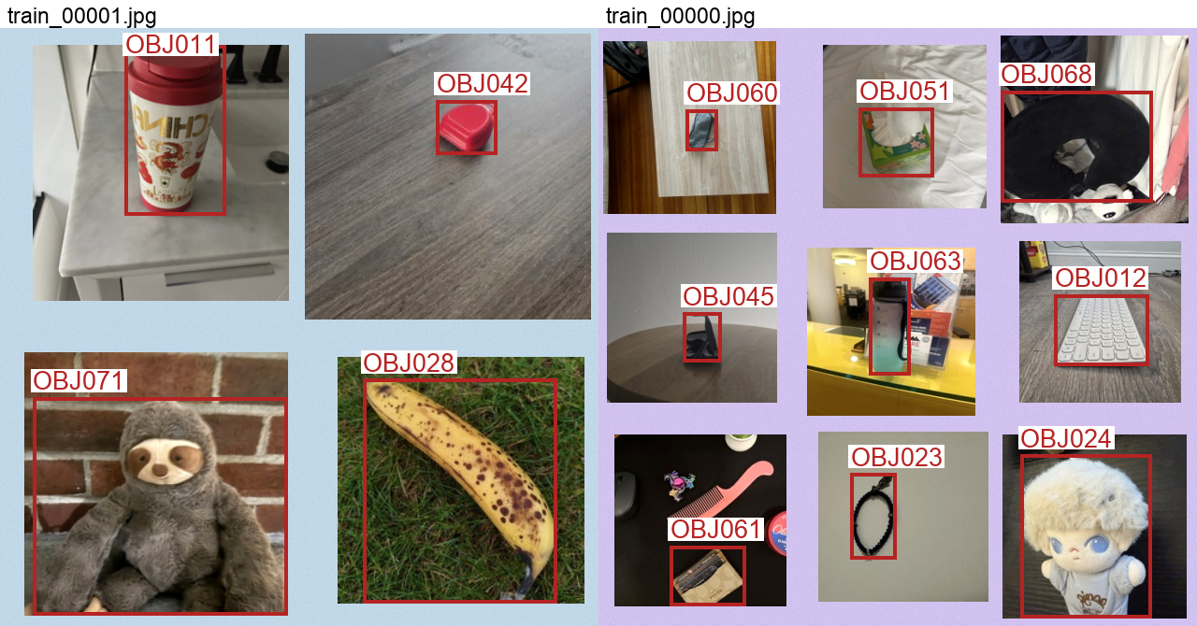
Generated 2×2 and 3×3 training images. Every cell has an annotated target. Red boxes show source annotations; full photos retain their context.

Training and measured performance
We fine-tuned COCO-pretrained YOLOv8s with Ultralytics 8.3.221 through Colab CLI on NVIDIA A100-SXM4-40GB. All 50 epochs completed in 34.2 minutes, including training-time validation. The detector scales RGB pixels to 0–1. Checkpoint selection uses validation mAP50–95; test results do not select the checkpoint. YOLOv8s provides a practical GPU training budget within the required model family.
Setting | Protocol
Budget and input | 50 epochs; 640 pixels; batch 32; seed 42; no early stopping
Optimization | AdamW; LR 0.001; cosine final factor 0.01; weight decay 0.0005; 3 warm-up epochs
Augmentation | Training-only mosaic; closed for final 10 epochs; rotation ±10°; translation 0.1; scale 0.3; mild HSV changes; horizontal flip 0.5
Evaluation | Fixed generated images; IoU thresholds 0.50–0.95 for AP; NMS IoU 0.7

Split | Precision | Recall | mAP50 | mAP50–95
Val | 96.06% | 93.06% | 95.34% | 84.81%
Test | 96.77% | 93.53% | 96.10% | 84.93%

AP measures the precision–recall curve for each class. mAP50 requires matching boxes at IoU ≥ 0.50; mAP50–95 averages ten IoU thresholds and rewards tighter localization. Table precision/recall are library class means at the best mean-F1 point on each split’s curve. The fixed-threshold results below use only validation to choose confidence.
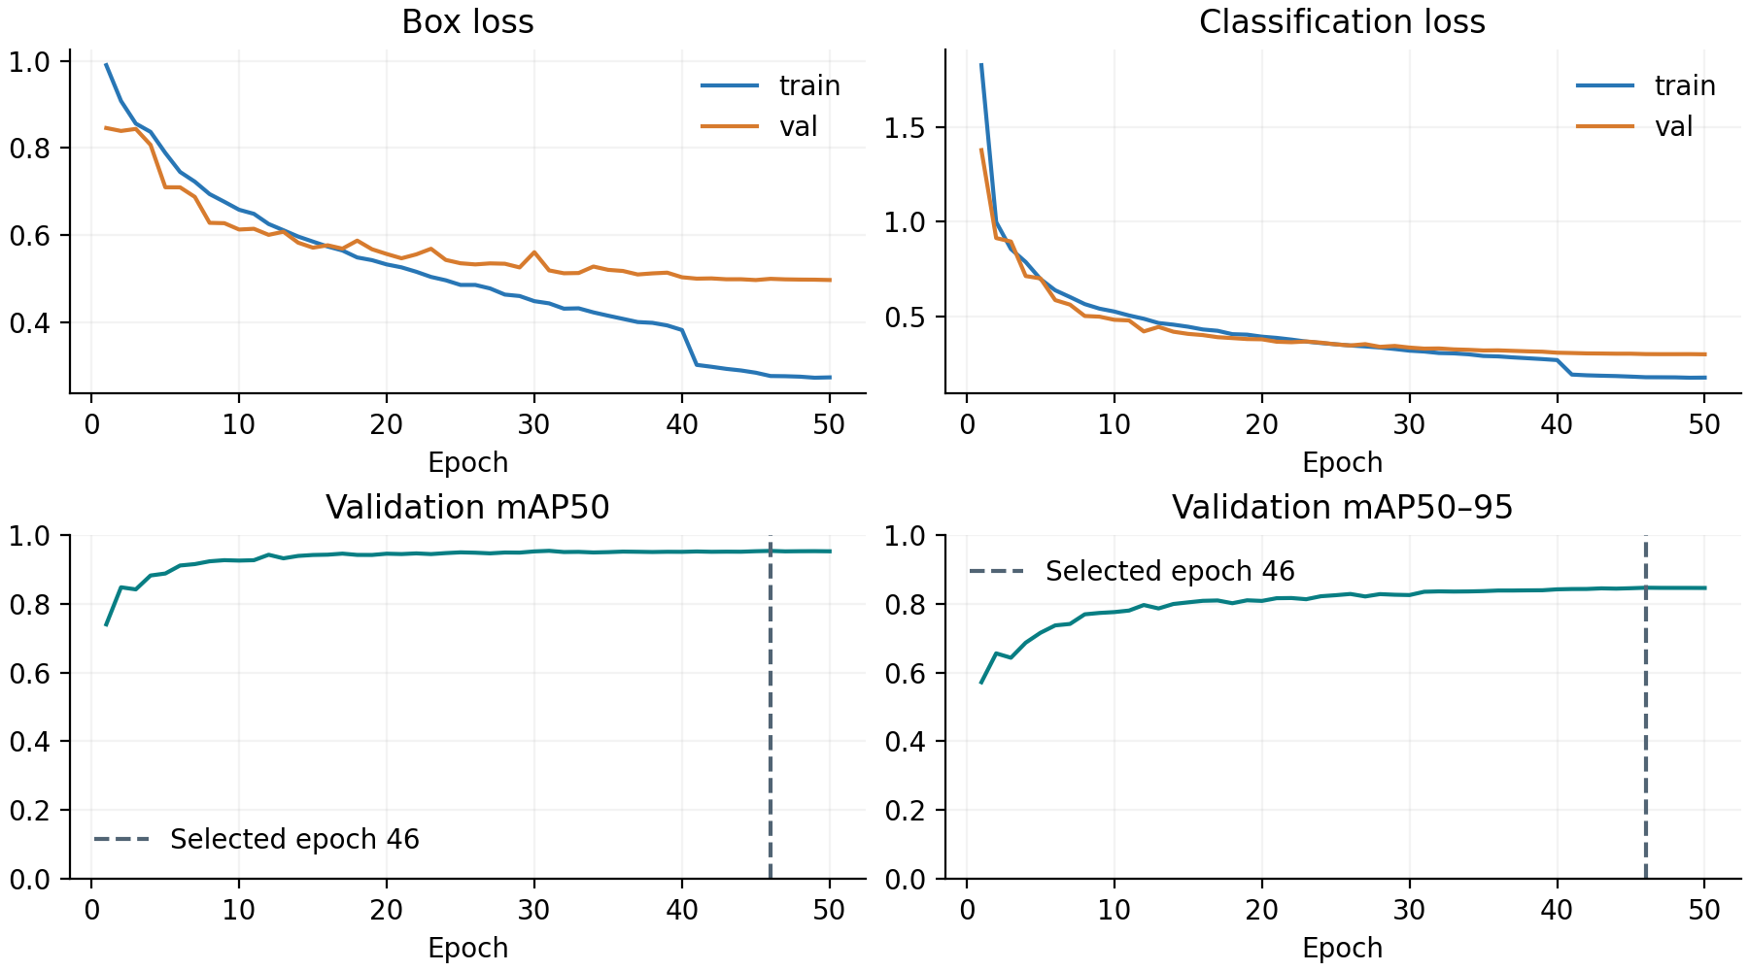
At a confidence threshold of 0.55, chosen only on validation micro-F1, the test set has 5,535 true positives, 190 false positives and 346 missed targets. Class-aware matching requires IoU ≥ 0.50. Micro precision is 96.68%, recall 94.12% and F1 0.9538. All annotated objects are correctly detected with no false positives in 690/1,000 images (69.00%).

Performance by layout
The dataset includes both grid layouts used for the demo and random placements. Each grid cell contains a photo with an annotated assigned target; no background-only photos or empty cells are used. Multiple instances inside a source photo receive separate boxes, so a grid can contain more targets than cells.
Layout | Train images | Val images | Test images
2×2 | 3,200 | 400 | 400
3×3 | 3,200 | 400 | 400
Random | 1,600 | 200 | 200

Every split/layout contains all 73 final Object IDs. We evaluate the same validation-selected checkpoint on each test subset. The global operating threshold is chosen once on the mixed validation set and remains fixed for all layouts.
Test layout | Images | mAP50 | mAP50–95 | Micro F1 | All objects
2×2 | 400 | 96.04% | 84.68% | 0.9503 | 74.00%
3×3 | 400 | 95.63% | 84.29% | 0.9521 | 54.25%
Random | 200 | 98.74% | 91.89% | 0.9736 | 88.50%

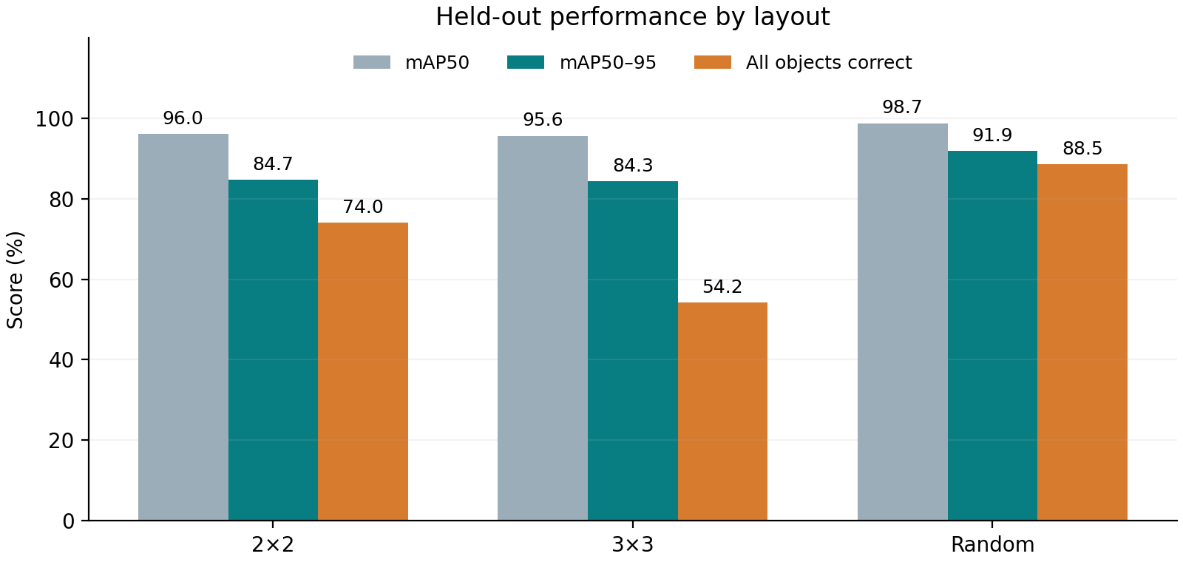
The lowest layout mAP50–95 is 84.29% for 3×3. Grid and random subsets differ in object size, photo context and target count; their scores describe those subsets without identifying one cause. Overall AP is computed across the full test set rather than by averaging layout scores.
The saved 2×2 and 3×3 samples are actual held-out dataset images. Their paths were sampled with seed 42 independently of predictions. Plain images, ground-truth boxes, model detections and final IDs are archived in samples/mixed_layouts_seed42/. These samples can be shared for the requested demo preparation.

Sample detection results
Two test paths per layout were sampled with seed 42 independently of predictions. The gallery shows one 2×2, one 3×3, one random image and the second 2×2 image. Teal boxes and labels are model outputs at the fixed validation-selected confidence threshold. TP, FP and FN use the same class-aware IoU matching as the reported operating metrics.
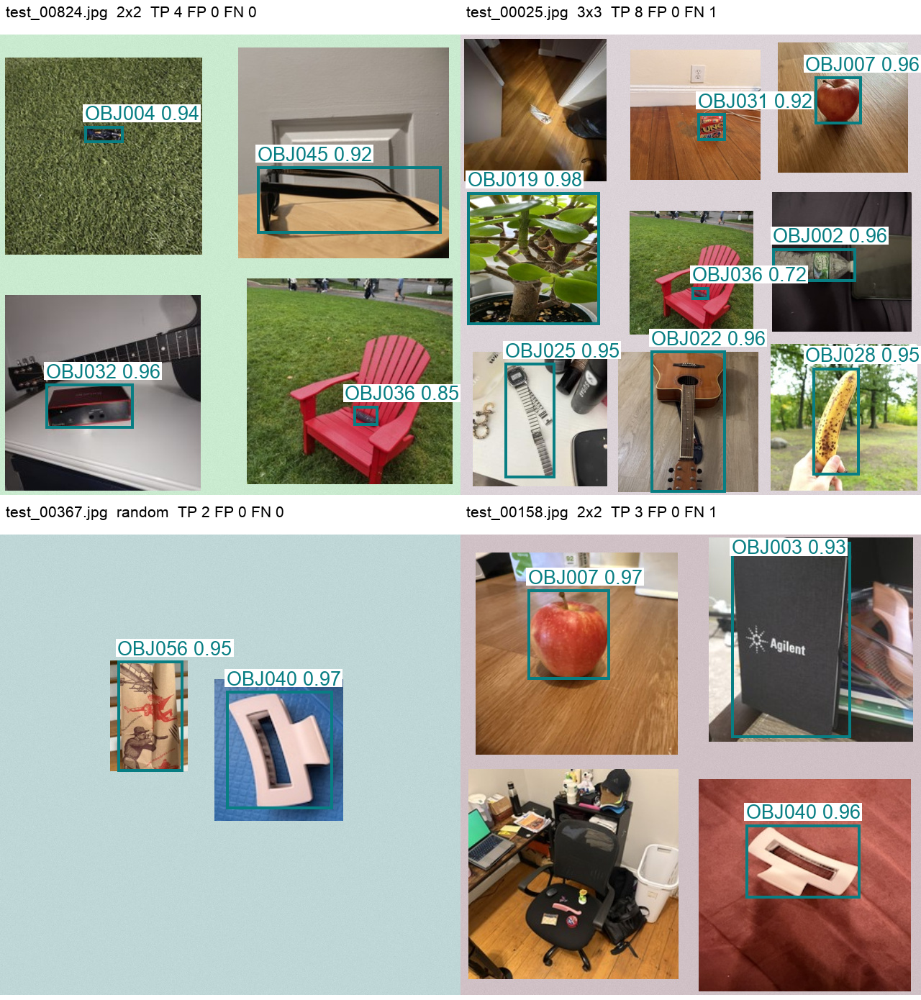
Labels show the final Object ID and model confidence. Box coordinates in the saved CSV/JSON refer to original-image pixels, with the origin at the upper-left. Every test image contributes to the aggregate metrics; this gallery is illustrative.

Error analysis and interpretation
Validation mAP50–95 is 0.12 percentage points lower than test mAP50–95. Test composites use different source photos, so viewpoints, partial views and retained backgrounds can affect detection. The gap describes this run and does not identify a single cause.
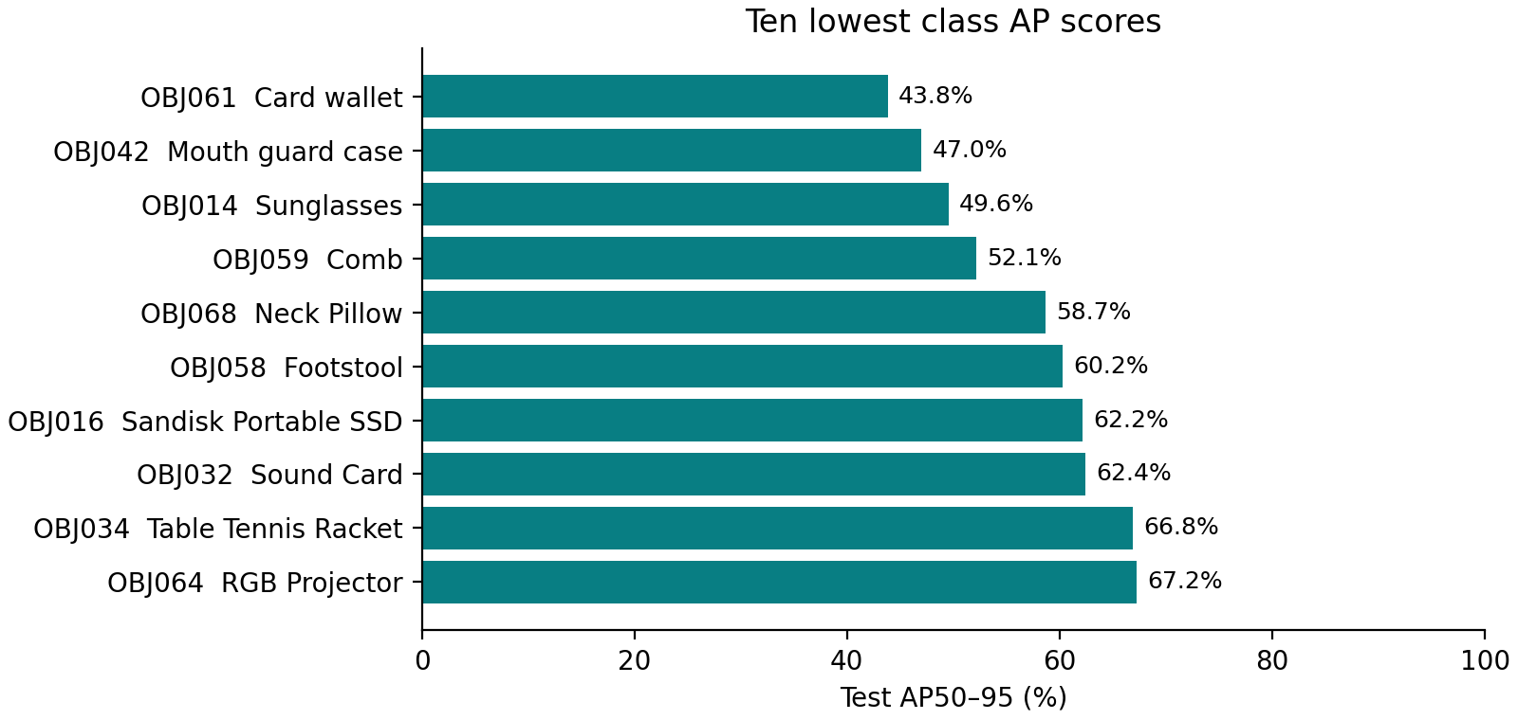
Class scores use 8–10 distinct test source photos per class, repeatedly recomposed into images. Sources can share physical objects and backgrounds. The full 73-class result table is archived.
The case below was selected by most missed targets, then false positives and filename. Red boxes show ground truth; teal boxes show predictions. This example explains a failure and does not estimate its frequency.
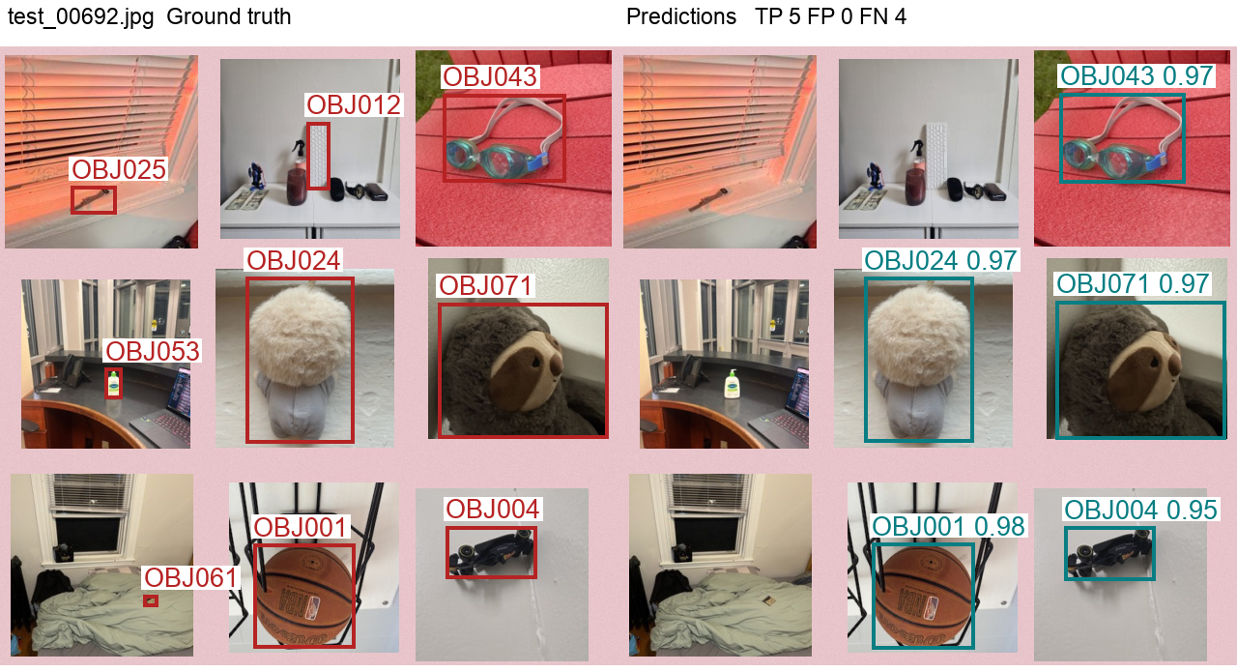
test_00692.jpg has 5 correct detections, 0 false positives and 4 missed targets. Small native targets can become blurred when enlarged; approximate annotations can also affect interpretation.

Final assessment and reproducibility
The trained YOLOv8s model detects Object IDs and locations on the held-out synthetic composites, with test mAP50–95 84.93%. The strict all-objects image score is 69.00%. Some images still contain missed targets or false positives. We retain the validation-selected checkpoint and confidence threshold for inference.

Example pixel locations
The following detections are from test_00824.jpg, the first independently sampled example. Each coordinate tuple is (x1, y1, x2, y2) in its 640 × 640 image.
Predicted ID | Official object name | Confidence | Box in pixels
OBJ032 | Sound Card | 0.96 | 64, 486, 185, 548
OBJ004 | Toy Car | 0.94 | 118, 127, 172, 150
OBJ045 | Wayfarer Sunglasses | 0.92 | 358, 184, 613, 277
OBJ036 | Pencil case | 0.85 | 491, 516, 526, 544

Class-aware matching at IoU ≥ 0.50 gives 4 correct detections, 0 false positives and 0 missed targets in this example. Exact coordinates and IDs for every test image are saved in the detection CSV.

Limits and next steps
Repeated synthetic compositions do not create independent photographs. Exact deduplication cannot establish independence between nearby captures or the same physical object. Crop boundaries, retained context, partial objects and approximate boxes can affect learning. Small native targets can become blurred when enlarged. Annotations cover the assigned folder target; incidental classes inside photos are not exhaustively labelled. Human review remains necessary to assess label quality.
We have not evaluated independently photographed real multi-object scenes. The next experiment should add a separately annotated real-scene test set and realistic occlusion and backgrounds. Current scores should be interpreted as synthetic benchmark performance. Checkpoint selection compares epochs of this YOLOv8s run; it does not establish superiority over other YOLOv8 architectures.

Code and experiment record
GitHub repository: https://github.com/zhuhongan/milestone2-object-detection
The public repository contains generation, validation, training, inference and reporting code, the final IDs, source annotations and this report. Generated images and weights remain outside Git. Training histories, package versions, checkpoint hashes, manifests and all test detections are archived. Pipeline tests passed, and all 10,000 generated image/label pairs passed validation. Colab artifacts were downloaded in checksum-verified parts and the GPU was released.
Inference: run predict.py with best.pt, your image and operating_threshold.json. Its annotated image and detections.json provide final IDs, official names, confidences and pixel locations.

References
Final merged dataset
Final Object ID sheet
Ultralytics YOLOv8 model documentation
Ultralytics YOLO detection dataset format
Grounding DINO annotation proposal model

