Object detection with YOLOv8
  - Milestone 2 group report using the final merged dataset
We trained YOLOv8s to identify the final Object IDs and bounding-box locations in multi-object images. The dataset contains 10,000 synthetic composites from 6,933 unique annotated source photos and covers all 73 classes. The checkpoint selected on validation is epoch 50. On 1,000 test images, mAP50 is 98.65% and mAP50–95 is 94.26%. These scores measure performance on the synthetic dataset.

Annotations and dataset generation
All 7,343 photos have annotation records. Grounding DINO processed 7,315 unique photos, followed by assistant review on 151 contact sheets. The 28 duplicates inherit canonical annotations and are excluded before splitting. The positive pool contains 6,933 unique photos and 7,080 boxes. No independent human verification was performed.
Split | Composites | Target instances | Source photos
Train | 8,000 | 24,606 | 5,549
Val | 1,000 | 3,093 | 696
Test | 1,000 | 3,049 | 688

Sources retain their exact-deduplicated Milestone 1 splits before synthesis. Composites use 80/10/10 and seed 42; every split covers 73 classes and every eligible source is used. Source paths, byte hashes and RGB-pixel hashes are disjoint between splits. Raw photos remain unchanged.
We excluded 382 unique photos without identifiable folder targets and recorded reasons. Background names alone did not exclude photos. Valid JPEG formats and dimensions were retained. EXIF orientation and RGB conversion precede resizing. Empty labels refer only to the folder ID.
Each 640 × 640 image combines 2–4 distinct classes, retaining repeated instances. Annotated crops include 5–15% context, are resized while preserving aspect ratio, then placed without overlap. Training crops receive brightness and contrast adjustments and horizontal flips. Recorded transforms update normalized YOLO coordinates.
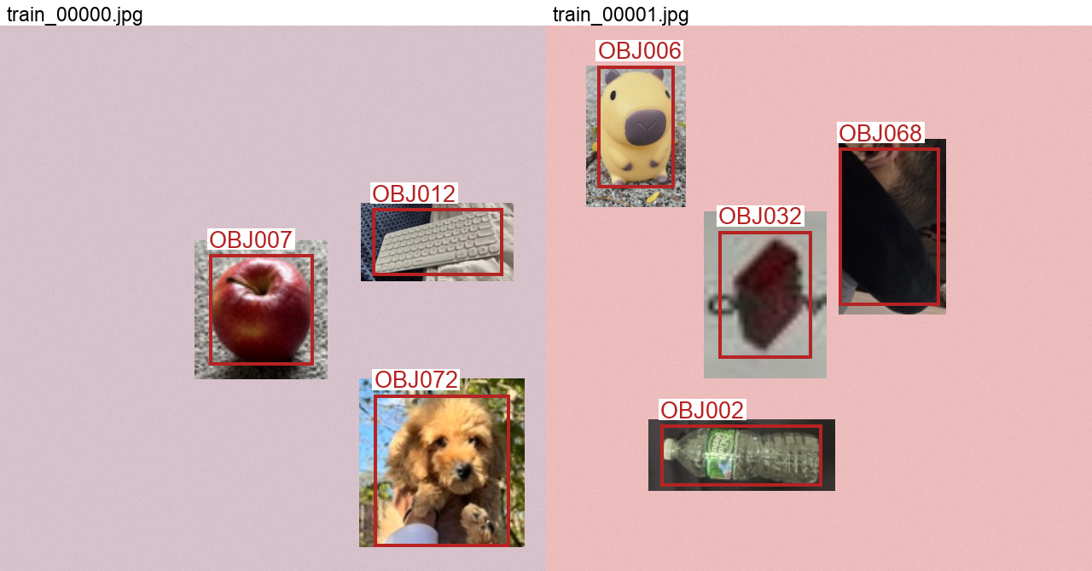
Two generated training composites. Red boxes are annotations, not model detections. Context inside each rectangular photo crop is retained.

Training and measured performance
We fine-tuned COCO-pretrained YOLOv8s with Ultralytics 8.3.221 through Colab CLI on NVIDIA A100-SXM4-40GB. All 50 epochs completed in 34.1 minutes, including training-time validation. The detector scales RGB pixels to 0–1. Checkpoint selection uses validation mAP50–95; test results do not select the checkpoint. YOLOv8s provides a practical GPU training budget within the required model family.
Setting | Protocol
Budget and input | 50 epochs; 640 pixels; batch 32; seed 42; no early stopping
Optimization | AdamW; LR 0.001; cosine final factor 0.01; weight decay 0.0005; 3 warm-up epochs
Augmentation | Training-only mosaic; closed for final 10 epochs; rotation ±10°; translation 0.1; scale 0.3; mild HSV changes; horizontal flip 0.5
Evaluation | Fixed generated images; IoU thresholds 0.50–0.95 for AP; NMS IoU 0.7

Split | Precision | Recall | mAP50 | mAP50–95
Val | 99.02% | 97.83% | 98.74% | 94.35%
Test | 98.66% | 97.47% | 98.65% | 94.26%

AP measures the precision–recall curve for each class. mAP50 requires matching boxes at IoU ≥ 0.50; mAP50–95 averages ten IoU thresholds and rewards tighter localization. Table precision/recall are library class means at the best mean-F1 point on each split’s curve. The fixed-threshold results below use only validation to choose confidence.
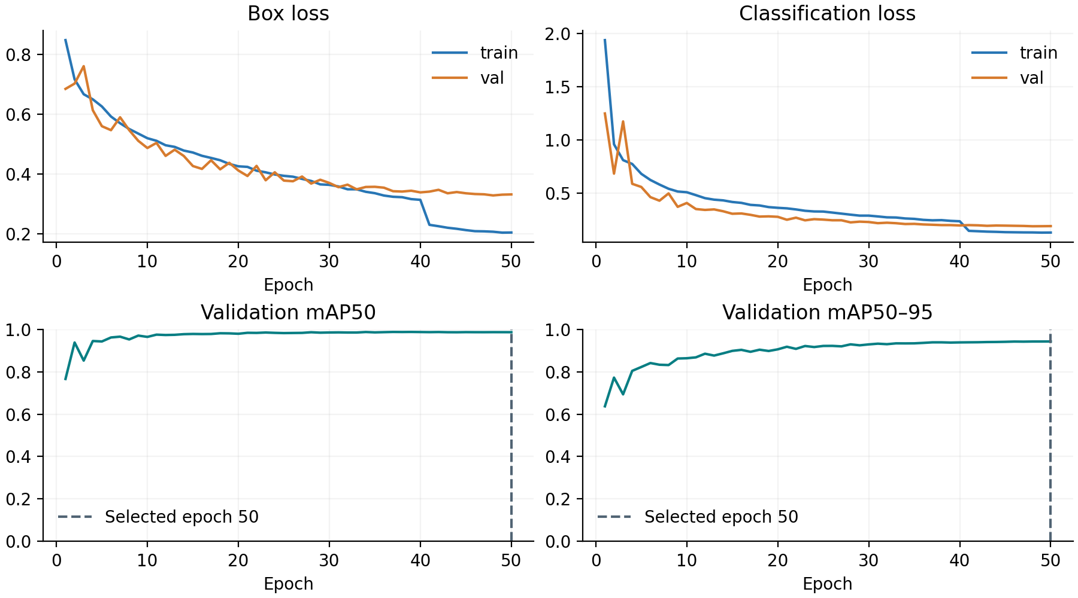
At a confidence threshold of 0.65, chosen only on validation micro-F1, the test set has 2,982 true positives, 37 false positives and 67 missed targets. Class-aware matching requires IoU ≥ 0.50. Micro precision is 98.77%, recall 97.80% and F1 0.9829. All annotated objects are correctly detected with no false positives in 929/1,000 images (92.90%).

Sample detection results
Four of six test paths sampled with seed 42 are shown in their original sample order. Paths were selected independently of predictions. Teal boxes and labels are model outputs at the fixed validation-selected confidence threshold. TP, FP and FN use the same class-aware IoU matching as the reported operating metrics.
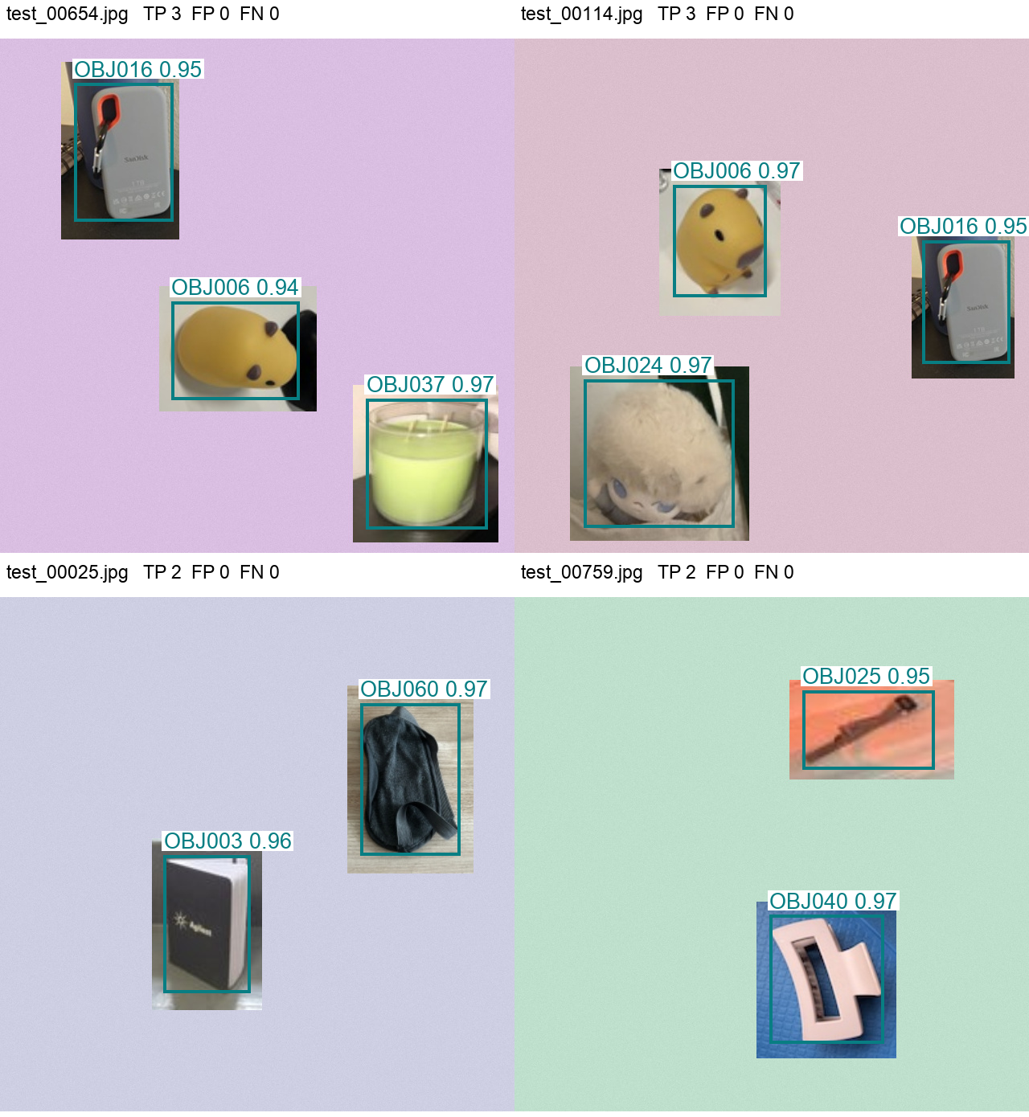
Labels show the final Object ID and model confidence. Box coordinates in the saved CSV/JSON refer to original-image pixels, with the origin at the upper-left. Every test image contributes to the aggregate metrics; this gallery is illustrative.

Error analysis and interpretation
Validation mAP50–95 is 0.09 percentage points higher than test mAP50–95. Test composites use different source photos, so viewpoints, partial views and retained backgrounds can affect detection. The gap describes this run and does not identify a single cause.
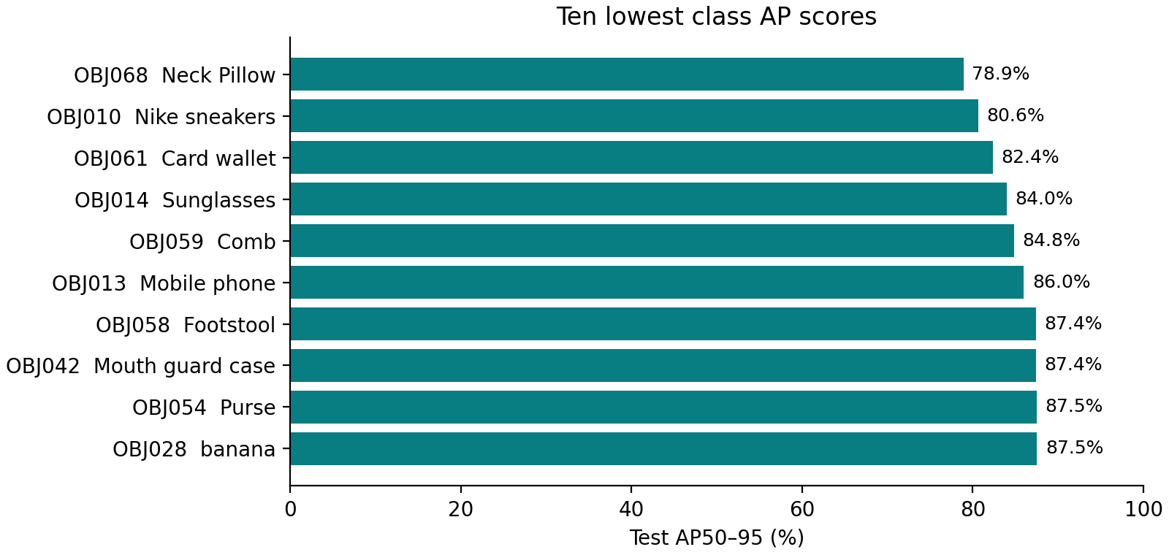
Class scores use 8–10 distinct test source photos per class, repeatedly recomposed into images. Sources can share physical objects and backgrounds. The full 73-class result table is archived.
The case below was selected by most missed targets, then false positives and filename. Red boxes show ground truth; teal boxes show predictions. This example explains a failure and does not estimate its frequency.
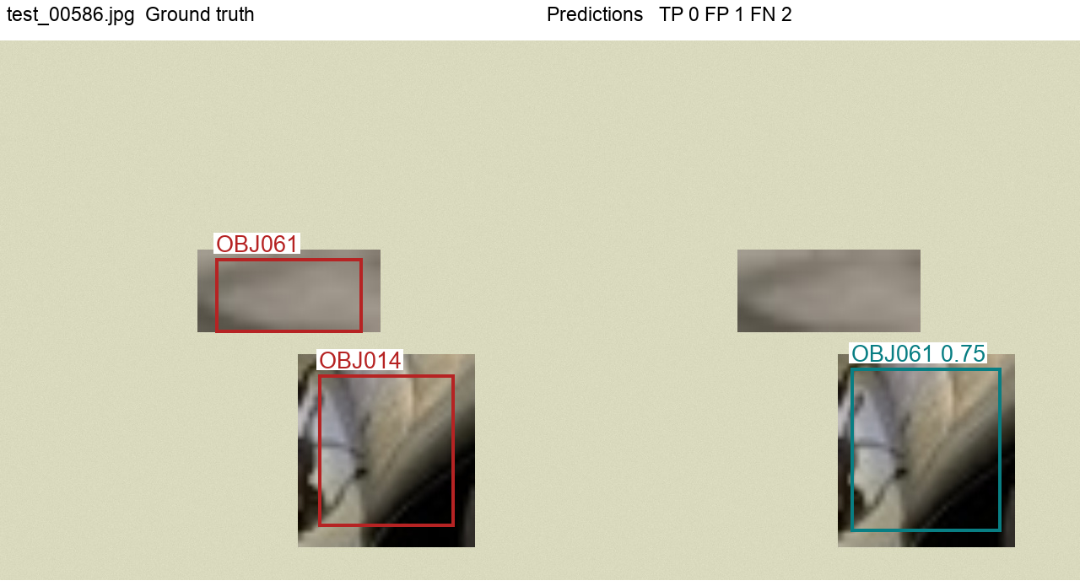
test_00586.jpg has 0 correct detections, 1 false positives and 2 missed targets. A patch annotated OBJ014 is predicted as OBJ061. Small native targets can become blurred when enlarged; approximate annotations can also affect interpretation.

Comparison with the earlier experiment
Both experiments fine-tuned COCO-pretrained YOLOv8s for 50 epochs with the same input size, optimizer settings and seed. The expanded experiment uses more source photographs and more optimizer steps per epoch. Its training and test distributions both changed, so this comparison describes the completed experiments without isolating the effect of more training data.
Measure | Earlier subset | Expanded dataset
Unique source photos | 365 | 6,933
Training composites | 1,168 | 8,000
Test composites | 146 | 1,000
Test mAP50 | 71.31% | 98.65%
Test mAP50–95 | 57.85% | 94.26%
Test micro F1 | 0.6778 | 0.9829
All objects correct | 21.23% | 92.90%

Expanded-data test mAP50–95 is 36.41 percentage points higher than the earlier result. Each experiment chose its operating threshold on its own validation set. A controlled follow-up would evaluate both saved models on the same independently annotated real-scene test set.
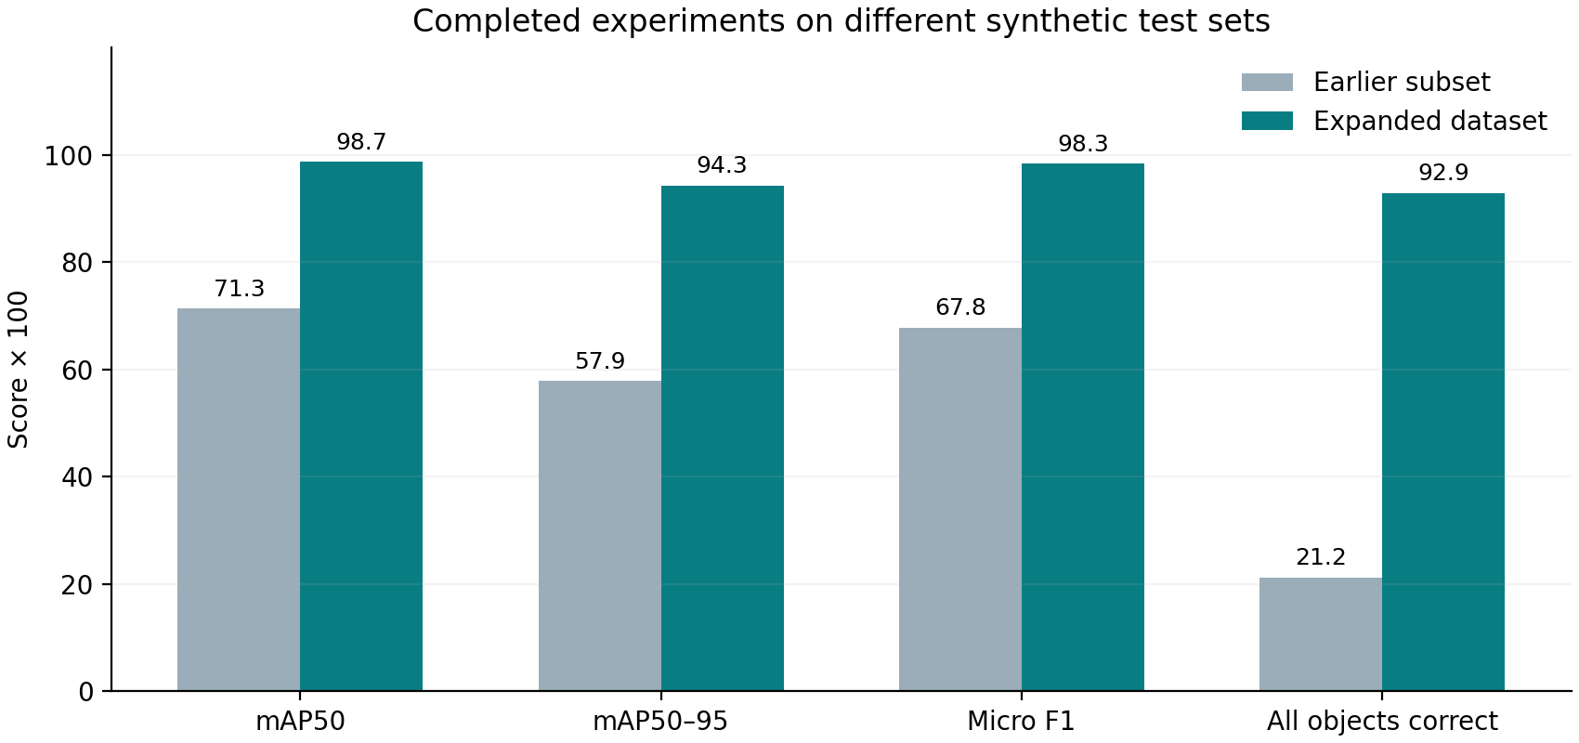
AP scores summarize precision–recall curves. Micro F1 and all-objects scores use each run’s validation-selected confidence threshold.

Final assessment and reproducibility
The trained YOLOv8s model detects Object IDs and locations on the held-out synthetic composites, with test mAP50–95 94.26%. The strict all-objects image score is 92.90%. Some images still contain missed targets or false positives. We retain the validation-selected checkpoint and confidence threshold for inference.

Example pixel locations
The following detections are from test_00654.jpg, the first independently sampled example. Each coordinate tuple is (x1, y1, x2, y2) in its 640 × 640 image.
Predicted ID | Official object name | Confidence | Box in pixels
OBJ037 | Candle | 0.97 | 456, 448, 606, 610
OBJ016 | Sandisk Portable SSD | 0.95 | 92, 56, 215, 227
OBJ006 | Capybara Toy | 0.94 | 213, 327, 373, 449

Class-aware matching at IoU ≥ 0.50 gives 3 correct detections, 0 false positives and 0 missed targets in this example. Exact coordinates and IDs for every test image are saved in the detection CSV.

Limits and next steps
Repeated synthetic crops do not create independent photographs. Exact deduplication cannot establish independence between nearby captures or the same physical object. Crop boundaries, retained context, partial objects and approximate boxes can affect learning. Small native targets can become blurred when enlarged. Annotations cover the assigned folder target; incidental classes inside crops are not exhaustively labelled. Human review remains necessary to assess label quality.
We have not evaluated independently photographed real multi-object scenes. The next experiment should add a separately annotated real-scene test set and realistic occlusion and backgrounds. Current scores should be interpreted as synthetic benchmark performance. Checkpoint selection compares epochs of this YOLOv8s run; it does not establish superiority over other YOLOv8 architectures.

Code and experiment record
GitHub repository: https://github.com/zhuhongan/milestone2-object-detection
The private repository contains generation, validation, training, inference and reporting code, the final IDs, source annotations and this report. Generated images and weights remain outside Git. Training histories, package versions, checkpoint hashes, manifests and all test detections are archived. Pipeline tests passed, and all 10,000 generated image/label pairs passed validation. Colab artifacts were downloaded in checksum-verified parts and the GPU was released.
Inference: run predict.py with best.pt, your image and operating_threshold.json. Its annotated image and detections.json provide final IDs, official names, confidences and pixel locations.

References
Final merged dataset
Final Object ID sheet
Ultralytics YOLOv8 model documentation
Ultralytics YOLO detection dataset format
Grounding DINO annotation proposal model

