**深 圳 大 学 实 验 报 告**

**课程名称：­ 随机信号处理**

**实验项目名称： Bayes’ theorem**

**学院： 电子与信息工程学院**

**专业： 电子信息工程**

**指导教师： 孙维泽**

**报告人：卫宏林 学号： 2022300013**

**班级： 文华班**

**实验时间： 2024.3.18**

**实验报告提交时间： 2024.3.18**

**教务处制**

Description of format:

* Use Times New Roman, 12 pt, single column, single line spacing.
* When inserting figures and tables, title of the figures and tables must be included.
* Do not change ‘1、Purposes of the experiment’ and ‘2、Design task and detail requirement’.

**1、Purposes of the experiment**

1. Use Matlab to show some commonly used distribution of random variables.
2. Use correct equations (Bayes’ theorem) to design a strategy for the games in ‘3. Advance’ and ‘4. Extra’.
3. Analyze the results and draw reasonable conclusions

**2、Design task and detail requirement**

See ‘Appendix 1 – Task and requirement for experimental report 1.doc’.

**3、The result and Analysis**

* **Part 1:** submit your programs only.
* **Part 2:**

1. **Your program, and the flow chart of your program, with explanation about ‘your modification of the default system’.**

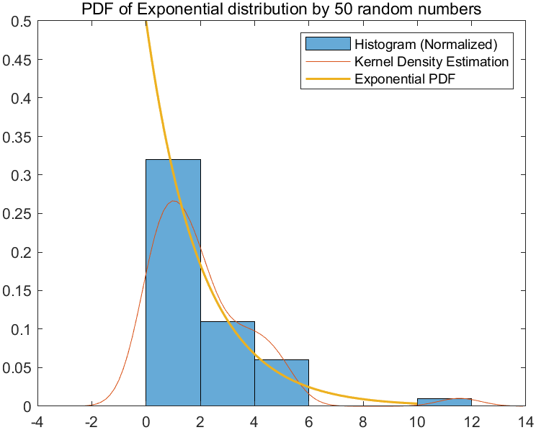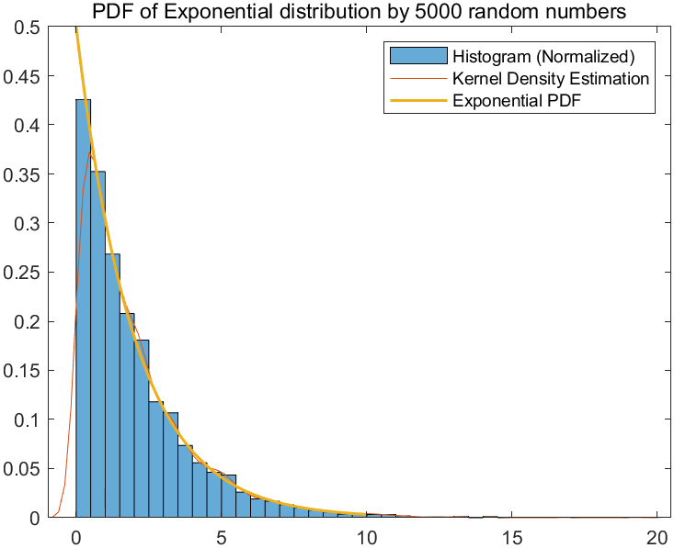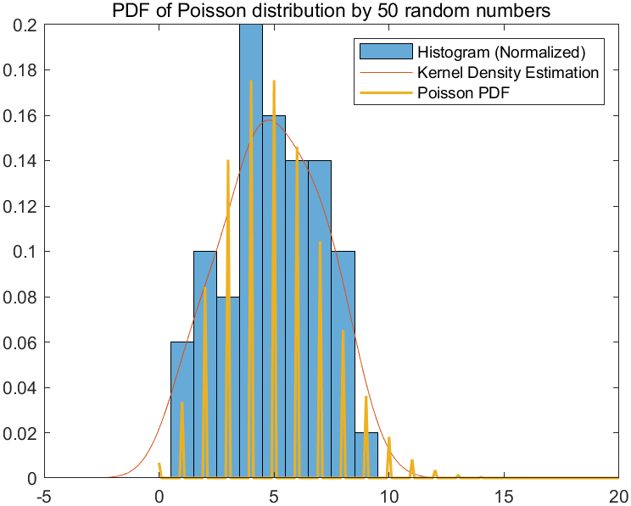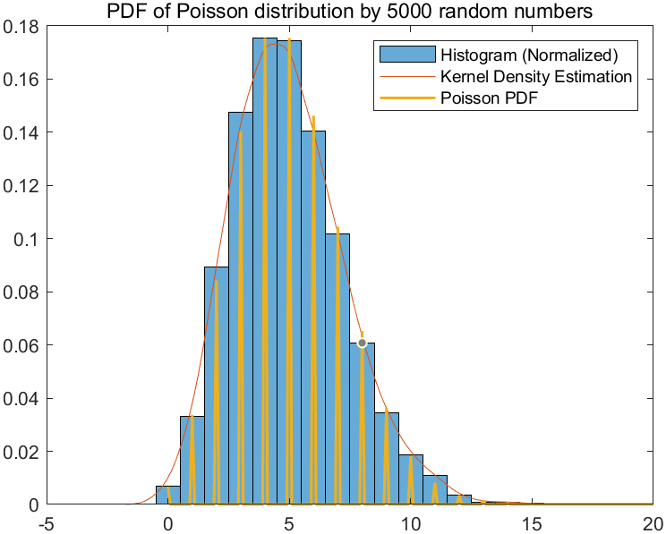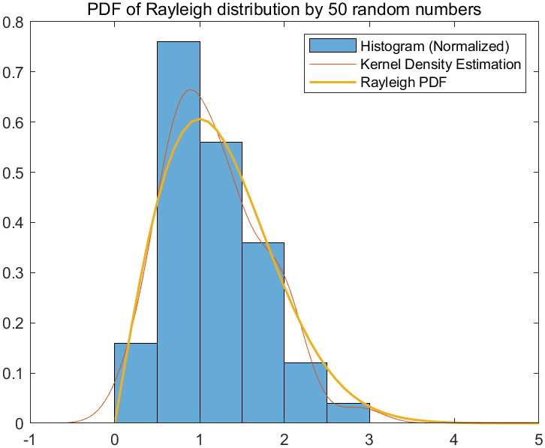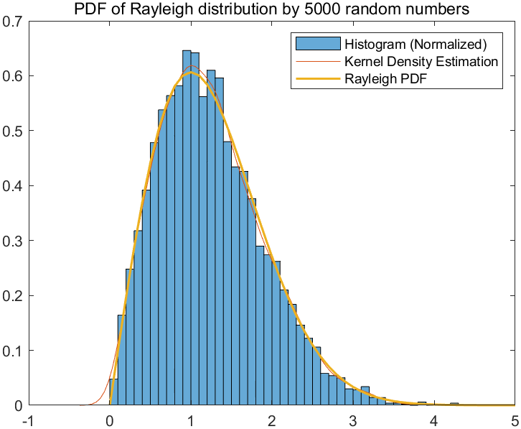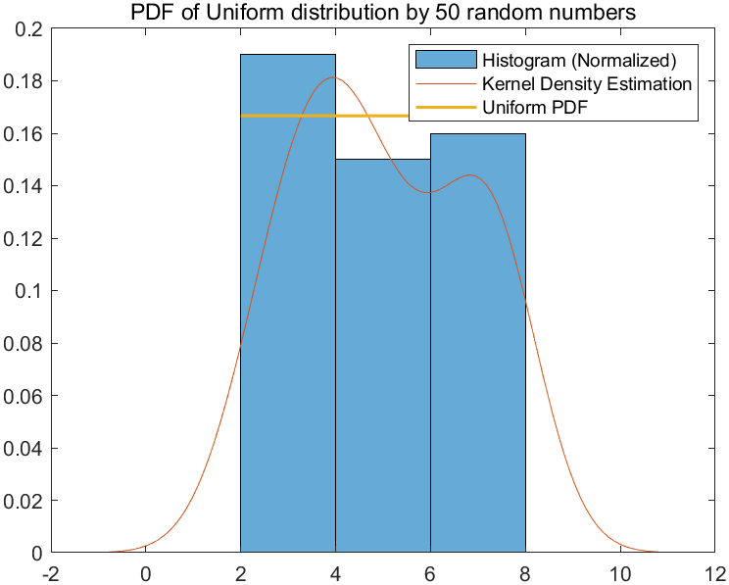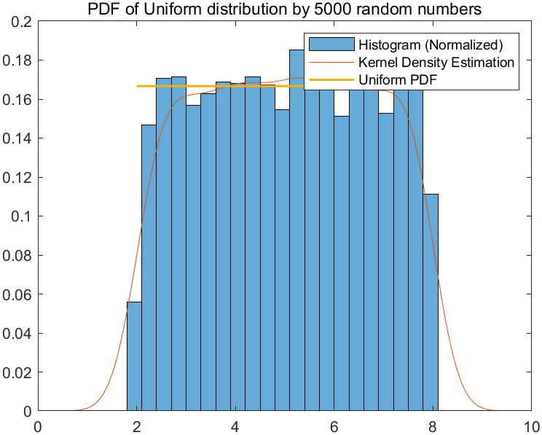

The random numbers of the Rayleigh distribution were generated using the raylrnd function.

The poissrnd function was used to generate random numbers for a Poisson distribution.

The unifrnd function was used to generate uniformly distributed random numbers.

The exprnd function is used to generate random numbers for an exponential distribution.

1. **The reason of your strategy**

Refer to practice 4 and plot Rayleigh distribution，Poisson distribution，Uniform distribution and Exponential distribution. The figure should contains the truth pdf, estimated pdf, and histogram.

1. **Your result figures and analysis**

The higher the number of randomly generated points, the closer the curve fitted by frequency and the probability curve become.

* **Part 3:Advance**

1. **Your program, and the flow chart of your program**

**Modify the default system:**

To design a system to evaluate your_strategy statistically, I can modify the default system as follows:

Increase the number of independent runs: Instead of just running the simulation once, I can repeat it multiple times to get a better understanding of the strategy's performance across different scenarios. In this case, let's test it for 500 independent runs.

Vary the counterparty's probability of betrayal: The counterparty's probability of betrayal should be a random variable with a uniform distribution between 0 and 1 in each independent run.

This code will generate a plot showing the average return up to each run. The x-axis represents the run number, and the y-axis represents the average return up to that run. Additionally, the average return (Avg_Return) will be displayed in the command window.

1. **Explain the reason of your strategy?**

To modify your strategy to potentially achieve a higher average return, you can incorporate adaptive behavior based on the previous actions of the counterparty.

This modified strategy adjusts the probability of your action (trust or call police) based on the recent behavior of the counterparty. If the counterparty has been betraying frequently, your strategy becomes more likely to call the police. Conversely, if the counterparty has been trusting frequently, your strategy becomes more likely to trust. This adaptive behavior aims to optimize your returns based on the observed behavior of the counterparty. Adjust the trust_threshold and betrayal_threshold values according to your preferences and observations.

1. **Results and analysis**

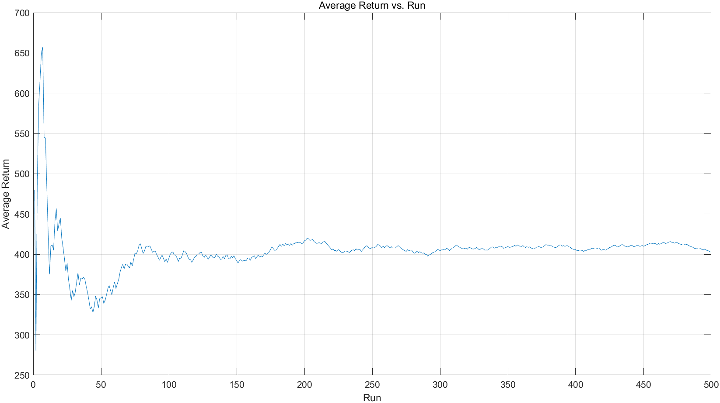

At the beginning, the Average Return undulate frequently. Gradually, the Average Return tent to be a constant but still have some undulation.

The result: Avg_Return = 438.2800

* **Part 4:Extra**

1. **Your program, and the flow chart of your program**

**Modify the default system:**

This script simulates the trading game 200 times, with each run involving trading with a different counterparty whose probability of betrayal follows a uniform distribution in the range [0.4, 0.8].

1. **The reason of your strategy**

The script estimates the counterparty's probability of betrayal based on information provided by 100 friends who have traded with the counterparty previously. The Your_Strategy function implements a simple strategy based on the estimated probability of betrayal.

1. **Results and analysis, together with: What indicator/indicators is/are used for evaluation? Explain it/them.**

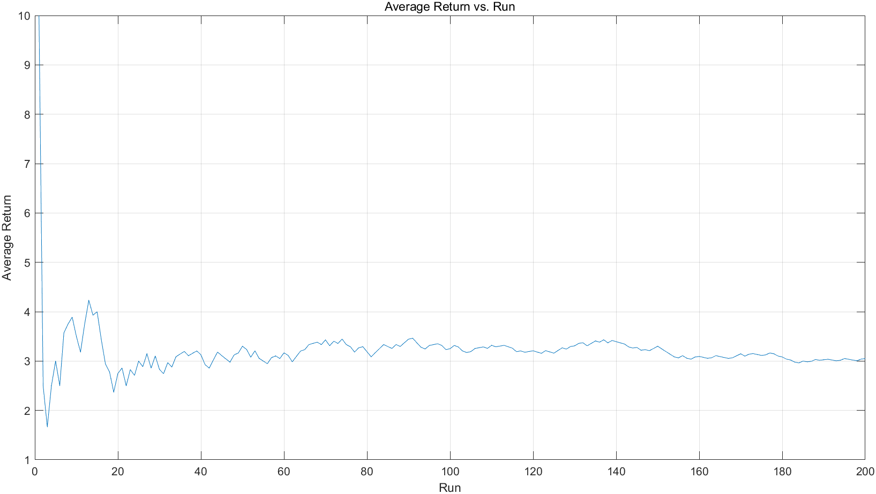

Average Return: 3.05

Because Average Return can directly show the strategy whether great or bad, I use the Average Return to evaluate my result.

**4、Conclusion**

In Part 1, I gained a basic understanding of Matlab syntax and successfully participated in a trading game.

In Part 2, I can proficiently create common probability function distributions using Matlab.

Through Part 3 and the extra section, I have developed a deeper understanding of the Bayes' theorem and applied it to trading strategies.

|  |
| --- |
| 指导教师批阅意见：  成绩评定：  指导教师签字：  年 月 日 |
| 备注： |

注：1、报告内的项目或内容设置，可根据实际情况加以调整和补充。

2、教师批改学生实验报告时间应在学生提交实验报告时间后10日内。