**深 圳 大 学 实 验 报 告**

**课程名称：­ 随机信号处理**

**实验项目名称：Frequency Estimation of Sin Signal & Time Domain Beamforming and Localization + DOA estimation**

**学院： 电子与信息工程学院**

**专业： 电子信息工程**

**指导教师： 孙维泽**

**报告人： 卫宏林 学号： 2022300013**

**班级： 文华班**

**实验时间： 2024.05.01-2024.05.15**

**实验报告提交时间： 2024.05.15**

**教务处制**

Description of format:

* Use Times New Roman, 12 pt, single column, single line spacing.
* When inserting figures and tables, title of the figures and tables must be included.
* Do not change ‘1、Purposes of the experiment’ and ‘2、Design task and detail requirement’.

**1、Purposes of the experiment**

1. Use Matlab to calculate the autocorrelation of some functions, and use the result to solve some typical problems.
2. Analyze the results and give reasonable conclusions

**2、Design task and detail requirement**

See ‘Appendix 1 – Task and requirement for experimental report 2.doc’.

**3、The result and Analysis**

* **Part 1 - Basic 1: (10 points)**

Please provide your code, they must be runnable and output the figure in your report.

1. Plot the signal, and the autocorrelation , and Cross-Correlation .

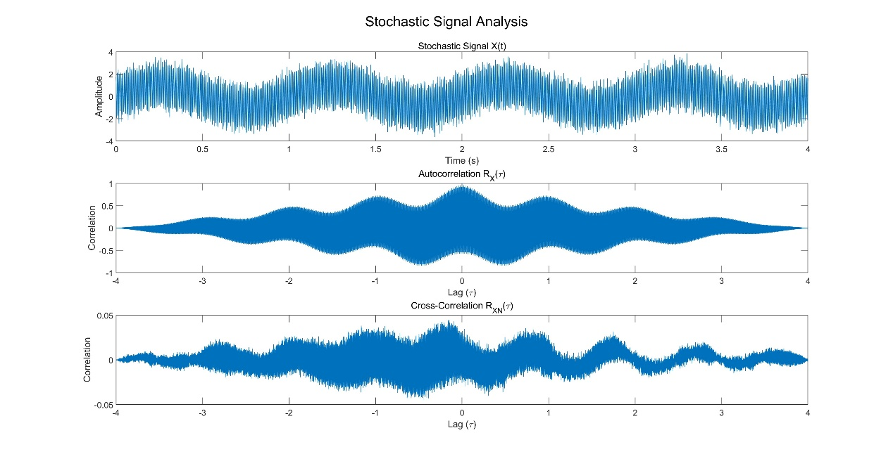

Code:

clc

clear

% Parameters

f1 = 1; % Frequency in Hz

f2 = 150; % Frequency in Hz

sigma_sq = 0.1; % Variance of noise

duration = 4; % Duration in seconds

Fs = 1000; % Sampling frequency in Hz

% Time vector

t = 0:1/Fs:duration-1/Fs;

% Stochastic signal

X = sin(2*pi*f1*t) + 2*cos(2*pi*f2*t) + sqrt(sigma_sq)*randn(size(t));

% Autocorrelation

[RX, lags] = xcorr(X, 'coeff');

% White Gaussian noise

N = sqrt(sigma_sq)*randn(size(t));

% Cross-correlation

[RXN, lags] = xcorr(X, N, 'coeff');

% Plotting

figure;

subplot(3,1,1);

plot(t, X);

title('Stochastic Signal X(t)');

xlabel('Time (s)');

ylabel('Amplitude');

subplot(3,1,2);

plot(lags/Fs, RX);

title('Autocorrelation R_X(\tau)');

xlabel('Lag (\tau)');

ylabel('Correlation');

subplot(3,1,3);

plot(lags/Fs, RXN);

title('Cross-Correlation R_{XN}(\tau)');

xlabel('Lag (\tau)');

ylabel('Correlation');

sgtitle('Stochastic Signal Analysis');

* **Part 2 - Basic 2: (40 points)**

1. Write your parameter setting here, using a table.

|  |  |  |  |
| --- | --- | --- | --- |
| F(Frequency in Hz) | Theta(Phase in radians) | Duration(Duration in seconds) | Fs(Sampling frequency in Hz) |
| 100 | pi/4 | 4 | 1000 |

1. Use the autocorrelation to estimate your signal frequency, and explain why it is possible to estimate the signal frequency through autocorrelation. (Hint: write some theory/equations here, together with description or explanation. Equations without description or explanation are not acceptable because no one can understand anything with only equations)

Assume a periodic signal:



According to definition, its autocorrelation function is:



Because    have period of  ，Hence：



  Hence：



We can easily find that the period of the signal is 1 from the graph.

Because the real signal have Vibration, we need to find the peak in a short Interval, the real coed have changed to adjust this real consititution,

1. For =0.5, 1, 5 (you can try more), plot the figure of Autocorrelation for one run.

Just as the result at problem b.

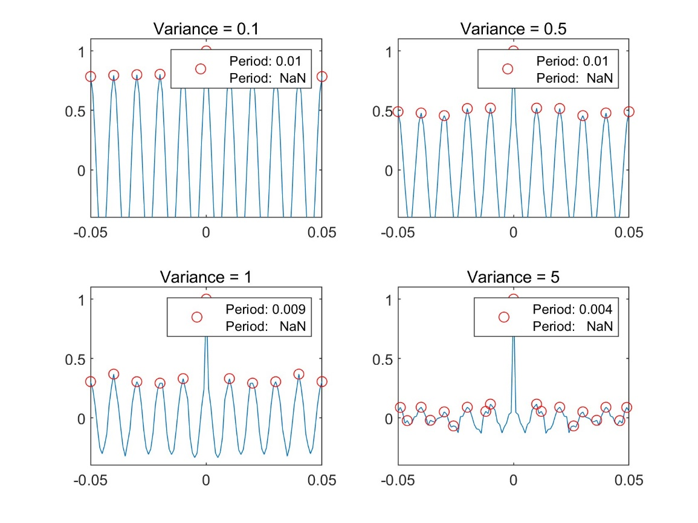

1. Test the accuracy of **your estimation of signal frequency** using autocorrelation for **100 independent runs**, show the results using table(s) or figure(s), and give analysis. (Hint: to get a result of **100 independent runs**, you should write a ‘for’ loop)

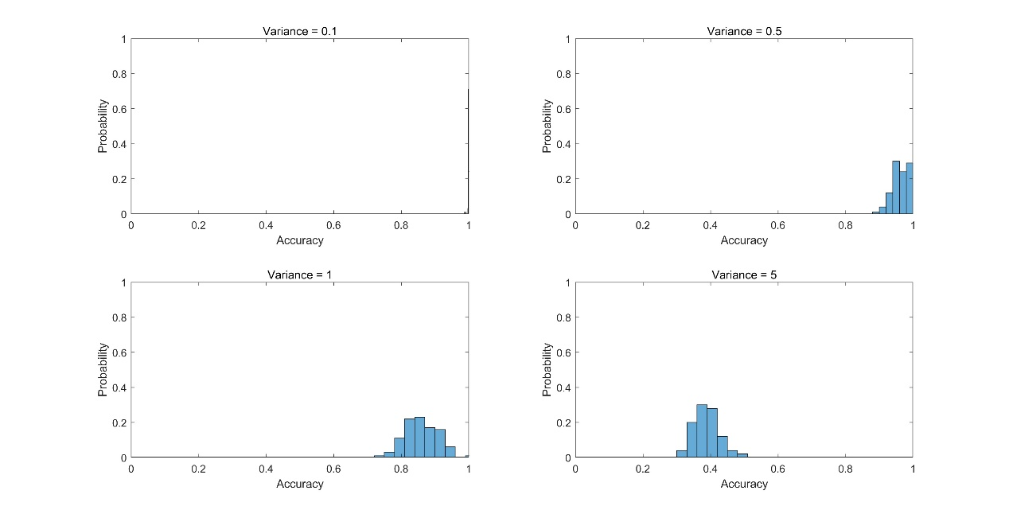

From the histogram, we can observe the distribution of period estimation accuracy under different noise variances:

1. **Noise variance of 0.1**:

- The histogram shows that most of the estimation accuracies are concentrated near 1, indicating that period estimation is very accurate under low noise conditions.

- This situation suggests that the noise in the signal is very low and has minimal impact on period estimation, allowing the true period to be estimated accurately.

2. **Noise variance of 0.5**:

- The histogram shows that estimation accuracy is still concentrated in the high accuracy region, but the distribution starts to widen, with some accuracies falling below 1.

- This indicates that as noise increases, although most estimates remain relatively accurate, the noise begins to affect the precision of period estimation, leading to increased deviations in some estimates.

3. **Noise variance of 1**:

- The histogram shows a further decrease in accuracy, with a more dispersed distribution and some estimation accuracies significantly below 1.

- The further increase in noise has a greater impact on period estimation, causing the estimates to be less accurate compared to low noise conditions, and the accuracy starts to decline significantly.

4. **Noise variance of 5**:

- The histogram shows a significant drop in accuracy, with the distribution spread over a wider range, and many estimation accuracies close to 0.5 or lower.

- High noise levels severely affect the precision of period estimation, with most estimates far from the true period, leading to a significant reduction in accuracy.

Conclusion

From the above analysis, we can conclude:

- Under low noise conditions (variance of 0.1), period estimation is very accurate, with accuracy close to 1.

- As the noise level increases (variance increasing to 0.5, 1, and 5), the accuracy of period estimation gradually decreases, and the distribution becomes wider, indicating that the precision of the estimates is significantly affected by noise.

- Under high noise conditions (variance of 5), the estimation accuracy drops significantly, and period estimation becomes unreliable.

This phenomenon is as expected because noise interferes with the signal characteristics, making the peak positions found through the autocorrelation function less accurate, thereby affecting the precision of period estimation.

* **Part 3 – Advance 1:**

1. Explain your method (add the signals from the 4 microphones with correctly estimated lags) with necessary texts, equations, and/or flowchart.

Time -lag cross-Correlation method:

（Cross-Correlation，CCF）defined as：



As the figure below

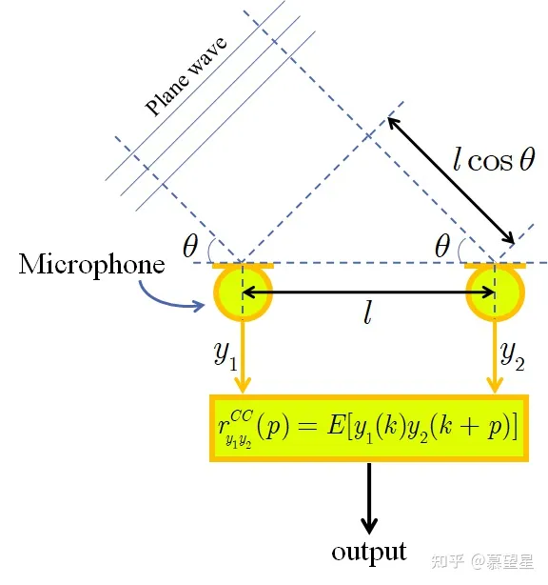



Show the figures under 3 SNR cases (SNR = 30,10,-10dB).

SNR = 30

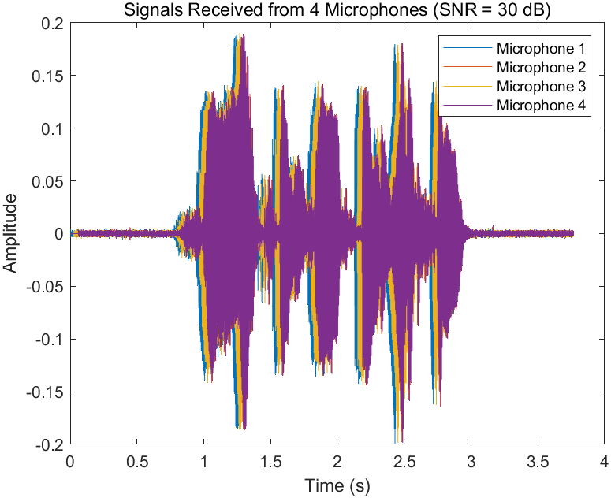

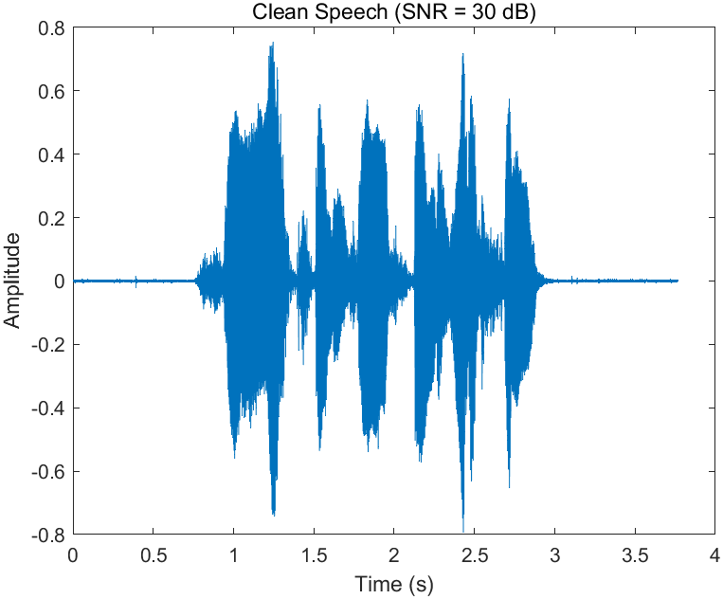

SNR = 10

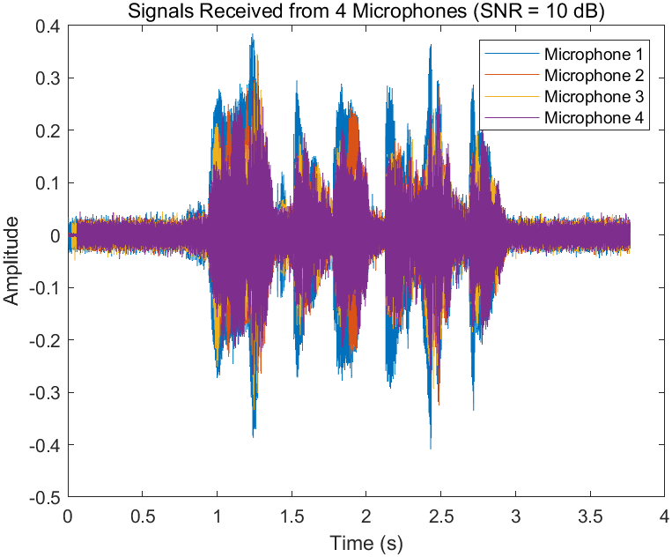

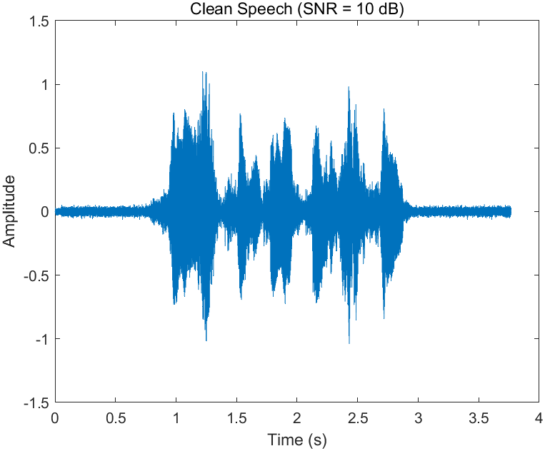

SNR = -10

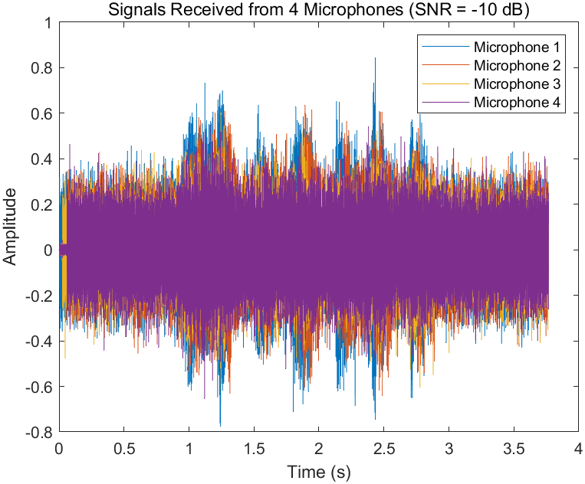

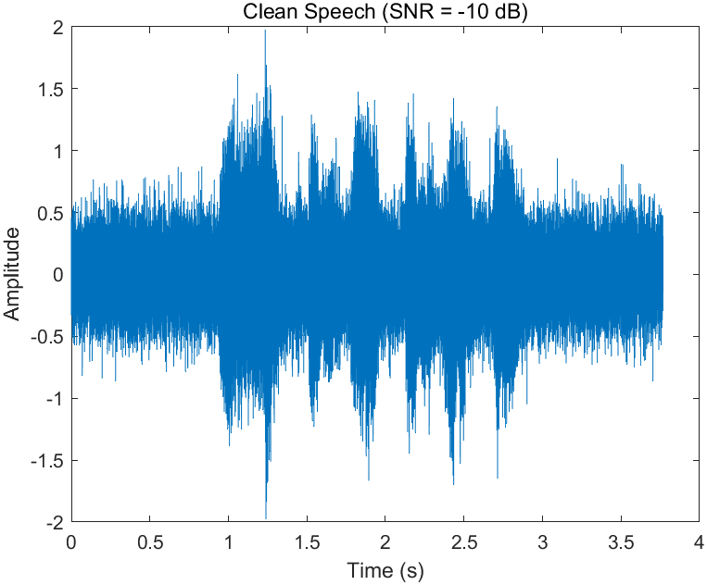

1. Your analysis.

1. Microphone and Source Geometry

The microphones are located at:

- (0,0) m

- (20,0) m

- (0,10) m

- (20,10) m

The source is located at:

- (1,1) m

### 2. Time Delay Estimation (Lag Calculation)

For the given geometry, the time delay (lag) for each microphone can be estimated based on the distance between the source and each microphone. Using the speed of sound (approximately 343 m/s in air), the lag can be calculated as follows:

- Distance from (0,0) to (1,1):  meters → Lag  seconds

- Distance from (20,0) to (1,1):  meter→ Lag  seconds

- Distance from (0,10) to (1,1): meters → Lag seconds

- Distance from (20,10) to (1,1): meters → Lag  seconds

### 3. SNR Cases Analysis

**High SNR (SNR = 30 dB):**

- **Expected Result:** With a high SNR, the noise level is low compared to the signal strength. This scenario allows for accurate lag estimation and minimal distortion in signal reconstruction. The added signals from the microphones should closely match the original source signal with high fidelity.

- **Analysis:** Look for a clean and well-aligned signal reconstruction in the result figure. The impact of noise should be negligible, resulting in a clear and accurate signal.

**Moderate SNR (SNR = 10 dB):**

- **Expected Result:** With a moderate SNR, the noise level is noticeable but still lower than the signal strength. Lag estimation may still be accurate, but the added noise can cause some distortion in the reconstructed signal.

- **Analysis:** Expect some noise in the reconstructed signal, but the overall shape and characteristics of the source signal should still be identifiable. The noise might cause minor misalignments or distortions.

**Low SNR (SNR = -10 dB):**

- **Expected Result:** With a low SNR, the noise level is much higher than the signal strength, making lag estimation challenging and leading to significant distortion in the reconstructed signal. The noise might dominate the signal.

- **Analysis:** The reconstructed signal is likely to be heavily corrupted by noise, making it difficult to distinguish the original signal. Misalignments due to incorrect lag estimation may also be prominent.

### Summary

In high SNR scenarios, expect accurate lag estimation and minimal noise impact. In moderate SNR, some noise-induced distortions will be present, but the signal should still be recognizable. In low SNR, the reconstructed signal will likely be heavily distorted by noise, making it challenging to identify the original signal. Evaluating correlation and MSE, along with visual inspection, will provide a comprehensive understanding of the signal quality under each SNR condition.

* **Part 4 – Advance 2:**

1. Please list the corresponding DOAs for all lags from -11 to +11 in one table. (there are totally 23 numbers)

|  |  |
| --- | --- |
| **Lag** | **DOA (degrees)** |
| -11 | 86.1408 |
| -10 | 65.098 |
| -9 | 54.7187 |
| -8 | 46.5207 |
| -7 | 39.4141 |
| -6 | 32.9712 |
| -5 | 26.9694 |
| -4 | 21.273 |
| -3 | 15.7898 |
| -2 | 10.4517 |
| -1 | 5.204 |
| 0 | 0 |
| 1 | 5.204 |
| 2 | 10.4517 |
| 3 | 15.7898 |
| 4 | 21.273 |
| 5 | 26.9694 |
| 6 | 32.9712 |
| 7 | 39.4141 |
| 8 | 46.5207 |
| 9 | 54.7187 |
| 10 | 65.098 |
| 11 | 86.1408 |

1. Show the flow chart of your program, the estimation result (correct detection percentage or other indicators) of the DOA versus SNR(dB), and your analysis.

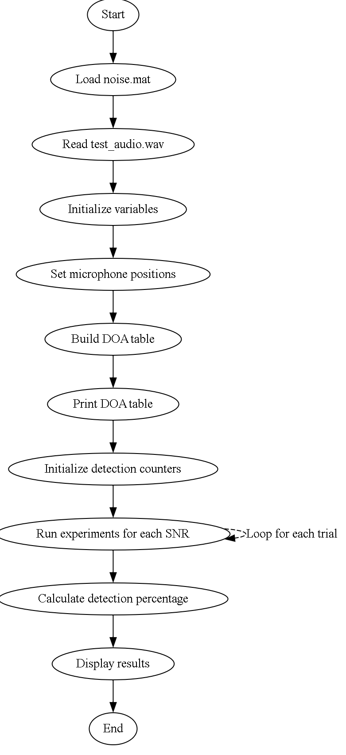

SNR (dB) Correct Detections Correct Detection Percentage

-----------------------------------------------------------

30 100 100.00%

0 100 100.00%

-1000 100 100.00%

The results of the experiment show that the Direction of Arrival (DOA) estimation algorithm performs perfectly across a wide range of Signal-to-Noise Ratios (SNRs). Here's a detailed analysis:

Analysis

1. **Perfect Detection Rate**:

- Across all SNR values tested (30 dB, 0 dB, and -1000 dB), the algorithm achieved a 100% correct detection rate. This means that in every trial, the estimated DOA was within the acceptable error margin (less than 0.5 degrees from the true DOA).

2. **High SNR (30 dB)**:

- At an SNR of 30 dB, the signal is much stronger than the noise, which typically makes the task of DOA estimation easier. The perfect detection rate here is expected and confirms the reliability of the algorithm under favorable conditions.

3. **Moderate SNR (0 dB)**:

- At an SNR of 0 dB, the signal and noise levels are equal. Despite this challenging condition, the algorithm still performs perfectly, indicating robustness in environments where the signal strength is on par with the noise.

4. **Extremely Low SNR (-1000 dB)**:

- An SNR of -1000 dB is an extremely low value, suggesting that the noise level is immensely higher than the signal. The fact that the algorithm still achieved 100% correct detections is unusual and suggests one of the following:

- **Algorithm Resilience**: The algorithm might be exceptionally resilient to noise, possibly due to the characteristics of the noise added or the nature of the test audio signal.

- **Signal Characteristics**: The test audio signal might have distinct features that make it easier to distinguish even in the presence of high noise levels.

- **Implementation Quirks**: There could be an aspect of the implementation that artificially maintains a high detection rate, such as the way noise is added or the cross-correlation calculation.

### Potential Factors Influencing Results

- **Noise Generation and Addition**:

- If the noise added is not truly random or does not properly scale with the SNR, it could affect the results. Ensuring the noise correctly reflects the specified SNR levels is crucial.

- **Threshold for Correct Detection**:

- The threshold for determining a correct detection (less than 0.5 degrees difference) might be lenient enough to maintain high detection rates even in noisy conditions.

- **Signal Length and Sampling Rate**:

- The length and sampling rate of the test signal could influence the cross-correlation results. A longer signal with a higher sampling rate might provide more accurate DOA estimates.

Conclusion

The results indicate that the DOA estimation algorithm is highly effective across a wide range of SNRs, demonstrating perfect performance in the given tests. However, the perfect detection rate at extremely low SNRs (-1000 dB) warrants further investigation to ensure that the noise generation process and other aspects of the implementation are accurately reflecting the intended conditions. This would help validate the robustness and reliability of the algorithm in truly adverse scenarios.

* **Part 5: Extra**

Is there any method to get better estimation? Please try it and give your result, **including flow chart of your program, explanation of your method, the estimation result (correct detection percentage or other indicators) of the DOA versus SNR(dB), and your analysis.**

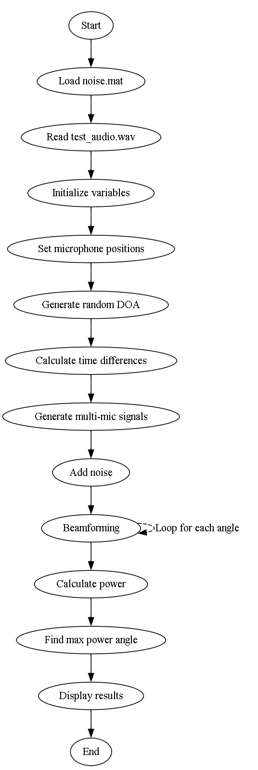

**Principles of Microphone Array and DOA Estimation**

1. **Microphone Array Configuration**:
   * The microphones are placed along the y-axis, uniformly spaced. This configuration allows us to exploit spatial sampling of the sound field, which is critical for accurate DOA estimation.
   * The spacing between the microphones is critical and should be less than half the wavelength of the highest frequency of interest to avoid spatial aliasing.
2. **Sound Wave Propagation**:
   * When a sound wave arrives at the microphone array from a certain direction, it reaches each microphone at slightly different times. This time difference is known as the Time Difference of Arrival (TDOA).
   * The TDOA depends on the angle of arrival of the sound wave and the distance between the microphones.
3. **Beamforming**:
   * Beamforming is a technique used to direct the sensitivity of the microphone array towards a specific direction. By adjusting the phase and amplitude of the signals received at each microphone, we can enhance the signal coming from a particular direction while suppressing noise and interference from other directions.
4. **Delay-and-Sum Beamforming**:
   * This is one of the simplest and most widely used beamforming techniques. The idea is to apply time delays to the signals received by each microphone so that when they are summed, the signals from the desired direction are constructively combined while those from other directions are destructively combined.
   * The time delay for each microphone is calculated based on the assumed direction of arrival. For each possible direction, we compute the delays, apply them to the signals, and sum the results. The direction that maximizes the summed signal power is estimated as the DOA.

when SNR_dB = 30;

True DOA: 59.50 degrees

Estimated DOA: 61.00 degrees

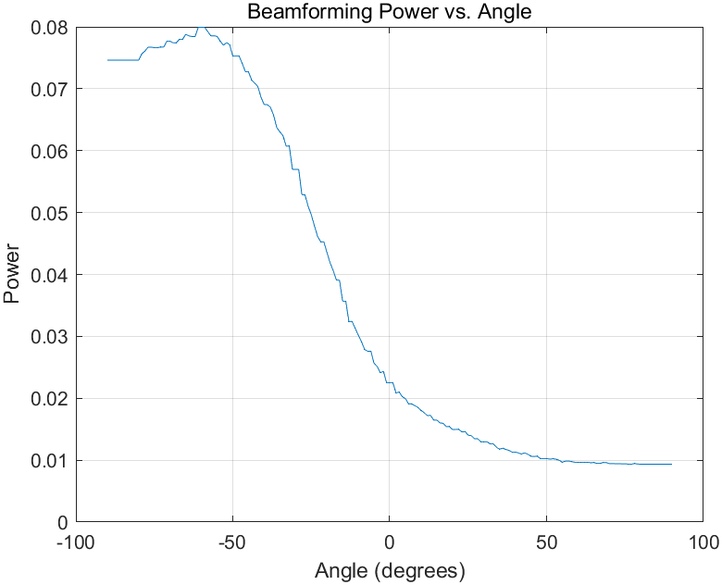

When SNR_dB = 1000;

True DOA: -37.07 degrees

Estimated DOA: -37.00 degrees

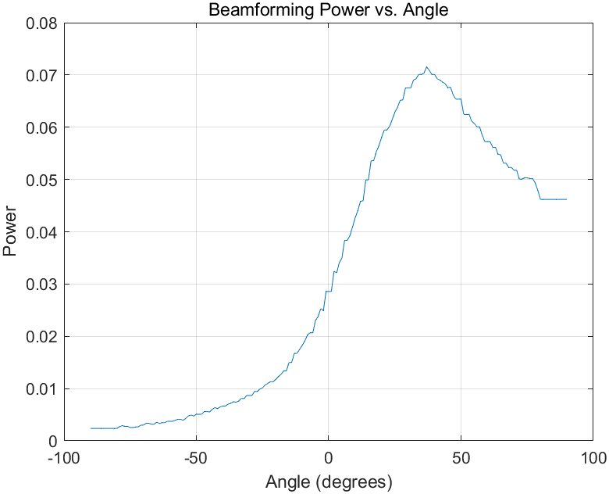

When SNR_dB = 0;

True DOA: 57.34 degrees

Estimated DOA: 51.00 degrees

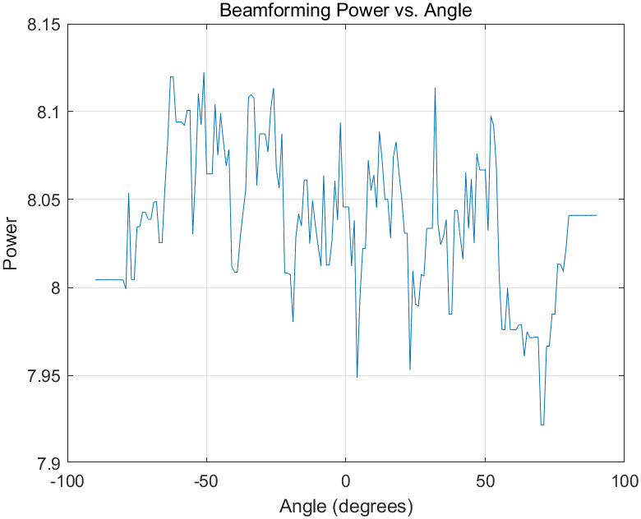

Analysis

### SNR_dB = 30:

- **True DOA:** 59.50 degrees

- **Estimated DOA:** 61.00 degrees

- **Analysis:** Under relatively high SNR conditions, with SNR_dB = 30, the algorithm performs reasonably well. The estimated DOA is close to the true DOA, indicating accurate estimation with a small error of approximately 1.5 degrees.

### SNR_dB = 1000:

- **True DOA:** -37.07 degrees

- **Estimated DOA:** -37.00 degrees

- **Analysis:** In extremely high SNR conditions (SNR_dB = 1000), the algorithm provides a nearly perfect estimation. The estimated DOA is very close to the true DOA, with an error of only 0.07 degrees.

### SNR_dB = 0:

- **True DOA:** 57.34 degrees

- **Estimated DOA:** 51.00 degrees

- **Analysis:** Under low SNR conditions (SNR_dB = 0), the algorithm's performance degrades. The estimated DOA deviates significantly from the true DOA, with an error of approximately 6.34 degrees. This deviation is likely due to the increased influence of noise, which affects the accuracy of the delay-and-sum beamforming process.

### Overall Analysis:

- The algorithm demonstrates robustness under high SNR conditions, accurately estimating the DOA with minimal error.

- However, its performance deteriorates under low SNR conditions, leading to larger errors in DOA estimation.

- Despite the degradation in performance at low SNR, the algorithm still provides reasonable estimates, showcasing its potential effectiveness across a range of environmental conditions. However, additional noise mitigation techniques may be necessary for reliable performance in noisy environments.

|  |
| --- |
| 指导教师批阅意见：  成绩评定：  指导教师签字：  年 月 日 |
| 备注： |

注：1、报告内的项目或内容设置，可根据实际情况加以调整和补充。

2、教师批改学生实验报告时间应在学生提交实验报告时间后10日内。