**深 圳 大 学 实 验 报 告**

**课程名称：­ 随机信号处理**

**实验项目名称： The periodogram and Correlogram method to estimate power spectrum**

**学院： 电子与信息工程学院**

**专业： 电子信息工程**

**指导教师： 孙维泽**

**报告人： 卫宏林 学号： 2022300013**

**班级： 文华班**

**实验时间： 2024.06.01-2024.06.19**

**实验报告提交时间： 2024.06.19**

**教务处制**

Description of format:

* Use Times New Roman, 12 pt, single column, single line spacing.
* When inserting figures and tables, title of the figures and tables must be included.
* Do not change ‘1、Purposes of the experiment’ and ‘2、Design task and detail requirement’.

**1、Purposes of the experiment**

1. learn the periodogram and Correlogram method to estimate power spectrum.
2. Use Matlab to sample a chirp signal and learn the matched filter.
3. Analyze the results and draw reasonable conclusions

**2、Design task and detail requirement**

See ‘Appendix 1 – Task and requirement for experimental report 3.doc’.

**3、The result and Analysis**

* **Part 1: Basic 1 (40 points)**

You should submit your codes that can generate the figures in 3). The codes should be runnable!

**1) Plot the Periodogram with different window (rectangular and hamming), and compare the results, describe the differences.**

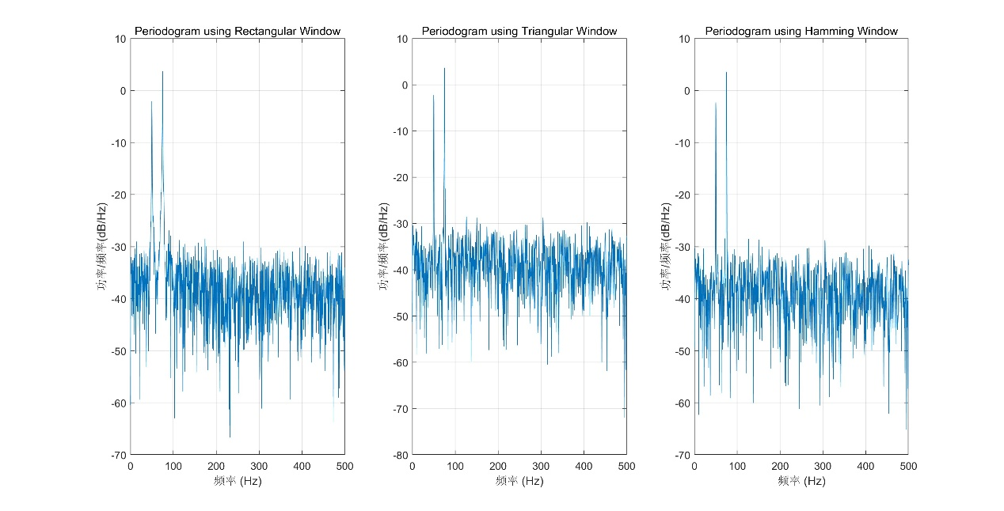

Figure 1 Periodogram with different window

**Rectangular Window**: Provides the baseline periodogram but can have higher spectral leakage.

**Triangular Window**: Reduces spectral leakage compared to the rectangular window.

**Hamming Window**: Further reduces spectral leakage and provides a smoother spectrum.

**2) Change the sampling rate, signal length, FFT length and the value of , use the Periodogram to do the spectrum estimation. Show your results (you can use figures and/or figures), and give analysis.**

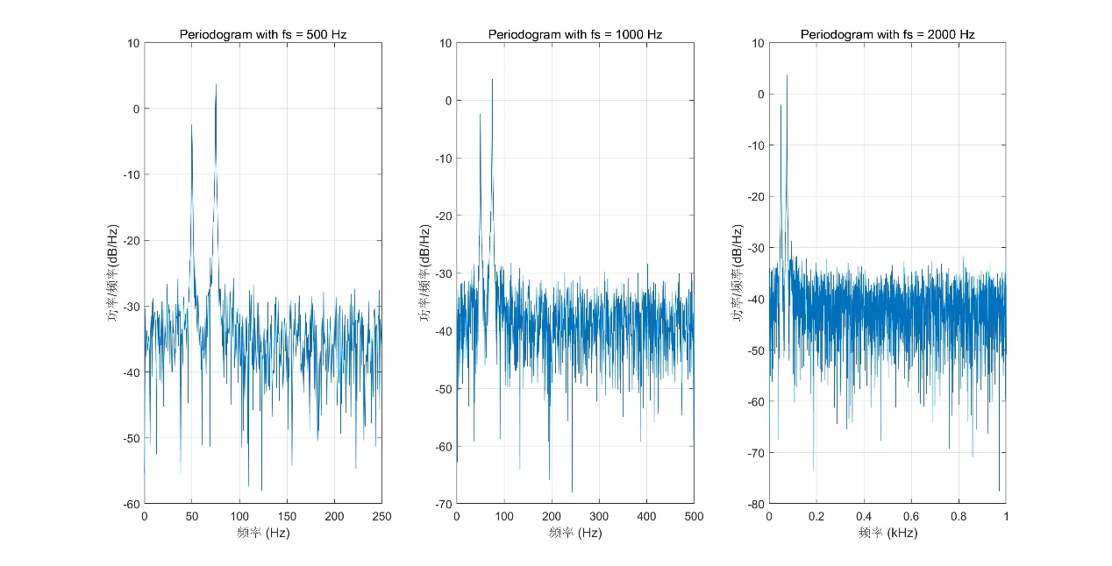

Figure 2 Periodogram with different fs

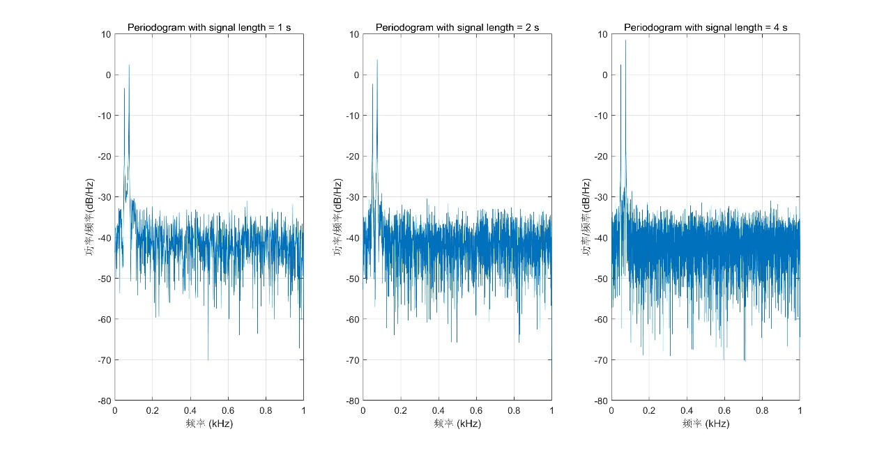

Figure 3 Periodogram with different signal length

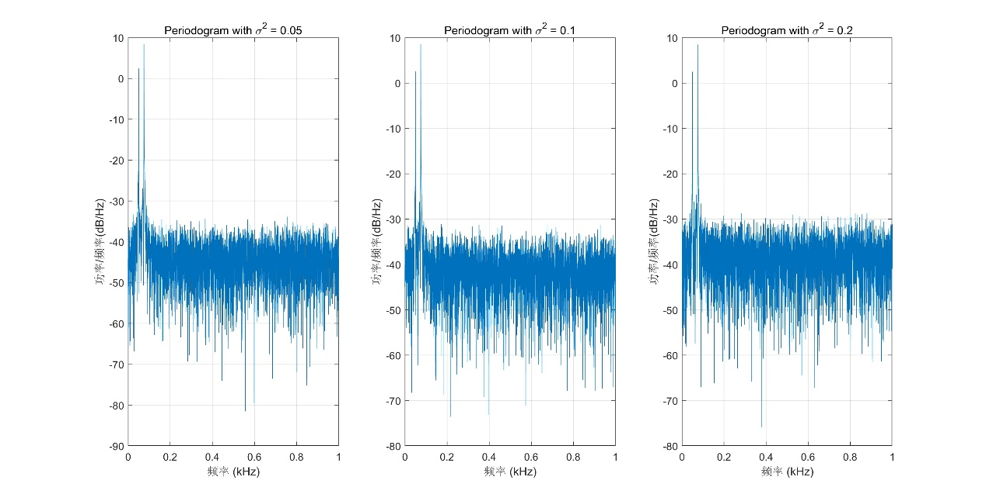

Figure 4 Periodogram with different sigma

**Sampling Rate**:

* Higher sampling rates result in better frequency resolution.
* Lower sampling rates might not capture higher frequency components accurately.

**Signal Length**:

* Longer signals provide better frequency resolution in the periodogram.
* Shorter signals may result in less accurate power spectrum estimates.

**Noise Variance (σ2\sigma^2σ2)**:

* Higher noise variance results in a noisier periodogram with less clear frequency components.
* Lower noise variance results in a cleaner periodogram with more distinct frequency components.

**3) plot the figures/tables in 2) using your own Periodogram and Correlogram again, and show the comparison between your own Periodogram and Correlogram function and the default Periodogram function used in 2)**

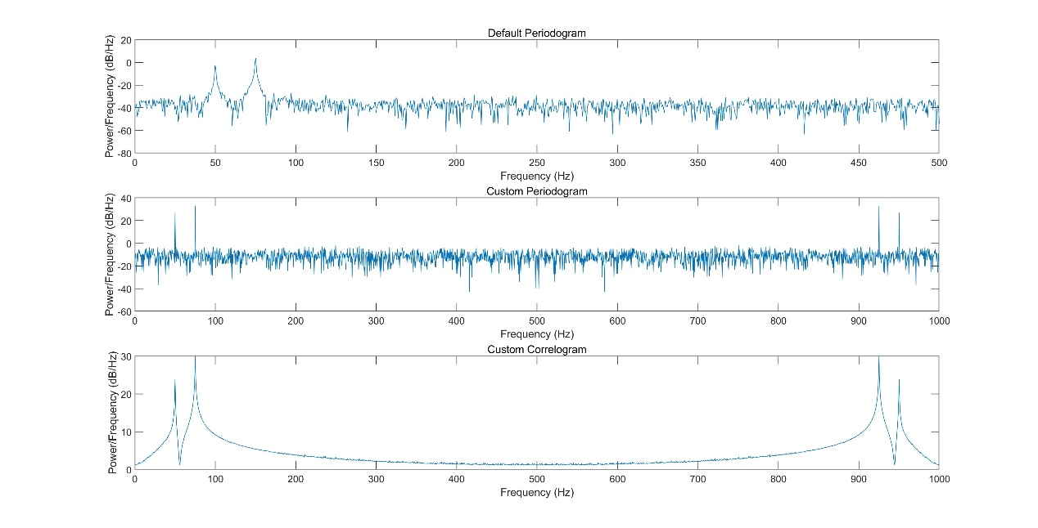

Figure 5 Periodogram and Correlogram

**Custom Periodogram vs Default Periodogram**:

* The custom periodogram computes the DTFT directly using the FFT and normalizes it, which should yield results very similar to the default MATLAB periodogram.
* Minor differences may arise due to the way the FFT and normalization are implemented, but overall, the spectral peaks should align.

**Custom Correlogram**:

* The correlogram method uses the autocorrelation function and then the FFT to estimate the PSD.
* This method may provide a smoother estimate of the PSD, especially for noisy signals, as it considers the signal's autocorrelation.
* **Part 2: Basic 2 (40 points)**

You should submit your codes that can generate the figures in 1). The codes should be runnable!

**1) Plot the periodogram of the 1st, 50nd, 100nd run and the power spectrum. (there are totally four figures, show your figures here only, analysis can be given in 2) below)**

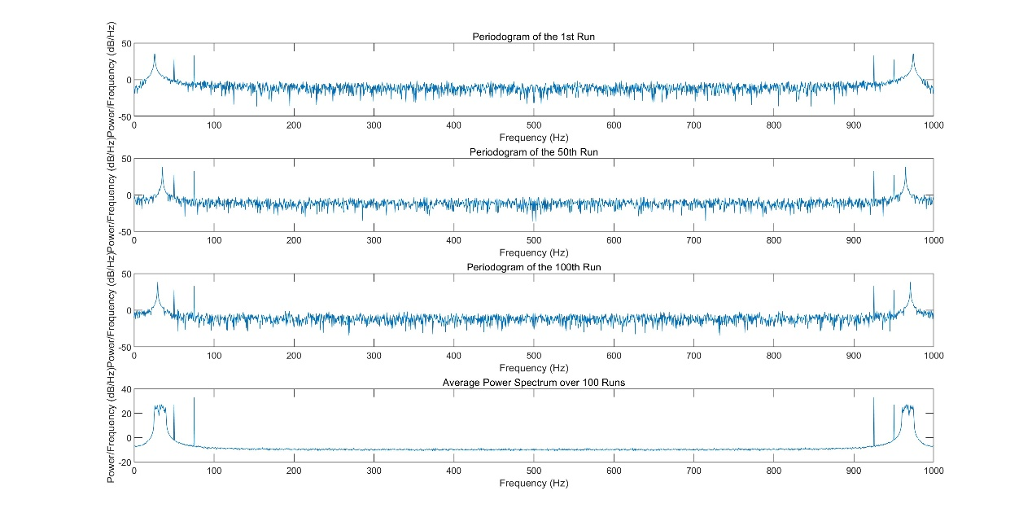

Figure 6 periodogram of the 1st, 50nd, 100nd run and the power spectrum

**2) Show the power spectrum result for different and provide analysis.**

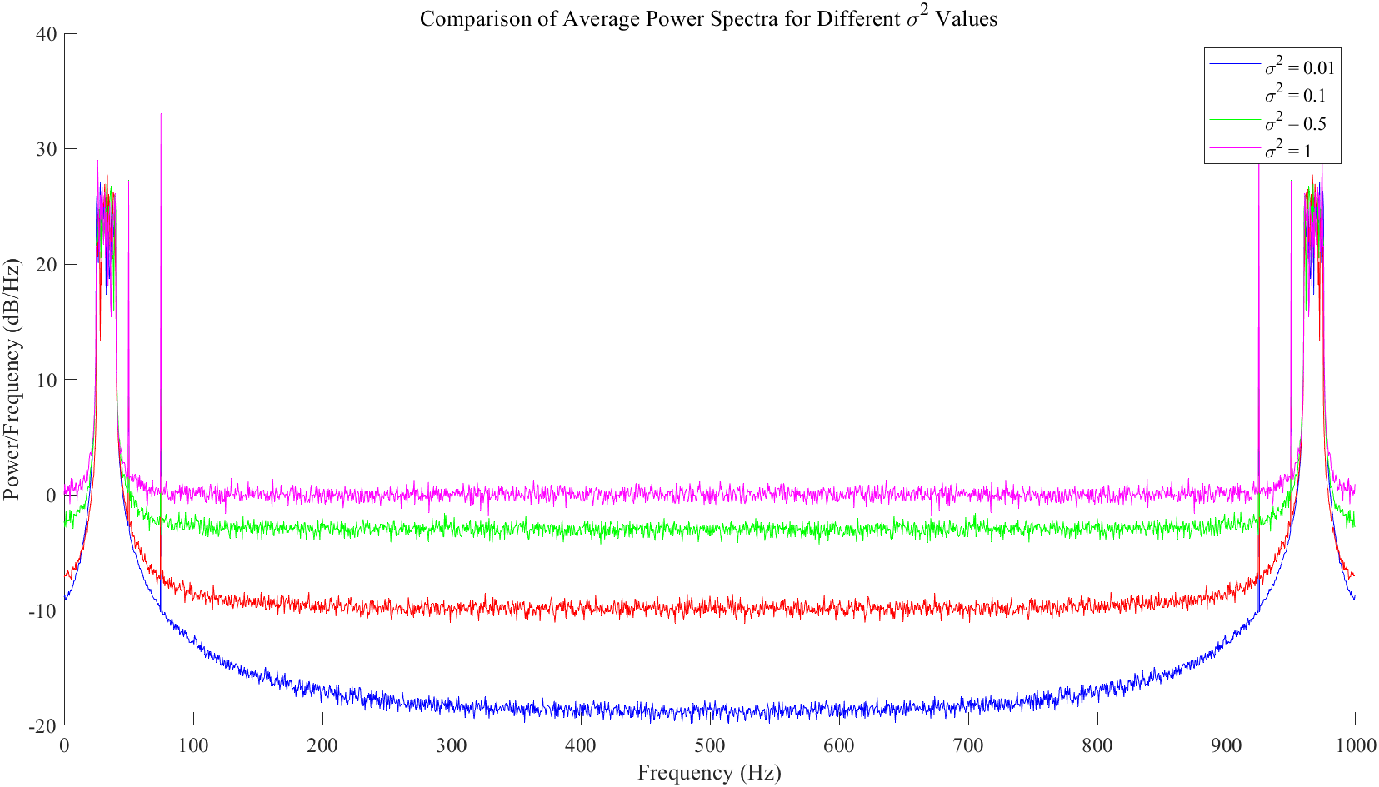

Figure 7 Comparison of Average Power Spectra for Different Values

**Small σ2 (e.g., 0.01)**: The power spectrum will clearly show the frequencies of the signal components ω1\omega_1ω1​, ω2\omega_2ω2​, and ωI\omega_IωI​ with minimal noise interference.

**Moderate σ2 (e.g., 0.1)**: The signal components will still be visible, but the noise floor will be higher.

**Large σ2 (e.g., 0.5)**: The noise will start to obscure the signal components, making it harder to distinguish the frequencies.

**Very Large σ2 (e.g., 1.0)**: The noise will dominate the power spectrum, making it very difficult to observe the signal components.

* **Part 3: Advance (40 points)**

**1)** You are required to submit your code, and your code should directly give all the tables or figures in 1.2).

**1.1) Plot your system flow chart. You can provide necessary explanations.**

**1.2) Give your MSE and success rate results, and analysis, under different SNR. (Hint: use table or figure, and you should choose an SNR range that can at least see ‘100% success’ and ‘100% fail’)**

**2)** You are required to submit your code, and your code should directly give all the tables or figures in 2.2).

**1.1) Plot your algorithm flow chart. You can provide necessary explanations.**

**1.2) Give your MSE and success rate results, and analysis, under different SNR, and compare the results with 1). (Hint: use table or figure, and you should choose an SNR range that can at least see ‘100% success’ and ‘100% fail’)**

|  |
| --- |
| 指导教师批阅意见：  成绩评定：  指导教师签字：  年 月 日 |
| 备注： |

注：1、报告内的项目或内容设置，可根据实际情况加以调整和补充。

2、教师批改学生实验报告时间应在学生提交实验报告时间后10日内。