Electromagnetic field and electromagnetic wave experiment two report

$$adj=\frac{序号}{10}$$

姓名 : 陈奇峰 学号：2022280453 序号：22 $adj=\frac{序号}{10}$ = 2.2

1. **Problem one**
2. Theoretical Calculation

Question: 内外半径分别为a和b的无限长空心圆柱中均匀分布轴向电流I，求柱内外的磁感应强度。

1. When r < a

$\oint{Bdl= μ_{0}I=0}$ then $B=0$

1. When a ≤ r ≤ b
$$\oint{Bdl= μ_{0}I=μ_{0}\frac{π(r^{2}-a^{2})}{π(b^{2}-a^{2})}}I$$

$$B 2πr=μ_{0}\frac{r^{2}-a^{2}}{b^{2-}a^{2}}I$$

$$B =\frac{μ_{0}I(r^{2}-a^{2})}{2πr(b^{2-}a^{2})}$$

2. When r > b
$$\oint{Bdl= μ_{0}I}$$

$$B 2πr=μ_{0}I$$

$$B =\frac{μ_{0}I}{2πr}$$

3. Simulation model

simulation无限长空心圆柱轴线为z轴，内外半径分别为1mm和1.5mm，其上均匀分布轴向电流(1+adj)A，求x轴上**B**的大小。

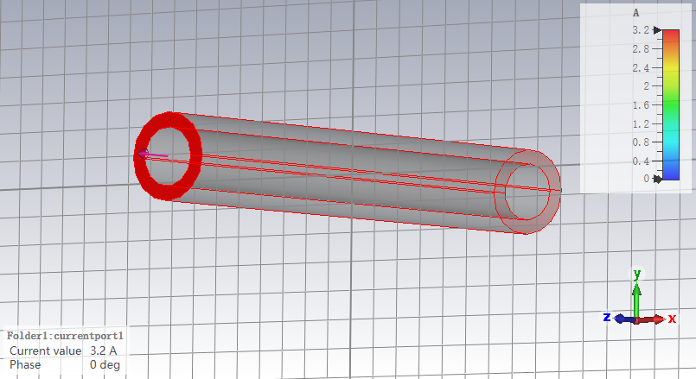

Figure A.1 Model cut graph

1. Comparison and analysis of simulation results and theoretical calculation results
2. The figure of simulation results and theoretical calculation results

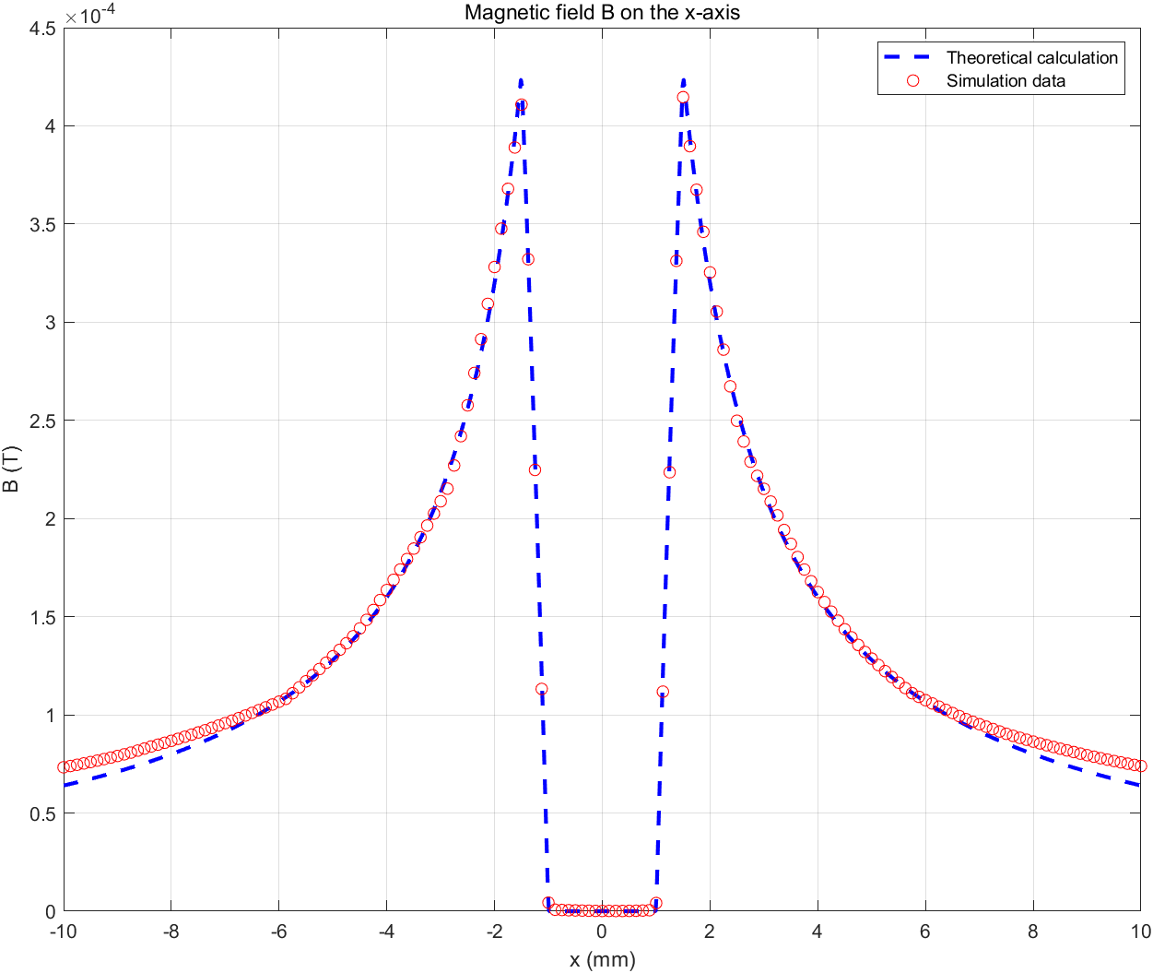

Figure A.2 simulation results and theoretical calculation results

1. The analysis of simulation results and theoretical calculation results

For 0≤x <1.5 mm：The B distribution is zero

For 1.5≤x <2 mm：The B distribution increases linearly.

For x≥2 mm：The B distribution decreases according to an inverse proportional function.

For 0≤x≤2 mm: The calculation and simulation values are in perfect agreement

For x>2 mm: Initially, the simulation values coincide with the calculation values. However, as x increases further, the simulation values gradually become larger than the calculation values. Although there exists tiny error, it is acceptable since it is impossible to absolutely simulate the real world condition.

1. **Problem two**
2. Theoretical Calculation

Question: 求载流的圆形导线回路在圆心处的**B**。

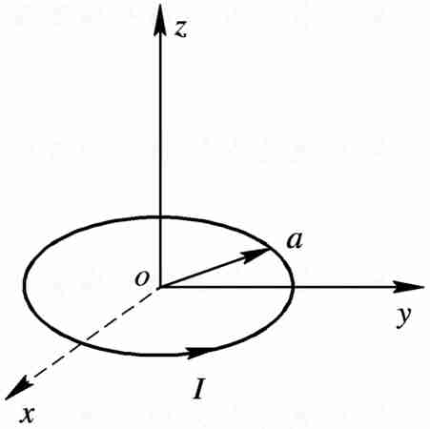

$$ⅆB=\frac{μ_{0}}{4π}⋅\frac{Iⅆr×\vec{γ}}{γ^{3}}=\frac{μ_{0}Iⅆl}{4πr^{2}}$$

$$since by = bz =0$$

$$B=∫Bx=∫\frac{μ_{0}Iⅆl}{4πr^{2}}\sin{θ}$$

$$B=2πa\frac{μ_{0}Ia}{4πr_{3}}=\frac{μ_{0}Ia^{2}}{2}{\left(\frac{1}{\sqrt{a^{2}+z^{2}}}\right)}^{3}$$

1. Simulation model

Simulation: 载流的圆形导线半径为(20+adj)mm,求圆心处**B**的大小。

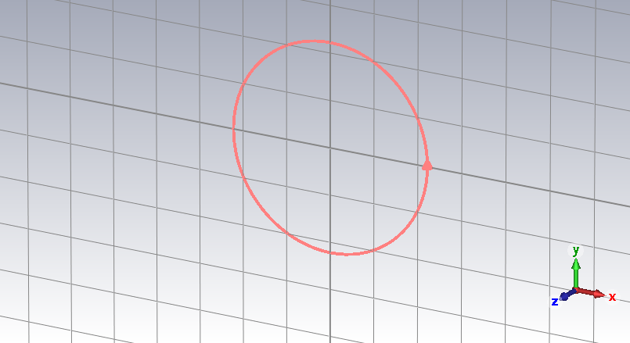

Figure B.1 Model cut graph

1. Comparison and analysis of simulation results and theoretical calculation results
2. The figure of simulation results and theoretical calculation results

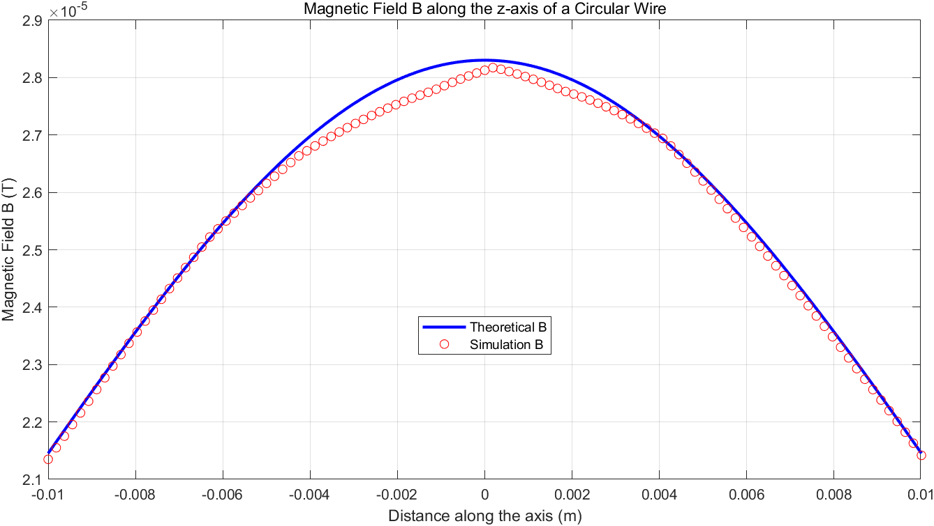

Figure B.2 simulation results and theoretical calculation results

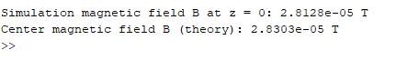

Figure B.3 The B at the center of the circle

1. The analysis of simulation results and theoretical calculation results

At x=0 mm: The B distribution reaches its maximum value. The results of simulation and theory are almost same.

For x>0 mm: The B distribution decreases according to an inverse proportional function.

Possible Reasons for Discrepancy:

The observed discrepancies around x=0 mm may be attributed to:

Solver Accuracy: The accuracy of the solver used in the simulation could also impact the results.

Despite these discrepancies, the errors are considered acceptable since it is inherently challenging to perfectly simulate real-world conditions.

1. **Problem Three**
2. Theoretical Calculation

Question: 同轴线内外导体半径为a，外导体的内半径为b,外半径为c，如下图。设内外导体分别流过反相的电流，两导体之间介质的磁导率为*μ*,求各区域的***H***、***B。***若电流流向+*z*方向

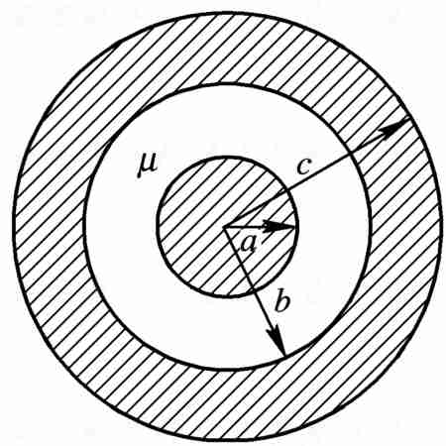

When r <a

$$∮Bⅆl=μ_{0}\frac{πr^{2}}{πa^{2}}I$$

$$2πrB=μ_{0}I\frac{r^{2}}{a^{2}}$$

$$B=\frac{μ_{0}Ir}{2πa^{2}}$$

$$H=\frac{Ir}{2πa^{2}}$$

When a ≤ r ≤ b

$$∮Bⅆl=μ_{0}I$$

$$B=\frac{μI}{2πr}$$

$$H=\frac{I}{2πr}$$

When b ≤ r ≤ c

$$∫Bⅆl=2πrB=μ_{0}\left(I-\frac{π}{π}\frac{\left(r^{2}-b^{2}\right)}{\left(C^{2}-b^{2}\right)}I\right)$$

$$B=\frac{μ_{0}I}{2π\left(C^{2}-b^{2}\right)}\frac{\left(C^{2}-r^{2}\right)}{r}$$

$$H=\frac{I}{2π\left(C^{2}-b^{2}\right)}\frac{\left(C^{2}-r^{2}\right)}{r}$$

When r > c:

$$∫BⅆL=μ_{0}I=0$$

$$B=0$$

$$H=0$$

1. Simulation model

Simulation:同轴线轴线为z轴，a=0.5mm,b=1mm,c=1.5mm, 两导体之间介质的相对磁导率为(4+adj)，求x轴上的***H***、***B***。

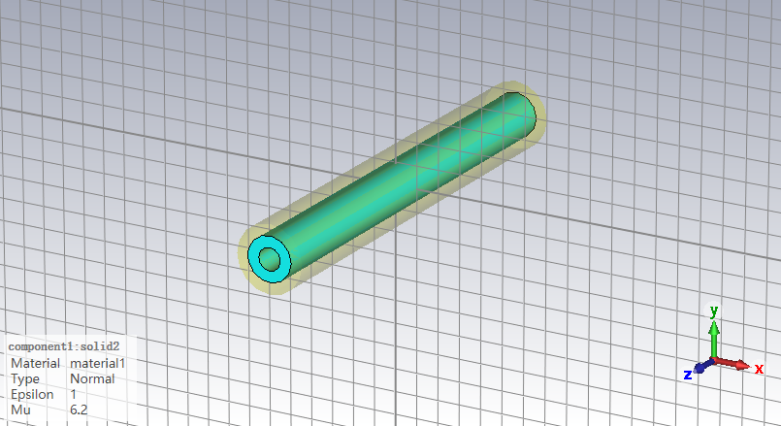  
Figure C.1 Model cut graph

1. comparison and analysis of simulation results and theoretical calculation results
2. The figure of simulation results and theoretical calculation results

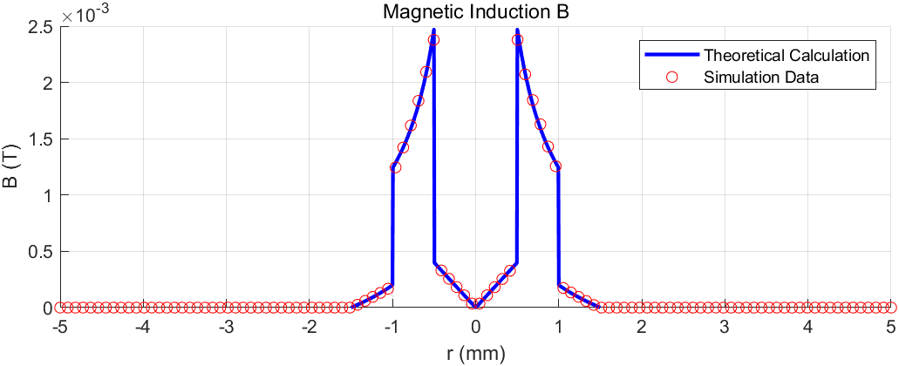

Figure C.2 The result of B

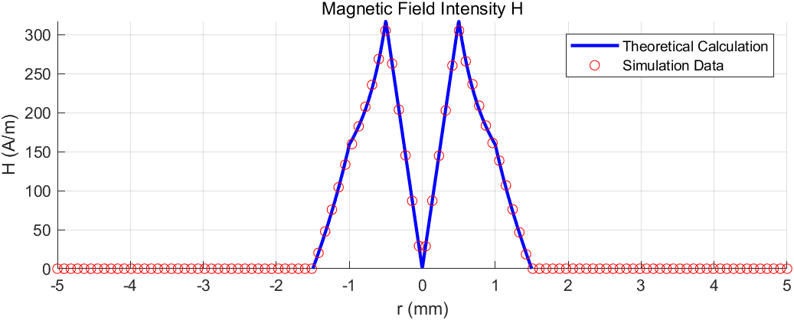 Figure C.3 The result of H

1. The analysis of simulation results and theoretical calculation results

At x=0 mm:

The B and H distribution is 0

For 0<x≤0.5 mm:

The B and H distribution increases linearly.

At x = 0.5 mm:

The B and H distribution reaches its maximum

For 0.5<x<1 mm:

The B and H distribution decreases according to an inverse proportional function.

For 1<x<1.5 mm:

The B and H distribution decreases linearly.

And because of the change of $μ$ when x = 1 mm. So B and H have different change when x = 1mm. The H drop suddenly when x = 1 mm

For x≥1.5 mm:

The B and H distribution is 0

Despite there are some minor discrepancies, the errors are considered acceptable because it is challenging to perfectly simulate real-world conditions.

1. Problem four
2. Theoretical calculation

Question: 两个半径都为a的圆柱体，轴间距为d, d<a，如下图。除两柱重叠部分R外，两柱上各有大小相等、方向相反的电流，密度为**J**,求区域R的**B**。



By adding current distributions with equal values (density J) and opposite directions in the overlapping areas, the current distribution of the original problem can be transformed into a uniformly distributed forward current within one cylinder and a uniformly distributed reverse current within another cylinder. The magnetic field generated by it can be calculated using the superposition principle.

The magnetic induction intensity generated by the current in the positive direction (left cylinder) in the overlapping area

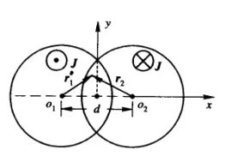

$$∮B_{1}ⅆL=2πr_{1}B_{1}=μ_{0}πr_{1}^{2}J$$

$$B_{1} = \frac{μ_{0}{Jr}_{1}}{2}$$

As the same reason, we can calculate he 2nd cylinder (right cylinder) in the in the overlapping area

$$B_{2} = - \frac{μ_{0}{Jr}_{2}}{2}$$

The we can get the formula below through

$$\vec{B}=\vec{B_{1}}+\vec{B_{2}}=\frac{μ_{0}J}{2}\vec{e_{y}}$$

So the value of B from -0.4 mm to 0.4 mm:

$$B = \frac{μ_{0}J}{2}$$

1. Simulation model

Simulation: 如下图所示，两个圆柱半径为1mm, 轴线与z轴平行，轴线位置分别为x=0.5mm和x=-0.5mm, 除两柱重叠部分R外，两柱上各有大小相等、方向相反的电流1A, 求x轴上[-0.4mm,0.4mm]范围上**B**的大小。

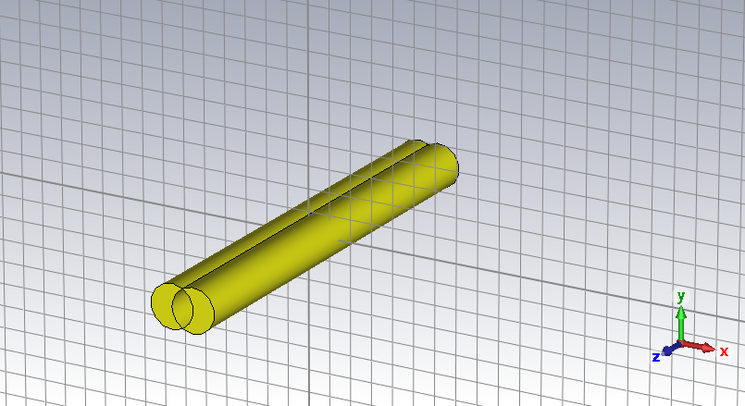

Figure D.1 Model cut graph

1. Comparison and analysis of simulation results and theoretical calculation results
2. The figure of simulation results and theoretical calculation results

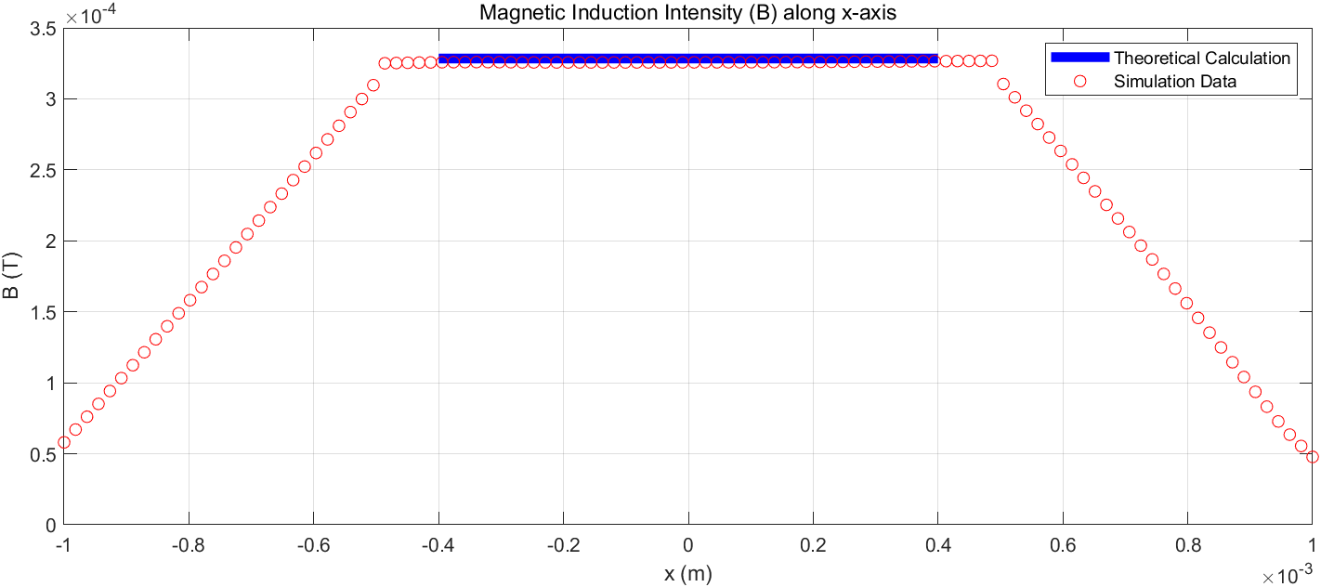

Figure D.2 The result of theory and simulation

1. The analysis of simulation results and theoretical calculation results

Due to the high accuracy corresponding to setting -0.4mm to 0.4mm, the displayed error is obvious and cannot fit well with MATLAB simulation.

So I set -1mm to 1mmWe first analyze the tendency of the B distribution for calculation and simulation value. In the range of [-0.4,0.4]mm, the B distribution is a constant that means the B distribution is the same value along these range.

From the figure, we observe that the calculation value and the simulation value is basically coincide which indicates that the setting of our experiment is reasonable.