Electromagnetic field and electromagnetic wave experiment one report

静电场仿真实验报告

学号：2022300013 姓名：卫宏林 序号 29

1. 理论问题：假设在半径为*a*的球体内均匀分布着密度为*ρ*0的电荷，试求任意点的电场强度。

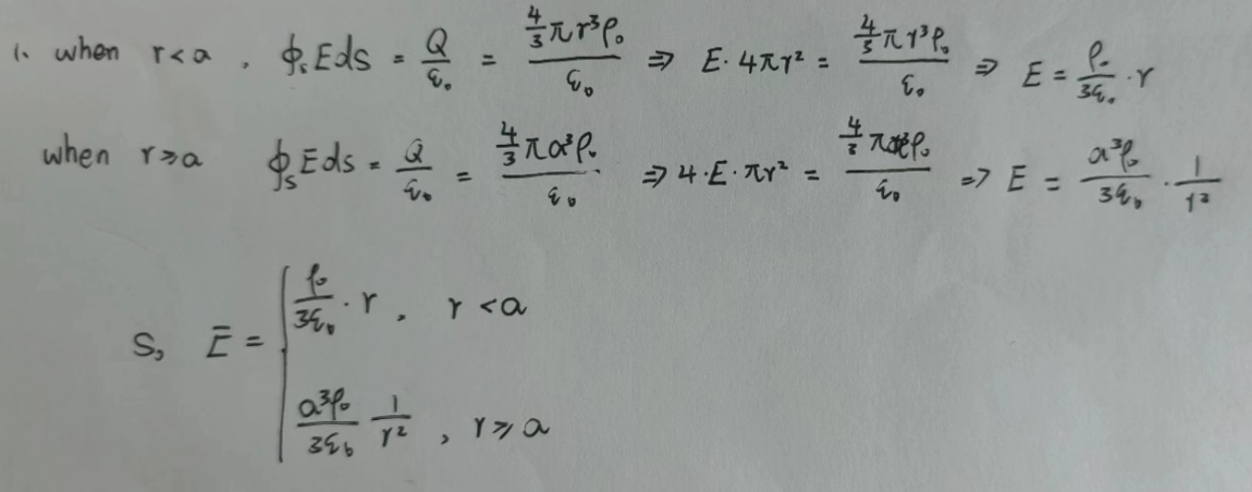

**仿真模型：半径为10mm,介电常数为(1+adj)的小球均匀分布着1C的电荷，当球心在坐标原点，求x轴上的电场.**

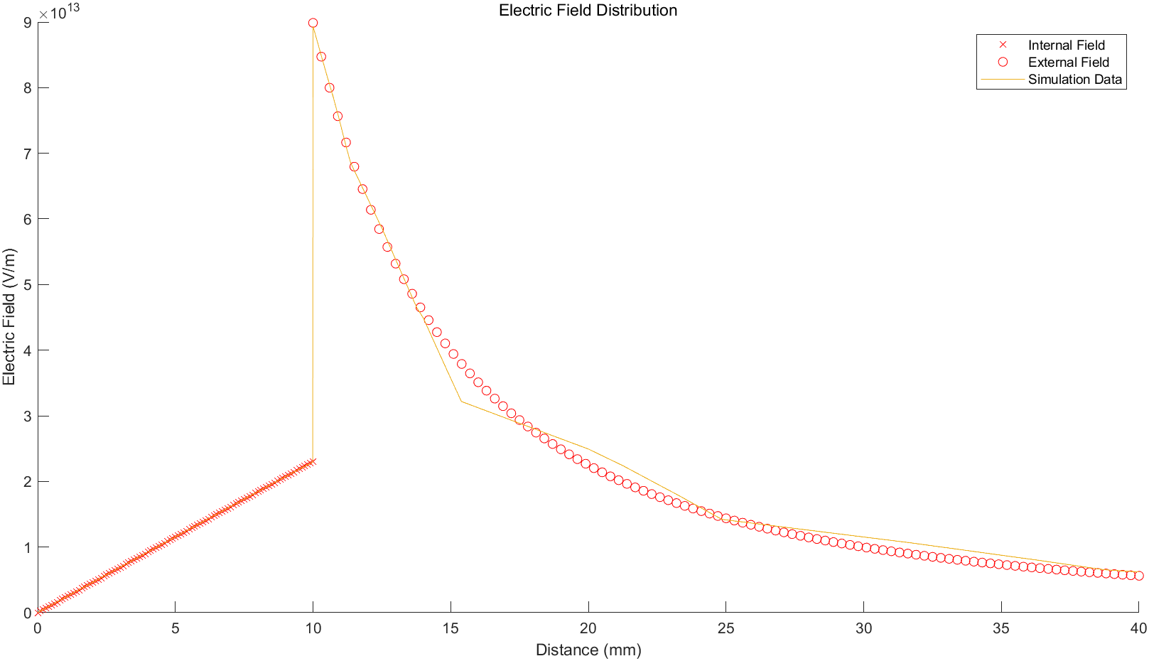

Due to the symmetry, I just show the range of x > 0. The value of x < 0 is the same as the x > 0.

We first observe the change tendency of the E distribution for calculation and simulation value. When R <= 10mm, the E distribution increases by Linear growth. When R > 10mm, the E distribution decreases by inverse proportional function.

When R > 10mm, the electric field intensity suddenly increases rapidly, then gradually decreases. the calculation and simulation value are coincide. However, the maximum of the calculation is different from simulation. The maximum of calculation value is larger than the simulation value. When R > 10mm, the front part is coincide, but with the increase of R, the simulation value is gradually larger than calculation value.

The different may causes by the boundary condition. In the experiment, I set the boundary condition equal to 40 which is relatively small compared to the real situation. Although there exists tiny error, it is acceptable since it is impossible to absolutely simulate the real world condition.

1. 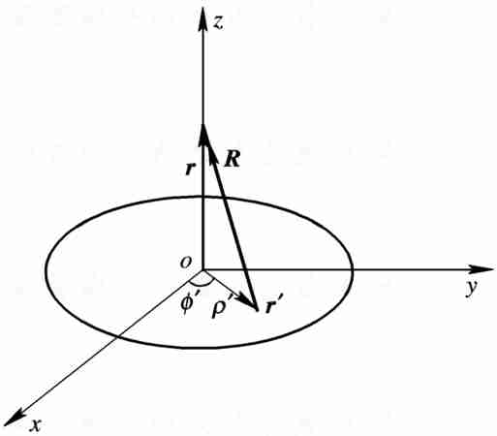理论问题：位于*xoy*平面上的半径为*a*、圆心在坐标原点的带电圆盘，面电荷密度为*ρS*，求*z*轴上的电场强度.

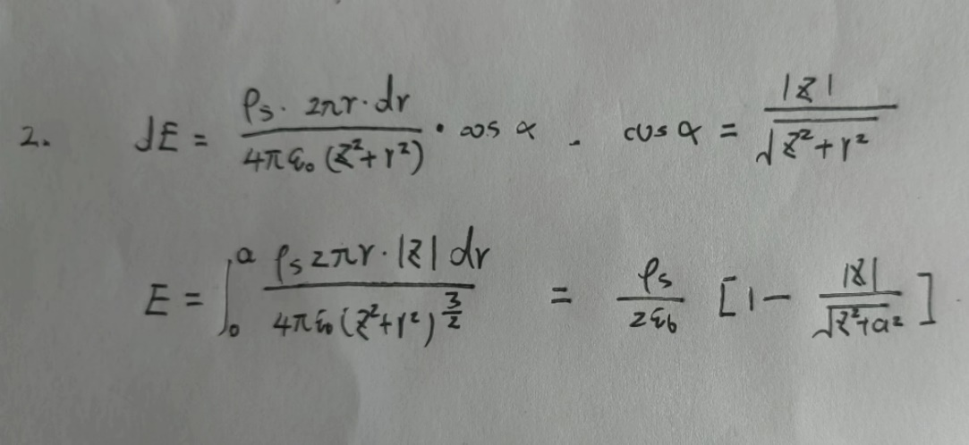

**仿真模型：位于xoy平面上，半径为10mm,介电常数为1的小圆盘匀分布着(1+adj)C的电荷，当圆心在坐标原点，求z轴上的电场.**

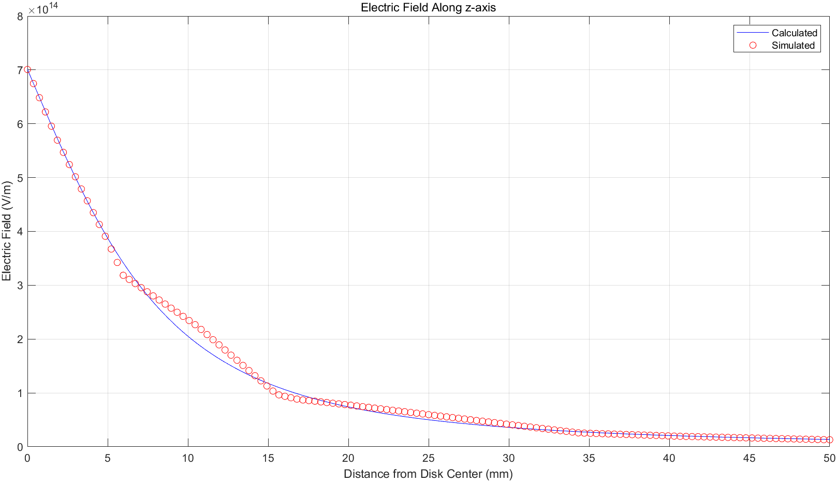

Due to the symmetry, I just show the range of z > 0. The value of z < 0 is the same as the z > 0.

We first observe the change tendency of the E distribution for calculation and simulation value. When z >= 0mm, the E distribution gradually decreases by inverse proportional function and finally stable around zero. From the figure, we observe that the calculation and simulation result is basic equal. When z closes to 30, there exists tiny error between calculation and simulation which affects by boundary condition.

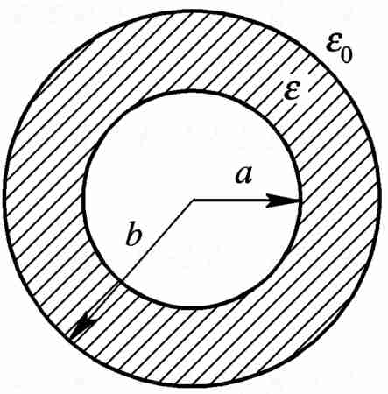3. 理论问题：一个半径为*a*的导体球，带电量为*Q*，在导体球外套有外半径为*b*的同心介质球壳，壳外是空气，如图 所示。求空间任一点的***D***、***E。***

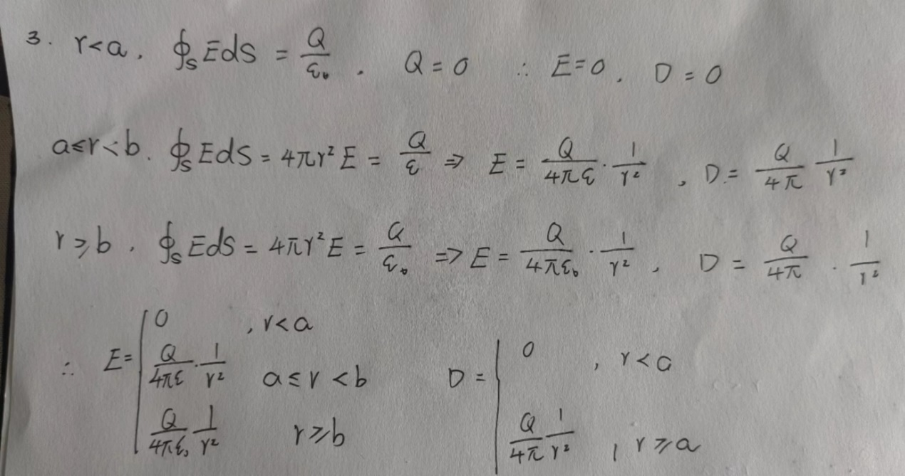

**仿真模型：半径为10mm的理想导体小球均匀分布着1C的电荷，球心在坐标原点。外套有半径为(20+adj*10)mm的相对介电常数为4的同心介质球壳，求x轴上的电场和电位移矢量D.**

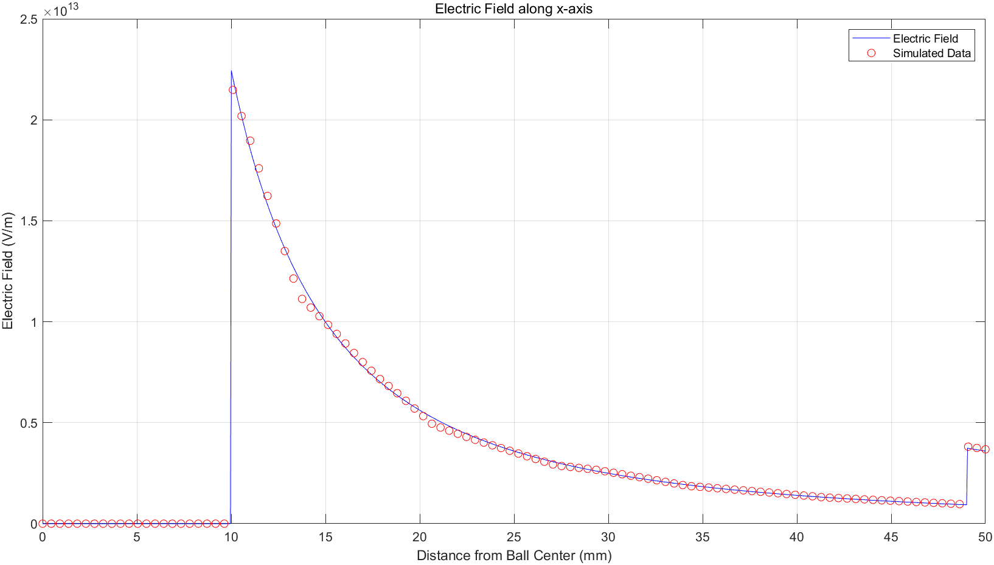

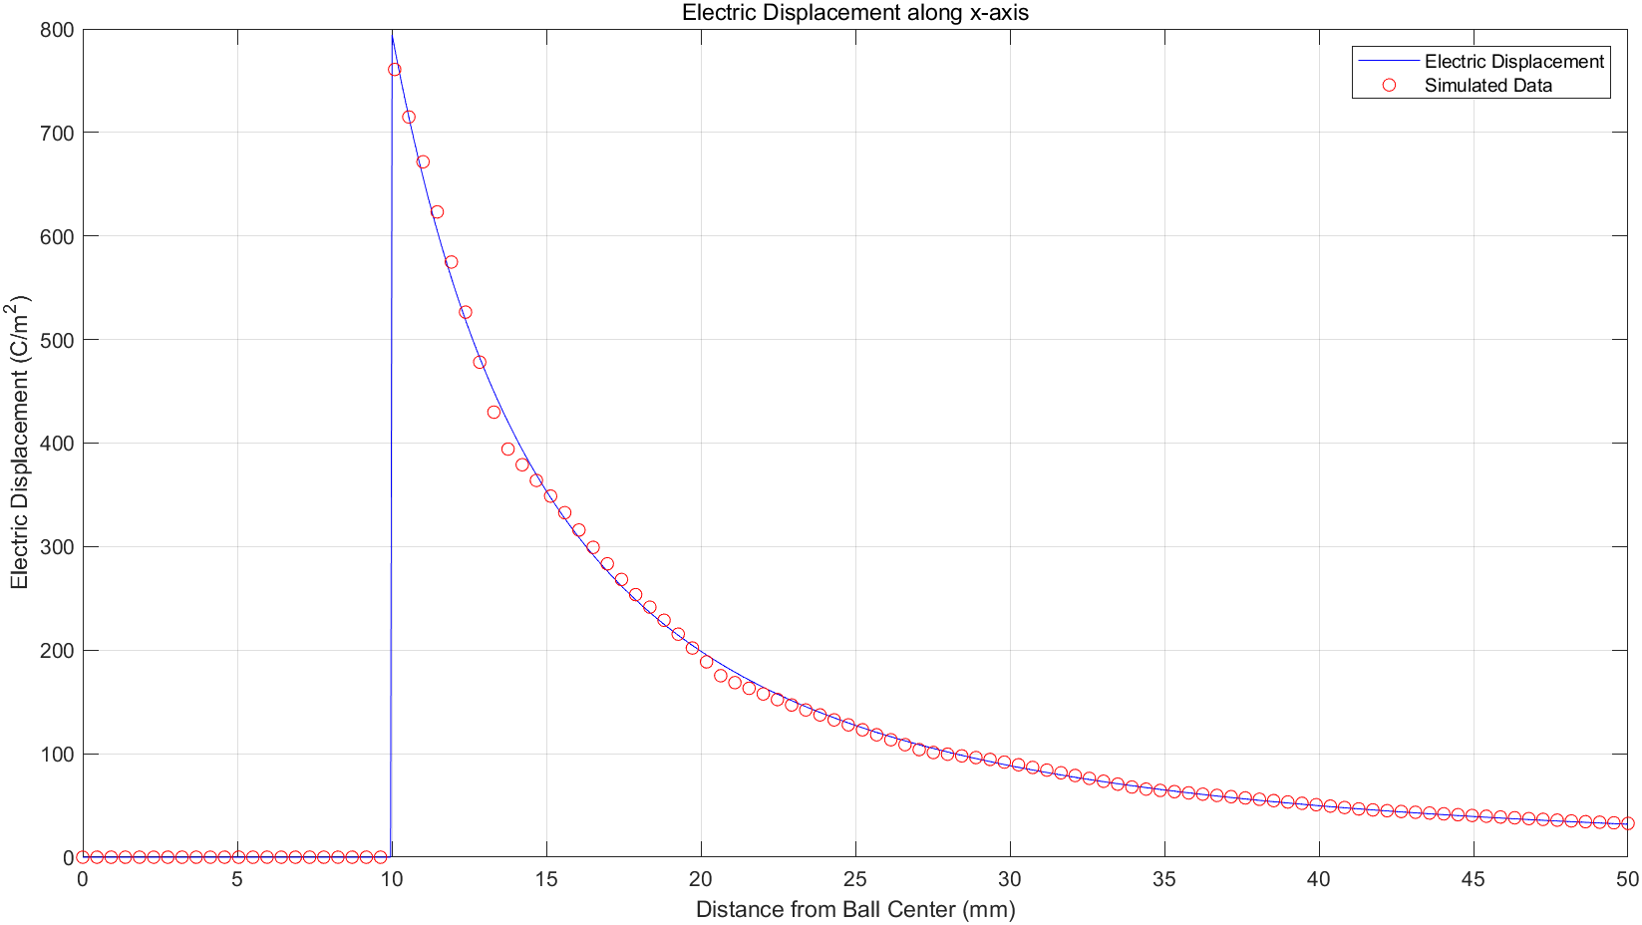

Due to the symmetry, I just show the range of x > 0. The value of x < 0 is the same as the x > 0.

We first observe the change tendency of the E distribution and D distribution for calculation and simulation value. For E distribution, when x < 10mm, the E is equal to 0 since the inner sphere has no charge. When x = 10mm, there happens a sudden change due to the surface charge of the inner sphere. When 10 < x < 20, E gradually decreases by inverse proportional function. When x = 20mm, there happens another sudden change due to the change of epsilon and E increased around four time. When x > 20mm, E gradually decreases by inverse proportional function and finally stable around zero. For D distribution, when x < 10mm, the D is equal to 0 since the inner sphere has no charge. When x = 10, there happen a sudden change due to the surface charge of the inner sphere. When x > 10mm, D gradually decreases by inverse proportional function and finally closes to zero. It is worth to say that D is irrelevant to epsilon, so there may not change in x = 20mm.

We observe there exists some error between calculation and simulation when x = 10mm, x = 20mm and x tendency to 43. For the error of x = 10mm and x = 20mm, one possible reason is that the material of the sphere. In the experiment, we use air material for conduct sphere, however, in real world the material of conduct sphere is different to air material. For the error of x > 43mm, this causes by the boundary condition which has been emphasized in the former experiment. In conclusion, it is Inevitable to avoid this tiny errors which are acceptable.

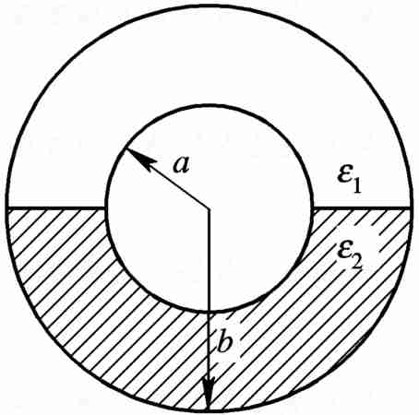4. 理论问题：同心球电容器的内导体半径为*a*，外导体的内半径为*b*，其间填充两种介质，上半部分的介电常数为*ε*1，下半部分的介电常数为*ε*2，如图 所示。设内、外导体带电分别为*q*和－*q*，求各部分的电位移矢量和电场强度。

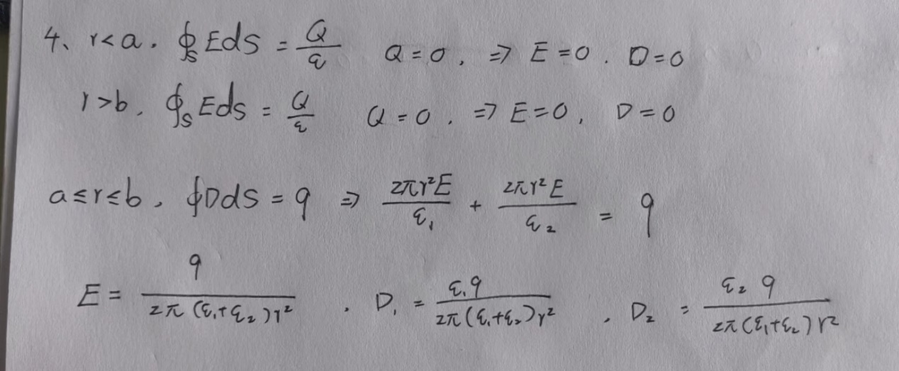



**仿真模型：同心球电容器的内导体半径为10mm，外导体的内半径为20mm，其间填充两种介质，上半部分的相对介电常数为(2+adj)，下半部分的相对介电常数为4，设内、外导体带电分别为1C和－1C，求x轴上的电场和电位移矢量D.(x轴经过两个介质半球的顶点与同心球的球心，指向介电常数较小的半球)**



**X轴**

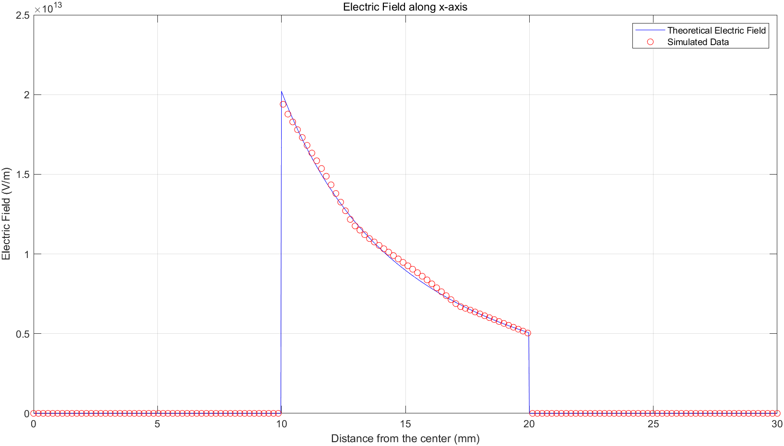

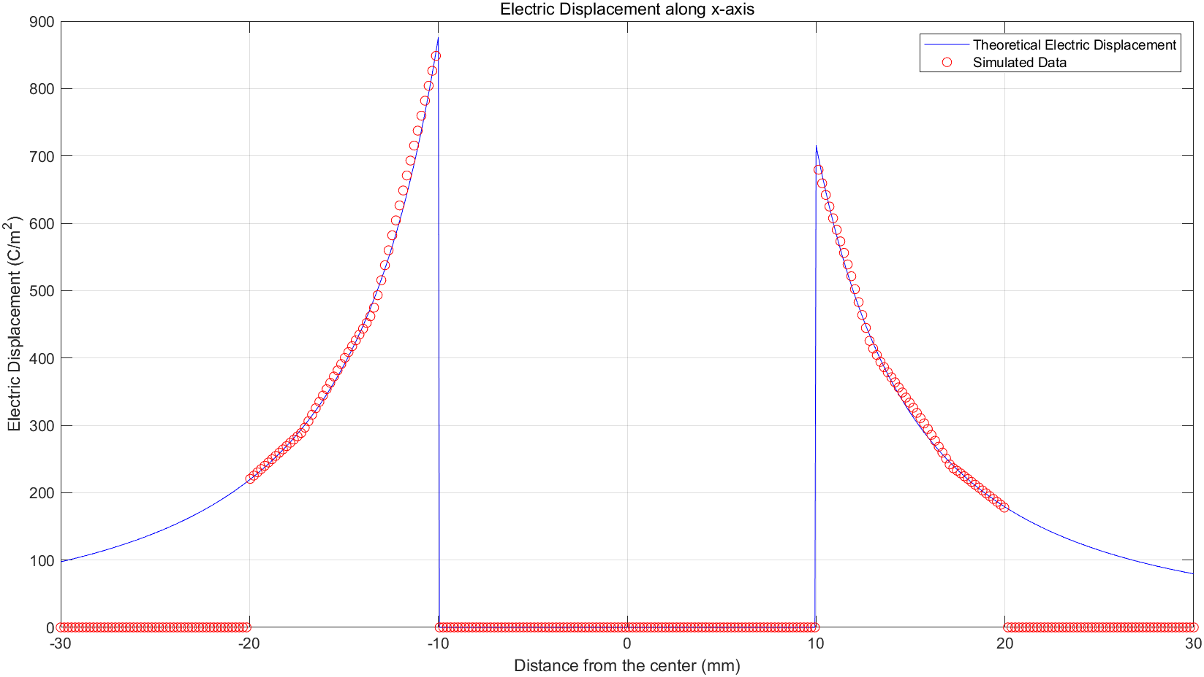

I plot the whole x axis for the E distribution and D distribution since there may be different around the x = 0mm. We first observe the change tendency of the E distribution and D distribution for calculation and simulation value. For E distribution, we observe that E is symmetry to x = 0mm duo to the boundary condition of E theorem, so we just look the range of x > 0mm. When 0 < x < 10mm, E is equal to 0 since there is no free charge in the inner sphere. When x = 10mm, there happens a sudden change due to the surface change of the inner sphere. When 10 < x <20, E gradually decreases by inverse proportional function. When x = 20mm, E is equal to 0 since conduct sphere isolates the outside area. For D distribution, when x < -20, D is equal to 0 since conduct sphere isolates the outside area. When x = -20mm, there happens a sudden change due to the surface charge of the inner sphere. When -20 < x < -10, D increases by inverse proportional function. When -10 <= x <= 10mm, D is equal to 0 due the characteristic of conduct sphere. When x = 10mm, there happen another change due to the surface charge of the inner sphere. When 10 < x <= 20mm, D is decreased by inverse proportional function. When x > 20mm, D is equal to 0 since the outer conduct sphere isolates the outside area. It is worth to say that when -20 < x < -10 and 10 < x < 20, the change magnitudes are different since the epsilon is different in these two specific area.

We observe there exist some error between calculation and simulation result when x = -10mm and x = 10mm. When x = -10 and x = 10mm, it cross the shell of the conduct sphere and its material is ideal PEC which may be different with the real word situation so it may cause this error, however, the tiny error is acceptable.

5. 理论问题：半径分别为a、b（a>b）,球心距为c(c<a-b)的两个球面间有密度为ρ的均匀体电荷分布，求半径为b的球面内任意一点的电场强度。设c沿着x轴正方向。

**c**

**b**

**a**

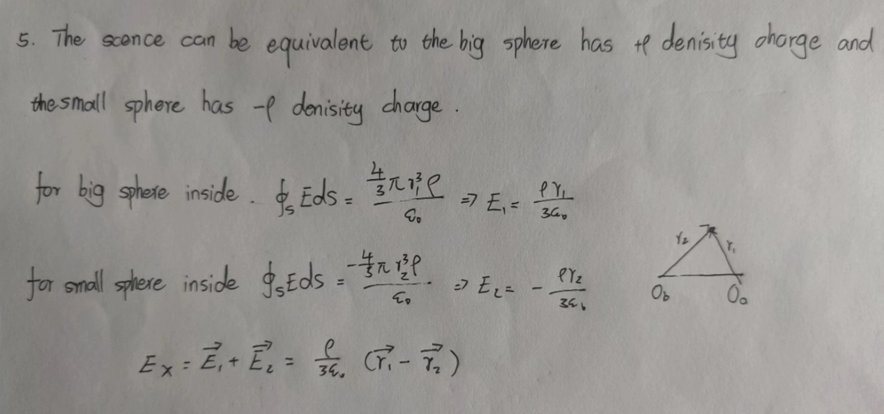



**仿真模型：半径分别为20mm、8mm, 对应球心坐标分别为（0,0,0）和（10mm,0,0）的两个球面间有1C均匀体电荷分布，求x轴上[2mm,18mm]的电场.**

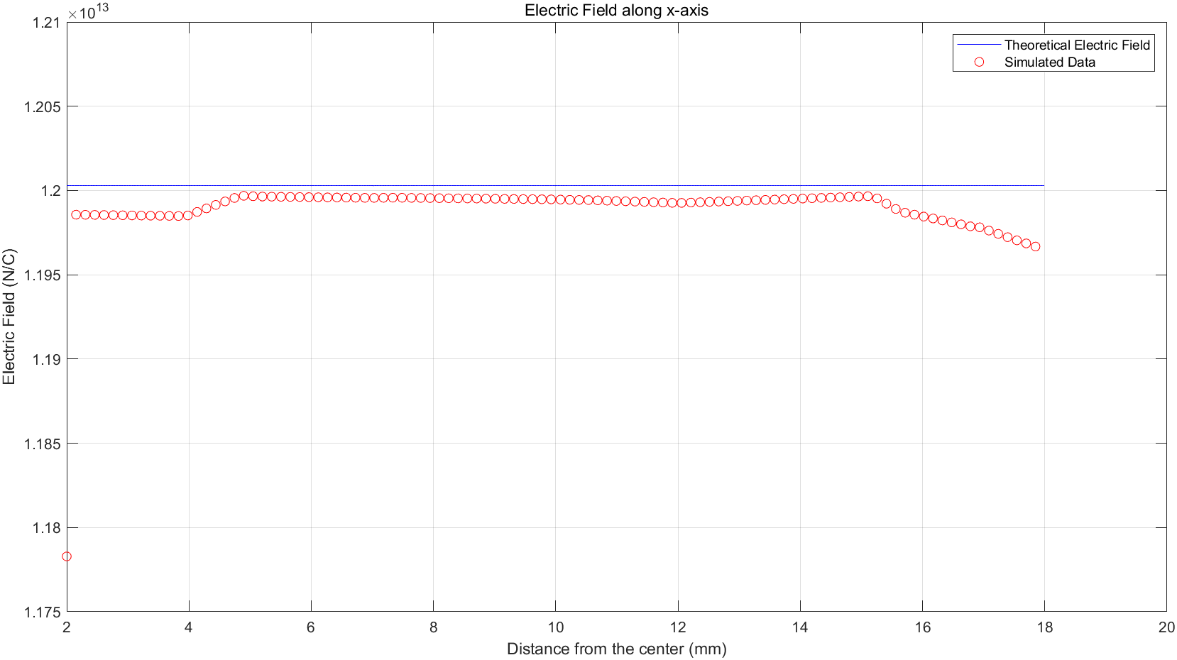

For calculation result, it confirms that E should be a constant value. But the simulation result show that in the range of 2mm-18mm, E may not be a constant and increases along x. In fact, the range of 2mm-18mm is in the inner sphere, so we calculate the E distribution in the inner sphere. We first consider the maximum error rate which is around (1.2-1.167)/1.2=2.75%. In this perspective, it seems that the error is acceptable. Now we try to analyse this error: First this may cause by boundary condition. If we enlarge the boundary condition, E may more close to 1.2×1013 and more stable. In addition, the effect integral by the charge distributed in the space between inner sphere and outer sphere is not uniform along 2mm-18mm so it may exist tiny error along x.