Electromagnetic field and electromagnetic wave experiment two report

稳恒电流的电场与磁场仿真实验报告

学号：2022300013 姓名：卫宏林 序号 29

1. Theoretical problem: The axial current I is uniformly distributed in an infinitely long hollow cylinder with inner and outer radii a and b, respectively, and the magnetic induction intensity inside and outside the column is obtained.



Simulation model: the infinite length hollow cylindrical axis is the z-axis, the inner and outer radii are 1mm and 1.5mm, respectively, and the axial current (1+adj)A is evenly distributed on it, and the magnitude of B on the x-axis is obtained.

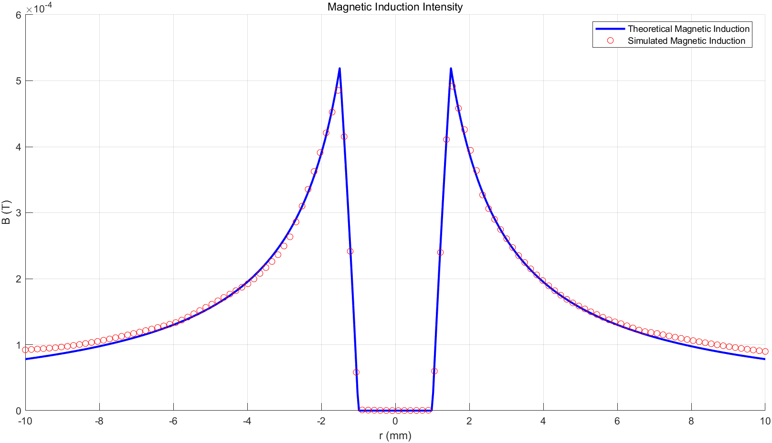

Figure 1simulation results and theoretical calculation results

1. The analysis of simulation results and theoretical calculation results

We first analyze the tendency of the B distribution for calculation and simulation value. From the figure, we observe that the B distribution is symmetrical so we only analyze the B distribution along positive x axis. When 0<=x<1.5mm, the B distribution is equal to 0. When 1.5<=x<2, the B distribution is linear increasing. When x>=2mm, the B distribution decreases by inverse proportional function.

When 0 <= x <= 2mm, the calculation value and simulation value is coincide. When x > 2mm, the front part is coincide, but with the increase of x, the simulation value is gradually larger than calculation value.

The difference may causes by the boundary condition. In the experiment, I set the boundary condition is equal to 5 for x axis and y axis respectively which is relatively small compared to the real situation. Although there exists tiny error, it is acceptable since it is impossible to absolutely simulate the real world condition.

1. Theoretical problem: Find B at the center of the circle of the circular wire loop that carries the current carry.



Simulation model: the radius of the current-carrying circular wire is (20+adj)mm, and the size of B at the center of the circle is obtained.

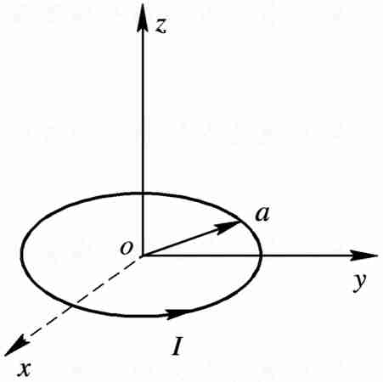

Figure 2 Diagram

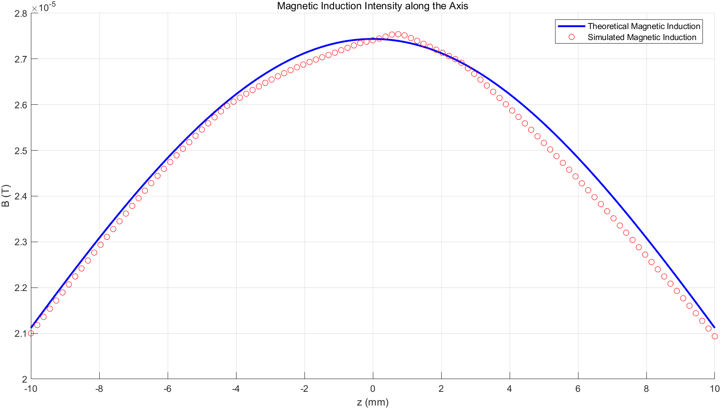

Figure 3simulation results and theoretical calculation results

We first analyze the tendency of the B distribution for calculation and simulation value. From the figure, we observe that the B distribution is symmetrical so we only analyze the B distribution along positive x axis. When x = 0mm, the B distribution reaches to the maximum. When x > 0mm, the B distribution decreases by inverse proportional function.

We observe that around x = 0mm, the calculation value and simulation value have some deviation. When x > 0mm, the calculation value and simulation value is basically coincide until x around 30mm.

The two difference may causes by the boundary condition or effected by the solver accuracy. In the experiment, I set the boundary condition is equal to 30 which is relatively small compared to the real situation. Although there exists tiny error, it is acceptable since it is impossible to absolutely simulate the real world condition.

3.The radius of the inner and outer conductors of the coaxial line is A, the inner radius of the outer conductor is B, and the outer radius is C, as shown in the figure below. Let the internal and external conductors flow through the inverted current, and the magnetic permeability of the medium between the two conductors is μ, and the H and B of each region are obtained***.***

Wakabin flow direction + Z direction



Simulation model: the coaxial axis is the z-axis, a=0.5mm, b=1mm, c=1.5mm, the relative permeability of the medium between the two conductors is (4+adj), and H and B on the x-axisare obtained.

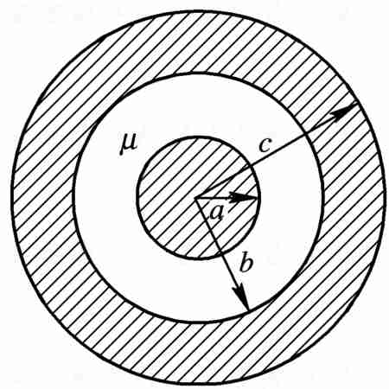

Figure 4 Diagram

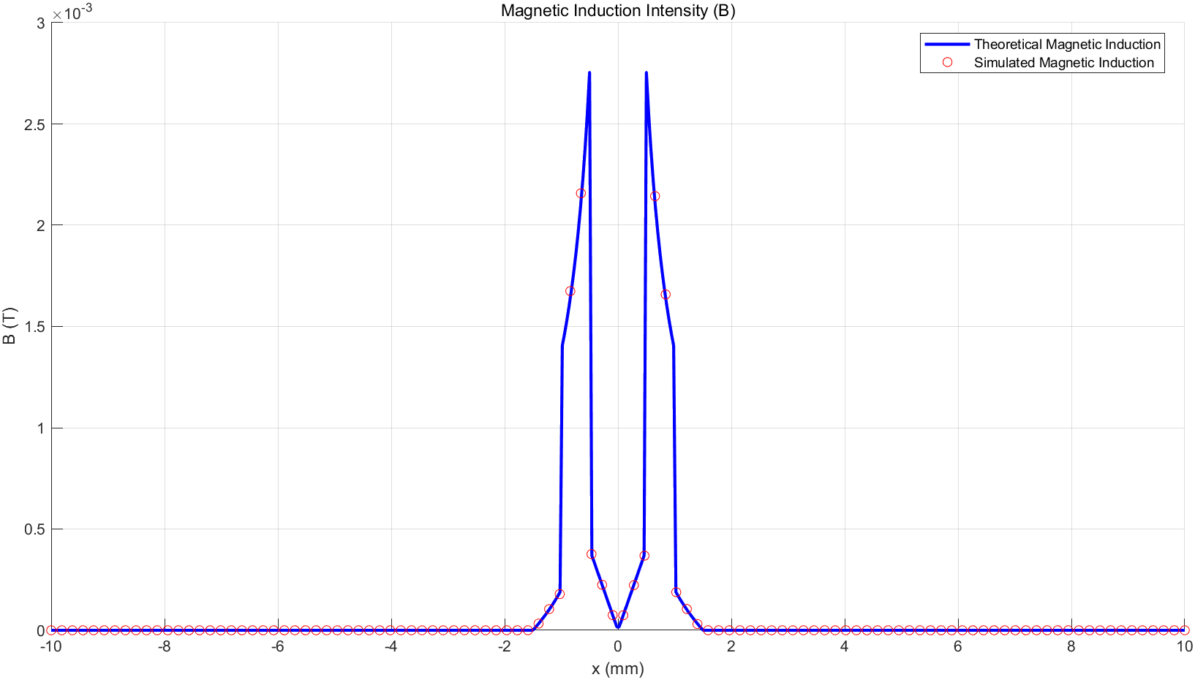

Figure 5 simulation results and theoretical calculation results for B

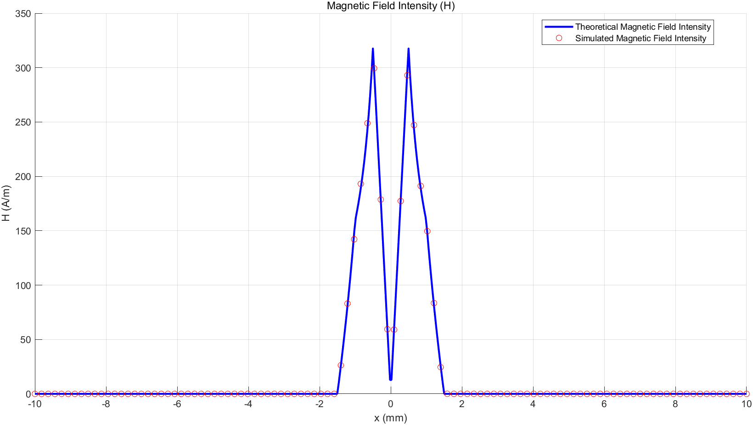

Figure 6 simulation results and theoretical calculation results for H

1. The analysis of simulation results and theoretical calculation results

We first analyze the tendency of the B distribution and H distribution for calculation and simulation value. From the figure, we observe that the B distribution and H distribution are symmetrical so we only analyze the B distribution and the H distribution along positive x axis. When x = 0mm, the B distribution is equal to 0. When 0 < x <=0.5mm, the B distribution is linear increasing. When x = 0.5mm, the B distribution reaches to the maximum. When 0.5 < x < 1mm, the B distribution decreases by inverse proportional function. When 1 < x <1.5mm, the B distribution is linear decreasing. When x >= 1.5mm, the B distribution is equal to 0. Now we analyze the H distribution. When x = 0mm, the H distribution is equal to 0. When 0 < x < 0.5mm, the H distribution decreases by inverse proportional function. When 0.5 <= x < 1.5mm, the H distribution has a tendency to linear decreasing. When x >= 1.5mm, the H distribution is equal to 0.

We observe that the E distribution is basically coincide except around x = 0.5. The maximum of calculation value in x = 0.5mm is larger than the maximum of the simulation value. The difference may causes by the material of the medium. In the experiment, I use the air material to fill the medium. In fact, the attributes of the medium used in the experiment may not the same as the ideal conduct. So in the surface of the medium, it may exists a bit error between simulation value and calculation. Although there exists tiny error, it is acceptable since it is impossible to absolutely simulate the real world condition. From the figure of H distribution, the calculation value and simulation value is basically coincide which indicates that our experiment is reasonable.

1. Theoretical problem: Two cylinders with radius a have a shaft spacing d, d<2a, as shown in the figure below. Except for the overlapping part R of the two columns, there are currents of equal magnitude and opposite direction on the two columns, the density is J, and B of the region R is found.

$$∮B_{1}ⅆL=2πr_{1}B_{1}=μ_{0}πr_{1}^{2}J$$

$$B_{1} = \frac{μ_{0}{Jr}_{1}}{2}$$

As the same reason, we can calculate he 2nd cylinder (right cylinder) in the in the overlapping area

$$B_{2} = - \frac{μ_{0}{Jr}_{2}}{2}$$

The we can get the formula below through

$$\vec{B}=\vec{B_{1}}+\vec{B_{2}}=\frac{μ_{0}J}{2}\vec{e_{y}}$$

So the value of B from -0.4 mm to 0.4 mm:

$$B = \frac{μ_{0}J}{2}$$

Simulation model: As shown in the figure below, the radius of the two cylinders is 1mm, the axis is parallel to the z-axis, and the axis positions are x=0.5mm and x=-0.5mm respectively, except for the overlapping part of the two columns R, there is a current of equal size and opposite direction on the two columns 1A, find [-0.4mm, 0.4mm] on the x-axis The size of B on the range.

 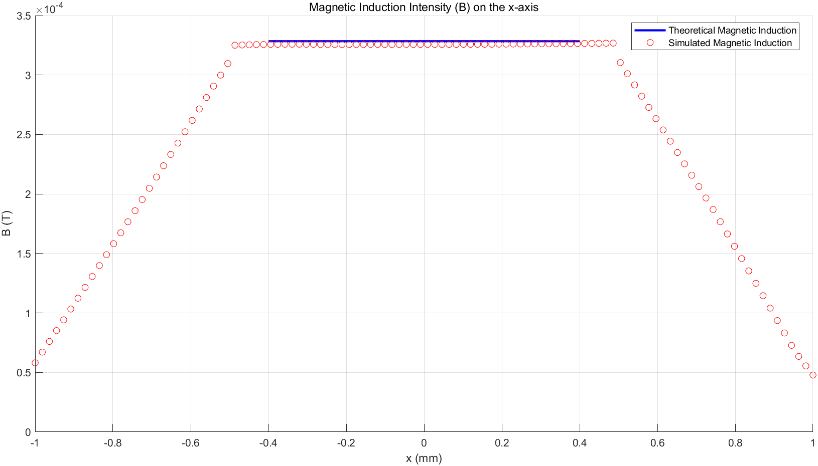

Figure 8 simulation results and theoretical calculation results

The analysis of simulation results and theoretical calculation results

We first analyze the tendency of the B distribution for calculation and simulation value. In the range of [-0.4,0.4]mm, the B distribution is a constant that means the B distribution is the same value along these range.

From the figure, we observe that the calculation value and the simulation value is basically coincide which indicates that the setting of our experiment is reasonable.