Electromagnetic field and electromagnetic wave experiment three report

1. **Problem one**
2. **Theoretical calculation**

The theoretical calculation is shown in the following figure.

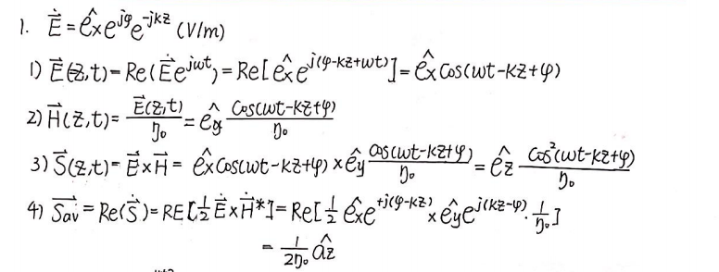

1. **Simulation model cut graph**

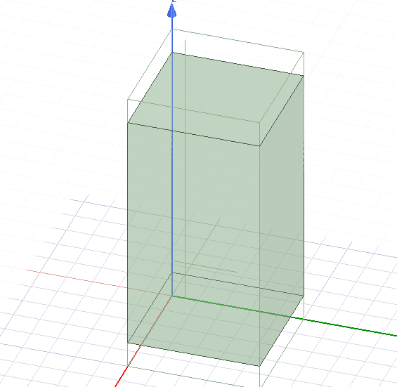

1. **Comparison and analysis of simulation results and theoretical calculation results**
2. **The figure of simulation results and theoretical calculation results**

The distribution of E filed along z axis, the distribution of H filed along z axis, the instantaneous poynting vector, the average poynting vector and the distribution of E filed along y axis are respectively shown in the following figures.

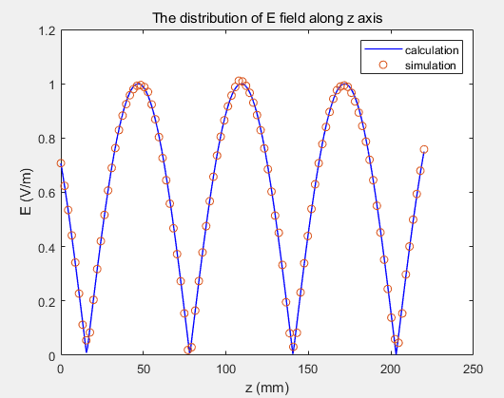 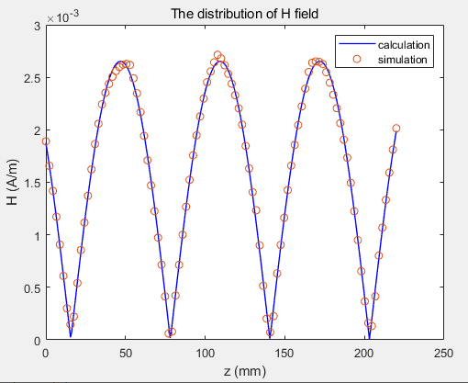

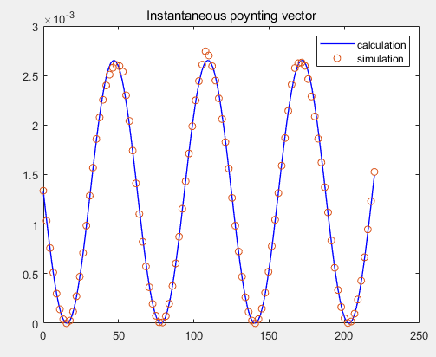 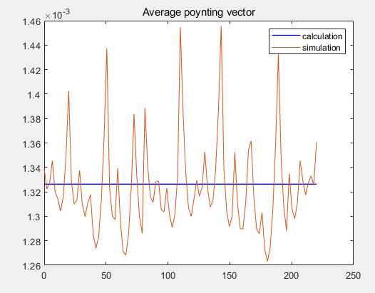

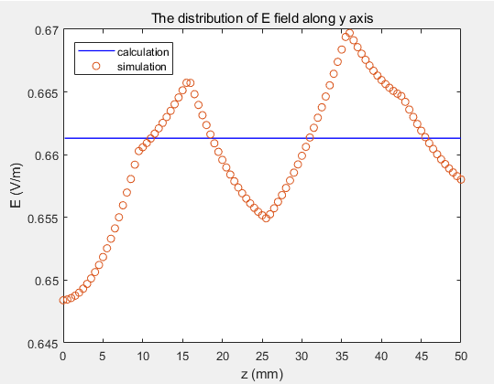

1. **The analysis of simulation results and theoretical calculation results**

For the distribution of E filed along z axis, we observe that the calculation result and simulation result is basically equal which proves that our experiment is correct. And we observe that the magnitude of E filed along z axis reaches to 1v and its spread form along axis z presents the shape of cosine function.

For the distribution of H filed along z axis, we observe that the calculation result and simulation result is basically equal which proves that our experiment is correct. Furthermore, we observe that the magnitude of H filed along z axis reaches to 0.00265v and its spread form along axis z presents the shape of cosine function. What’s more, we observe that except the magnitude, the distribution of H filed along z axis is the same as the distribution of E filed along z axis since they are only different from a poynting constant.

For instantaneous poynting vector, we observe that the calculation result and simulation result is basically equal which proves that our experiment is correct. The only tiny error exists on the maximum of magnitude since may affected by the method of calculation of HFSS (Finite difference method). In addition, we observe that the spread form of instantaneous poynting vector along axis z presents the shape of sine function.

For the average poynting vector, theoretically, it should be a constant 0.00133w along z axis. However, we observe that in experiment, the average poynting vector has a range of change but a tiny region. If we scale the axis, the average poynting vector obtained by experiment should be a straight line which is basically same with the theory. So it can prove that our experiment is correct. The reason why the average poynting vector along z axis is not equal to a constant in experiment is in experiment, we can’t strictly perform average for continuous time. In HFSS, we use Finite difference method to calculate the result so it may cause a bit error between simulation and calculation.

Since the E filed only relates to phase and Z, if the two parameters is determined, the E filed should be constant. For the distribution of E filed along y axis, the calculation is a constant which is accord with the former analysis, but in experiment, the distribution of E filed along y axis change in a tiny range which is acceptable and stay around 0.6615 v/m. So it proves that our experiment is correct. The reason why the distribution of E filed along y axis is not equal to a constant in experiment is the same as the reason why the average poynting vector along z axis is not equal to a constant in experiment. Look back on the experiment we has been doing, if the calculation is a constant, the simulation result are all not equal to a constant but change in a tiny range.

1. **Problem one**
2. **Theoretical calculation**

The theoretical calculation is shown in the following figure.

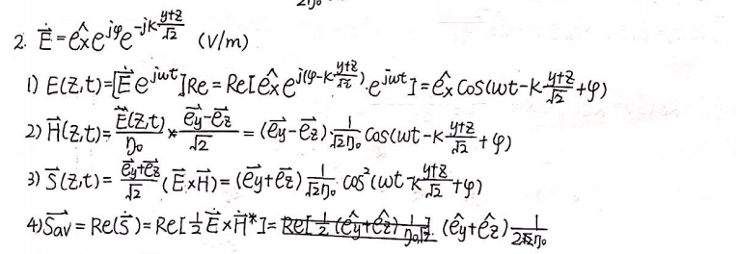

1. **Simulation model cut graph**

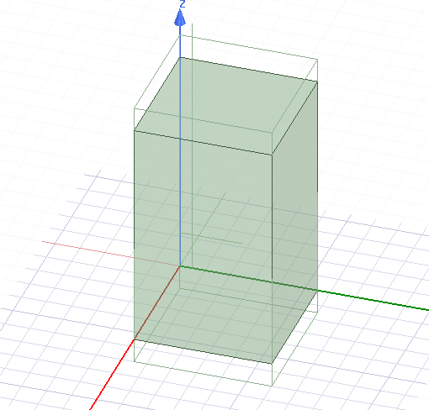

1. **Comparison and analysis of simulation results and theoretical calculation results**
2. **The figure of simulation results and theoretical calculation results**

The distribution of E filed along z axis, the distribution of H filed along z axis, the instantaneous poynting vector, the average poynting vector and the distribution of E filed along y axis are respectively shown in the following figures.

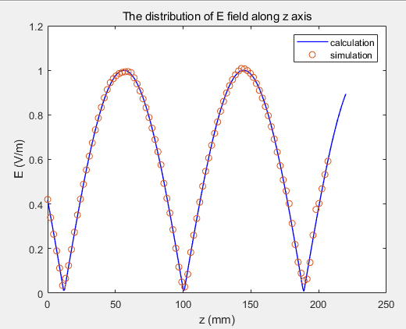 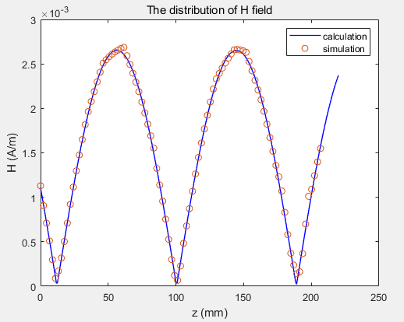

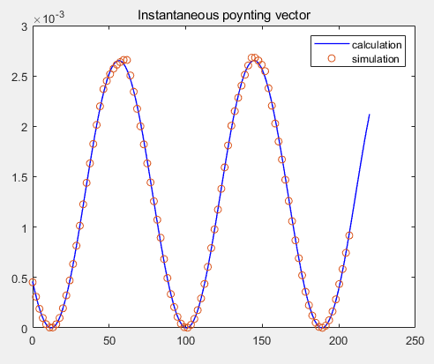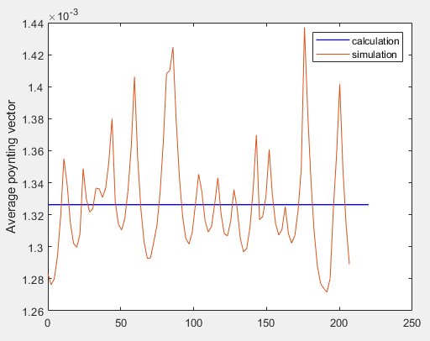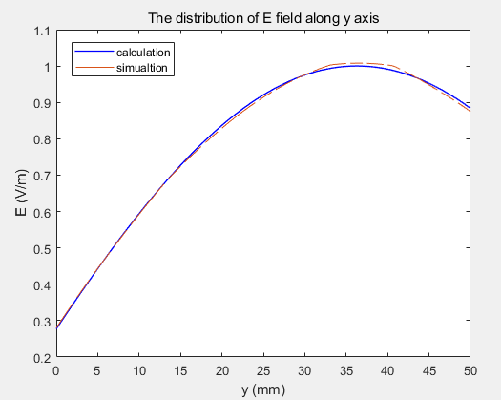

1. **The analysis of simulation results and theoretical calculation results**

For the distribution of E filed along z axis, we observe that the calculation result and simulation result is basically equal which proves that our experiment is correct. And we observe that the magnitude of E filed along z axis reaches to 1v and its spread form along axis z presents the shape of cosine function.

For the distribution of H filed along z axis, we observe that the calculation result and simulation result is basically equal which proves that our experiment is correct. Furthermore, we observe that the magnitude of H filed along z axis reaches to 0.00265v and its spread form along axis z presents the shape of cosine function. What’s more, we observe that except the magnitude, the distribution of H filed along z axis is the same as the distribution of E filed along z axis since they are only different from a poynting constant.

For instantaneous poynting vector, we observe that the calculation result and simulation result is basically equal which proves that our experiment is correct. The only tiny error exists on the maximum of magnitude. The reason is elaborated in the former part.

For the average poynting vector, theoretically, it should be a constant 0.00133w along z axis. However, we observe that in experiment, the average poynting vector has a range of change but a tiny region. If we scale the axis, the average poynting vector obtained by experiment should be a straight line which is basically same with the theory. So it can prove that our experiment is correct. The reason is elaborated in the former part.

Since at this time, the E filed relates to phase and Z and Y, if fix phase and Z , the E filed will change along y axis. For the distribution of E filed along y axis, we observe that the calculation result and simulation result is basically equal which proves that our experiment is correct. And when y<=35mm, the distribution of E filed increases along y axis. when 35<y<=50mm, the distribution of E filed decreases along y axis.

Compared to the first sub-experiment, except the average poynting vector, the other distribution along z axis has a difference on additional phase. In other word, the difference in the corresponding distribution along z axis is only the translation of the coordinate axis. That influences by the incident direction of plane wave.

1. **Problem one**
2. **Theoretical calculation**

The theoretical calculation is shown in the following figure.

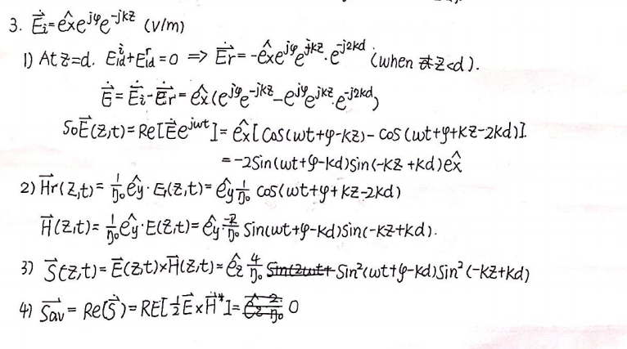

1. **Simulation model cut graph**

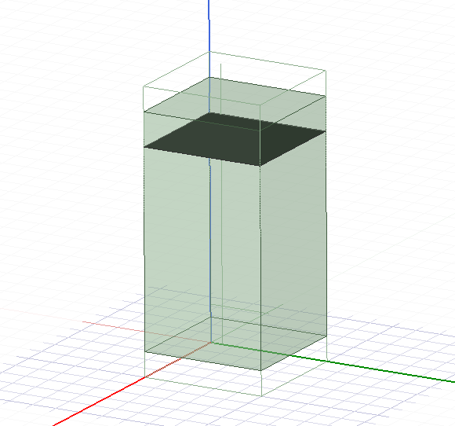

1. **Comparison and analysis of simulation results and theoretical calculation results**
2. **The figure of simulation results and theoretical calculation results**

The distribution of E filed along z axis, the distribution of H filed along z axis, the instantaneous poynting vector, the average poynting vector and the distribution of E filed along y axis are respectively shown in the following figures.

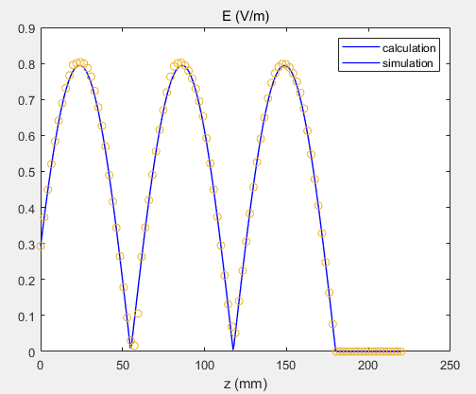 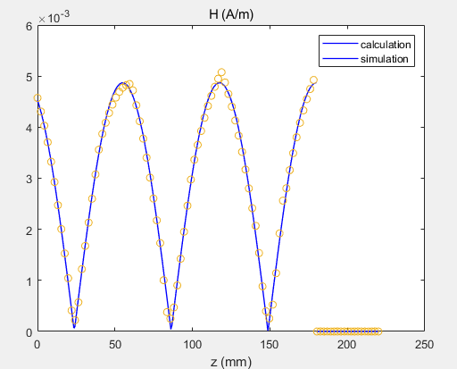

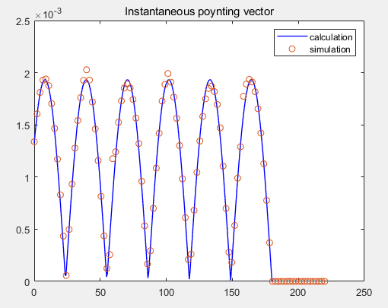 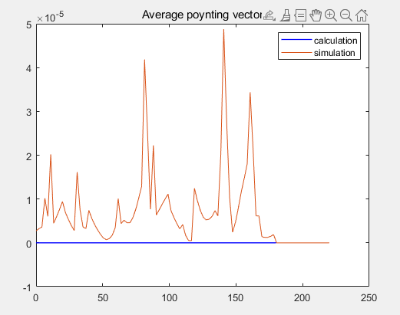

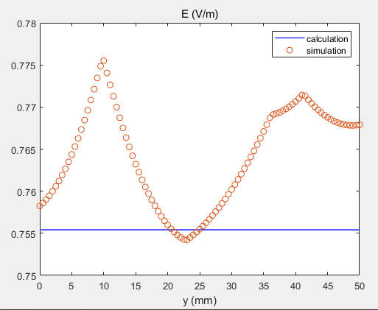

1. **The analysis of simulation results and theoretical calculation results**

For the distribution of E filed along z axis, we observe that the calculation result and simulation result is basically equal which proves that our experiment is correct. And we observe that the magnitude of E filed along z axis reaches to 0.8v. When z<=180mm, its spread form along axis z presents the shape of cosine function. When x >180mm, the E is equal to 0 since the ideal conductor hinders the transmission of plane wave.

For the distribution of H filed along z axis, we observe that the calculation result and simulation result is basically equal except the maximum of the magnitude which proves that our experiment is correct. Furthermore, we observe that the magnitude of H filed along z axis reaches to around 0.0048v. When z<=180mm, its spread form along axis z presents the shape of cosine function. When x >180mm, the H is equal to 0 since the ideal conductor hinders the transmission of plane wave. Note that the distribution of H filed along z axis is not longer the same as the distribution of E filed along z axis except the magnitude. Except magnitude, the difference between E filed and H filed distribution also includes the translation of the coordinate axis.

For instantaneous poynting vector, we observe that the calculation result and simulation result is basically equal which proves that our experiment is correct. The only tiny error exists on the maximum of magnitude. The reason is elaborated in the former part. When z<=180mm, its spread form along axis z presents the shape of cosine function. When x >180mm, the instantaneous poynting vector is equal to 0.

For the average poynting vector, theoretically, it should be equal to 0 along z axis. However, we observe that in experiment, the average poynting vector has a range of change but a tiny region. If we scale the axis, the average poynting vector obtained by experiment should be a straight line which is basically same with the theory. So it can prove that our experiment is correct. The reason is elaborated in the former part. When z<=180mm, its spread form along axis z presents the shape of cosine function. When x >180mm, the average poynting vector is equal to 0.

Since the E filed only relates to phase and Z, if the two parameters is determined, the E filed should be constant. For the distribution of E filed along y axis, the calculation is a constant which is accord with the former analysis, but in experiment, the distribution of E filed along y axis change in a tiny range which is acceptable and stay around 0.7756v/m. If we scale the axis, the distribution of E filed along y axis obtained by experiment should be a straight line. So it proves that our experiment is correct. The reason is elaborated in the former part.

1. **Problem one**
2. **Theoretical calculation**

The theoretical calculation is shown in the following figure.

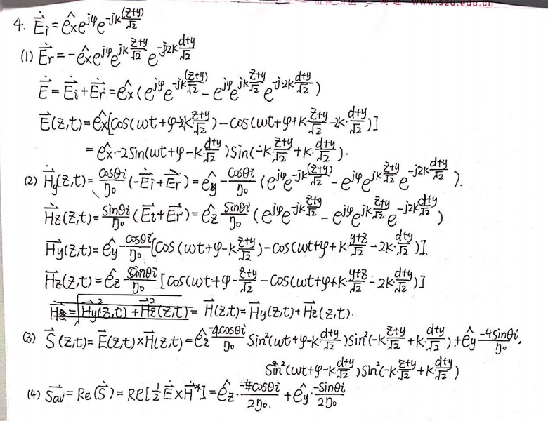

1. **Simulation model cut graph**



1. **Comparison and analysis of simulation results and theoretical calculation results**
2. **The figure of simulation results and theoretical calculation results**

The distribution of E filed along z axis, the distribution of H filed along z axis, the instantaneous poynting vector, the average poynting vector and the distribution of E filed along y axis are respectively shown in the following figures.

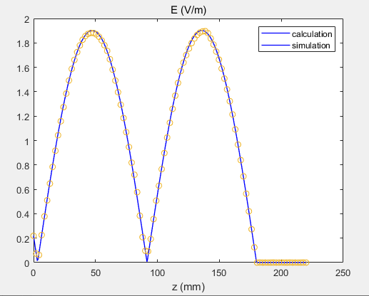 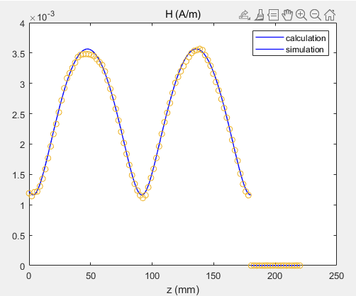

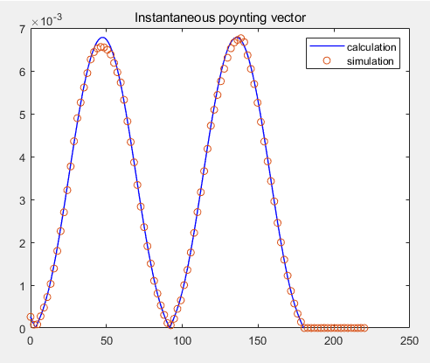 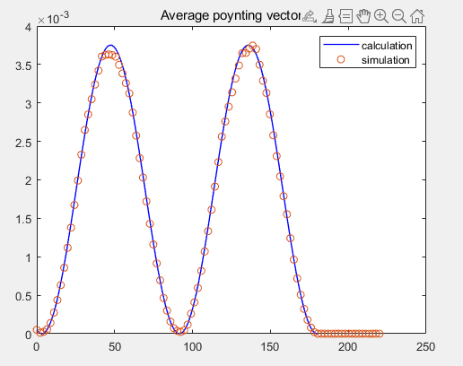

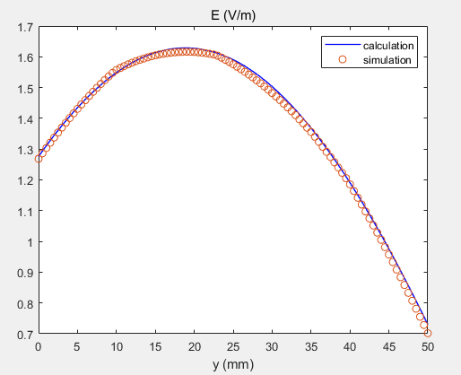

1. **The analysis of simulation results and theoretical calculation results**

For the distribution of E filed along z axis, we observe that the calculation result and simulation result is basically equal which proves that our experiment is correct. And we observe that the magnitude of E filed along z axis reaches to 1.9v. When z<=180mm, its spread form along axis z presents the shape of cosine function. When x >180mm, the E is equal to 0 since the ideal conductor hinders the transmission of plane wave.

For the distribution of H filed along z axis, we observe that the calculation result and simulation result is basically equal except the maximum of the magnitude which proves that our experiment is correct. Furthermore, we observe that the magnitude of H filed along z axis reaches to around 0.0036v. When z<=180mm, its spread form along axis z presents the shape of cosine function. When x >180mm, the H is equal to 0 since the ideal conductor hinders the transmission of plane wave. Note that the distribution of H filed along z axis is always positive and its minimum magnitude is around 0.0012v.

For instantaneous poynting vector, we observe that the calculation result and simulation result is basically equal which proves that our experiment is correct. When z<=180mm, its spread form along axis z presents the shape of cosine function. When x >180mm, the instantaneous poynting vector is equal to 0 since the ideal conductor hinders the transmission of plane wave.

For the average poynting vector, theoretically, we observe that the calculation result and simulation result is basically equal which proves that our experiment is correct. When z<=180mm, its spread form along axis z presents the shape of cosine function. When x >180mm, the average poynting vector is equal to 0 since the ideal conductor hinders the transmission of plane wave. Note that except the magnitude, the average poynting vector along z axis is the same as the instantaneous poynting vector along z axis.

Since at this time, the E filed relates to phase and Z and Y, if we fix phase and Z , the E filed will change along y axis. For the distribution of E filed along y axis, we observe that the calculation result and simulation result is basically equal which proves that our experiment is correct. And when y<=20mm, the distribution of E filed increases along y axis. when 20<y<=50mm, the distribution of E filed decreases along y axis.