Electromagnetic field and electromagnetic wave experiment two report

1. **Problem one**
2. Theoretical calculation

Question: 内外半径分别为a和b的无限长空心圆柱中均匀分布轴向电流I，求柱内外的磁感线强度。

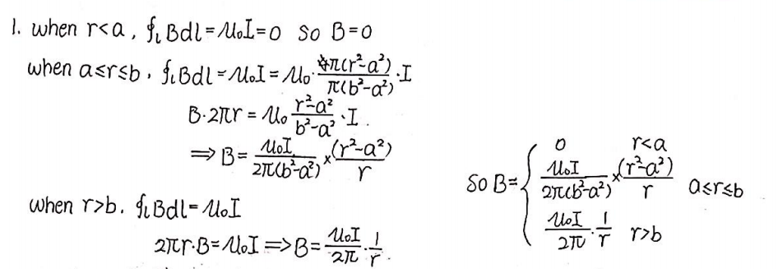

1. Simulation model cut graph

Simulation: 无限长空心圆柱轴线为z轴，内外半径分别为1mm和1.5mm，其上均匀分布轴向电流1A，求x轴上**B**的大小。

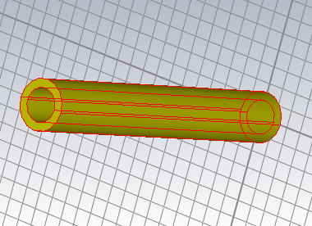 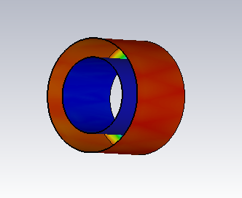

Model cut graph B field distribution

1. Comparison and analysis of simulation results and theoretical calculation results
2. The figure of simulation results and theoretical calculation results

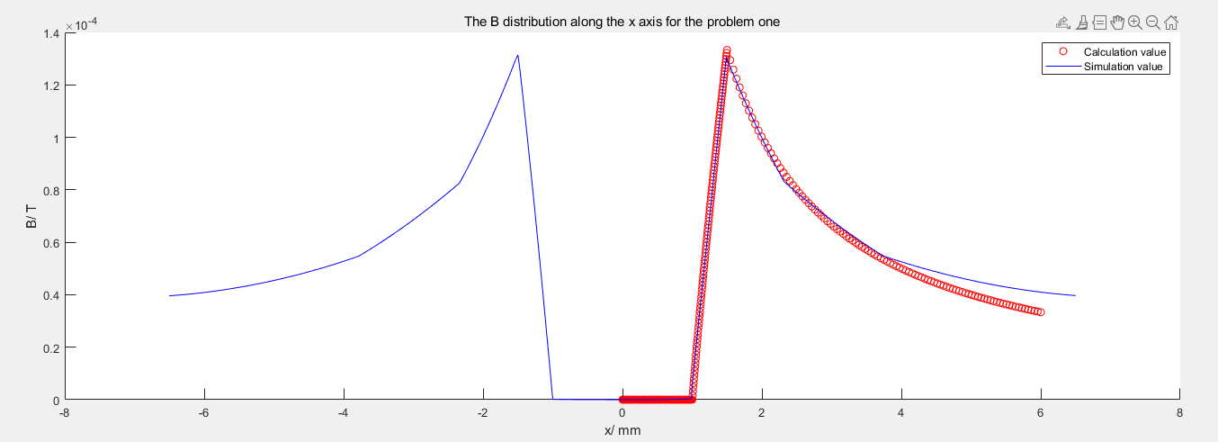

1. The analysis of simulation results and theoretical calculation results

We first analyze the tendency of the B distribution for calculation and simulation value. From the figure, we observe that the B distribution is symmetrical so we only analyze the B distribution along positive x axis. When 0<=x<1.5mm, the B distribution is equal to 0. When 1.5<=x<2, the B distribution is linear increasing. When x>=2mm, the B distribution decreases by inverse proportional function.

When 0 <= x <= 2mm, the calculation value and simulation value is coincide. When x > 2mm, the front part is coincide, but with the increase of x, the simulation value is gradually larger than calculation value.

The difference may causes by the boundary condition. In the experiment, I set the boundary condition is equal to 5 for x axis and y axis respectively which is relatively small compared to the real situation. Although there exists tiny error, it is acceptable since it is impossible to absolutely simulate the real world condition.

1. **Problem two**
2. Theoretical calculation

Question: 求载流的圆形导线回路在圆心处的**B**。

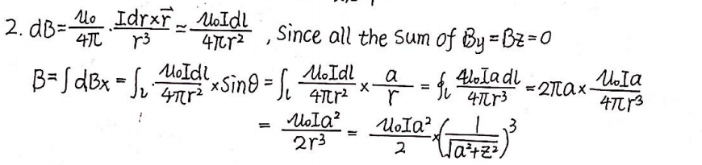

1. Simulation model cut graph

Simulation: 载流的圆形导线半径为20mm,求圆心处**B**的大小。

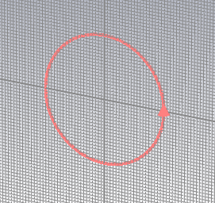 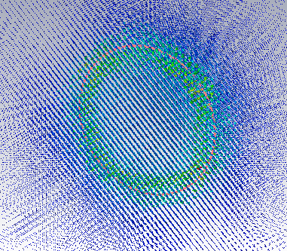

Model cut graph B field distribution

1. Comparison and analysis of simulation results and theoretical calculation results
2. The figure of simulation results and theoretical calculation results

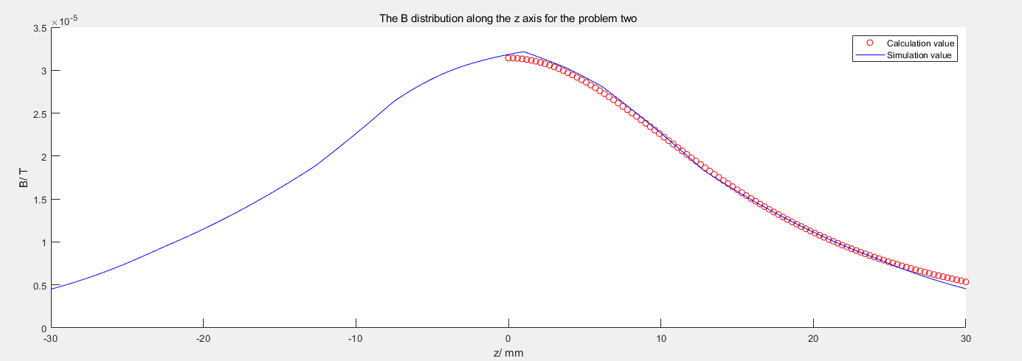

1. The analysis of simulation results and theoretical calculation results

We first analyze the tendency of the B distribution for calculation and simulation value. From the figure, we observe that the B distribution is symmetrical so we only analyze the B distribution along positive x axis. When x = 0mm, the B distribution reaches to the maximum. When x > 0mm, the B distribution decreases by inverse proportional function.

We observe that around x = 0mm, the calculation value and simulation value have some deviation. When x > 0mm, the calculation value and simulation value is basically coincide until x around 30mm.

The two difference may causes by the boundary condition or effected by the solver accuracy. In the experiment, I set the boundary condition is equal to 30 which is relatively small compared to the real situation. Although there exists tiny error, it is acceptable since it is impossible to absolutely simulate the real world condition.

1. **Problem three**
2. Theoretical calculation

Question: 同轴线内外导体半径为a，外导体的内半径为b,外半径为c，如下图。设内外导体分别流过反相的电流，两导体之间介质的磁导率为*μ*,求各区域的***H***、***B。***

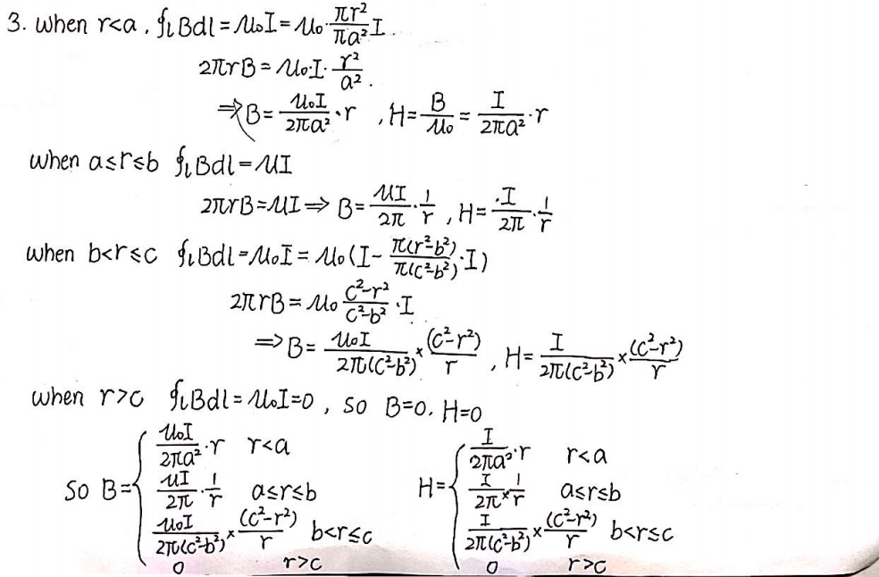

1. Simulation model cut graph

Simulation: 同轴线轴线为z轴，a=0.5mm,b=1mm,c=1.5mm, 两导体之间介质的相对磁导率为4，求x轴上的***H***、***B***。

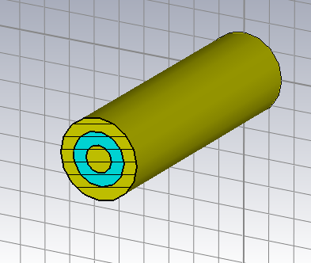 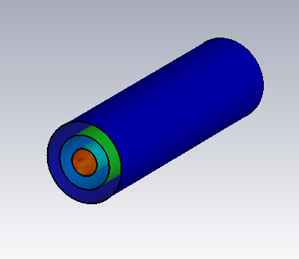

Model cut graph B field distribution

1. Comparison and analysis of simulation results and theoretical calculation results
2. The figure of simulation results and theoretical calculation results

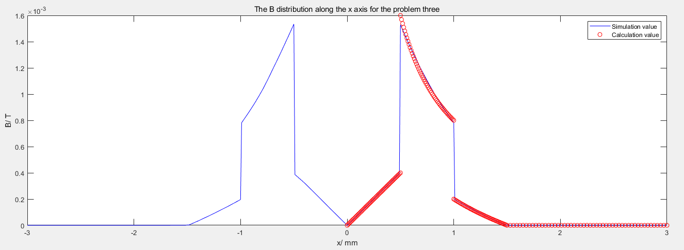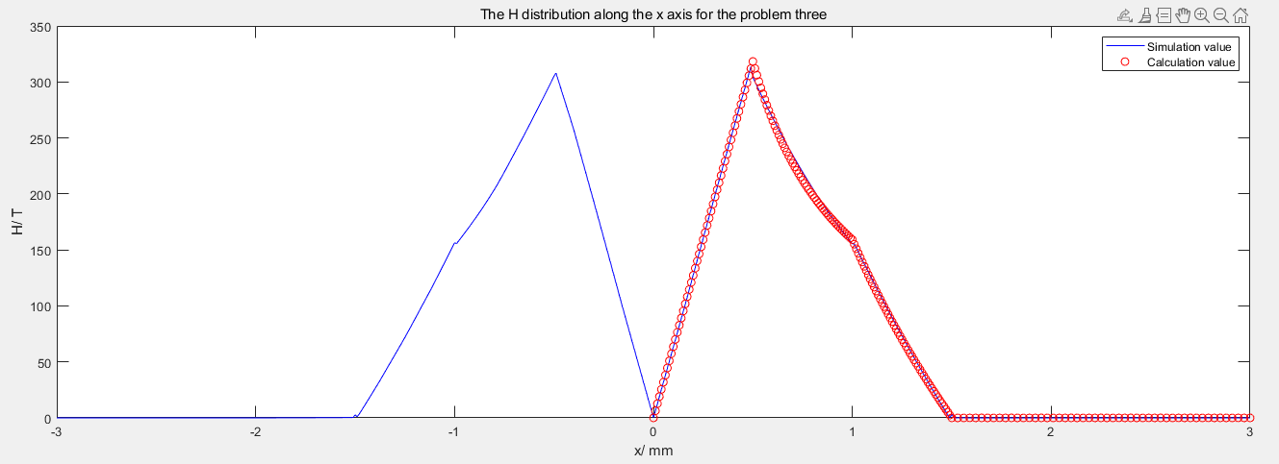

1. The analysis of simulation results and theoretical calculation results

We first analyze the tendency of the B distribution and H distribution for calculation and simulation value. From the figure, we observe that the B distribution and H distribution are symmetrical so we only analyze the B distribution and the H distribution along positive x axis. When x = 0mm, the B distribution is equal to 0. When 0 < x <=0.5mm, the B distribution is linear increasing. When x = 0.5mm, the B distribution reaches to the maximum. When 0.5 < x < 1mm, the B distribution decreases by inverse proportional function. When 1 < x <1.5mm, the B distribution is linear decreasing. When x >= 1.5mm, the B distribution is equal to 0. Now we analyze the H distribution. When x = 0mm, the H distribution is equal to 0. When 0 < x < 0.5mm, the H distribution decreases by inverse proportional function. When 0.5 <= x < 1.5mm, the H distribution has a tendency to linear decreasing. When x >= 1.5mm, the H distribution is equal to 0.

We observe that the E distribution is basically coincide except around x = 0.5. The maximum of calculation value in x = 0.5mm is larger than the maximum of the simulation value. The difference may causes by the material of the medium. In the experiment, I use the air material to fill the medium. In fact, the attributes of the medium used in the experiment may not the same as the ideal conduct. So in the surface of the medium, it may exists a bit error between simulation value and calculation. Although there exists tiny error, it is acceptable since it is impossible to absolutely simulate the real world condition. From the figure of H distribution, the calculation value and simulation value is basically coincide which indicates that our experiment is reasonable.

1. **Problem four**
2. Theoretical calculation

Question: 两个半径都为a的圆柱体，轴间距为d,d<1a，如下图。除两柱重叠部分R外，两柱上各有大小相等、方向相反的电流，密度为**J**,求区域R的**B**。

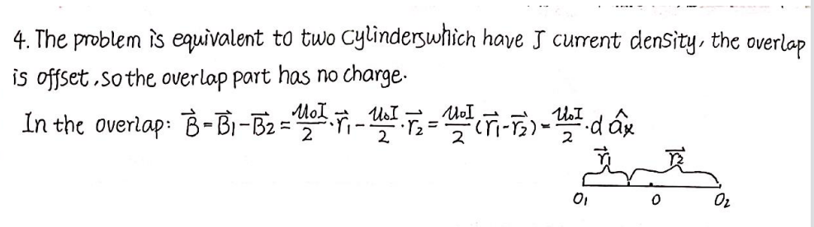

1. Simulation model cut graph

Simulation: 如下图所示，两个圆柱半径为1mm, 轴线与z轴平行，轴线位置分别为x=0.5mm和x=-0.5mm, 除两柱重叠部分R外，两柱上各有大小相等、方向相反的电流1A, 求x轴上[-0.4mm,0.4mm]范围上**B**的大小。

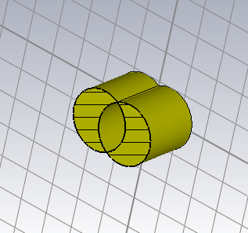 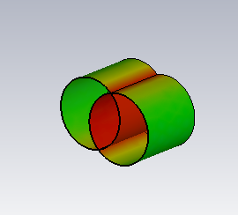

Model cut graph B field distribution

1. Comparison and analysis of simulation results and theoretical calculation results
2. The figure of simulation results and theoretical calculation results

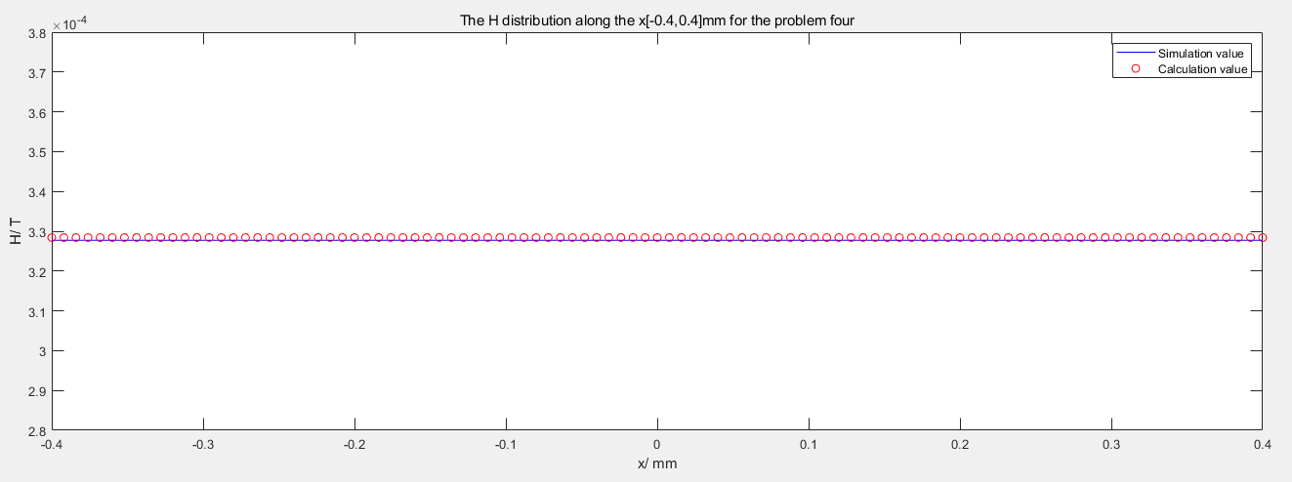

1. The analysis of simulation results and theoretical calculation results

We first analyze the tendency of the B distribution for calculation and simulation value. In the range of [-0.4,0.4]mm, the B distribution is a constant that means the B distribution is the same value along these range.

From the figure, we observe that the calculation value and the simulation value is basically coincide which indicates that the setting of our experiment is reasonable.