|  |  |  |
| --- | --- | --- |
| **Problem Chosen** F | **2020 MCM/ICM Summary Sheet** | **Team Control Number** 2010652 |

Where to go next

**Key words:**

**Contents**

1 Introduction 2

1.1 Background 2

1.2 Restatement of the Problem 2

2 Analysis of the Problem 2

3 Symbols 3

4 Simplifying Assumptions 3

5 Model Design 3

5.1 Model I: Growth model of EDPs 3

5.1.1 Sea Level Rise 4

5.2 Model II: Model of Cultural Loss 6

5.2.1 Cultural Classification and Loss of Culture 6

5.2.2 Quantify culture 6

5.2.3 Degree of Cultural Similarity & The Feasibility of Cultural Behavior 7

5.2.4 Conclusion 10

6 Sensitivity Analysis 10

7 Strengths and weakness 10

8 References 10

9 Appendix 10

9.1 Data 10

9.2 program 11

# Introduction

## Background

With carbon dioxide emissions rising, global warming is increasingly serious. Recent decades have seen sea level rising. Several island nations, such as The Maldives, Tuvalu, Kiribati, and The Marshall Islands are facing a series of impacts of climate change, for instance, the reduction of the territory area, flood disaster and land salinization, etc. They are not only in danger of sinking but also face the challenges about cultural differences and human rights. Therefore, these environmentally displaced persons (EDPs) need to relocate as their homeland becomes uninhabitable. In fact, the term “climate refugees” is not legally valid as the 1951 Refugee Convention does not recognize environmental factors as criteria to define a refugee.

Recently, a UN ruling has opened the door to the theoretical recognition of EDPs as refugees. As the IPCC report says, if greenhouse gas emissions continue to rise, sea-level will rise at 1.1m by 2100 and low-lying coastal countries will be at risk of disappearing. It is necessary to design a reasonable model and analyze this complex issue of when, why, and how the UN should take action to address the problem on the increasing number of EDPs. In particular, the response system guidance should include the desire of protections of cultural heritage.

## Restatement of the Problem

Considering the background, it is essential to establish an appropriate model to solve out the problem including three core aspects, which are the relocation decisions, resettlement and cultural preservation, and time factors. At the same time, make accurate predictions about the size of it. Under the circumstance, we are consulted to help address the complex issue of the migration of climate refugees. our main work is as follows:

* Define the scope of the issue of EDPs. Based on the data we collected, we use time series to predict the time and number of climate refugees.
* Propose policies to address EDPs. We are supposed to take human rights and cultural preservation into account. The risk of loss of culture is characterized by the retention rate of national cultures. Considering the cultural differences, we establish a cultural optimization model to integrate the immigrant cultures and native cultures better.
* Describe the development of a model used to measure the potential impact of proposed policies. Explain how to design our models and how they do good to proposed policies.
* State the importance of proposed policies in light of our analyzation and results. Give advice on the migration of EDPs. Let most countries pay attention to the issue of EDPs. Explain who should shoulder more responsibility for assisting climate refugees and what other aspects should we capture to develop our models.

# Analysis of the Problem

**Problem 1:**

**Problem 2:**

**Problem 3:**

# Symbols

Table 1 Symbols and Definitions

|  |  |
| --- | --- |
|  |  |
|  |  |
|  |  |
|  |  |

# Simplifying Assumptions

1. It is assumed that coastal countries are unable to achieve internal migration to help EDPs, so the victims of rising sea levels are all climate refugees.
2. It is assumed that coastal countries don’t build dams to prevent flooding. If the sea rises, it will flood the country's land directly.
3. Assuming that the elevation of the land in this country increases gradually from the sea level to the middle of the land, the extent to which the land is submerged by the sea changes gradually with the height of the sea.
4. Sea levels are rising at a steady rate.
5. We suppose that the birth rate is equal to the death rate, and there are no people moving in and out for a long time.

# Model Design

## Model I: Growth model of EDPs

Our task is to explore the number of EDPs due to the sinking land. In order to solve this problem, we need to know how much land is flooded, because the earth's crust is not going to rise or fall dramatically in the short term, so we think that flooding is entirely due to sea level rise. We fitted historical sea level data from NASA.

### Sea Level Rise

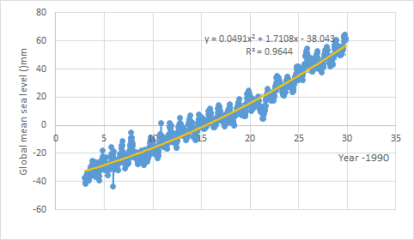

Figure 1 quadratic model

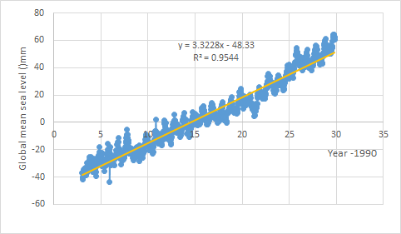

Figure 2 linear model

Obviously, the fitting effect of the quadratic model is better than that of the linear model. And the quadratic coefficient of the quadratic model is much smaller than the coefficient of first order. However, this small difference will lead to a big difference in the predicted future sea level rise. Given the dramatic rise in carbon dioxide emissions in recent decades in many developing countries, notably China, and the melting of glaciers as a result of global warming, we would prefer to use secondary models to fit the global sea-level rise data.

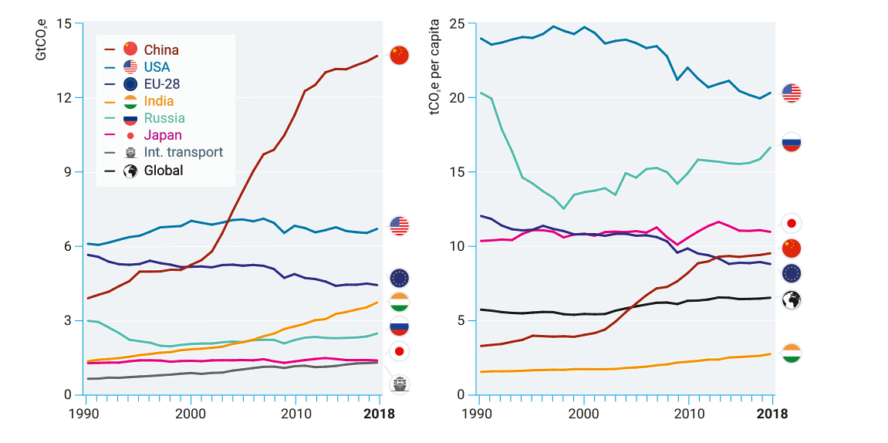

Figure 3 Emissions Gap report 2019 from UN[5]

IPCC pointed out that the global sea-level rise rate has been  mm/a since 1961, and since 1993 it has increased by mm/a. This confirms our suspicions, so we have reason to use quadratic model to fitting the data of global sea level rise.

The figure below sets the average sea level height in 2020 to zero as a reference plane to study future sea level rise relative to today. It shows the projected future mean sea level, which will rise by 0.728 m by 2100.

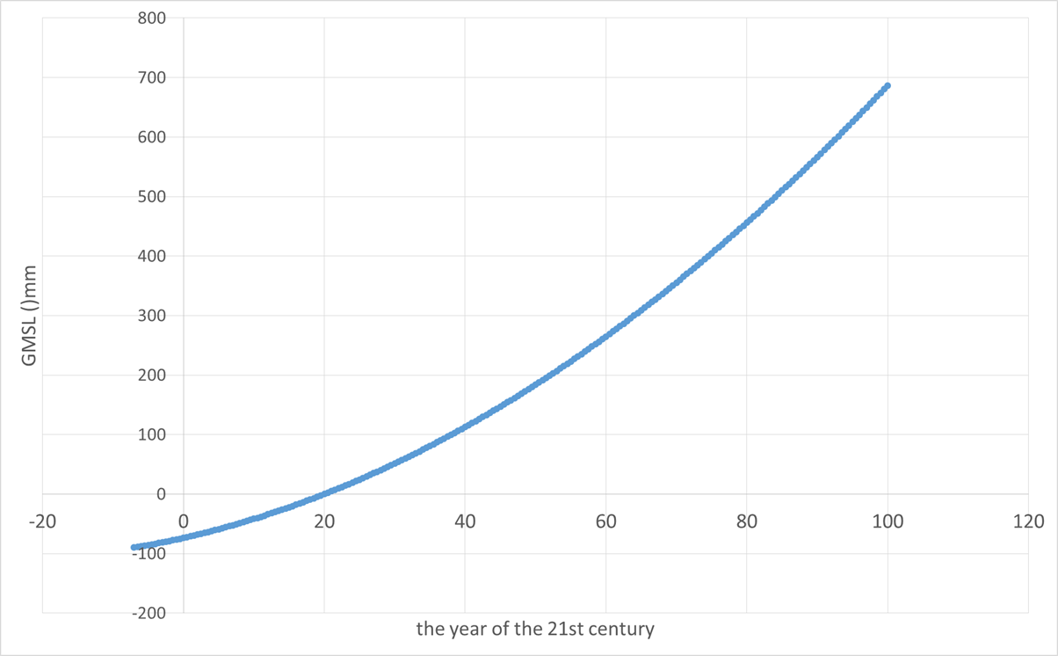

Figure 4 prediction of future mean sea level height

Although 0.728 m is a high figure, it is still an underestimate of the risk to rely solely on the comparison of this figure with land elevation data to calculate the submerged area. As we can see, the sea level data itself is subject to seasonal fluctuations, and the maximum value of such fluctuations should be added on the basis of 0.728 meters. Since the fluctuation itself is somewhat random, we replace it with the absolute value of the maximum residual value fitted by the data, so the most conservative estimate of sea level rise is:



Now we have a high prediction of future sea level rise, and what is the relationship between that height and the submerged area? We compared the elevation data of the global terrain with this height to determine which areas would be flooded. The accuracy of the SRTM 90m dataset from CIAT reached 90m, which can roughly estimate the global and subdivide the submerged area to each country or region. We are very fortunate that this work has been done. Dasgupta et al., back in 2007, gave us the area that would be submerged by a sea level rise of 1-5 meters.

This year, compared with 2007, the global mean sea level has risen by 4cm. We can correct for this error and fit their calculations to get the details. There are several reasons why it is difficult to give very precise estimates. The first is that future trends in climate and sea level rise are still highly uncertain; The second is that when we think about the risk of flooding we also have to think about astronomical tides and water levels in extreme weather conditions, which are very different on a global scale, and if we want to be precise we have to look at a lot of details, not averages; The third is that the global coastline topography varies greatly in slope, which makes it difficult to unify the change function of submerged area as sea level rises. Through observation, we find that with the rise of sea level, the change value of submerged area can be well fitted by a quadratic function. Combined with the global population density distribution, we can get the number of people affected by sea level rise.

## Model II: Model of Cultural Loss

### Cultural Classification and Loss of Culture

Culture refers to all the spiritual activities and products of human beings relative to economy and politics. Specifically, it refers to the traditional customs, life style, religious belief, literature and art, legal system and so on. We have a simple classification for our purposes.

Firstly, culture can be divided into material culture and intangible culture. Material culture can be divided into portable and non-portable categories, among which the portable category refers to the items that can be carried such as books, appliances, etc., while the non-portable category refers to the items that cannot be carried along in the process of national migration, such as buildings. The intangible cultural category can be divided into the behavioral category and the non-behavioral category. Behavior refers to the language (which can also be classified into a category), the culture embodied by specific behaviors such as living habits, customs, festivals and national skills, while the non-behavioral category refers to cultural signs, aesthetic interests and values.

Next, we define cultural damage. A material class is defined as damaged when it is damaged or lost. The destruction of intangible culture is defined as follows: for the culture of behavior, when all or most of the people in the nation lose the ability to perform the behavior or have the ability to perform the behavior but fail to happen after a certain year, the cultural behavior has been lost; A non-behavioral class is defined as a lost state when the culture is forgotten and unsearchable.

### Quantify culture

Because different countries have different populations, different areas and different cultural forms, their value cannot be compared with material richness and commercial value. In material terms, the total value of the culture of a large country is much greater than that of a small island country. In order to measure culture easily, we use the retention rate of national culture in this question to describe:



Where  represent the retention rate of culture, the retention rate of a certain item in culture, and the importance of this cultural category. The sum of  is equal to 1.  can be obtained by investigating a nation's evaluation of the importance of different cultural categories. We can consider different cultural categories equally important in the absence of a survey:



Refine  further, the formula is as follows:



In analogy,  is the cultural value weight of the behavior, and is the retention rate of the behavior. In a similar way, the sum of  is equal to 1.

We suppose  represents the retention rate of behavioral cultures. ( *j* = 1,2,3,…) represents the retention rate of various behaviors in , such as languages, festivals, life habits, etc. If the classification reaches a level, and the level cannot be subdivided, the retention rate of a factor *Q* in this level can be calculated by the following formula:



Where  refers to the number of people who retain a cultural behavior before migration, while  refers to the number of people who retain the behavior after migration.

Similar retention rates are calculated for other cultural categories. If *P* is non-behavioral and *Q* is assumed to be an identifier, then  is the total number of identifiers retained after migration, and  is the total number of identifiers existed before migration.

Due to the large number of cultural categories in this study, we do not discuss the two factors of language and behavior. We need to study the loss of culture in the process of national migration, which is to discuss what factors affect the behavior or language of these characteristics, what conditions will lead to the retention and acceptance of a behavior or a language, and what factors will limit it.

### Degree of Cultural Similarity & The Feasibility of Cultural Behavior

In our opinion, the more similar a behavior is to the cultural behavior of the local residents in the place of migration, the more likely it is to be retained. For example, when people from both countries choose to shake hands, the culture of shaking hands will be retained. A thumbs-up is a compliment in some countries, a derogatory gesture in others. Different but not conflicting depending on the enforceability of the act, for example people in one country like fishing, moving to a dry landlocked country is difficult to achieve and the cultural act of fishing cannot be preserved.

We set up the following set of comments to depict the degree of cultural similarity.

Table 2 degree of cultural similarity

|  |  |  |  |  |  |
| --- | --- | --- | --- | --- | --- |
| Similarity | Quite the same | Very similar | Different but not conflicting | generally conflicting | severely conflicting |
|  | 1.0 | 0.8 | 0.5 | 0.2 | 0 |

Similarly, we use a collection of comments to describe the feasibility of cultural behavior.

Table 3 the feasibility of cultural behavior

|  |  |  |  |  |  |
| --- | --- | --- | --- | --- | --- |
| Feasibility | Completely feasible | Very feasible | Generally feasible | Slightly limited | Severely limited |
|  | 1.0 | 0.8 | 0.5 | 0.2 | 0 |

The cultural retention rate is a function of *f* and *s*. The function is as follows:



Where *e* represents a random quantity. We take into account that culture itself can also decline or develop.

As the cultural retention rate is the weighted sum of each cultural subclass, the cultural retention rate is a function of the cultural similarity between the immigrating nation and the local residents of the place of migration. In other words, the higher the cultural similarity is, the higher the cultural retention rate is, with other factors unchanged.



In the formula above,  is the cultural retention rate of the part of culture that can be transferred with the national migration, *s* is the cultural similarity, and *E* is the part explained by other factors.

Immovable culture, such as buildings, will be submerged by the sea, but it does not mean total damage, and may be partially eroded by the sea. But the seabed remains its cultural value, so the retention rate of immovable culture is not equal to zero, so



Where  is the retention rate of that part of the culture which cannot be transferred.  is the area of the country submerged by the sea, and  is the area of the country before it was submerged.

How to depict cultural similarity? We divide culture into subclasses one by one, and the similarity of each subclass can be given by comparing and referring to the above comment set in a very specific way, and the analytic hierarchy process can be used to obtain the total cultural similarity.

Comment sets are used in the above modeling process. They contain many subjective factors, which can be dealt with by fuzzy algorithm.

**Method:**

When evaluating the cultural similarity of a certain cultural category at a certain level, it is assumed that there are *i* cultural subclasses that participate in the assessment of cultural similarity, and each subclass is rated with five levels. It is assumed that  is the percentage of the number of people who give grade *j* to the *i*th cultural category. Then we can get a rating matrix of *i* row *j* column, called fuzzy matrix *R*.

Suppose , , and the fuzzy matrix



is called the composition of *A* and *B*, where .

Suppose the weight vector of I subclasses is . Calculate  and get vector , and compare the element size of vector *C*. The subscript corresponding to the maximum value is the rating of the cultural category.

The above method can be used to measure the overall cultural similarity between two countries or nations, but sometimes we may prefer to retain some part of the culture when we choose the destination of migration, so it is necessary for us to come up with an algorithm to measure the relative importance of different cultural subclasses. As mentioned earlier, cultural subclasses have different value weights, and here we will give a systematic method for obtaining this weight.

We can use analytic hierarchy process to measure the relative importance of culture. We set three levels of norms to measure the relative importance of culture: cohesion, order, and value.

**Method:**

Suppose that there are several subclasses of a culture class, now we want to evaluate the weight of *i* subclasses. Then we can first compare these subclasses in pairs, and let  represent the importance of subclass *i* relative to subclass.

Table 4 The meaning of scale

|  |  |
| --- | --- |
| Scale | Meaning |
| 1 | Two factors are of equal importance |
| 3 | The former is slightly more important than the latter |
| 5 | The former is obviously more important than the latter |
| 7 | The former is more important than the latter |
| 9 | The former is more important than the latter |
| 2,4,6,8 | Represents the intermediate value of the above adjacent judgment |
| reciprocal | If the ratio of the importance of *i* to *j* is , then the ratio of the importance of *j* to *i* is |

Then you get the judgment matrix .

Find the maximum eigenvector  of A. At the same time, the eigenvector *t* is obtained, and the values of each element of the eigenvector represent the relative importance of each subclass.

**Step1: calculate the consistency index **



Step2: find the corresponding average random consistency index RI.

For *n* = 1, …, 9, Saaty gives the value of *RI*, as shown in Table 5.

Table 5 The Value of *RI*

|  |  |  |  |  |  |  |  |  |  |
| --- | --- | --- | --- | --- | --- | --- | --- | --- | --- |
| n | 1 | 2 | 3 | 4 | 5 | 6 | 7 | 8 | 9 |
|  | 0 | 0 | 0.58 | 0.90 | 1.12 | 1.24 | 1.32 | 1.41 | 1.45 |

**Step3: calculate consistency ratio** *CR*



When , the consistency of the judgment matrix is considered acceptable, otherwise the judgment matrix should be appropriately modified.

### Conclusion

In the section of cultural classification, we divide the differentiation into multiple layers. We only need to assign weights to them layer by layer and multiply the weight layers to obtain the total ranking of all the lowest cultural categories.

# Sensitivity Analysis

# Strengths and weakness

# References

1. <https://migrationdataportal.org/themes/environmental_migration>
2. Cai Chang. Study on the problem of environmental refugees in Tuvalu [D]. Central China Normal University, 2012.
3. IPCC. Special report on global warming of 1.5℃[M]. UK: Cambridge University Press, 2019.
4. IPCC. Climate Change 2007, the Fourth Assessment Report (AR4) of the United Nations Intergovernmental Panel on Climate Change[M]. 2007.
5. UN. Emissions Gap Report 2019[M]. 2019.

# Appendix

## Data

1. Global mean sea level data

Source:

NASA. https://podaac-tools.jpl.nasa.gov/drive/files/allData/merged_alt/L2/TP_J1_OSTM/global_mean_sea_level

1. World sea-level rise dataset

Source:

The WORLD BANK. https://datacatalog.worldbank.org/dataset/world-sea-level-rise-dataset

1. Population density

Source:

OECD. <https://stats.oecd.org/>

## program