http://www.jb51.net/os/windows/298507.html
http://www.tecmint.com/ubuntu-14-04-installation-guide/
http://forum.ubuntu.org.cn/viewtopic.php?f=139&t=361017

Partition size in MB – min 20GB
Partition Type as Primary
Location at the beginning
Ext4 journaling file system
Root as Mount Point “/“

Swap 两倍的内存大小
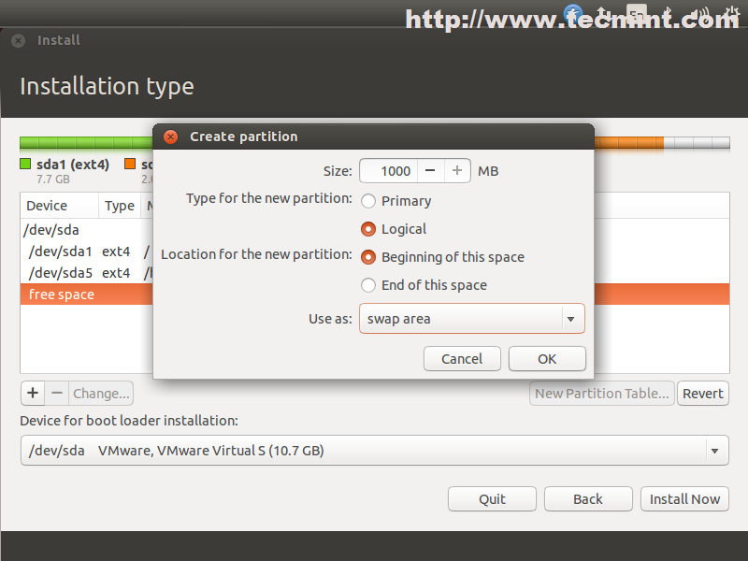
home
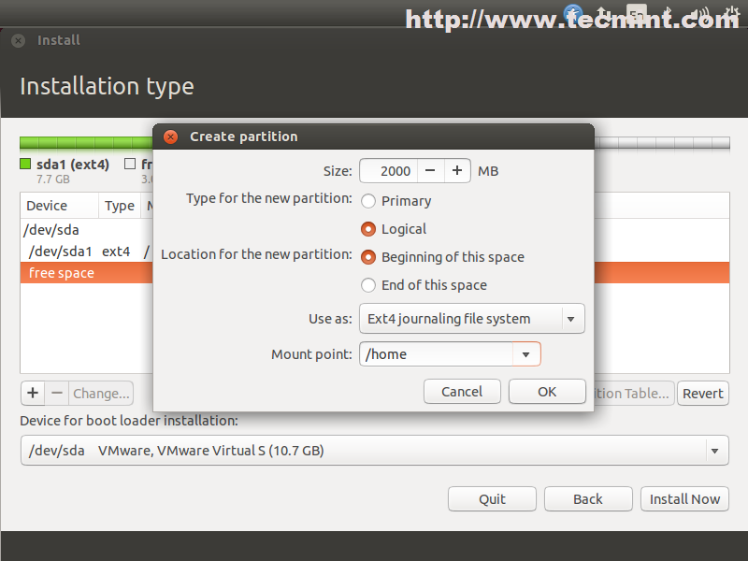

4 final
