Tested by valid.py (single_object)
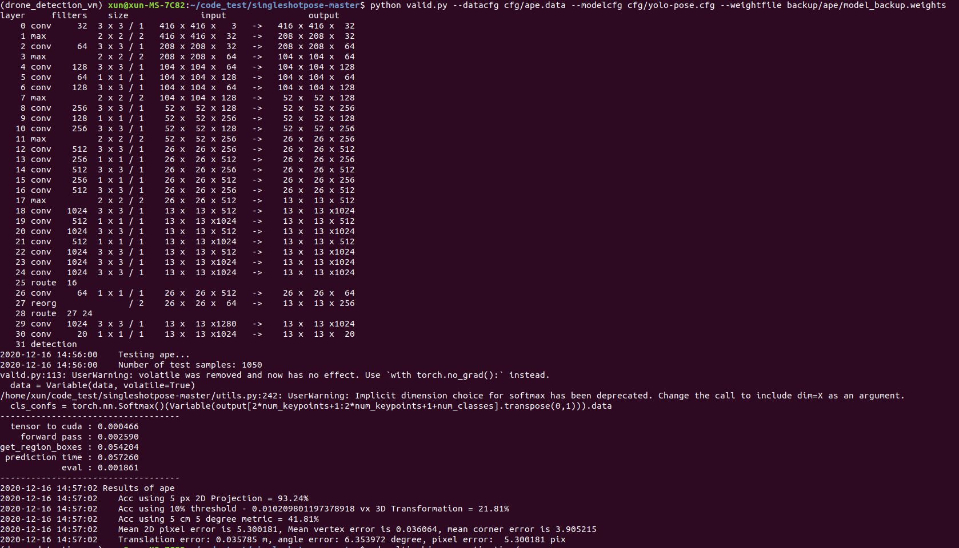

By using the valid_multi.ipynb to test, the result as follows:
2020-12-16 15:43:24 Testing ape...
2020-12-16 15:44:35 Acc using 5 px 2D Projection = 4.36%
2020-12-16 15:44:35 Acc using 10 px 2D Projection = 32.39%
2020-12-16 15:44:35 Acc using 15 px 2D Projection = 54.44%
2020-12-16 15:44:35 Acc using 20 px 2D Projection = 64.96%
2020-12-16 15:44:35 Acc using 25 px 2D Projection = 69.40%
2020-12-16 15:44:35 Acc using 30 px 2D Projection = 71.79%
2020-12-16 15:44:35 Acc using 35 px 2D Projection = 72.56%
2020-12-16 15:44:35 Acc using 40 px 2D Projection = 73.59%
2020-12-16 15:44:35 Acc using 45 px 2D Projection = 74.02%
2020-12-16 15:44:35 Acc using 50 px 2D Projection = 74.79%
2020-12-16 15:44:36 Testing can...
2020-12-16 15:45:47 Acc using 5 px 2D Projection = 8.45%
2020-12-16 15:45:47 Acc using 10 px 2D Projection = 54.43%
2020-12-16 15:45:47 Acc using 15 px 2D Projection = 76.06%
2020-12-16 15:45:47 Acc using 20 px 2D Projection = 84.09%
2020-12-16 15:45:47 Acc using 25 px 2D Projection = 87.08%
2020-12-16 15:45:47 Acc using 30 px 2D Projection = 89.89%
2020-12-16 15:45:47 Acc using 35 px 2D Projection = 90.97%
2020-12-16 15:45:47 Acc using 40 px 2D Projection = 92.29%
2020-12-16 15:45:47 Acc using 45 px 2D Projection = 92.87%
2020-12-16 15:45:47 Acc using 50 px 2D Projection = 93.29%
2020-12-16 15:45:48 Testing cat...
2020-12-16 15:47:03 Acc using 5 px 2D Projection = 2.11%
2020-12-16 15:47:03 Acc using 10 px 2D Projection = 17.94%
2020-12-16 15:47:03 Acc using 15 px 2D Projection = 33.02%
2020-12-16 15:47:03 Acc using 20 px 2D Projection = 43.13%
2020-12-16 15:47:03 Acc using 25 px 2D Projection = 48.44%
2020-12-16 15:47:03 Acc using 30 px 2D Projection = 52.15%
2020-12-16 15:47:03 Acc using 35 px 2D Projection = 54.68%
2020-12-16 15:47:03 Acc using 40 px 2D Projection = 56.36%
2020-12-16 15:47:03 Acc using 45 px 2D Projection = 57.88%
2020-12-16 15:47:03 Acc using 50 px 2D Projection = 59.14%
2020-12-16 15:47:03 Testing duck...
2020-12-16 15:48:15 Acc using 5 px 2D Projection = 2.97%
2020-12-16 15:48:15 Acc using 10 px 2D Projection = 15.84%
2020-12-16 15:48:15 Acc using 15 px 2D Projection = 29.13%
2020-12-16 15:48:15 Acc using 20 px 2D Projection = 53.28%
2020-12-16 15:48:15 Acc using 25 px 2D Projection = 73.49%
2020-12-16 15:48:15 Acc using 30 px 2D Projection = 79.88%
2020-12-16 15:48:15 Acc using 35 px 2D Projection = 81.45%
2020-12-16 15:48:15 Acc using 40 px 2D Projection = 82.24%
2020-12-16 15:48:15 Acc using 45 px 2D Projection = 82.50%
2020-12-16 15:48:15 Acc using 50 px 2D Projection = 82.85%
2020-12-16 15:48:16 Testing glue...
2020-12-16 15:49:13 Acc using 5 px 2D Projection = 4.32%
2020-12-16 15:49:13 Acc using 10 px 2D Projection = 20.93%
2020-12-16 15:49:13 Acc using 15 px 2D Projection = 33.22%
2020-12-16 15:49:13 Acc using 20 px 2D Projection = 40.75%
2020-12-16 15:49:13 Acc using 25 px 2D Projection = 44.41%
2020-12-16 15:49:13 Acc using 30 px 2D Projection = 46.51%
2020-12-16 15:49:13 Acc using 35 px 2D Projection = 47.62%
2020-12-16 15:49:13 Acc using 40 px 2D Projection = 47.95%
2020-12-16 15:49:13 Acc using 45 px 2D Projection = 48.39%
2020-12-16 15:49:13 Acc using 50 px 2D Projection = 49.39%
2020-12-16 15:49:21 Testing holepuncher...
2020-12-16 15:51:08 Acc using 5 px 2D Projection = 7.27%
2020-12-16 15:51:08 Acc using 10 px 2D Projection = 35.87%
2020-12-16 15:51:08 Acc using 15 px 2D Projection = 50.41%
2020-12-16 15:51:08 Acc using 20 px 2D Projection = 58.93%
2020-12-16 15:51:08 Acc using 25 px 2D Projection = 66.28%
2020-12-16 15:51:08 Acc using 30 px 2D Projection = 72.23%
2020-12-16 15:51:08 Acc using 35 px 2D Projection = 77.85%
2020-12-16 15:51:08 Acc using 40 px 2D Projection = 83.72%
2020-12-16 15:51:08 Acc using 45 px 2D Projection = 87.52%
2020-12-16 15:51:08 Acc using 50 px 2D Projection = 89.83%
​

