**Jinghui Zhu | jinghuiz**

**a) What traffic patterns did you see in the load sent to the ELB by the load generator? How did you actually figure out the load pattern? (Please provide appropriate screenshots from the AWS dashboard wherever necessary) 3 pts**

In the “Network Out” monitor of Load Generator, we can see the traffic out from the Load Generator. The line is not straight but burst the traffic and then stop a while.

And at the beginning of the test, the “HTTP 2XXs” receiving traffic pattern just the same as the traffic out from the Load Generator. However, at the 2nd part I circle, the load generator begins to burst traffic in a short time back and forth, but the “HTTP 2xx” monitor does not show the same pattern, which probably the adjustment operations need some time to react. Although my average RPS is 16.33 but I think my policy can be optimized.

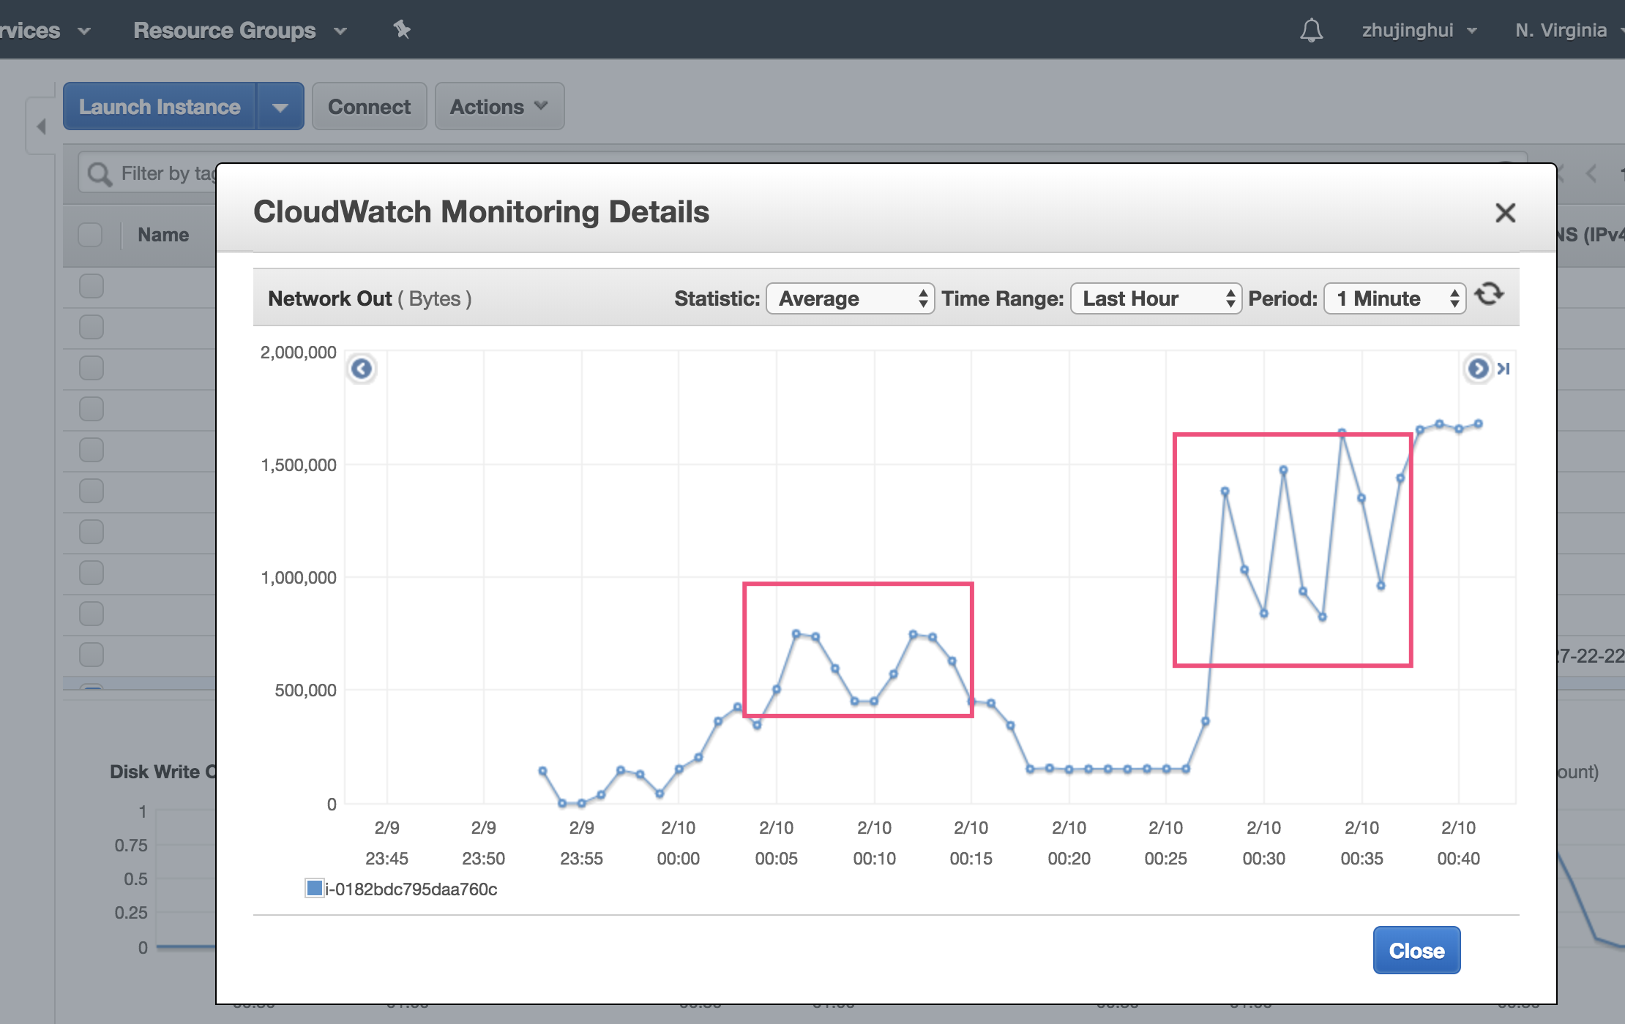

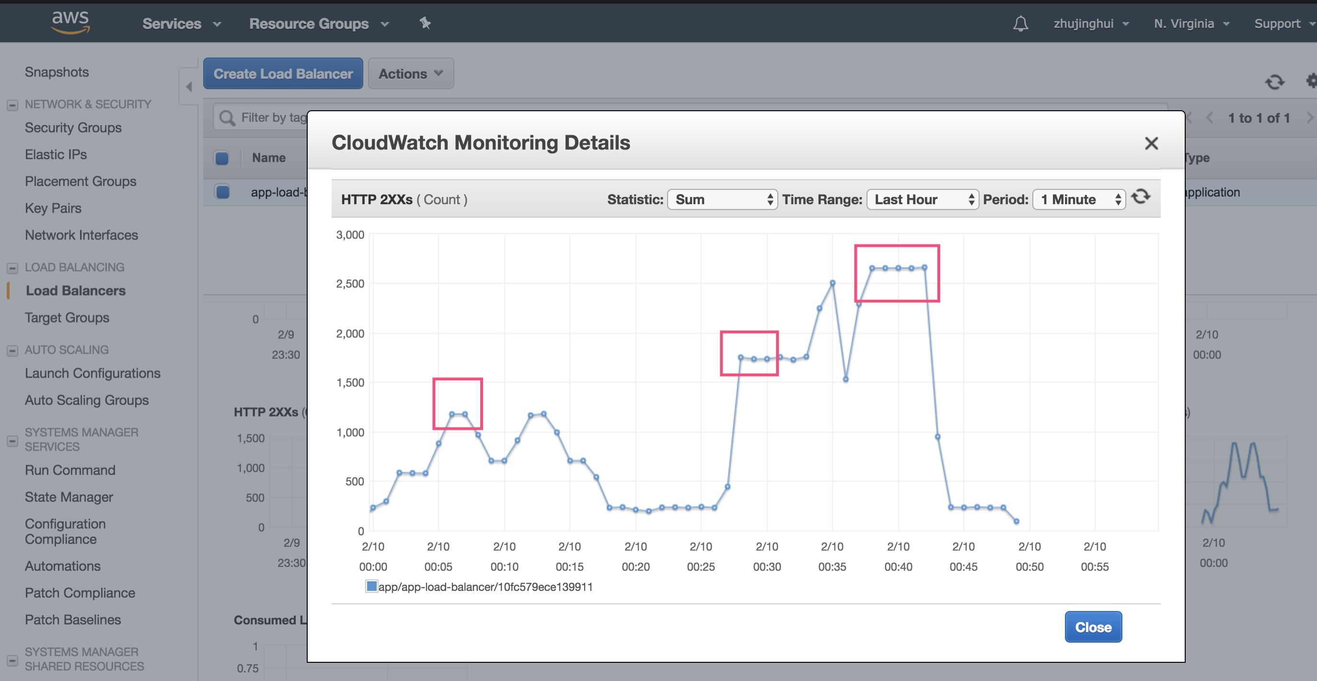

b) How did you model the policies for the AutoScaling Group in response to the insights gained in the above question? 2 pts

My scaling out policy is when it exceed threshold 65: (0-10) add 1 instance, (10-20) add 2, (20-35)add 3, (above 35)add 4.

Scaling out policy is when it is under the threshold 35: (-15-0) minus 1 instance, (-35- -15)minus 2, (lower -35)minus 3

My policy in terraform code shows below:

scale-out-policy(threshold 65):

**step_adjustment** {  
 scaling_adjustment = 1  
 metric_interval_lower_bound = 0  
 metric_interval_upper_bound = 10  
}  
  
**step_adjustment** {  
 scaling_adjustment = 2  
 metric_interval_lower_bound = 10  
 metric_interval_upper_bound = 20  
}  
  
 **step_adjustment** {  
 scaling_adjustment = 3  
 metric_interval_lower_bound = 20  
 metric_interval_upper_bound = 35  
}  
  
**step_adjustment** {  
 scaling_adjustment = 4  
 metric_interval_lower_bound = 35  
}

scale-in-policy(threshold 35):

**step_adjustment** {  
 scaling_adjustment = -1  
 metric_interval_lower_bound = -15  
 metric_interval_upper_bound = 0  
}  
  
**step_adjustment** {  
 scaling_adjustment = -2  
 metric_interval_lower_bound = -35  
 metric_interval_upper_bound = -15  
}  
  
 **step_adjustment** {  
 scaling_adjustment = -3  
 metric_interval_upper_bound = -35  
}