作业3

Write out the code to estimate the parameters _ and jj using the LS-method,

with the following sample covariance matrix.

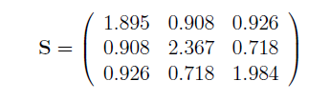





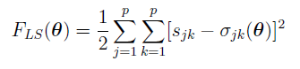

0.8506667 $Ψ_{11}=$ 1.0443333 $Ψ_{22}=$ 1.5163333 $Ψ_{33}=$ 1.1333333

代码：

> f=matrix(c(9,1,1,1,

+ 1,1,0,0,

+ 1,0,1,0,

+ 1,0,0,1),4,4)

> rf=matrix(c(11.35,

+ 1.895,

+ 2.367,

+ 1.984),c(4,1))

> solve(f,rf)

[,1]

[1,] 0.8506667

[2,] 1.0443333

[3,] 1.5163333

[4,] 1.1333333

得出估计值